FACULTY OF ENGINEERING AND TECHNOLOGY
Object Oriented Programming (CEUE203) - Semester 3
Practical 11: Object Serialization and Java NIO File Handling
Student Name: Krutin | Enrolment No: 25CS034

Problem 1: Object Serialization with Transient Fields
Problem Statement:
Define a Serializable Student class with an id, name, and transient password field.
Serialize an array of student objects to a binary file using ObjectOutputStream inside try-with-resources. Deserialize the array back using ObjectInputStream, demonstrating that serialized fields survive while transient fields remain null.

Java Source Code:
/**
* Student Name : Krutin
* Enrolment No : 25CS034
* Course : CEUE203 - Object Oriented Programming
*/
import java.io.FileInputStream;
import java.io.FileOutputStream;
import java.io.IOException;
import java.io.ObjectInputStream;
import java.io.ObjectOutputStream;
import java.io.Serializable;
class Student implements Serializable {
int id;
String name;
transient String password;
Student(int id, String name, String password) {
this.id = id;
this.name = name;
this.password = password;
}
void display() {
System.out.println("ID: " + id + ", Name: " + name + ", Password: " + password);
}
}
public class Saveload {
public static void main(String[] args) {
System.out.println("Enrolment No: 25CS034 | Name: Krutin");
Student[] students = {
new Student(101, "Krutin", "abc123"),
new Student(102, "Rahul", "xyz456")
};
try (ObjectOutputStream out = new ObjectOutputStream(new FileOutputStream("students.dat"))) {
out.writeObject(students);
System.out.println("Objects saved successfully.");
} catch (IOException e) {
e.printStackTrace();
}
try (ObjectInputStream in = new ObjectInputStream(new FileInputStream("students.dat"))) {
Student[] loadedStudents = (Student[]) in.readObject();
System.out.println("\nObjects loaded successfully:");
for (Student s : loadedStudents) {
s.display();
}
} catch (IOException | ClassNotFoundException e) {
e.printStackTrace();
}
}
}

Execution Output Screenshot:

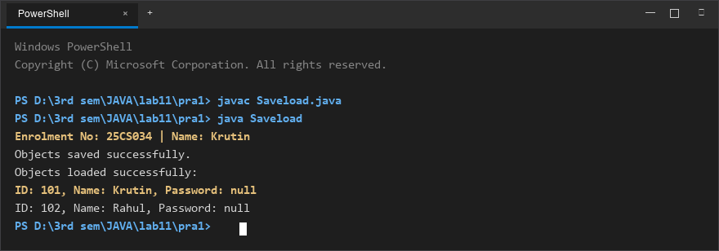
Figure 1: Console execution output for Problem 1 (Student ID: 25CS034)

Problem 2: NIO Directory Stream & Log Analyzer
Problem Statement:
Create multiple log text files using modern Java NIO (Files, Path).
Iterate through the directory using Files.newDirectoryStream(), read line-by-line with BufferedReader, count total lines and keyword matches ("ERROR"), and inspect file sizes using Files.readAttributes().

Java Source Code:
/**
* Student Name : Krutin
* Enrolment No : 25CS034
* Course : CEUE203 - Object Oriented Programming
*/
import java.io.BufferedReader;
import java.io.IOException;
import java.nio.file.DirectoryStream;
import java.nio.file.Files;
import java.nio.file.Path;
import java.nio.file.Paths;
import java.nio.file.attribute.BasicFileAttributes;
import java.util.Arrays;
public class Loganalyzer {
public static void main(String[] args) {
System.out.println("Enrolment No: 25CS034 | Name: Krutin");
Path folder = Paths.get("logs");
String keyword = "ERROR";
int totalLines = 0;
int totalKeywordLines = 0;
try {
Files.createDirectories(folder);
Files.write(folder.resolve("a.txt"), Arrays.asList(
"INFO Server started",
"ERROR Database failed",
"INFO User logged in"
));
Files.write(folder.resolve("b.txt"), Arrays.asList(
"INFO Request received",
"ERROR File not found",
"INFO Request completed",
"ERROR Server stopped"
));
Files.write(folder.resolve("c.txt"), Arrays.asList(
"INFO System running",
"INFO Backup completed"
));
try (DirectoryStream<Path> files = Files.newDirectoryStream(folder, "*.txt")) {
for (Path file : files) {
int lines = 0;
int keywordLines = 0;
try (BufferedReader reader = Files.newBufferedReader(file)) {
String line;
while ((line = reader.readLine()) != null) {
lines++;
if (line.contains(keyword)) {
keywordLines++;
}
}
}
BasicFileAttributes attrs = Files.readAttributes(file, BasicFileAttributes.class);
long size = attrs.size();
System.out.println("File: " + file.getFileName());
System.out.println("Size: " + size + " bytes");
System.out.println("Lines: " + lines);
System.out.println("Contains ERROR: " + keywordLines);
System.out.println();
totalLines += lines;
totalKeywordLines += keywordLines;
}
}
System.out.println("===== Overall Result =====");
System.out.println("Total Lines: " + totalLines);
System.out.println("Total Lines Containing ERROR: " + totalKeywordLines);
} catch (IOException e) {
System.out.println("Error: " + e.getMessage());
}
}
}

Execution Output Screenshot:

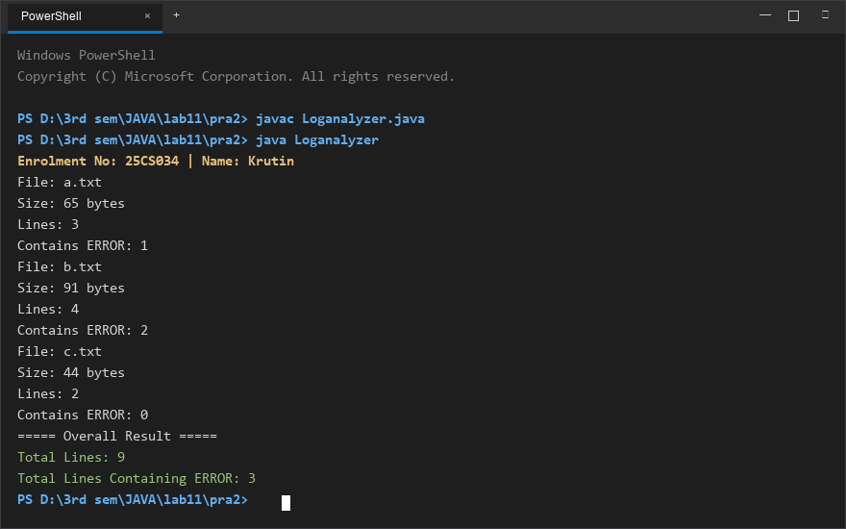
Figure 2: Console execution output for Problem 2 (Student ID: 25CS034)

