FACULTY OF ENGINEERING AND TECHNOLOGY
Object Oriented Programming (CEUE203) - Semester 3
Practical 12: Java Collections Framework (HashMap, Set, and Custom Sorting)
Student Name: Krutin | Enrolment No: 25CS034

Problem 1: Word Frequency Analyzer with Comparator
Problem Statement:
Tokenize a paragraph into lowercase words, count the occurrences of each word using a HashMap<String, Integer>, and sort the entry set in descending order of frequency using a custom Comparator / lambda.

Java Source Code:
/**
* Student Name : Krutin
* Enrolment No : 25CS034
* Course : CEUE203 - Object Oriented Programming
*/
import java.util.ArrayList;
import java.util.HashMap;
import java.util.List;
import java.util.Map;
public class WordFrequency {
public static void main(String[] args) {
System.out.println("Enrolment No: 25CS034 | Name: Krutin");
String paragraph = "java is easy and java is powerful java is popular";
String[] words = paragraph.toLowerCase().split("\\s+");
HashMap<String, Integer> frequency = new HashMap<>();
for (String word : words) {
frequency.put(word, frequency.getOrDefault(word, 0) + 1);
}
List<Map.Entry<String, Integer>> list = new ArrayList<>(frequency.entrySet());
list.sort((a, b) -> b.getValue().compareTo(a.getValue()));
System.out.println("Words sorted by frequency:");
for (Map.Entry<String, Integer> entry : list) {
System.out.println(entry.getKey() + " : " + entry.getValue());
}
}
}

Execution Output Screenshot:

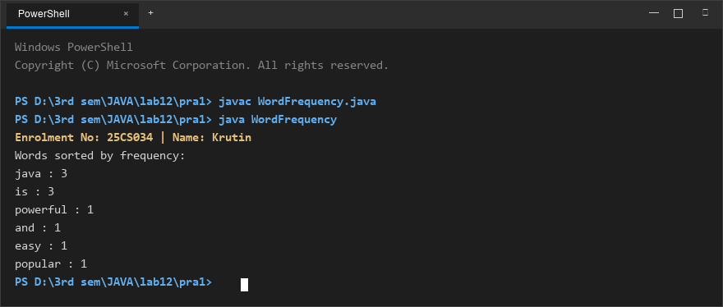
Figure 1: Console execution output for Problem 1 (Student ID: 25CS034)

Problem 2: Unique Visitors Tracker (HashSet & LinkedHashSet)
Problem Statement:
From a stream of user login names containing duplicates, use a HashSet to count unique visitors and a LinkedHashSet to preserve first-seen insertion order.
Print the total distinct visitor count and display the first three distinct visitors in order.

Java Source Code:
/**
* Student Name : Krutin
* Enrolment No : 25CS034
* Course : CEUE203 - Object Oriented Programming
*/
import java.util.Arrays;
import java.util.HashSet;
import java.util.LinkedHashSet;
import java.util.List;
public class UniqueVisitors {
public static void main(String[] args) {
System.out.println("Enrolment No: 25CS034 | Name: Krutin");
List<String> loginNames = Arrays.asList(
"Krutin",
"Rahul",
"Amit",
"Krutin",
"Neha",
"Rahul",
"Priya",
"Jay"
);
HashSet<String> uniqueUsers = new HashSet<>(loginNames);
LinkedHashSet<String> firstSeenUsers = new LinkedHashSet<>(loginNames);
System.out.println("Unique users: " + uniqueUsers.size());
System.out.println("First three distinct names:");
int count = 0;
for (String name : firstSeenUsers) {
System.out.println(name);
count++;
if (count == 3) {
break;
}
}
}
}

Execution Output Screenshot:

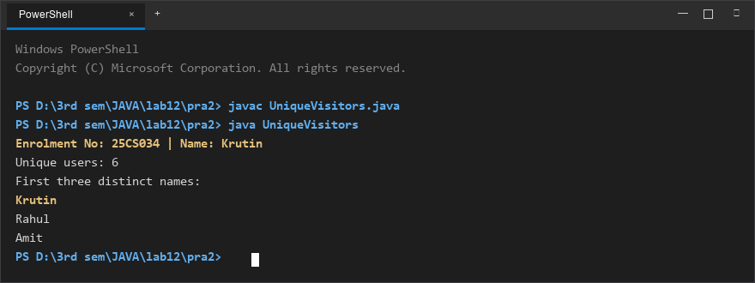
Figure 2: Console execution output for Problem 2 (Student ID: 25CS034)

