FACULTY OF ENGINEERING AND TECHNOLOGY
Object Oriented Programming (CEUE203) - Semester 3
Practical 13: Java Generics (Generic Classes, Methods, and Bounded Types)
Student Name: Krutin | Enrolment No: 25CS034

Problem 1: Generic Containers (Box & Pair)
Problem Statement:
Implement generic container classes Box<T> and Pair<A, B> with getter and setter methods.
Demonstrate compile-time type safety with different types (Integer, String) without explicit casting, and write a generic method <T> T firstElement(T[] array) that returns the first element of any array.

Java Source Code:
File: Box.java
/**
* Student Name : Krutin
* Enrolment No : 25CS034
* Course : CEUE203 - Object Oriented Programming
*/
public class Box<T> {
private T value;
public Box(T value) {
this.value = value;
}
public T get() {
return value;
}
public void set(T value) {
this.value = value;
}
}

File: Pair.java
/**
* Student Name : Krutin
* Enrolment No : 25CS034
* Course : CEUE203 - Object Oriented Programming
*/
public class Pair<A, B> {
private A first;
private B second;
public Pair(A first, B second) {
this.first = first;
this.second = second;
}
public A getFirst() {
return first;
}
public B getSecond() {
return second;
}
}

File: GenericDemo.java
/**
* Student Name : Krutin
* Enrolment No : 25CS034
* Course : CEUE203 - Object Oriented Programming
*/
public class GenericDemo {
public static <T> T firstElement(T[] array) {
return array[0];
}
public static void main(String[] args) {
System.out.println("Enrolment No: 25CS034 | Name: Krutin");
Box<Integer> b1 = new Box<>(100);
System.out.println("Box Integer: " + b1.get());
b1.set(200);
System.out.println("Updated Box: " + b1.get());
Box<String> b2 = new Box<>("Hello");
System.out.println("Box String: " + b2.get());
Pair<String, Integer> p1 = new Pair<>("Age", 20);
System.out.println("Pair First: " + p1.getFirst());
System.out.println("Pair Second: " + p1.getSecond());
Integer[] numbers = {10, 20, 30};
System.out.println("First Integer: " + firstElement(numbers));
String[] names = {"Java", "Python", "C++"};
System.out.println("First String: " + firstElement(names));
}
}

Execution Output Screenshot:

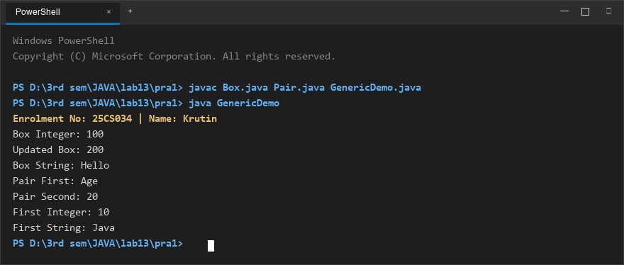
Figure 1: Console execution output for Problem 1 (Student ID: 25CS034)

Problem 2: Bounded Type Generic Method
Problem Statement:
Write a bounded type generic method <N extends Number> double average(N[] values) that computes the arithmetic mean for any numeric array (Integer[], Double[], Long[]).
Demonstrate how the upper bound ensures type safety and allows calling Number methods like doubleValue().

Java Source Code:
/**
* Student Name : Krutin
* Enrolment No : 25CS034
* Course : CEUE203 - Object Oriented Programming
*/
public class BoundedStats {
static <N extends Number> double average(N[] values) {
double sum = 0;
for (N n : values) {
sum += n.doubleValue();
}
return sum / values.length;
}
public static void main(String[] args) {
System.out.println("Enrolment No: 25CS034 | Name: Krutin");
Integer[] intValues = {1, 2, 3, 4, 5};
Double[] doubleValues = {1.0, 2.0, 3.0, 4.0, 5.0};
Long[] longValues = {10L, 20L, 30L, 40L, 50L};
System.out.println("Integer Average: " + average(intValues));
System.out.println("Double Average: " + average(doubleValues));
System.out.println("Long Average: " + average(longValues));
}
}

Execution Output Screenshot:

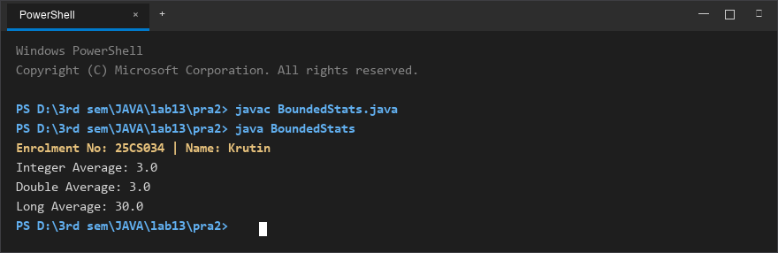
Figure 2: Console execution output for Problem 2 (Student ID: 25CS034)

