FACULTY OF ENGINEERING AND TECHNOLOGY
Object Oriented Programming (CEUE203) - Semester 3
Practical 14: Layered Application Architecture, Testing, and State Persistence
Student Name: Krutin | Enrolment No: 25CS034

Problem 1: Modular Layered Student Management Service
Problem Statement:
Build a layered application featuring a model entity (Student), an in-memory service layer (StudentService backed by ArrayList), and an interactive console interface (Main) for managing records, accompanied by JUnit unit tests validating business rules.

Java Source Code:
File: Student.java
/**
* Student Name : Krutin
* Enrolment No : 25CS034
* Course : CEUE203 - Object Oriented Programming
*/
public class Student {
private int id;
private String name;
private String course;
public Student(int id, String name, String course) {
this.id = id;
this.name = name;
this.course = course;
}
public int getId() {
return id;
}
public String getName() {
return name;
}
public String getCourse() {
return course;
}
@Override
public String toString() {
return "ID: " + id + ", Name: " + name + ", Course: " + course;
}
}

File: StudentService.java
/**
* Student Name : Krutin
* Enrolment No : 25CS034
* Course : CEUE203 - Object Oriented Programming
*/
import java.util.ArrayList;
public class StudentService {
private ArrayList<Student> students = new ArrayList<>();
public void addStudent(Student student) {
if (student == null) {
throw new IllegalArgumentException("Student cannot be null");
}
students.add(student);
}
public ArrayList<Student> getStudents() {
return new ArrayList<>(students);
}
public int getCount() {
return students.size();
}
}

File: Main.java
/**
* Student Name : Krutin
* Enrolment No : 25CS034
* Course : CEUE203 - Object Oriented Programming
*/
import java.util.Scanner;
public class Main {
public static void main(String[] args) {
System.out.println("Enrolment No: 25CS034 | Name: Krutin");
StudentService service = new StudentService();
Scanner sc = new Scanner(System.in);
boolean running = true;
while (running) {
System.out.println("\n--- Student Management ---");
System.out.println("1. Add Student");
System.out.println("2. List Students");
System.out.println("3. Exit");
System.out.print("Enter choice: ");
if (!sc.hasNextInt()) {
break;
}
int choice = sc.nextInt();
switch (choice) {
case 1:
System.out.print("Enter ID: ");
int id = sc.nextInt();
sc.nextLine();
System.out.print("Enter Name: ");
String name = sc.nextLine();
System.out.print("Enter Course: ");
String course = sc.nextLine();
service.addStudent(new Student(id, name, course));
System.out.println("Student added. Total: " + service.getCount());
break;
case 2:
System.out.println("\nStudents List:");
for (Student s : service.getStudents()) {
System.out.println(s);
}
break;
case 3:
running = false;
System.out.println("Goodbye!");
break;
default:
System.out.println("Invalid choice.");
}
}
sc.close();
}
}

File: StudentServiceTest.java
/**
* Student Name : Krutin
* Enrolment No : 25CS034
* Course : CEUE203 - Object Oriented Programming
*/
import org.junit.jupiter.api.Test;
import static org.junit.jupiter.api.Assertions.assertEquals;
import static org.junit.jupiter.api.Assertions.assertThrows;
public class StudentServiceTest {
@Test
void addingStudentIncreasesCount() {
StudentService service = new StudentService();
service.addStudent(new Student(1, "Rahul", "CSE"));
assertEquals(1, service.getCount());
}
@Test
void addingTwoStudentsGivesCountTwo() {
StudentService service = new StudentService();
service.addStudent(new Student(1, "Rahul", "CSE"));
service.addStudent(new Student(2, "Priya", "IT"));
assertEquals(2, service.getCount());
}
@Test
void addingNullStudentThrowsException() {
StudentService service = new StudentService();
assertThrows(IllegalArgumentException.class, () -> service.addStudent(null));
}
}

Execution Output Screenshot:

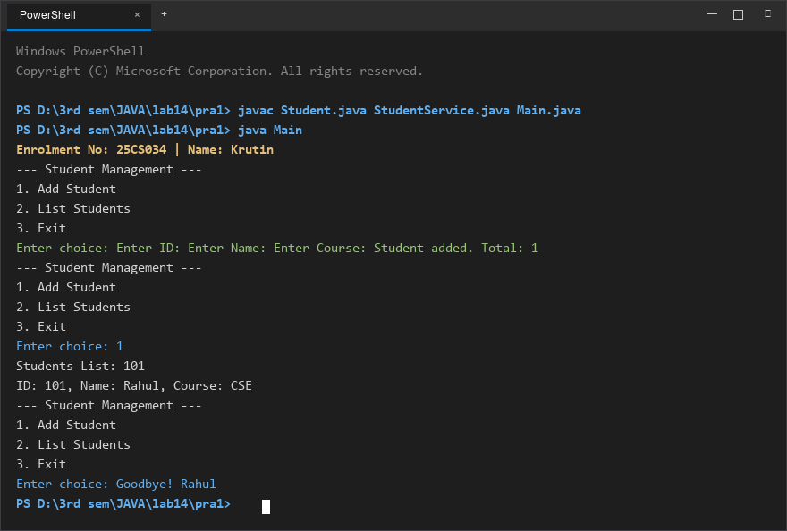
Figure 1: Console execution output for Problem 1 (Student ID: 25CS034)

Problem 2: Application State Serialization Persistence
Problem Statement:
Design a standalone persistent application that encapsulates student records into serializable objects, writes state to disk on exit, and reloads data upon startup verifying state persistence.

Java Source Code:
/**
* Student Name : Krutin
* Enrolment No : 25CS034
* Course : CEUE203 - Object Oriented Programming
*/
import java.io.FileInputStream;
import java.io.FileOutputStream;
import java.io.IOException;
import java.io.ObjectInputStream;
import java.io.ObjectOutputStream;
import java.io.Serializable;
import java.util.ArrayList;
class StudentRecord implements Serializable {
private int id;
private String name;
public StudentRecord(int id, String name) {
this.id = id;
this.name = name;
}
@Override
public String toString() {
return "ID: " + id + ", Name: " + name;
}
}
public class App {
public static void main(String[] args) {
System.out.println("Enrolment No: 25CS034 | Name: Krutin");
ArrayList<StudentRecord> list = new ArrayList<>();
list.add(new StudentRecord(101, "Rahul"));
list.add(new StudentRecord(102, "Priya"));
String filename = "data.dat";
try (ObjectOutputStream out = new ObjectOutputStream(new FileOutputStream(filename))) {
out.writeObject(list);
System.out.println("Data saved successfully.");
} catch (IOException e) {
e.printStackTrace();
}
try (ObjectInputStream in = new ObjectInputStream(new FileInputStream(filename))) {
@SuppressWarnings("unchecked")
ArrayList<StudentRecord> loaded = (ArrayList<StudentRecord>) in.readObject();
System.out.println("Data reloaded successfully:");
for (StudentRecord s : loaded) {
System.out.println(s);
}
} catch (IOException | ClassNotFoundException e) {
e.printStackTrace();
}
}
}

Execution Output Screenshot:

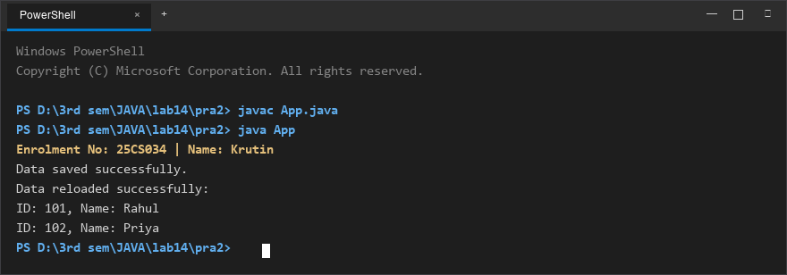
Figure 2: Console execution output for Problem 2 (Student ID: 25CS034)

