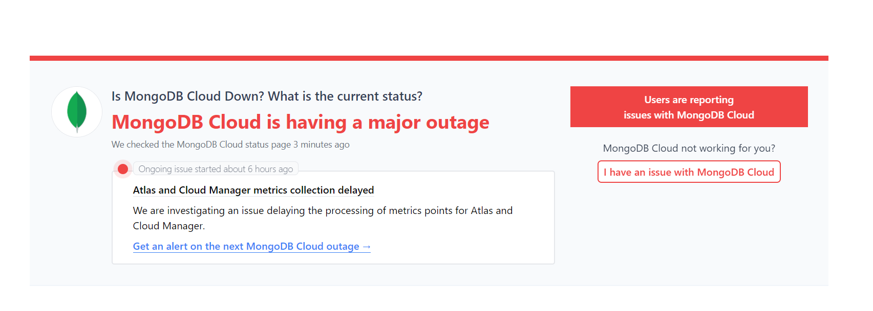

Because of server issue of mongoDB. I was not able to create backend using mongoDB. As It consumed so much time.

To Start the frontEnd Server –

Naviate to backend folder and run

npm start

To Start the backend Json Server -

Naviate to backend folder and run

npx json-server --watch --port 5000 db.json