**Objective 1.1:**

Explore the claims data (using graphs/plots) using PowerBI or Python to tell a story with actionable business insight.



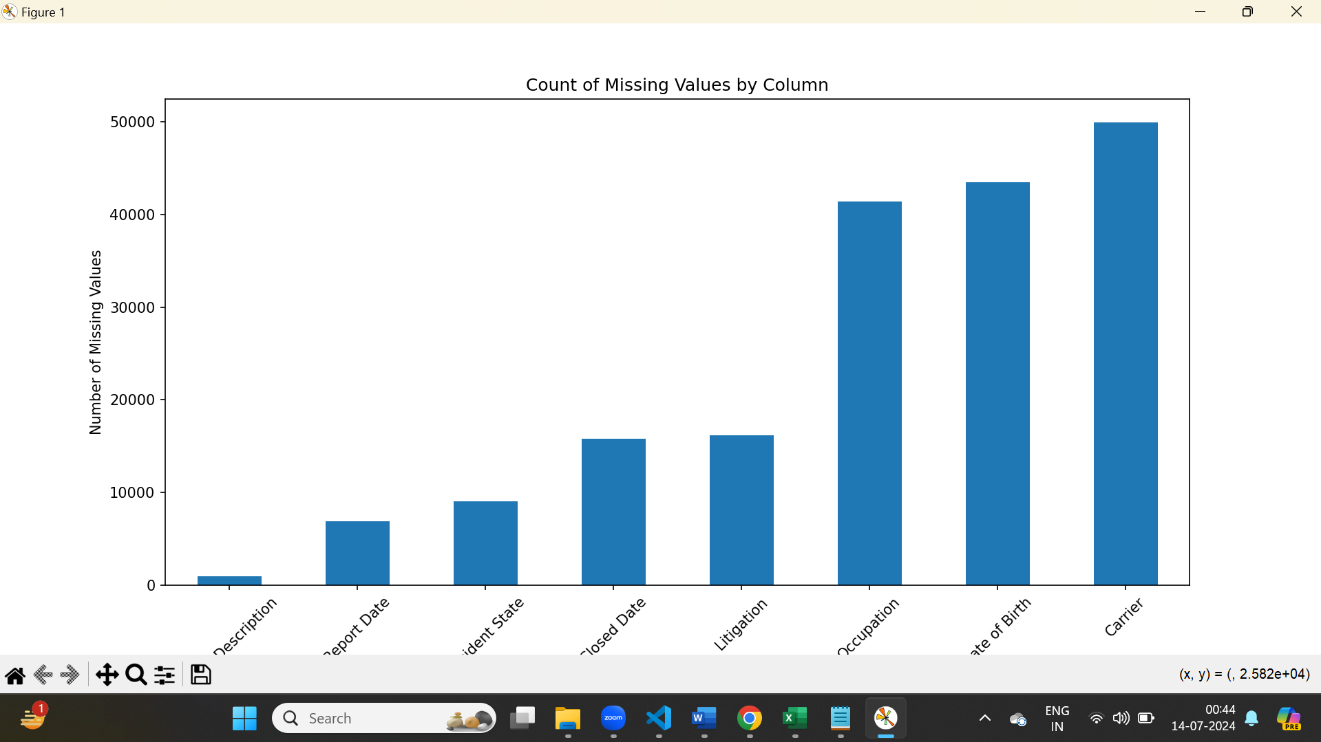

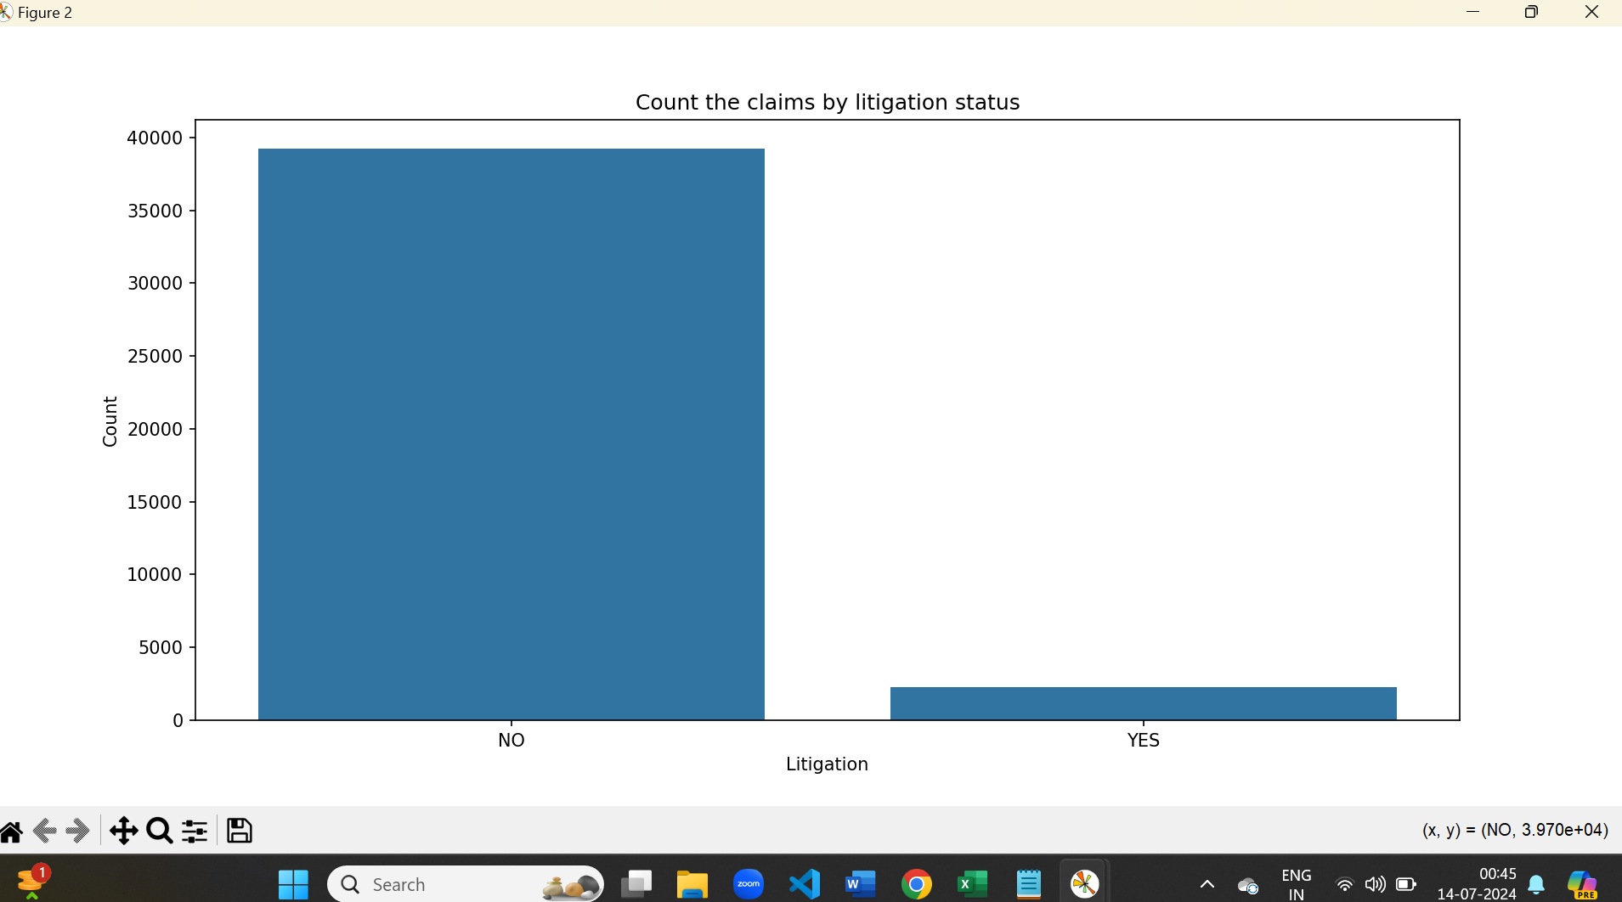

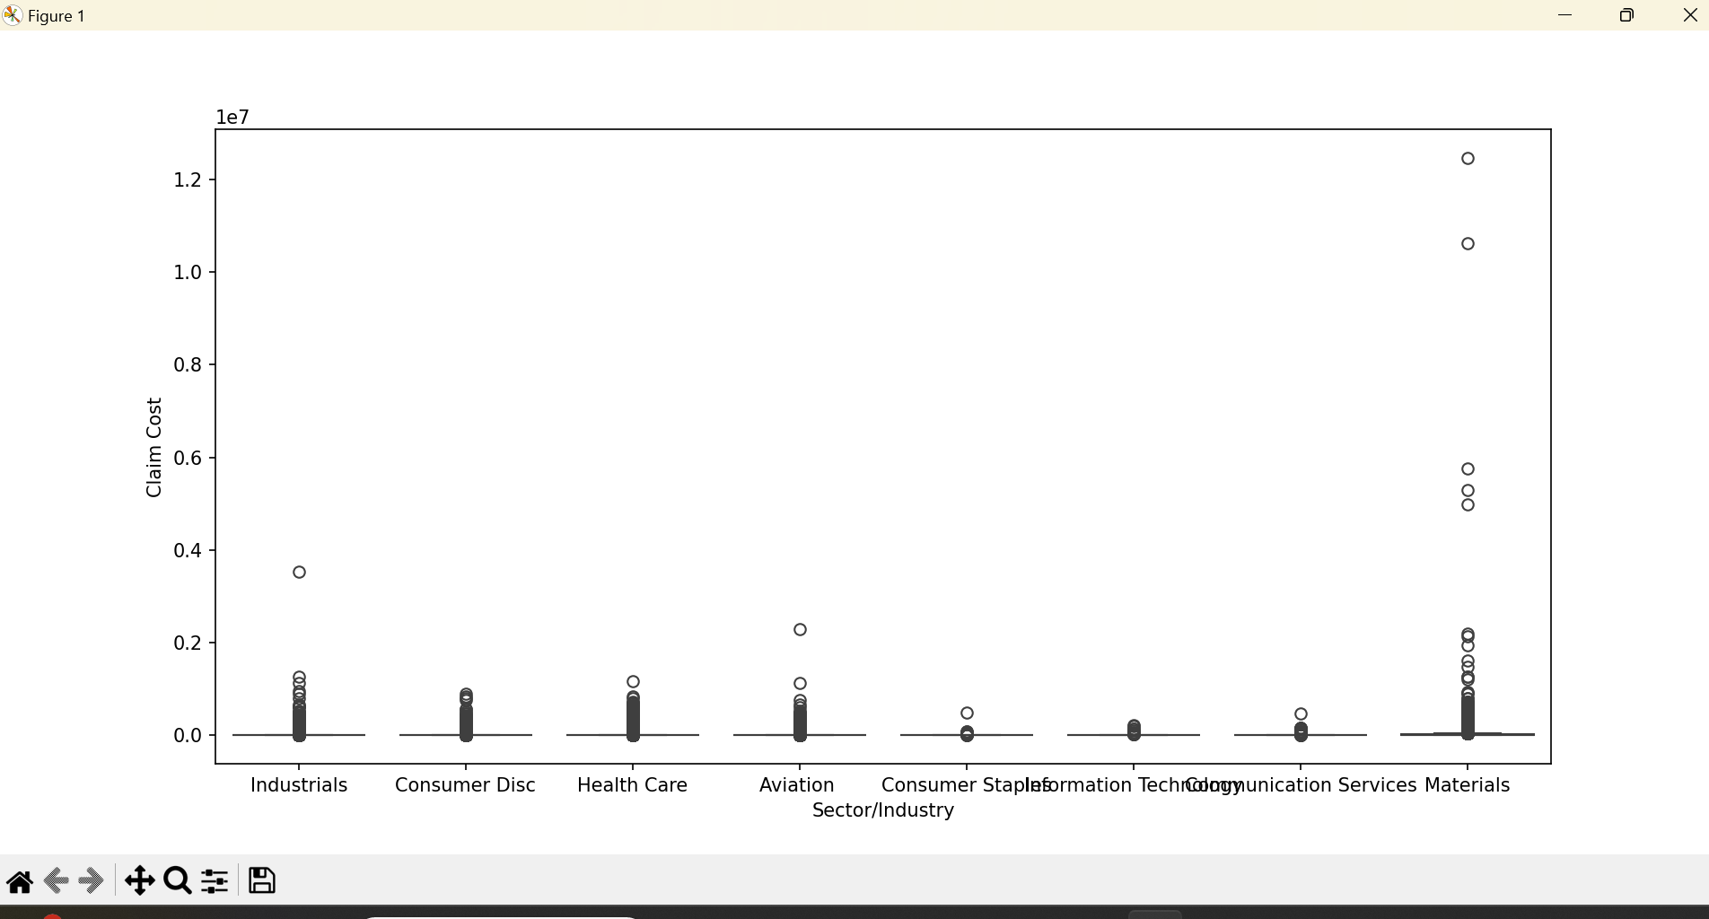

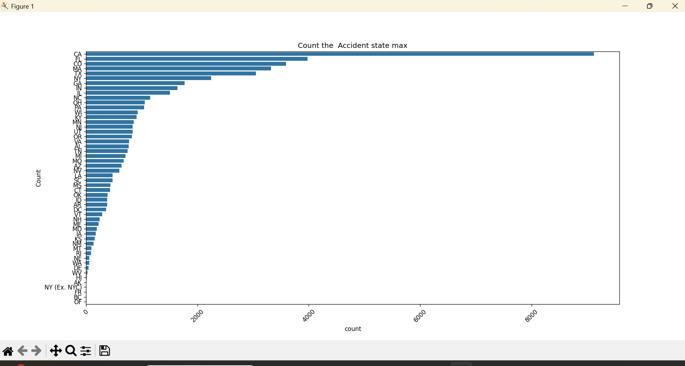

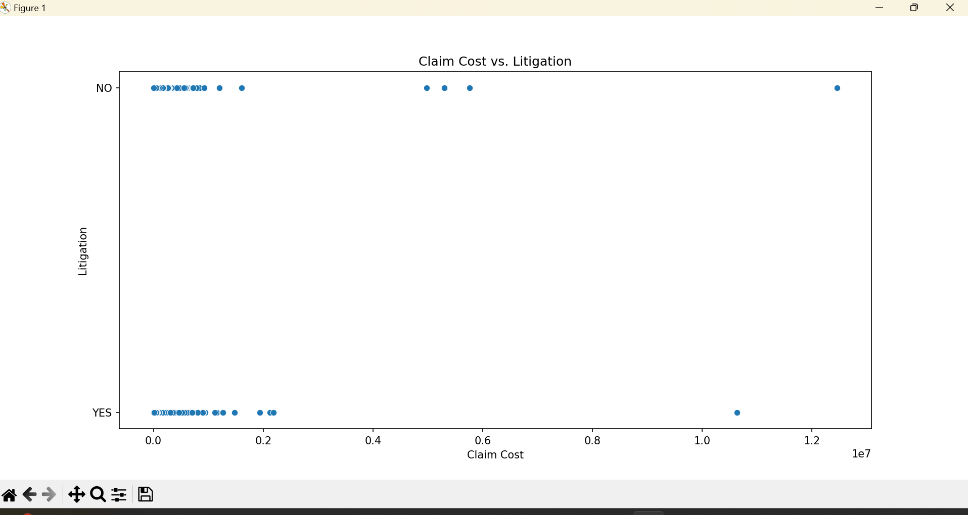



**Objective 1.2:**

Build a model to predict high cost workers compensation claim and highlight the key drivers of high-cost claims.

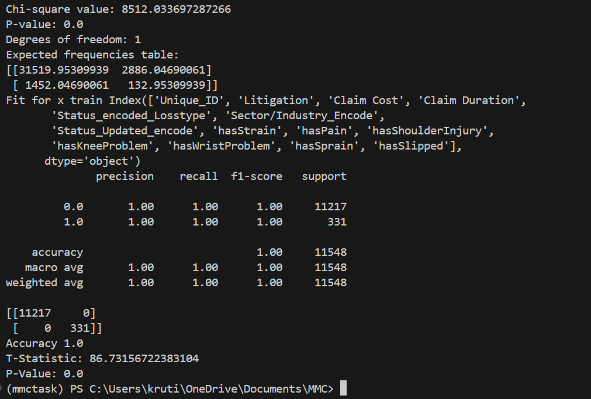

**Objective 1.3:**

Prove that litigation is the key driver of high-cost claims using statistical analysis and tests. Predict if the case will go for litigation.

Couldn’t complete this task , as I was getting error that would take time to resolve