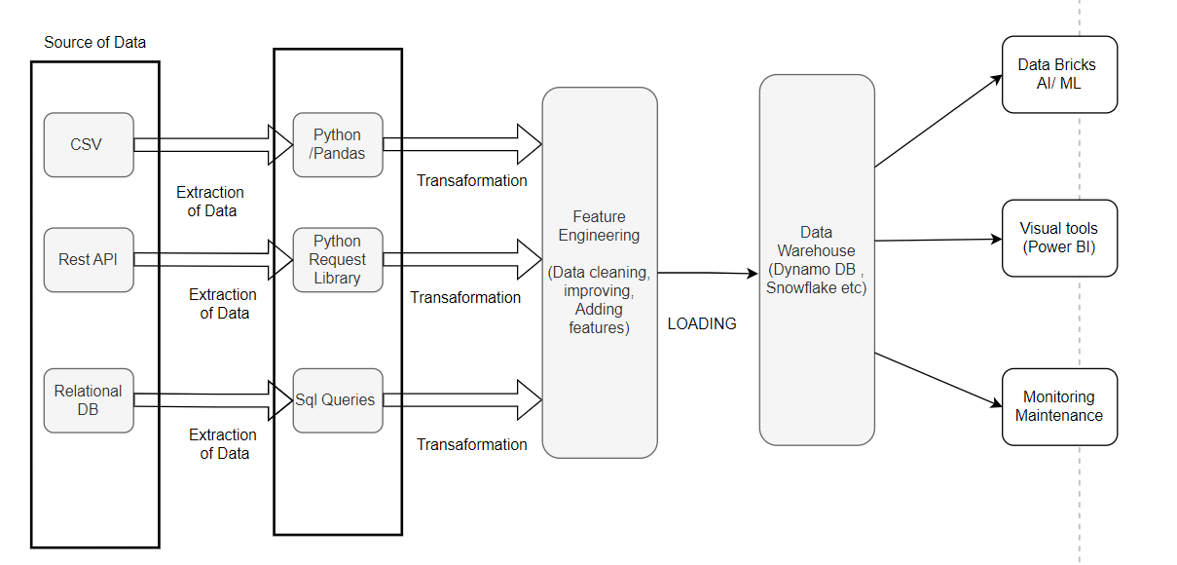

1. Extraction  
     
   Data will be coming from different sources like CSV,Rest API &/Or Relation Database. For CSV files we can use pandas , For rest api’s Python request library and sql queries for Relation database type source. Once the data is extracted from each of these tools , they are carried to next step for transforming the data.
2. Transformation   
   Transformation will include cleaning data removing null values , handling missing data , or standardizing formats like date type or categorical values in litigation etc.  
   Apart from them adding features to the data using the existing data based on the type of data we are handling .

Features like – duration for claim to be processed (when the claim was reported to when the claim was closed),Based on loss type which has more claim amount.

1. Loading  
   Load all the transformed data in data warehouse like snowflake or Amazon Redshift (in python we can use psycopg2 for Redshift to connect to it)

and use ETL tools to automate ETL process.  
Then visualize these data using tableau or power BI, seaborn or matplotlib in python  
Also setting up monitoring for performance, and ensure ETL processes are running smoothly.