Input data:

All compounds from TraceFinder (#sheets): 167

Compounds with SMILES: 44 (54 different SMILES, some suspects had multiple smiles) (contains all 33 SMILES of compounds Thomas used for calibration though?)

Calibration compounds (have theoretical amount): 18

Cal compounds (with theoretical amount and smiles): 14 (EtFOSE, HFPO-DA, MeFOSE, PFOS-br)

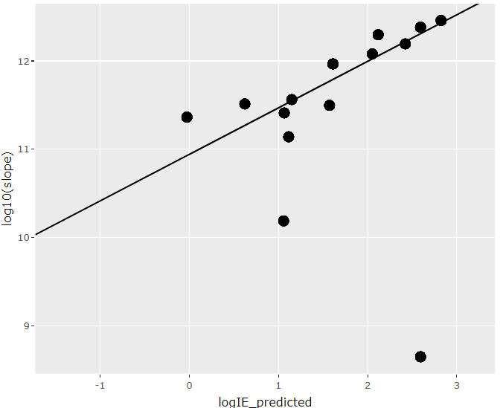

For 14 cal compounds: pred vs theoretical

