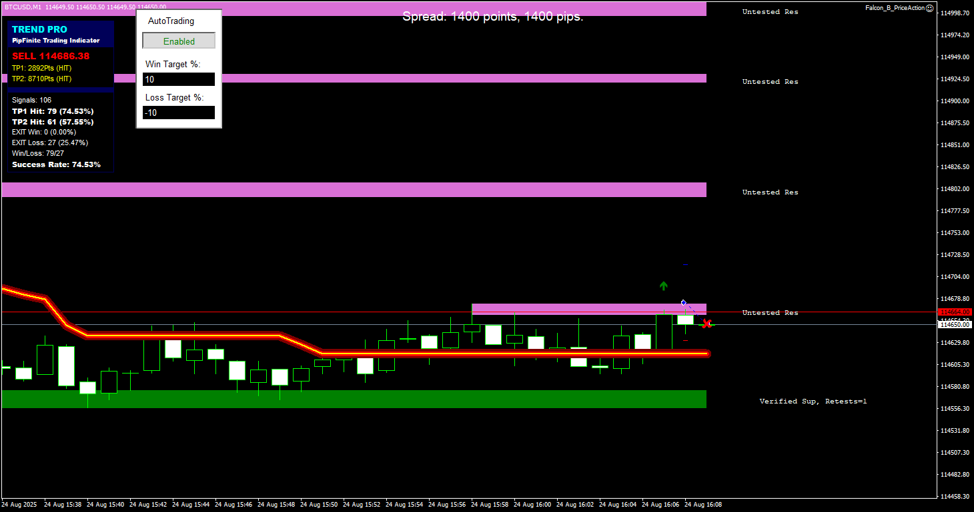

0 16:07:58.360 Falcon_B_PriceAction BTCUSD,M1: Entry Signal - BUY after PipFinite crossing

0 16:07:58.360 Falcon_B_PriceAction BTCUSD,M1: Stop is too large, using ATR for Stop Loss: 4265.0

0 16:07:58.360 Falcon_B_PriceAction BTCUSD,M1: Trying to place a market order...

2 16:07:58.500 Falcon_B_PriceAction BTCUSD,M1: open #666013099 buy 2.34 BTCUSD at 114674.75 sl: 114632.10 tp: 114717.40 ok

0 16:07:58.500 Falcon_B_PriceAction BTCUSD,M1: Order successfully placed. Ticket: 666013099

0 16:08:58.521 Falcon_B_PriceAction BTCUSD,M1: Entry Signal - SELL on DOWN_TREND after DOWN retracement ---- **wrong --- fixed**

0 16:08:58.521 Falcon_B_PriceAction BTCUSD,M1: Exit Signal - SELL on reversal to DOWN_TREND ---- **wrong**

0 16:08:58.740 Falcon_B_PriceAction BTCUSD,M1: Entry Signal - breakout, SELL below supply or demand line ---- **wrong – check again**

0 16:08:58.740 Falcon_B_PriceAction BTCUSD,M1: Stop is too large, using ATR for Stop Loss: 3750.0

0 16:08:58.740 Falcon_B_PriceAction BTCUSD,M1: Trying to close position 666013099 ...

2 16:08:58.868 Falcon_B_PriceAction BTCUSD,M1: close #666013099 buy 2.34 BTCUSD at 114674.75 sl: 114632.10 tp: 114717.40 at price 114650.00

0 16:20:58.206 Falcon_B_PriceAction BTCUSD,M1: Entry Signal - BUY on UP_TREND after UP retracement

0 16:20:58.389 Falcon_B_PriceAction BTCUSD,M1: Stop is too large, using ATR for Stop Loss: 5990.0

0 16:20:58.389 Falcon_B_PriceAction BTCUSD,M1: Trying to place a market order...

2 16:20:58.517 Falcon_B_PriceAction BTCUSD,M1: open #666013417 buy 2.48 BTCUSD at 114842.63 sl: 114782.73 tp: 114902.53 ok

0 16:20:58.517 Falcon_B_PriceAction BTCUSD,M1: Order successfully placed. Ticket: 666013417

0 16:21:44.159 Falcon_B_PriceAction BTCUSD,M1: Entry Signal - SELL after losing BUY trade

0 16:21:44.159 Falcon_B_PriceAction BTCUSD,M1: Losses count: 2 Updated Risk: 2.0

0 16:21:44.193 Falcon_B_PriceAction BTCUSD,M1: Stop is too large, using ATR for Stop Loss: 5990.0

0 16:21:44.193 Falcon_B_PriceAction BTCUSD,M1: Max consecutive failures reached, no new trades will be opened until breakout.

0 16:22:58.696 Falcon_B_PriceAction BTCUSD,M1: Entry Signal - SELL after PipFinite crossing

0 16:22:58.701 Falcon_B_PriceAction BTCUSD,M1: Stop is too large, using ATR for Stop Loss: 6395.0

0 16:22:58.701 Falcon_B_PriceAction BTCUSD,M1: Max consecutive failures reached, no new trades will be opened until breakout.

0 16:42:58.267 Falcon_B_PriceAction BTCUSD,M1: Entry Signal - breakout, BUY above supply or demand line ---- **wrong**

0 16:42:58.267 Falcon_B_PriceAction BTCUSD,M1: Stop is too large, using ATR for Stop Loss: 7512.399999999907

0 16:42:58.267 Falcon_B_PriceAction BTCUSD,M1: BUY signal canceled - only sell allowed below pipFinite line

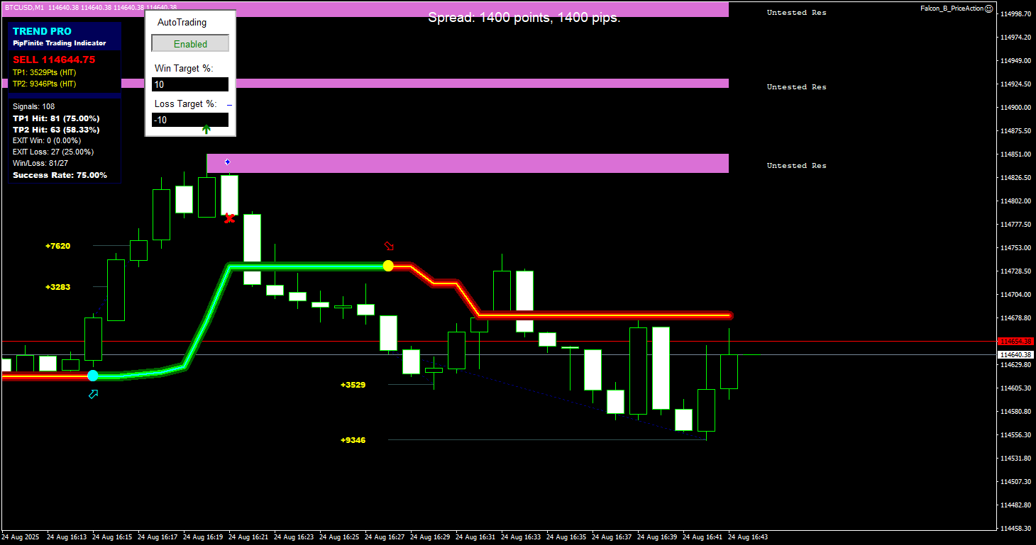

0 16:43:58.321 Falcon_B_PriceAction BTCUSD,M1: Entry Signal - BUY on UP_TREND after DOWN retracement (reversal) – **wrong** – didn’t go above previous high peak

0 16:43:58.463 Falcon_B_PriceAction BTCUSD,M1: Stop is too large, using ATR for Stop Loss: 8210.0

0 16:43:58.463 Falcon_B_PriceAction BTCUSD,M1: BUY signal canceled - only sell allowed below pipFinite line

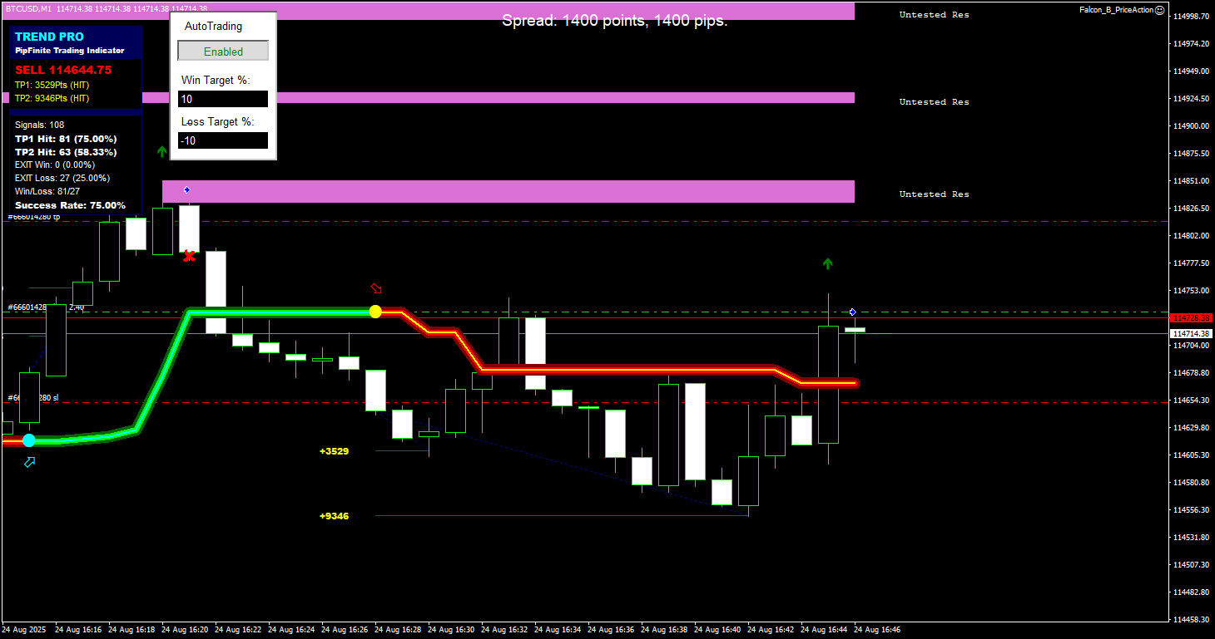

0 16:45:58.191 Falcon_B_PriceAction BTCUSD,M1: Entry Signal - BUY on UP_TREND after UP retracement

0 16:45:58.335 Falcon_B_PriceAction BTCUSD,M1: Stop is too large, using ATR for Stop Loss: 8140.0

0 16:45:58.335 Falcon_B_PriceAction BTCUSD,M1: Trying to place a market order...

2 16:45:58.463 Falcon_B_PriceAction BTCUSD,M1: open #666014280 buy 2.40 BTCUSD at 114733.50 sl: 114652.10 tp: 114814.90 ok

0 16:45:58.463 Falcon_B_PriceAction BTCUSD,M1: Order successfully placed. Ticket: 666014280

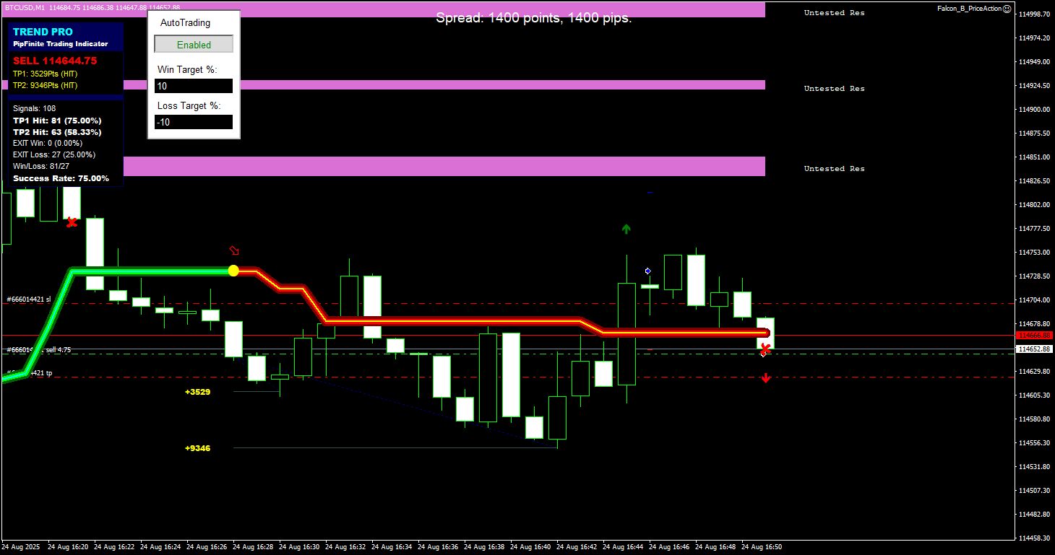

0 16:51:51.300 Falcon_B_PriceAction BTCUSD,M1: Entry Signal - SELL after losing BUY trade

0 16:51:51.300 Falcon_B_PriceAction BTCUSD,M1: Losses count: 3 Updated Risk: 2.5

0 16:51:51.345 Falcon_B_PriceAction BTCUSD,M1: Stop is too large, using ATR for Stop Loss: 5047.399999999907

0 16:51:51.345 Falcon_B_PriceAction BTCUSD,M1: Trying to place a market order...

2 16:51:51.473 Falcon_B_PriceAction BTCUSD,M1: open #666014421 sell 4.75 BTCUSD at 114647.88 sl: 114700.10 tp: 114624.39 ok

0 16:51:51.473 Falcon_B_PriceAction BTCUSD,M1: Order successfully placed. Ticket: 666014421

0 16:51:51.473 Falcon_B_PriceAction BTCUSD,M1: Entry Signal - SELL after losing BUY trade - **wrong**

0 16:51:51.473 Falcon_B_PriceAction BTCUSD,M1: Losses count: 3 Updated Risk: 2.5

0 16:51:51.494 Falcon_B_PriceAction BTCUSD,M1: Stop is too large, using ATR for Stop Loss: 5047.399999999907

0 16:51:51.535 Falcon_B_PriceAction BTCUSD,M1: Entry Signal - SELL after losing BUY trade

0 16:51:51.535 Falcon_B_PriceAction BTCUSD,M1: Losses count: 3 Updated Risk: 2.5

0 16:51:51.577 Falcon_B_PriceAction BTCUSD,M1: Stop is too large, using ATR for Stop Loss: 5047.399999999907

0 16:51:51.623 Falcon_B_PriceAction BTCUSD,M1: Entry Signal - SELL after losing BUY trade

0 16:51:51.623 Falcon_B_PriceAction BTCUSD,M1: Losses count: 3 Updated Risk: 2.5

0 16:51:51.664 Falcon_B_PriceAction BTCUSD,M1: Stop is too large, using ATR for Stop Loss: 5047.399999999907

0 16:51:51.730 Falcon_B_PriceAction BTCUSD,M1: Entry Signal - SELL after losing BUY trade

0 16:51:51.730 Falcon_B_PriceAction BTCUSD,M1: Losses count: 3 Updated Risk: 2.5

0 16:51:51.758 Falcon_B_PriceAction BTCUSD,M1: Stop is too large, using ATR for Stop Loss: 5047.399999999907

0 16:51:51.925 Falcon_B_PriceAction BTCUSD,M1: Entry Signal - SELL after losing BUY trade

0 16:51:51.925 Falcon_B_PriceAction BTCUSD,M1: Losses count: 3 Updated Risk: 2.5

0 16:51:51.969 Falcon_B_PriceAction BTCUSD,M1: Stop is too large, using ATR for Stop Loss: 5047.399999999907

0 16:51:58.169 Falcon_B_PriceAction BTCUSD,M1: Entry Signal - SELL on DOWN_TREND after UP retracement (reversal)

0 16:51:58.314 Falcon_B_PriceAction BTCUSD,M1: Stop is too large, using ATR for Stop Loss: 5045.0

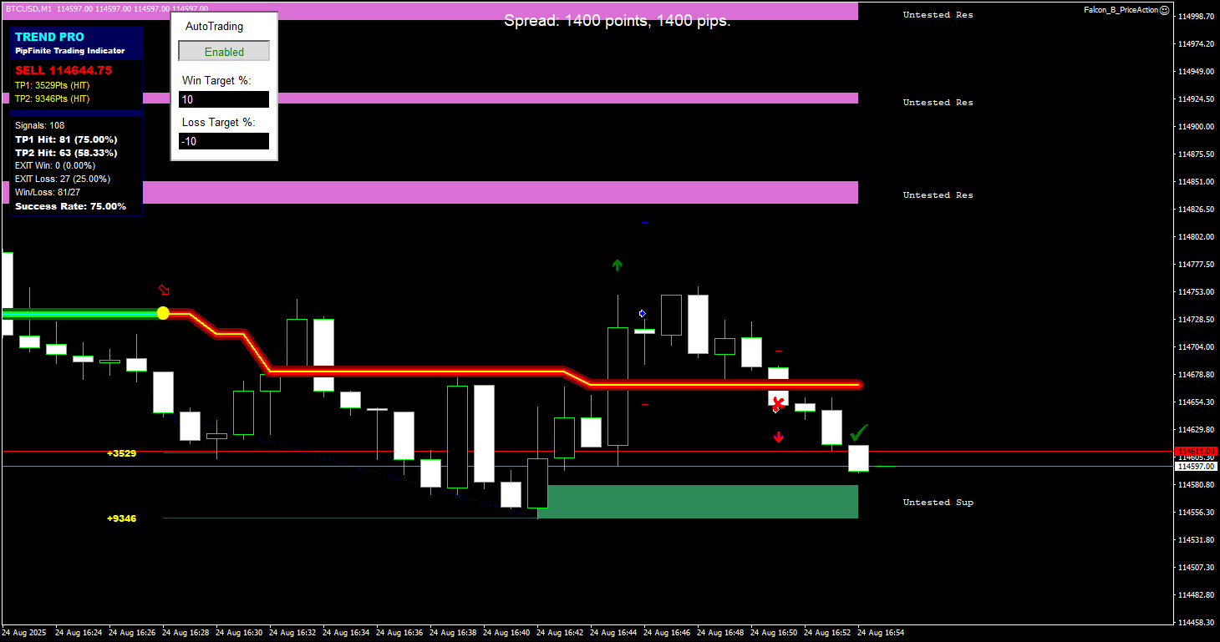

0 16:54:00.457 Falcon_B_PriceAction BTCUSD,M1: Arears Money Management - Updated Risk: 2.0 – **wrong** – should have happened only onece

0 16:54:00.548 Falcon_B_PriceAction BTCUSD,M1: Arears Money Management - Updated Risk: 1.5

0 16:54:00.567 Falcon_B_PriceAction BTCUSD,M1: Arears Money Management - Updated Risk: 1.0

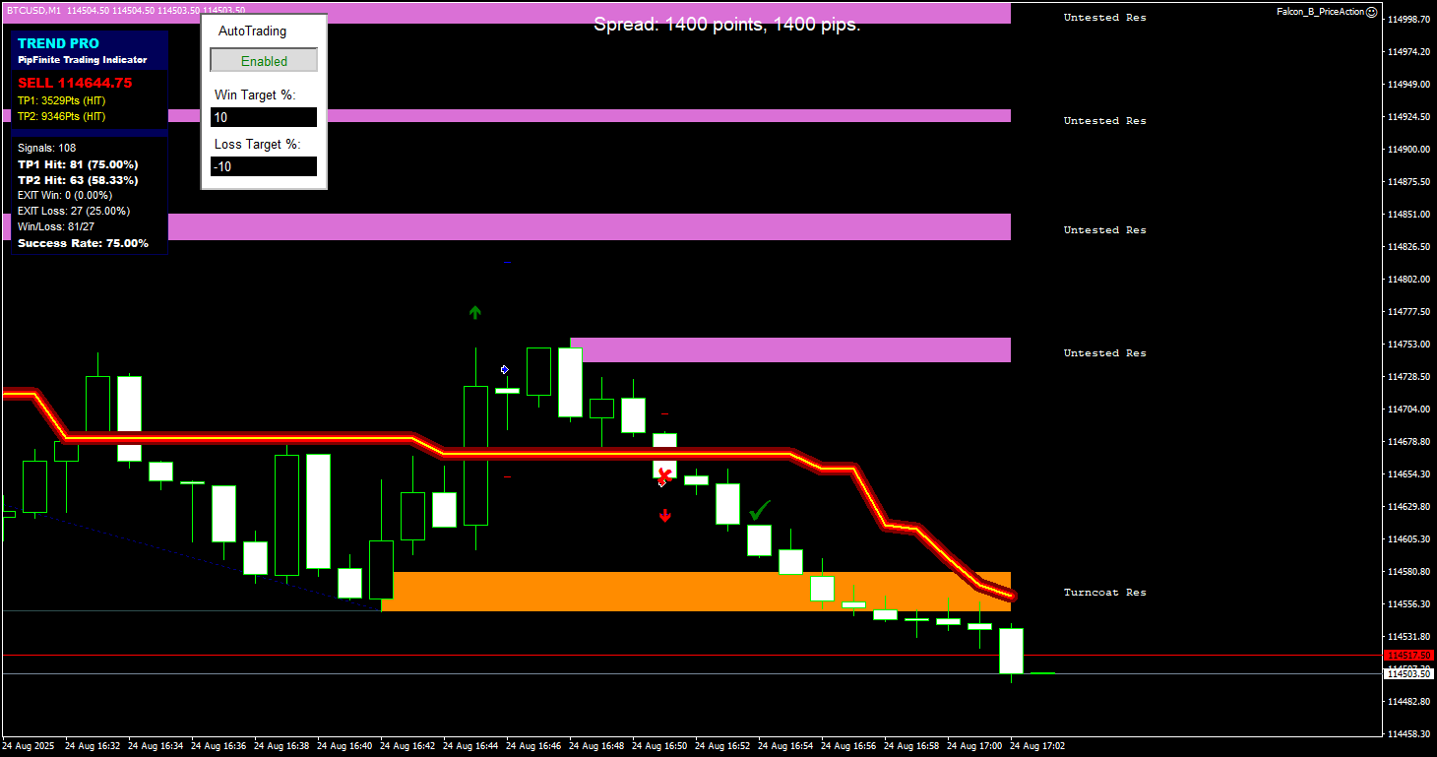

0 16:58:58.604 Falcon_B_PriceAction BTCUSD,M1: Entry Signal - breakout, SELL below supply or demand line

0 16:58:58.604 Falcon_B_PriceAction BTCUSD,M1: Stop is too large, using ATR for Stop Loss: 2809.799999999814

0 16:58:58.604 Falcon_B_PriceAction BTCUSD,M1: Current spread is too high: 1400.0 pips. ATR: 2809.799999999814 pips

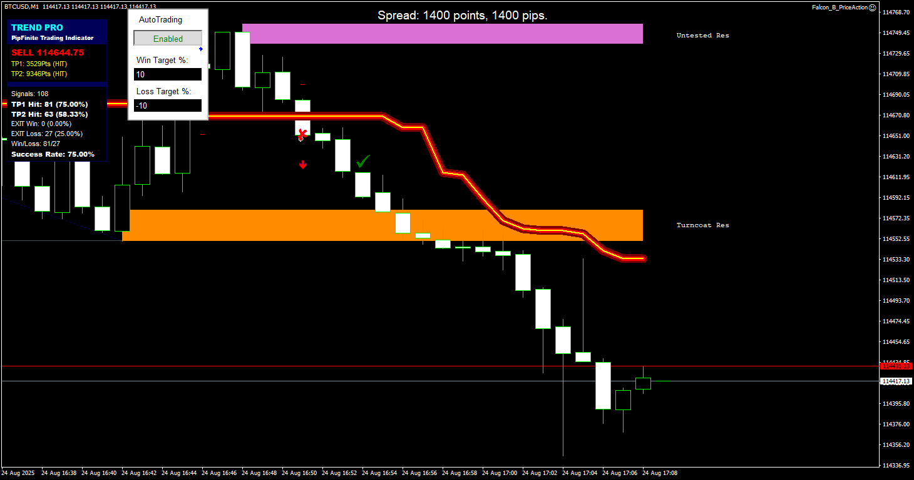

0 17:08:58.060 Falcon_B_PriceAction BTCUSD,M1: Entry Signal - BUY on UP_TREND after DOWN retracement (reversal) – **wrong** – still in retracemenet

0 17:08:58.209 Falcon_B_PriceAction BTCUSD,M1: Stop is too large, using ATR for Stop Loss: 7165.0

0 17:08:58.209 Falcon_B_PriceAction BTCUSD,M1: BUY signal canceled - only sell allowed below pipFinite line

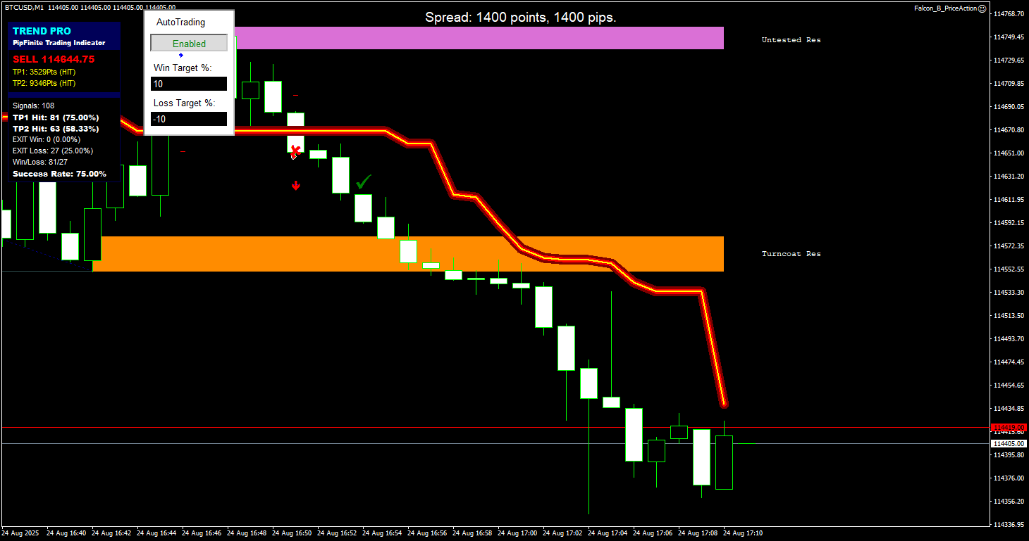

0 17:10:58.195 Falcon_B_PriceAction BTCUSD,M1: Entry Signal - BUY on UP_TREND after UP retracement – **wrong** – still DOWN_RETRACEMENT

0 17:10:58.351 Falcon_B_PriceAction BTCUSD,M1: Stop is too large, using ATR for Stop Loss: 4962.600000000093

0 17:10:58.351 Falcon_B_PriceAction BTCUSD,M1: BUY signal canceled - only sell allowed below pipFinite line

0 17:12:58.070 Falcon_B_PriceAction BTCUSD,M1: Entry Signal - SELL on DOWN_TREND after UP retracement (reversal) – **wrong** – just DOWN_TREND continues

0 17:12:58.211 Falcon_B_PriceAction BTCUSD,M1: Stop is too large, using ATR for Stop Loss: 4447.600000000093

0 17:12:58.211 Falcon_B_PriceAction BTCUSD,M1: Trying to place a market order...

2 17:12:58.339 Falcon_B_PriceAction BTCUSD,M1: open #666015094 sell 2.18 BTCUSD at 114358.63 sl: 114407.61 tp: 114318.65 ok

0 17:12:58.339 Falcon_B_PriceAction BTCUSD,M1: Order successfully placed. Ticket: 666015094