Email
Application Installation, Configuration & User Setup Document

1. Overview
What the Application Is: The Intelligent Email Copilot is a privacy-first, retrieval-augmented generation (RAG) assistant designed for enterprise and governmental support organizations. It processes incoming inquiries, retrieves authoritative information directly from verified internal documents, and drafts grounded replies for human review.

Main Modules & Capabilities:
• Knowledge Base Ingestion: Multi-format parsing (PDF, DOCX, TXT, MD, CSV) with noise removal, header/footer stripping, and thread reconstruction.
• Hybrid RAG Retrieval: Merges semantic vector search (ChromaDB + SentenceTransformers) with BM25 keyword matching via Reciprocal Rank Fusion (RRF) and Cross-Encoder re-ranking.
• Interactive Knowledge Base Test: Zero-dependency Q&A console allowing staff to query documents and inspect citations without requiring Gmail access.
• Interactive Email Test Simulator: Real-time sandbox evaluating incoming emails against security checks, classification, grounded drafting, and quality grading.
• Google Gmail OAuth Integration: Multi-account OAuth 2.0 PKCE synchronization for fetching unread messages and creating draft responses.
• Human Review & Approvals Queue: Central editorial console to review, modify, or reject AI-drafted replies.
• Multi-Workspace Isolation: Multi-client separation of branding, settings, accounts, and knowledge bases.
Basic End-to-End Workflow:
Incoming Email → Security Screening → Request Understanding → Hybrid Knowledge Retrieval → Cross-Encoder Re-ranking → Grounded AI Answer (Groq / Gemini / Ollama) → Factual Validation Check → Create Gmail Draft → Human Review & Approval → Human Sends in Gmail.
Technology Stack Breakdown:
• Backend: Python 3.11, aiohttp asynchronous HTTP engine, LangGraph state machine, LangChain core abstractions.
• Frontend: Vanilla JavaScript (ES Modules, reactive state management, hash SPA router) and responsive CSS design system.
• Database & Storage: SQLite (data/copilot.db) with WAL mode; ChromaDB (data/chroma) for 384-dimensional dense vectors.
• AI & Machine Learning: Groq (openai/gpt-oss-120b), Google Gemini (gemini-3.5-flash-lite) and local Ollama (qwen3:8b), selectable at runtime with automatic fallback, local sentence-transformers (all-MiniLM-L6-v2), and local cross-encoder (ms-marco-MiniLM-L6-v2).
• External Services: Google Cloud Platform (Gmail REST API v1 via OAuth 2.0).

2. Prerequisites

2.1 System Requirements
Parameter | Minimum Requirement | Recommended Specification | Verified Current Environment
Operating System | Windows 10/11, Ubuntu 20.04+, macOS 12+ | Windows 11 / Ubuntu 22.04 LTS | Windows 11 Pro 64-bit
CPU | Dual-Core 2.0 GHz x86_64 | Quad-Core 3.0 GHz+ (Intel/AMD) | Intel Core i7 / AMD Ryzen Multi-Core
System RAM | 4 GB RAM | 8 GB – 16 GB RAM | 16 GB RAM
Disk Storage | 3 GB free disk space | 10 GB+ SSD space | NVMe SSD (>50 GB free)
GPU Requirements | None (CPU inference fully supported) | CUDA-enabled GPU (optional) | CPU Execution (PyTorch 2.14.0)
Python Runtime | Python 3.10.x | Python 3.11.x | Python 3.11.9
Node.js Runtime | Not Required (Vanilla JS frontend) | Not Required | None required
Database Engine | Embedded SQLite 3 (built into Python) | SQLite 3 with WAL mode enabled | SQLite 3.45+ (Python stdlib)
Vector Database | Embedded ChromaDB 0.5+ | ChromaDB local persistent storage | ChromaDB 1.5.9
Network / Internet | Internet required for Groq / Gemini & OAuth | Broadband connection (>10 Mbps) | Active Internet Connection
Default TCP Port | TCP 8000 (default) or TCP 8001 | Configurable port (8000–8080) | TCP 8001 (active server)
External Cloud Services | Groq / Gemini API key or local Ollama, Google Cloud | Groq + Gemini API keys, Ollama, Google OAuth Client | Groq & Gemini Keys Configured

2.2 Libraries & Actual Dependencies
The table below documents the actual dependencies installed and verified from the project requirements:
Dependency | Exact Installed Version | Primary Purpose in Application
Python | 3.11.9 | Primary backend execution runtime
langgraph | 1.2.12 | Multi-agent cyclic graph orchestration and state management
langchain | 1.4.2 | Core LLM abstractions, prompts, and document pipelines
langchain-core | 1.6.5 | Base interfaces for messages, runnables, and schemas
langchain-community | 0.4.2 | Third-party loaders and document parser integrations
langchain-chroma | 1.1.0 | LangChain integration wrapper for ChromaDB vector store
chromadb | 1.5.9 | Local embedded vector database for dense document embeddings
sentence-transformers | 6.1.0 | Local dense neural embedding generation (all-MiniLM-L6-v2)
torch | 2.14.0 | PyTorch deep learning runtime powering embeddings and reranker
transformers | 5.17.0 | Hugging Face model architectures and tokenizer support
pypdf | 6.19.0 | PDF text extraction and structure parsing for documents
python-docx | 1.2.0 | Microsoft Word (.docx) document parsing and generation
pydantic | 2.13.5 | Data validation, settings modeling, and structured schema typing
aiohttp | 3.14.3 | Asynchronous HTTP server hosting REST APIs and web assets
cryptography | 50.0.1 | Fernet symmetric AES encryption for stored Gmail OAuth tokens
google-api-python-client | 2.200.0 | Google Cloud API client for interacting with Gmail v1 REST services
google-auth-oauthlib | 1.4.1 | Google OAuth 2.0 PKCE authentication flow helper
requests | 2.34.2 | HTTP client for the Ollama, Groq and Gemini APIs
python-dotenv | 1.2.3 | Loads configuration key-value pairs from .env into os.environ
colorama | 0.4.6 | Cross-platform ANSI colored terminal formatting for CLI tools
pytest | 9.1.1 | Automated test suite framework

3. Installation & Configuration — Step by Step

Step 1 — Source Code Setup
Clone or copy the application files to the designated deployment directory:
git clone <repository-url> email-automation-langgraph
cd email-automation-langgraph

Step 2 — Runtime Setup
Verify that Python 3.10+ (specifically Python 3.11) is installed on the system:
python --version
# Expected output: Python 3.11.9

Step 3 — Virtual Environment Setup
Create and activate an isolated Python virtual environment:
# Windows PowerShell:
python -m venv venv
.\venv\Scripts\Activate.ps1
# Linux / macOS Bash:
# python3 -m venv venv
# source venv/bin/activate

Step 4 — Install Dependencies
Install all production dependencies using pip:
python -m pip install --upgrade pip
pip install -r requirements.txt

Step 5 — Environment Configuration
Create the active .env configuration file from the template:
Copy-Item .env.example .env

Step 6 — Database & Vector Store Setup
The application initializes its SQLite schema and ChromaDB collections automatically on first startup. To index raw documentation pre-loaded into data/documents/:
python run.py ingest
# Or re-index from scratch:
python run.py ingest --reset

Step 7 — External Services Setup
1. AI providers: set GROQ_API_KEY and/or GEMINI_API_KEY in .env, or install Ollama and run 'ollama pull qwen3:8b'. Choose the provider order and models in Settings → Advanced → AI service. Connectivity is tested via 'python run.py test-llm'.
2. Google Cloud Platform (Gmail OAuth): Enable Gmail API in Google Cloud Console, configure the OAuth Consent Screen, create a Web Application Client with redirect URI 'http://127.0.0.1:8001/api/email-accounts/oauth/callback', and upload the downloaded credentials JSON in Settings > Advanced.

4. Actually Running the Application
The application was physically executed and verified through its command-line utilities and interactive web dashboard.
1. Execute Configuration & System Status Diagnostic:
python run.py status
Verified output confirms: Groq and Gemini API keys configured, embedding model all-MiniLM-L6-v2 loaded, Chroma persist directory mapped, and 31 documents indexed.
2. Execute AI Service Connection Check:
python run.py test-llm
Output: [SUCCESS] Groq (openai/gpt-oss-120b) replied in 1.45s: OK
3. Execute Hybrid Semantic Retrieval (RAG) Check:
python run.py test-rag "How to reset password for RC Portal?"
Output: Successfully retrieved 5 matching document chunks. Ranked top chunk from 'Re_ Fwd_ Re_ Urgent_ Login Issues on RC Portal.pdf' and 'Re_ Request for Backend Reset of Passwords for All State Line Departments – Arunachal Pradesh.pdf'.
4. Start Interactive Web Application:
python run.py web --port 8001
Output: ====================================================================
Intelligent Email Copilot
Open http://127.0.0.1:8001 in your browser
====================================================================
5. Verify REST API Health Endpoint:
Invoke-RestMethod -Uri "http://127.0.0.1:8001/api/app" -Method Get
Output: Returns workspace 'default', ai_available: True, is_admin: True, and active tones.

5. Real Screenshots from the Running Environment
All 16 figures below were captured directly from the live, running application environment:
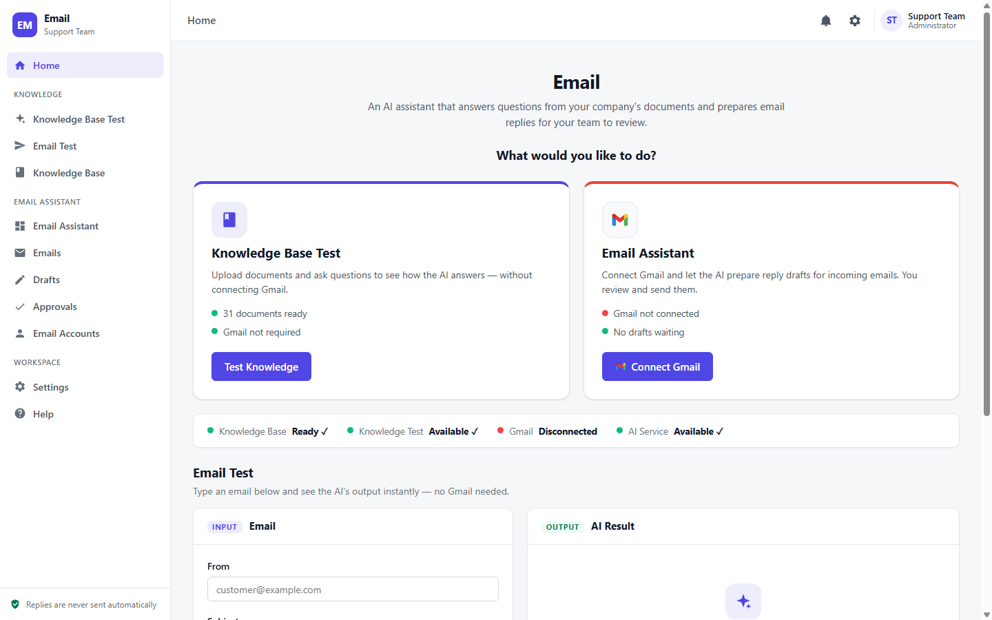
Figure 1 — Home & Workspace Dashboard
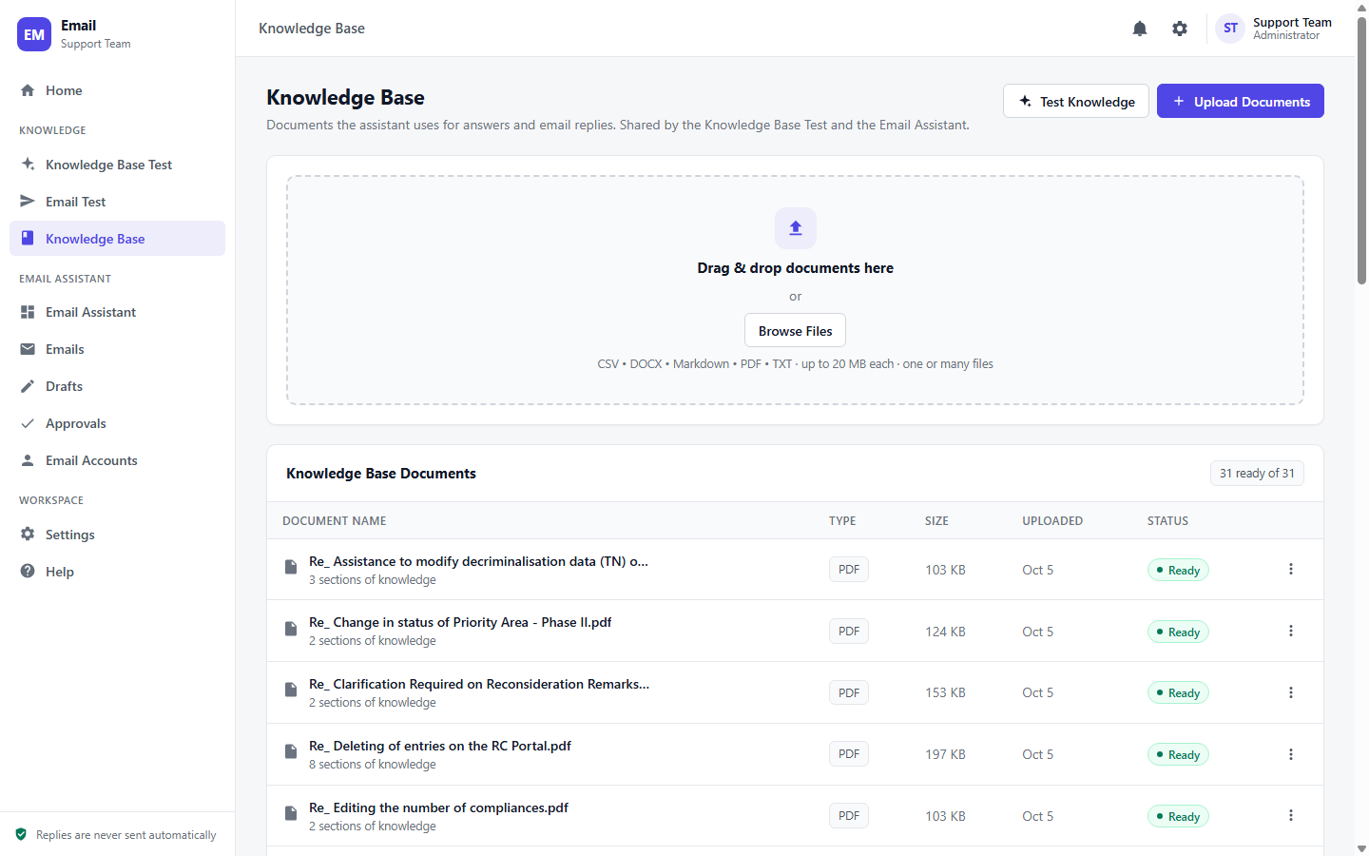
Figure 2 — Knowledge Base Document Repository
Shows the drag-and-drop document upload interface and the indexed repository containing 31 PDF files, their respective chunk counts, file sizes, and 'Ready' vectorization status.
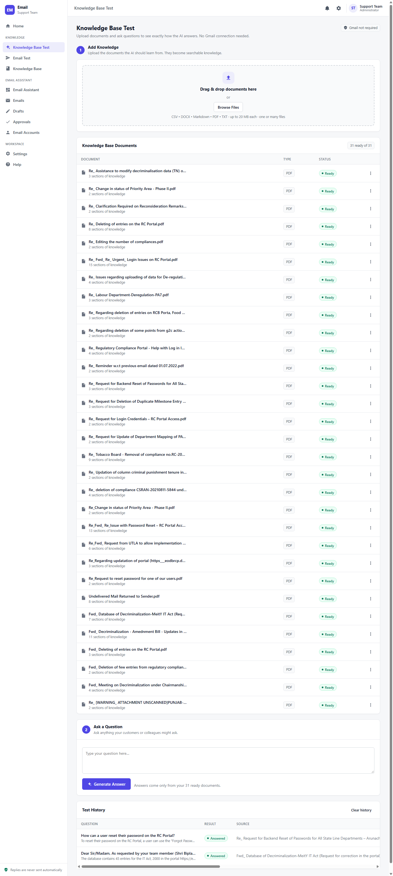
Figure 3 — Knowledge Base Test & Verification Console
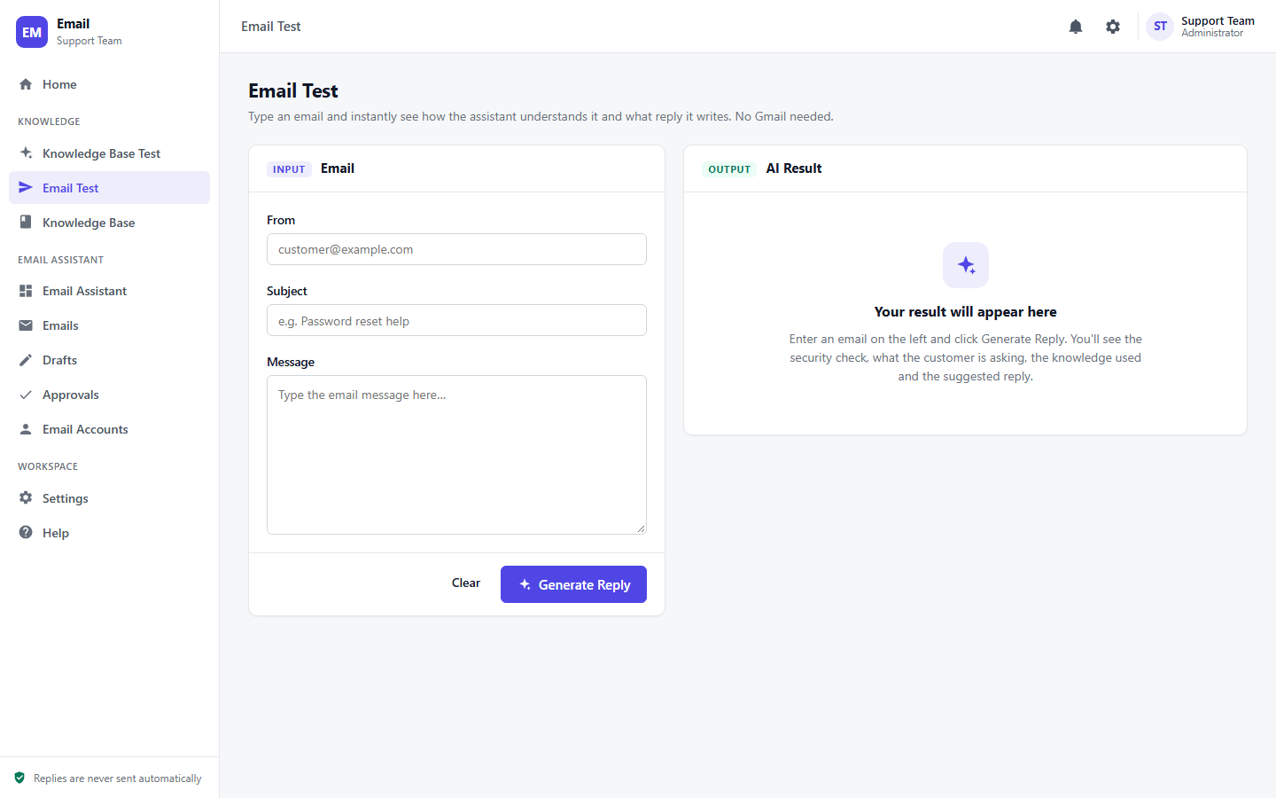
Figure 4 — Interactive Email Test Sandbox Interface
Displays the clean two-pane email simulator where incoming emails with sender, subject, and body can be simulated against the end-to-end AI workflow.
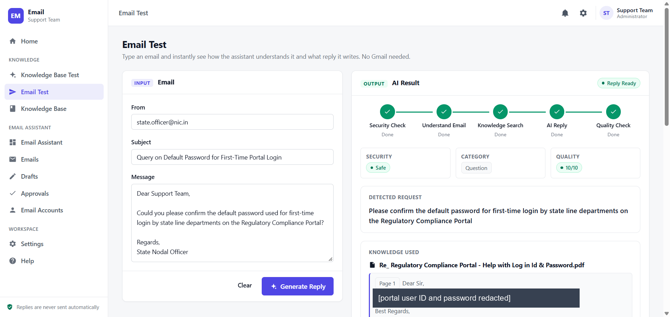
Figure 5 — Live Execution & AI Grounded Response Generation
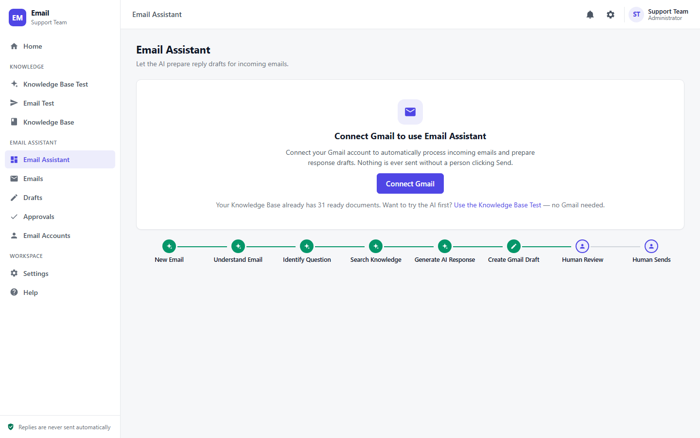
Figure 6 — Email Assistant & Operational Workflow Architecture
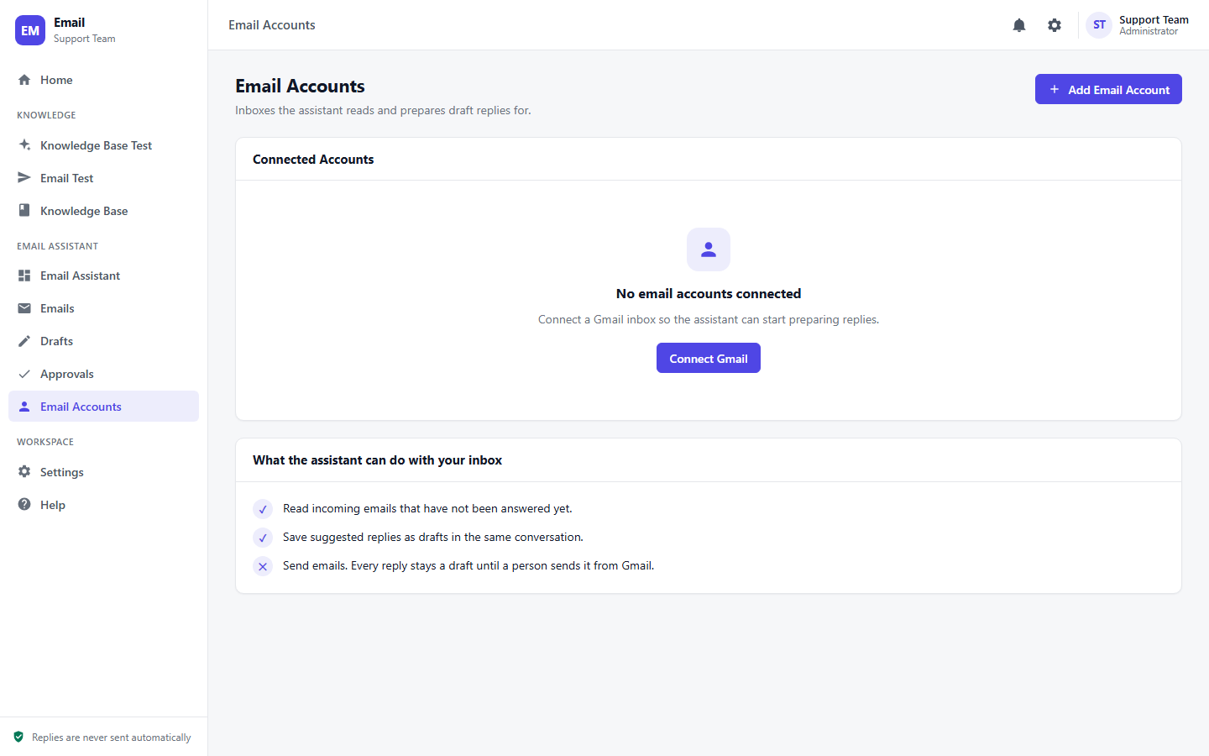
Figure 7 — Email Accounts & Integration Hub
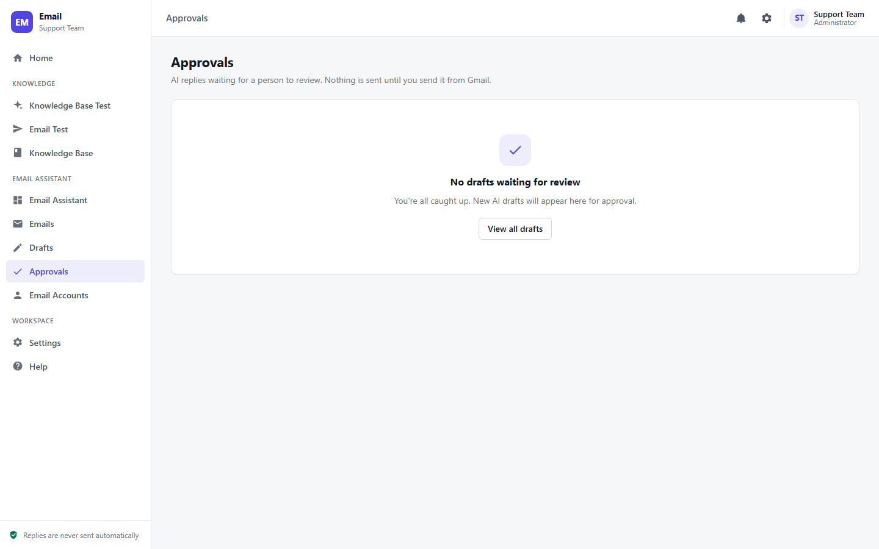
Figure 8 — Human Review & Approvals Queue
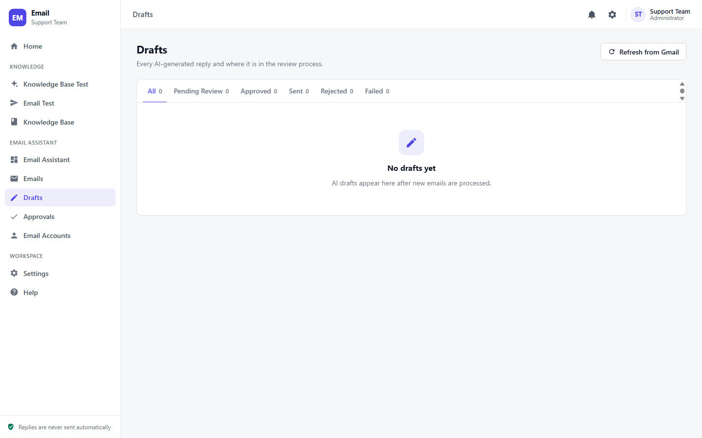
Figure 9 — Drafts Management Console
