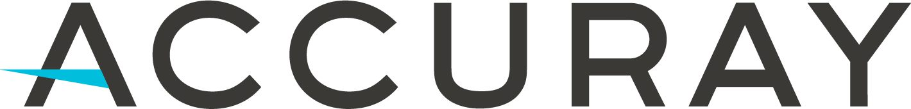

Creating ECO Items and Changes

WI 032394

REV Q

Accuray Confidential
Copyright © 2024 Accuray Incorporated

Revision History

Rev | Change # | Description of Change | Revised By | Date
N | ECO-21374 | Removed reference to non-product docs that have been moved to DCO WI 1066467. Changed 1052622 from FRM to Record. Removed duplicate definitions and referred to procedure that defines them. Added it is not suggested to include Mfr. Names or MPNs for OTS Mfr. Parts as they can be MCO’d and titles cannot change via MCO. Added new Manufacturer Part (OTS) field. Included 3rd party service access LPs to DRT field. Added SW and Standards are not trained to. Referred to WIs 1003688 and 1063971. Removed New Rev Effective Date and Old Rev Obsolete Date fields as they are hidden in the new ECO View. Updated Test Results MCO field requirements. Updated template attributes. | Shannon Brown | 11-Nov-2021
O | DCO-00964 | - 6.1.12.1 Provide additional detail for Product Component Yes description.  - 6.1.15.3 and 6.2.10.3 List and define Location Ownership field options.  - 6.1.18.5.12 Add OTS MPN attachments not restricted as trade secret.  - 6.2.10.4.4 Add that ATRs must have “No Training Required” and remove Standards.  - Remove reference titles from content besides Section 4. | Randy Joswig,  Shannon Brown | 05-Oct-2022
P | CHG-00607 | - Updates for Proj Accelerate  - Remove reference to CAP FRM 1063996  - Removed that Mfr parts cannot be released as Pre-Production  - Removed requirements for Mfr part attachment filenames  - Revised 1st Article Required field section 5.4.12.6 | Melissa Cooper,  Randy Joswig,  Shannon Brown | 03-May-2024
Q | CHG-00647 | - Removed FRM 033017 from being attached to ECOs. Moved to ECO Relationships Tab section as FRM 033017 is only attached to ECRs, and those ECRs are related to the ECO.  - Removed reference to FRM 1070413 as it is being made obsolete.  - Changed AERO system name to AEx.  - 5.1.10.6.1 – Updated THAP field section to expand use.  - 5.1.11.13 – Changed Hazardous Material field name to Hazardous Shipping Material  - 5.4.11.7 – Added to check Where Used for Supplier Notification Required field.  - Appendix B – Updated Make/Buy requirements and added clarification. | Shannon Mack | See DMS
Table of Contents
1 Purpose 4
2 Scope 4
3 Reference Documents 4
4 Definitions 5
5 Procedure 6
5.1 Creating New Parts 6
5.2 Creating New Documents 22
5.3 Creating BOMs 26
5.4 Creating ECOs 31
5.5 Creating MCOs 46
6 Records 51
7 Appendices 52
7.1 Appendix A – Item Type/Subclass Values 52
7.2 Appendix B – SAP Material Type Options for Parts and Decision Tree 53
7.3 Appendix C – ECO Workflow 54
7.4 Appendix D – MCO Workflow 54

Purpose
Provide instructions for creation/revision of parts and product documents and preparation/submittal of Engineering Change Orders (ECOs) and Manufacturing Change Orders (MCOs) in Agile.

Scope
Applies to Accuray employees who have been granted the 02 ECO Creator role in Agile.
This procedure is within the scope of SOP 016827 Change Control and SOP 1004376 Document Control.
Non-product documents (in MasterControl) and Design History File (DHF) (in Agile) are out of scope of this procedure. See WI 1066467 Creating MasterControl Documents and Changes or WI 018949 Design History File.
For full Agile use instructions, see WI 1040306 Agile Employee User Guide.

Reference Documents
- SOP 016827 Change Control (Parent SOP)
- SOP 014437 Employee Training
- SOP 016087 Item Numbering and Naming
- SOP 016824 Quality Records and Records Retention
- SOP 1004376 Document Control
- SOP 1049123 Product Development Process
- SOP 1053314 Rework
- SOP 1059029 Component Classification
- WI 018949 Design History File
- WI 021197 Rework
- WI 028094 First Article Inspection
- WI 1003688 Engineering Drawing Standards
- WI 1040306 Agile Employee User Guide
- WI 1041758 Third Party Access to Agile
- WI 1046213 Product Surveillance Committee
- WI 1061475 AERO User Documentation Management
- WI 1063933 Product Change Review Board
- WI 1063971 Using SolidWorks with Agile
- WI 1066467 Creating MasterControl Documents and Changes
- WI 1069247 FRU Development and Release Process
- FRM 021105 Rework Instructions Form
- FRM 033017 Initial Change Assessment
- FRM 1063735 Item ECO Checklist
- RECORD 1052622 Change Reviewer Matrices
- RECORD 1089757 Accuray Acronyms and Definitions

Definitions
See Accuray Acronyms and Definitions (1089757).

Procedure

Creating New Parts

Create New > Items > Parts.
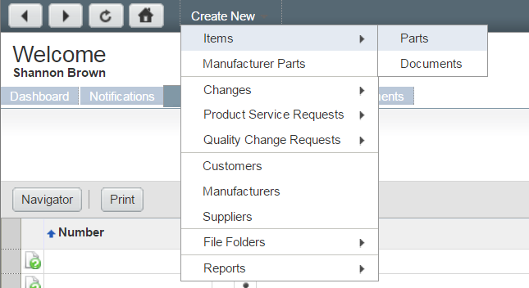
Figure 1: Create New Part
Or navigate to an existing part with the same Subclass, and click Actions > Save As. This will automatically preserve the same field selections under a new part number.
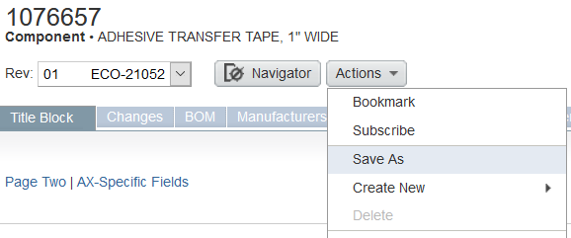
Figure 2: Save As from Existing Part to Create New Part

Type – How the part is categorized in Agile. The Item Type field is equivalent to the Subclass field in the Title Block tab of the part. It is important to choose the correct value as this classifies the part in the ERP system and will also populate custom fields on page three depending on the type (i.e., a fastener or capacitor). For guidance on what Type value to choose, please see Appendix A. This field locks once selected and cannot be changed; contact Document Control to make edits, if needed.
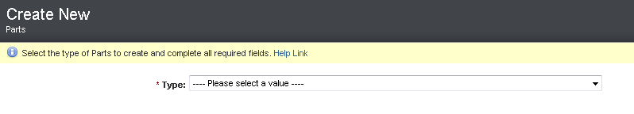
Figure 3: Create New Part Type (Part Subclass)

Once a Type (part Subclass) is selected, the Create New screen will pop-up. Populate *required fields.
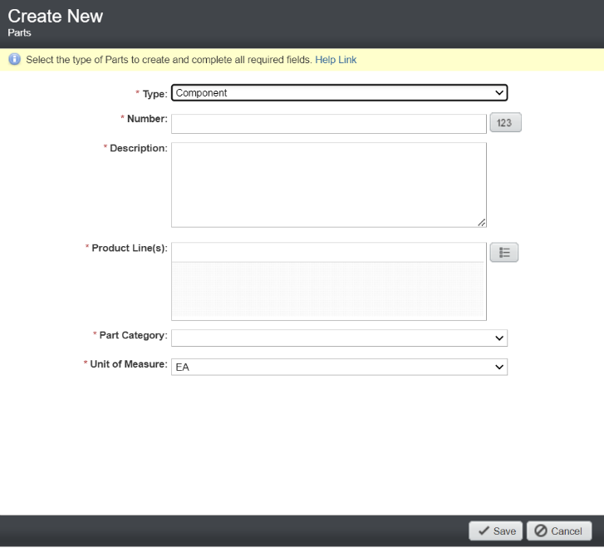
Figure 4: Create New Part Pop-up

Number – Press the icon to issue the next auto number in the sequence (if not already auto-populated). Do not press the icon more than once as this will create a new number each time that continues to increment. Prefix options may be provided for certain Types (part Subclasses). A free-form number may be entered only as instructed by SOP 016087 Item Numbering and Naming. Once created, the number cannot be changed.

Description – Enter the title of the part.

The description must match the title as it appears in the attachment content exactly (when attachments present).

Recommend this text to match the SAP description field, but not required. This field allows for additional character space for enhanced search capabilities in Agile. If desired, enter a more detailed title, description, or spell out abbreviations. If text does not match the SAP Description field, the two fields must at least be cohesive.

Do not include Manufacturer names or Manufacturer Part Numbers (MPNs) in the description field for Off-the-Shelf (OTS) Manufacturer parts where alternates from different manufacturers can be added. The Description field can only be changed with an ECO, not an MCO.

Abbreviating is acceptable.

Enter on one line; do not hit enter for multiple lines/rows (causes export issues).

See SOP 016087 Item Numbering and Naming and RECORD 1089757 Accuray Acronyms and Definitions for guidance.

Product Line(s) – Select the correct value(s) for the part. If more than one value is appropriate, select all that apply. If the part is a common item that could be used for both platforms (i.e., a bolt), select both Robotics and Helical.
Robotics | Pertains to CyberKnife.
Helical | Pertains to TomoTherapy/Radixact.
Software Applications | Pertains to Precision/iDMS.

Part Category – Choose from the dropdown. This value is the system, subsystem, or assembly the part is associated with OR represents the functionality of the part. This value should match or be cohesive with the value in Part Type/Subclass field. Choose “Service” if this part is a FRU, Installation Part, Service WI, Service Tool, or Service Upgrade Kit.

Unit of Measure (UOM) – Choose from the dropdown list. This field cannot be changed after Pre-Production release because it cannot be changed in the ERP system. If a different UOM is needed, a new part number will be required.
Note that EA is the only UOM option that must use whole numbers; cannot use fractional numbers (e.g., 1.0 EA is acceptable, but 1.1 EA is not).

Click Save and complete the remaining applicable fields.

Part Title Block Tab – Page Two
To reveal a list of selection values for a field that has the icon to the right of the field, click the icon, enter an asterisk (*), and click enter. The potential choices will be displayed.

SAP Description – Text entered here is what will be shown in SAP. This field is limited to 40 characters. Values can be different but cannot conflict from the Description field. It is suggested not to include Manufacturer names or Manufacturer Part Numbers (MPNs) for Off-the-Shelf (OTS) Manufacturer parts where alternates can be added.

Notes (optional) – May be used to record information that does not fit into the other fields on the cover page. Do not use this field for instructions or actions to be completed related to the part (these details would be entered in the ECO or MCO’s Cover Page).

Accessible By (optional) – Grants access for third party user groups to view the part, when needed. See WI 1041758 Third Party Access to Agile.

Location Ownership – Choose from the dropdown. Select the region that owns the part. This contributes to the auto-selection of minimum required reviewers per RECORD 1052622 Change Reviewer Matrices.
- AJKK = Japan
- AMS = Americas
- AMS (APAC) = AMS owns design; APAC approves/consulted on design
- APAC = Chengdu China
- EIMEA = Europe

RoHS Compliant – Status shall be indicated and match attachments (when present).

Yes – parts manufactured without any of the hazardous materials defined in the RoHS directive.

For Manufacturer parts, the RoHS Compliant field must be Yes if a RoHS certificate is attached, or the datasheet indicates the part is RoHS Compliant.

See Section 5.3.4 RoHS Compliant (Yes) BOMs for additional BOM requirements when the parent is RoHS Yes.

No – parts manufactured with one or more of the hazardous materials defined in the RoHS directive. This includes any assembly that contains a component or subassembly that contains any of those hazardous materials defined in the RoHS directive.

Not Applicable – can only be applied to material outside the scope of the RoHS directive, such as software, user manuals, packaging materials, etc. Most material items should not have Not Applicable.

Unknown (no longer used) – legacy parts not researched against the ROHS directive yet. When revising parts listed as “Unknown”, that part must be researched to determine if it is ROHS Yes, No, or Not Applicable.

There are components that claim exemption to RoHS where the Supplier's justification for the RoHS exemption is incorrect. Refer to current RoHS directive.

Test House Audited Part – Status shall be indicated and match attachments, where applicable.

Yes – parts that are listed in a Nationally Recognized Test House (NRTL) report (e.g., Intertek/ITS, TUV, LMTI, BIMT), or identified in a Medical Device Product Technical Requirements report (PTR), or in some other regulatory or compliance filing or certification. This field is informational but indicates that the associated regulatory and compliance reports shall be reviewed and an assessment executed to determine what actions are needed (e.g., testing, re-registration, document update, etc.). The specific regulatory and/or compliance reports that are affected by the part should be identified in the Notes field.

Otherwise, select No.

Shelf Life (days) – The number of days a limited life material is deemed acceptable by the manufacturer. If not known at the time of ECO, leave blank. Actual expiration dates are tracked within the ERP system for these parts. Contact Purchasing/Materials for additional information.

Part Title Block Tab – SAP-Specific Fields

SAP Material Type – See Appendix B for options. Creates a template of several fields in SAP to correctly transfer a part. This field cannot be changed after Pre-Production release because it cannot be changed in the ERP system. If a different SAP Material Type is needed, a new part number will be required.

Make/Buy – Sets the fields in SAP to help the part drive demand correctly in the ERP system and function correctly in financial transactions.

Make – parts and assemblies that are intended to be built by Accuray manufacturing by production order within SAP.

Buy – purchased parts and assemblies.

Service Part Classification – This field allows users to choose what kind of service part is being created. This field is required for Production Lifecycle if the part Subclass is Service Part or if the Refurbishable field is set to “Yes”.

FRU - the part is intended to be ordered as a service FRU (Field Replaceable Unit). See WI 1069247 FRU Development and Release Process for associated FRU deliverable requirements.

Installation Part – collection of parts and/or tools required at system install.

Service Manual – document created to provide instruction to the service organization.

Service Tool – item released and controlled through the PLM & ERP systems to support work in the field.

Service Upgrade Kit – collection of parts and/or tools required to upgrade a system in the field.

Refurbishable – Only required when the Service Part Classification field is set to FRU. Used to define whether a FRU may be refurbished. This field is not required for non-FRU parts.

Yes – when a process to refurbish and test this part has been defined at the supplier or within Accuray.

No – when there is no refurbishment process.

Service Part Substitute (optional) – If there is another Agile part number that can replace this specific part number in the field, list it in this section. It may be an alternate FRU or refurbished version of the FRU. This provides a way for Service to be aware of acceptable part replacements and to have traceability for these substitutions.

Refurbished – indicates whether this part itself is a ‘refurbished’ part.

Yes – select if the part is refurbished. For example, if this part is 123456-X, it follows the refurbished part number naming, and the Refurbished flag must be set to Yes to indicate it is a refurbished part.

No – select if the part is not refurbished.

Key Component –

Yes – the part meets the definition of a key component per SOP 1059029 Component Classification. The Key Attributes field must be completed. The Justification for Key Component = No field must be blank.

No – the part does not meet the definition of a key component per SOP 1059029. The Justification for Key Component = No field must be completed. The Key Attributes field must be blank.

Undetermined – appears on existing legacy parts or can be used for prototype parts, do not use for non-prototype new or revised parts.

Justification for Key Component = No – Required when Key Component is No. Identify why the part is not a key component per SOP 1059029. See FRM 1063735 Item ECO Checklist for additional guidance.

Key Attributes – Required when Key Component is Yes. Identify the key attributes of the part per SOP 1059029 when the part is identified as a Key Component.

Top Level System –

Yes – the part is representative of the registered medical device model and its part number is eligible to be recorded as the reference number on a system label.

Otherwise, select No.

Saleable – Only required for Service Parts or Marketing numbers. This helps designate parts in SAP that Accuray can sell.

Yes – Select for Service Parts or Marketing Classification on a part.

No – Select when item is not an item we charge for or is part of a parent part that is saleable.

Supplier Documentation Required –

Yes – the Supplier is required to provide acceptance documentation such as a Certificate of Conformance (CoC) or test report for each unit provided to Accuray; only applies to Buy parts. The specification on the part must define the documentation expectations of the supplier before marking “Yes”.

No – the Supplier is not required to provide acceptance documentation for each unit provided to Accuray; use for Make parts and children of Buy parts.

Undetermined – appears on existing legacy parts or can be used for prototype parts, do not use for non-prototype new or revised parts.

Hazardous Shipping Material – Hazardous Materials pose a significant safety risk while being transported, so the U.S. Department of Transportation’s (DOT) hazmat regulations requires that Hazardous Materials are be properly classified, packaged, labeled, handled, and stowed for transportation.
This will flag any part needing special consideration for shipment and/or handling.

Yes – select if the part contains a substance or material capable of posing an unreasonable risk to health, safety, and property when transported in commerce.
Hazardous materials would be explosives, gases, flammable liquid and combustible liquid, Flammable Solid, Spontaneously Combustible and Dangerous when Wet, Oxidizer and organic peroxide, poison (toxic) and poison inhalation, radioactive, corrosive, etc. Common hazard shipping materials in our operation are compressed gases (SF6 and Xenon) and lithium batteries.
If you have identified a potential hazardous material or are unsure, please reach out to the EHS department for final determination. Incorrect labelling of hazardous materials creates operational delays in service and fulfillment.

Otherwise, No.

Manufacturer Part (OTS) – Applicable to all parts except Marketing Numbers.

Yes – Off-the-Shelf (OTS) manufacturer parts commercially available and offered to Accuray without modification in the same form it is sold in the commercial marketplace. See WI 1003688 Engineering Drawing Standards for additional details.
Changes can be made via ECO or MCO. Only the Manufacturers tab can be used.

No – Custom manufacturer part or Accuray part. Custom manufacturer parts can be manufacturer parts not commercially available and exclusively made to fit Accuray’s requirements, or they can be manufactured parts commercially available and modified to fit Accuray’s requirements. See WI 1003688 for additional details.
Changes can only be made via ECO as ECO validation requirements apply. Both the Manufacturers tab and item’s Attachment tab can be used, just the Manufacturers tab can be used, or just the item’s Attachments tab can be used. Manufacturer names and part numbers can appear on Accuray documentation, when applicable.

Installed Base Relevant – A part is Installed Base Relevant if it is a Service Part or is otherwise configuration-defining for the product. This designation is required to enable systemic installed base configuration reporting. Values entered into this field need service representative review.

Product Hierarchy (optional) – Only needed if the “Saleable” field is set to Yes. Select the hierarchy value that most accurately describes the part. Populate all levels of the hierarchy. This field helps define what model of system a customer has, to analyze saleable items, and to determine the cost of systems and FRUs.

Product Compatibility – Select all systems this part can be used on. This field is used by ServiceMax and the FRU Catalog to let FSEs know which field configuration a particular part is compatible with.

Part Title Block Tab – Installed Base Relevant Part Category Fields
Subsystem, Element, and Generation are used to categorize the functional role of the part to a product. The fields help build an organized catalog of FRUs. They also provide more targeted Agile searches and groupings of common parts and can be used for selecting change approvers.

Subsystem (required for Installed Base Relevant parts) – Select the subsystem(s) this part should report to based on system architecture documentation. A part can report to more than one subsystem if it is used in more than one place. For guidance, review system architecture documents or FRU catalog.

Element (required for Installed Base Relevant parts) – This field is used to describe a part’s distinct functional purpose to the product. The Element is the core category used through consumption and reliability reporting and should stand alone as a descriptor for the part. Choose a value from this list that best describes the role part being created.

Generation – This field is used to differentiate in expectations of capability or reliability for parts with the same Element. The Generation field should not be used to note differences in other factors such as compatibility, import restrictions, serialization requirements, or refurbishment traceability. Generation values should harmonize with previous generation values of parts of the same function.

General instructions/FRU categorization examples for field value selections:

An Element combination should describe one type of component performing a specific function to the product. An Element should not be used with parts performing different functions to the product with the exception of “miscellaneous” values used to group various components not in need of unique categorization (e.g., cables, brackets, fasteners).

If a part already exists performing the same function as the one being created, use the Subsystem - Element combination of the existing part. For example, if releasing a new magnetron, use the category values for the existing magnetron. Then, evaluate if a new Generation value is needed.

For questions regarding service part categorization or if a new value needs to be added, contact the IB Management Team. Examples:
Item # | Item Name | Subsystem | Element | Generation
1015129 | FRU, RF Magnetron Tube, MG7495 | MV Radiation Generation | Magnetron | Blue Tube
1041975 | FRU, RF Magnetron Tube, MG7495, China Only | MV Radiation Generation | Magnetron | Blue Tube
1051735 | FRU, Sidearm Magnetron | MV Radiation Generation | Magnetron | Sidearm
1048337 | FRU, Front Gen2 Jaw Actuator, Red | MV Radiation Collimation | Jaw Actuator | Gen 2
106293 | FRU, Assy, Actuator, Jaw, Gen2 | MV Radiation Collimation | Jaw Actuator | Gen 2 w/ QDI
1086578 | FRU, Back Gen3 Jaw Actuator, Blue | MV Radiation Collimation | Jaw Actuator | Gen 3

Part Title Block Tab – Weights and Dims
This section helps define the physical attribute of the part & packaging. This information is used for shipping and stocking purposes. The following fields are only required for FRU parts.

Unit Net Weight (kgs) – Enter net weight of part. This weight is only for the part at this point, do not include or anticipate packaging, etc.

Packaging Type – Choose correct packaging material from the dropdown.

Gross Weight (kgs) – The weight of the FRU, and package it will go into.

Packaged Length (cm) – Overall length of packaging for this part.

Packaged Width (cm) – Overall width of packaging for this part.

Packaged Height (cm) – Overall height of packaging for this.

Click Save.

Now that attributes have been created for the part, additional information can be added.
Parts require at least one of the following: BOM, Manufacturers tab, or viewable file attachment. Exceptions are:
- Marketing Numbers/Sales Materials
- Prototypes
- Service/Partnership Agreements
- -1 Part Numbers
- Legacy -01 Part Numbers (does not apply to new -01 Part Numbers)

Part BOM Tab – If a BOM is needed, see Section 5.3 Creating BOMs.

Part Manufacturers Tab

In most cases, Manufacturer parts are Off-the-Shelf (OTS) parts that can be defined by adding one or more Manufacturer Part Numbers (MPNs) to the Manufacturers tab (Preferred and any Alternates). OTS manufacturer parts may include a datasheet and/or drawing specifications and when applicable, include RoHS evidence to the Manufacturers Attachments tab, nothing attached to the Accuray PN’s Attachments tab.

A manufacturer is the entity that owns the design specification for the product. Accuray will be using this feature for OTS parts that are defined by the manufacturer’s specifications (i.e., drawing, datasheet).

A Supplier is the company the component would be bought from. In many cases, this could be the same as the manufacturer. Accuray does not include Supplier information in Agile; instead, it is maintained in SAP.

Custom parts – See Section 5.1.11.14.2.

Duplicate manufacturer parts are generally not allowed. This is where we have two separate Accuray PNs that consist of the same exact MPN. Any change made to one Accuray PN will affect the other Accuray PN without forcing a review on the impact on the other. However, there are some exceptions:

There are some cases, for example, when there may be two Accuray PNs that have the same Preferred MPN, but different Alternates listed.

There may be a case where a legacy PN has a specified UOM (MM, FT, etc.) and we want to start listing it as EA. Check to see if the legacy part is listed under other BOMs via the Where Used tab:

If listed under other BOMs, inactivate the legacy PN via MCO until removed from those BOMs and release the duplicate EA PN. Once removed, obsolete the part.

If not listed under other BOMs, obsolete the legacy PN and release the duplicate EA PN.

There may be cases where an OTS MPN was released on an Accuray PN utilizing the Manufacturers tab, and we also find a legacy SCD on a different Accuray PN listing the MPN on the SCD without utilizing the Manufacturers tab.

Select one of the two Accuray PNs to be the PN we use going forward. Check the Where Used tab of each part to determine whether they are listed under other BOMs. If one is not used on other BOMs, it is best to obsolete that part.

Whichever part will no longer be used will need to be inactivated (if needed) and ultimately made obsolete.

If listed under other BOMs, inactivate the PN via MCO until removed from those BOMs. Once removed, obsolete the part.

If not listed under other BOMs, obsolete the part.

If it is a duplicate MPN situation, justification must be provided on the ECO Cover Page indicating why the MPN is being duplicated. This could happen when below the Buy level. It should be more heavily scrutinized or assessed when at the Buy level as this could affect other departments such as Materials and Purchasing.

Creating New MPNs

Click the Manufacturers tab and click Add.

Since the MPN did not previously exist, click the create icon .
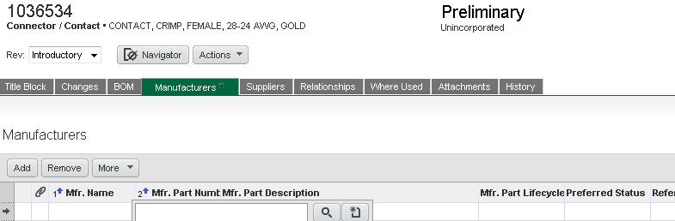
Figure 5: Adding AML Information
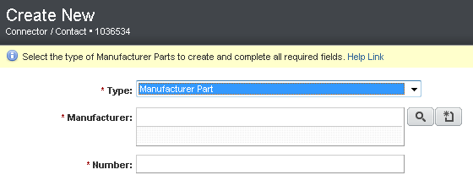
Figure 6: Creating a New MPN

Manufacturer Name – Populate the Manufacturer Name.

Make sure to perform this search confirming that the Manufacturer does not already exist before creating a new Manufacturer to avoid duplication.

If the Manufacturer Name already exists, make sure to select the most accurate.

If the Manufacturer Name does not exist, create a new Manufacturer.

Click Create New > Manufacturers. If this privilege has not been granted, contact Document Control to assign you the appropriate role.

Type the full name of the Manufacturer and click Save.

The Lifecycle Phase must be Approved.

Enter the Mfr. Part Description, and click Save.

Return to Section 5.1.17.4.1.

Number – Enter the MPN and click Add.

Preferred Status – Defaults to Preferred. When adding more than one MPN, the additional parts would be identified as Alternate. Only one MPN can be identified as Preferred.

Mfr. Part Lifecycle Phase – Must be Active.
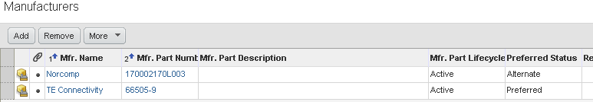
Figure 7: Manufacturers Tab Example

Click the MPN.

General Info – Click Edit, enter the Description, and click Save.

Attachments – Manufacturer parts must have an attachment. This is usually the manufacturer’s datasheet. RoHS evidence must also be attached, when applicable. Attachments should be in PDF format.

The MPN and Manufacturer name must be in the datasheet and/or drawing specification attachment. If the provided Mfr. attachment does not contain this information, add a text box to the PDF with this information for traceability purposes.

If RoHS evidence is attached or the datasheet indicates the part is RoHS Compliant, the RoHS Compliant field in the part’s Title Block tab must be Yes.

Filenames do not have formatting requirements but cannot contain conflicting information.
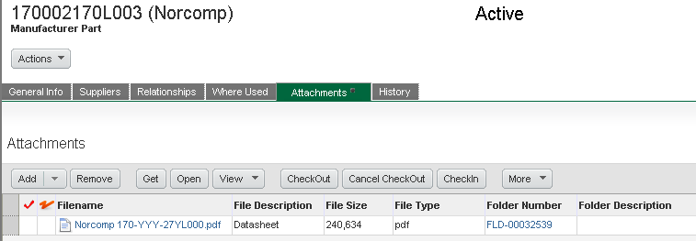
Figure 8: Manufacturer Attachment Example

OTS MPN attachments are not restricted as trade secrets. Custom MPNs may be restricted as trade secrets on a case-by-case basis.

Editing MPNs

Design verification evidence must be provided for any changes made to manufacturer parts:

Provide a summary on the CO Cover Page including any item number references to documentation that has been released in Agile.

Attach any associated documentation to the CO Attachments tab (unless already identified on CO Cover Page by item number).

To delete a row, highlight the entire row by clicking on the gray box at the start of the row, and click Remove.

To add a new row, click Add, type in or search for the MPN, and Enter. Then populate required fields for that row and click Save.

To edit attributes, double-click in a single cell, change the value, and click save. The only applicable field that can be edited in the Accuray PN’s Manufacturers tab is the Preferred Status field. All other edits must be made in the MPN by clicking on the Mfr. Part Number hyperlink.

Lifecycle Phase can be changed to End of Life or Obsolete only when the MPN is being removed, the Accuray PN is being made inactive, or the Accuray PN is being made obsolete on an MCO.

Click Save when finished.

Part Relationships Tab – It is suggested to create relationships with any item numbers referenced in a document attachment for traceability purposes (when attachment present).
Relationships can be added to other items (parts or documents) associated with the part. Do not add relationships to changes.
Part relationships are automatically established when checking CAD files into Agile. See WI 1063971 Using SolidWorks with Agile.

Part Attachments Tab – DO NOT add attachments during part creation (Introductory Rev). Attachments can only be added after the item number has been added to the Affected Items tab of an ECO, i.e., Rev (A) or Rev (01).

Creating New Documents

Create New > Items > Documents.
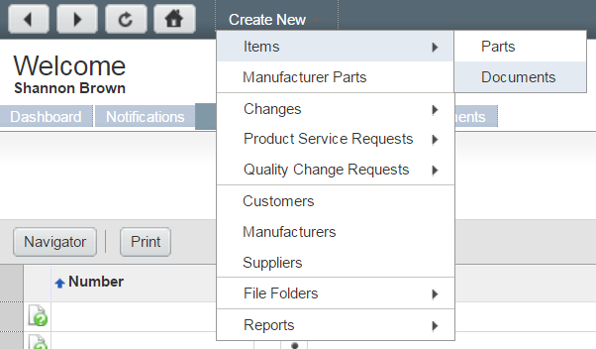
Figure 9: Create New ECO Document
Or navigate to an existing document with the same Subclass, and click Actions > Save As. This will automatically preserve the same field selections under a new document number.
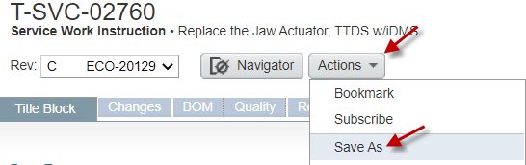
Figure 10: Save As from Existing ECO Document to Create New ECO Document

Type (equivalent to document Subclass) – How the document is categorized in Agile. Only ECO document Subclasses can be selected. This field locks once selected and cannot be changed; contact Document Control to make edits, if needed.
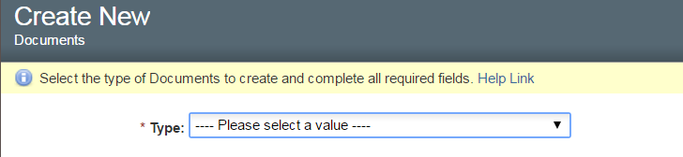
Figure 11: Create New ECO Document Type (Document Subclass)

Once a Type (document Subclass) is selected, the Create New screen will pop up. Populate *required fields.
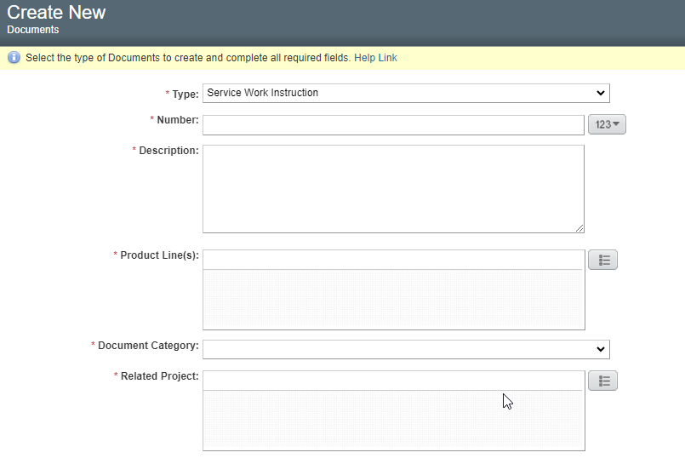
Figure 12: Create New ECO Document Pop Up

Number – Press the icon to issue the next auto number in the sequence (if not already auto-populated). Do not press the icon more than once as this will create a new number each time that continues to increment. Prefix options may be provided for certain Types (document Subclasses). A free-form number may be entered only as instructed by SOP 016087 Item Numbering and Naming. Once created, the number cannot be changed.

Description – Enter the title of the document.

This title must match the title as it appears in the attachment content exactly.

Abbreviating is acceptable.

Enter on one line; do not hit enter for multiple lines/rows (causes export issues).

See SOP 016087 Item Numbering and Naming and RECORD 1089757 Accuray Acronyms and Definitions for guidance.

Product Line(s) – Select the correct value(s) for the document. If more than one value is appropriate, select all that apply. If the document is common and applies to both platforms, select both Robotics and Helical.
Robotics | Pertains to CyberKnife.
Helical | Pertains to TomoTherapy/Radixact.
Software Applications | Pertains to Precision/iDMS.

Document Category – Choose from the dropdown. This is the functionality of the document.

Related Project (when field present) – Used as a search tool to identify when an ECO document is related to a Product Development Process (PDP) project. Only select a project in this field if an affected item satisfies a requirement of that project. Select NA if not applicable.

Click Save and complete the remaining applicable fields.

Document Title Block Tab – Page Two

Notes (optional) – May be used to record information that does not fit into the other fields on the cover page. Do not use this field for instructions or actions to be completed related to the document (these details would be entered in the ECO or MCO’s Cover Page).

Accessible By (optional) – Grants access for third party user groups to view the document, when needed. See WI 1041758 Third Party Access to Agile.

Location Ownership – Choose from the dropdown. Select the region that owns the document. This contributes to the auto-selection of minimum required reviewers per RECORD 1052622 Change Reviewer Matrices.
- AJKK = Japan
- AMS = Americas
- AMS (APAC) = AMS owns design; APAC approves/consulted on design
- APAC = Chengdu China
- EIMEA = Europe

Departments Requiring Training (DRT) – Used by Accuray University to assign documents to Learning Plan (LPs). Also grants access for third party Service users to view the document, when needed.

Must include all applicable LPs responsible to train to the document.

Populate as “No Training Required” if training is not needed/required, third party Service access is not required, or the document is in the Development phase.

Discontinued LPs cannot be added and must be removed if present.

The following Subclasses must have “No Training Required” unless third party Service access is required:
- Assembly Test Records (ATRs)
- Software

See SOP 014437 Employee Training for additional information.

SAP Description – Text entered here is what will be shown in SAP. This field is limited to 40 characters. Cannot conflict with the Description field. It is suggested not to include Manufacturer names or Manufacturer Part Numbers (MPNs) for Off-the-Shelf (OTS) Manufacturer parts where alternates can be added.

Product Compatibility – select the correct saleable system(s) this document reports to.

Click Save.

Now that attributes have been created for the document, additional information can be added.

Document BOM Tab – If a BOM is needed, see Section 5.3 Creating BOMs.

Document Relationships Tab – It is suggested to create relationships with any item numbers referenced in the document for traceability purposes.
Relationships can be added to other items (parts or documents) associated with the document. Do not add relationships to changes.

Document Attachments Tab – DO NOT add attachments during document creation (Introductory Rev). Attachments can only be added after the item number has been added to the Affected Items tab of an ECO, i.e., Rev (A) or Rev (01).

Creating BOMs

See WI 1003688 Engineering Drawing Standards for additional information.

Lifecycle Phases of children cannot be less than the parent unless they're being released to the same lifecycle phase as the parent or above on the same ECO or on a separate ECO that is released prior to the parent ECO. Make sure to check the parent to see if its lifecycle phase is being changed.

For example, parents in Production or Released lifecycle phase cannot have Pre-Production, Prototype, or Development children in its BOM.

Existing Inactive children can appear in BOMs. Review BOMs for any Inactive children to see if they need to be removed, replaced, or are good as is for now.

RoHS Compliant (Yes) BOMs

When a BOM ("parent") is designated as RoHS Compliant Yes and is not a purchased component/assembly (“Make”), then all of its components ("children") must either be designated as RoHS Compliant Yes or Not Applicable to the purchased level, at a minimum. If the purchased component level does not designate RoHS compliance is required (SCD, Drawing, and/or manufacturer part that includes RoHS compliance designation) then all “children” must either be designated as RoHS Compliant Yes or Not Applicable.

RoHS Yes Buy BOMs with RoHS evidence attached do not require that all children are RoHS Compliant Yes or Not Applicable.

RoHS Yes Buy BOMs without RoHS evidence attached require that all children are RoHS Compliant Yes or Not Applicable.

RoHS Yes Make BOMs require that all children are RoHS Compliant Yes or Not Applicable.

Creating New BOMs

From the parent item, click the BOM tab.

There are multiple methods to add items to the BOM. See WI 1040306 Agile Employee User Guide for full instructions on how to add items to BOMs.
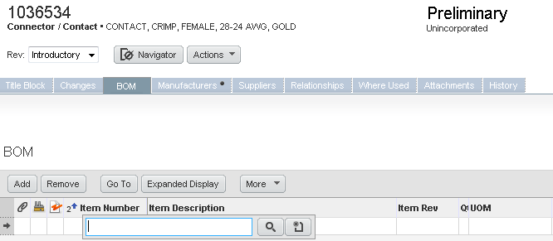
Figure 13: Creating a New BOM on a New Item Number before Adding on an ECO

Editing BOMs

When removing parts from a BOM, always check the Where Used tab of those parts. If a part is not used anywhere else, it must be reviewed, and details explained in the ECO Cover Page Change Solution and Material Plan field. See Section 5.4.11.4 for additional information.

If there is no remaining stock of the part, an MCO should be submitted to obsolete the part.

If there is remaining stock of the part, an MCO should be submitted to inactivate the part until stock is used up. Once stock is used up, an MCO should be submitted to obsolete the part.

To delete a row, highlight the entire row by clicking on the gray box at the start of the row, and click Remove.

To add a new row, click Add, type in the item number, and Enter. Then populate required fields for that row and click Save.

To edit attributes, double-click in the field, enter the appropriate value, and click Save.
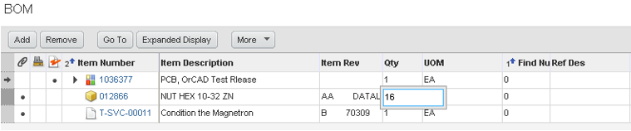
Figure 14: Editing BOM Attributes on a New Item Number

Quantity – Represents the amount of the item to be used for the BOM in terms of the unit of measure designated for the item. By default, all items will be added to the BOM with a Quantity of 1. A quantity of 0 cannot be used. Quantity also cannot be blank.
For example, if the unit of measure is FT and the quantity is 7, the BOM is calling for 7 FT. If the unit of measure is EA, the quantity is the count of items used.
The following examples are intended as design guidelines for use of the Quantity field:

Decimals:
Decimals can be used.
When the UOM is EA, decimals are acceptable, but they cannot be fractions. For example, 1.0 EA is OK, but 1.1 EA is not. Only whole numbers are acceptable.

Negative Quantities:
There may be instances where a negative number would be needed.
For example, after a BOM or High-Level Assembly is completed, and the parts would need to be removed from that High-Level Assembly and shipped separately on the Sales Order.

Bulk Material (such as Loctite) Consumed in a Process (Consumables):
Select a quantity of 1 to indicate that it is consumed/shipped as part of the product as directed by drawings, work instructions, or BOM notes.
There are part numbers for dimensionless (no demand on inventory) floor stock which applies in this situation. Shows usage, but not a stocked item.
Conversely, if the intent is to stock, pick, and ship an item (such as a small bottle of Loctite that ships with a FRU), the quantity should reflect the non-floorstock/bulk part number and the count of the item to be included.

Labels:
Indicate the quantity consumed on the product for all labels with part numbers. A label used solely to ID and assembly with part number applied by sticker, engraving, or marker is not listed on the BOM.
This applies to labels with label part number, item part number, and/or serial number. Also, any other label that has a part number like safety or regulatory body labels. A simple part number label solely used to ID an assembly, applied either by sticker, engraving, or marker is not recorded on the BOM.

Items Fabricated to a Drawing (such as a Cable Harness):
The preferred method is to include a BOM for the item, and the bulk components such as a wire would be denominated with a UOM (e.g., MM) and the BOM quantity reflects the quantity appropriate for the assembly. In this context, the quantity helps plan material, but ultimately the drawing establishes conformance (e.g., BOM may indicate 12 IN to account for scrap and waste, but per print only 10 inches is required).
If the assembly calls for an item with UOM of EA, use a quantity of 1 and add clarification in the BOM notes to communicate quantity.

Find Numbers – Defaults to 0. See WI 1003688 for additional information.

Reference Designators – See WI 1003688.
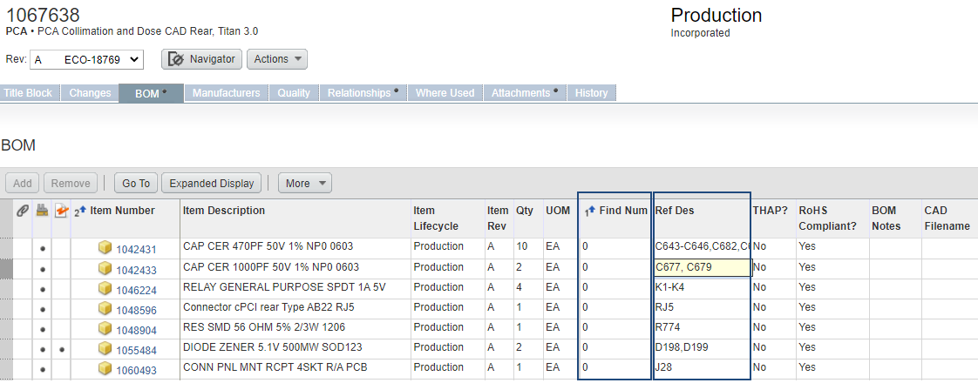
Figure 15: Find Number and Reference Designator Example
Reference Designators have referential integrity checks to ensure that the Quantity of the items and the numbers of reference designators match.
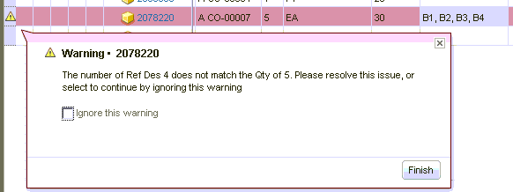
Figure 16: Reference Designator Warning

Copying an Existing BOM to a Create New BOM

Find and open the BOM to copy.

Click Actions > Save As.
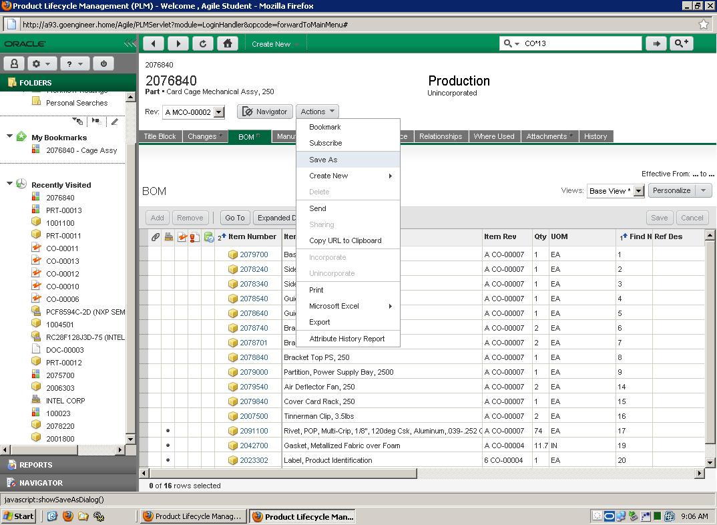
Figure 17: Save As Option

Save the BOM as a new item. All information will be preserved.

Click the BOM tab of the new item and make any required modifications.

Drag and Drop Items from Existing BOM to Create New BOM
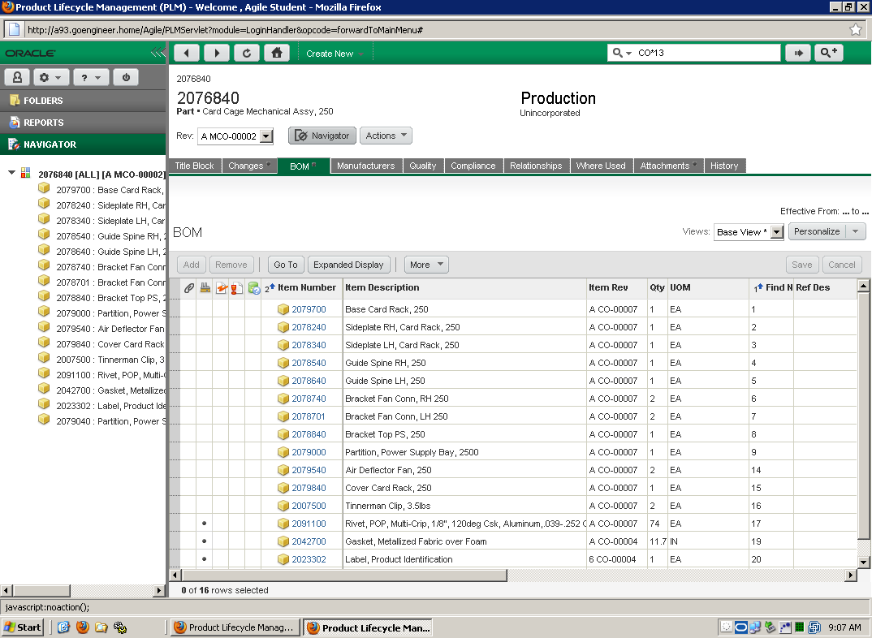
Figure 18: Already Created BOM

Find and open the BOM to copy.

Click Navigator to push the BOM to the Navigator drawer in the left column.

Search for or click the new assembly part number and open the BOM tab.

Drag and drop the desired items from the existing BOM to the new BOM. Drag an individual item, multiple lines by holding down the Ctrl or Shift keys, or the entire BOM by holding down the Shift key, clicking the first item, and clicking the last item.
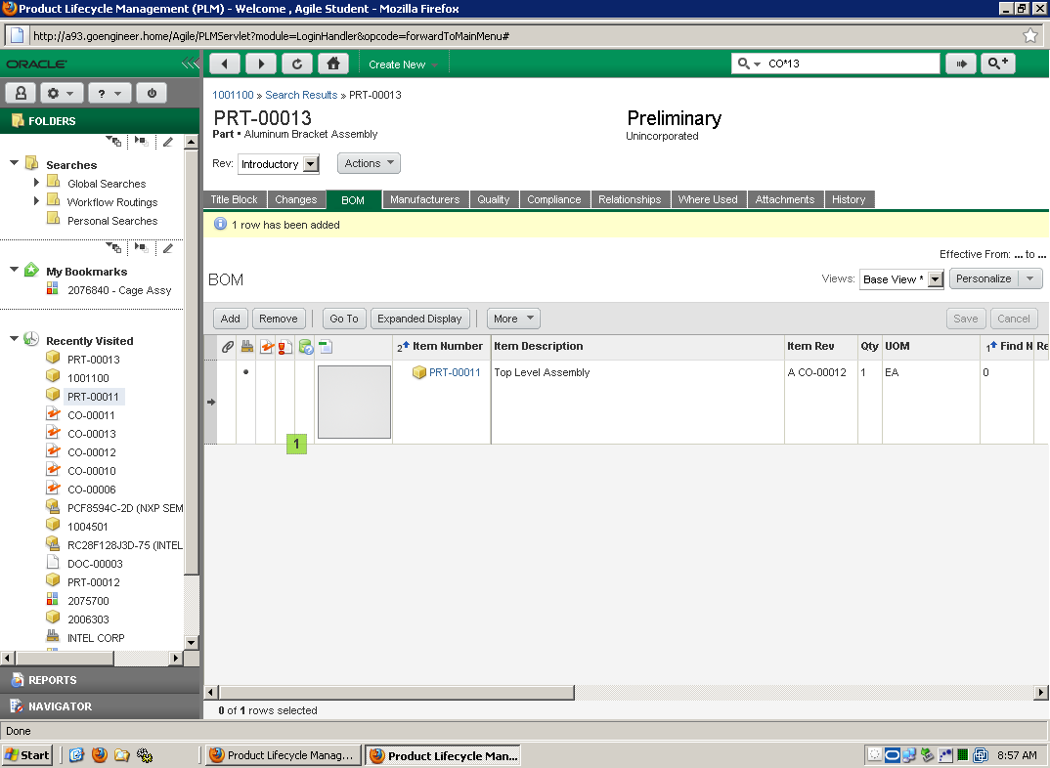
Figure 19: Drag and Drop to Create New BOM

Click the BOM tab of the new item, make any required modifications to the BOM attributes, and click Save.

Creating ECOs

Utilize the following checklist depending on the Change Type (some Change Types do not yet have a checklist). Unless specifically indicated as optional, guidance text in the FRM documents indicate requirements:
- FRM 1063735 Item ECO Checklist

Create New > Changes > Change Orders.
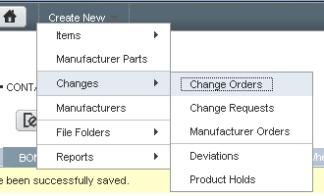
Figure 20: Create New ECO
Or navigate to the item and click Actions > Create New > Changes. This will automatically add the item to the Affected Items tab of the ECO.
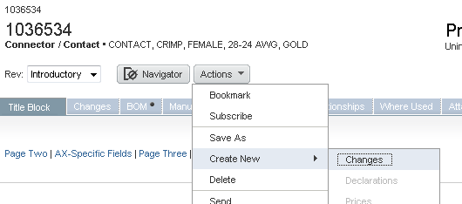
Figure 21: Create New ECO for Specific Item

Type (equivalent to change Subclass) = ECO
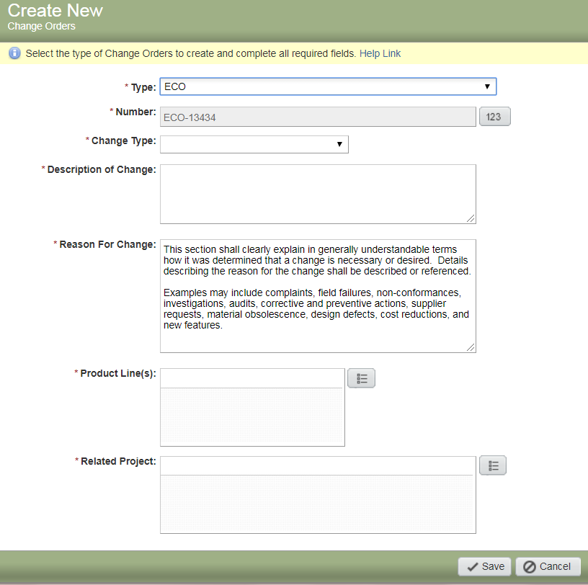
Figure 22: Create New ECO Pop-up

Number – Do not click the increment button. It is auto generated.

Change Type – Choose from the dropdown. This contributes to the auto-selection of minimum required reviewers per RECORD 1052622 Change Reviewer Matrices.
Engineering/Proto | Only changes to items being released to Prototype/Development. Numbered revisions only; no lettered revisions.
Item | Only changes to parts beyond Prototype (Pre-Production/ Production).  Product Docs can be included with parts on this type (Released).  (Includes Software)  Lettered revisions only; no numbered revisions.
Product Doc | Only changes to Product Docs released beyond Development (Released).  Parts cannot be included.  Lettered revisions only; no numbered revisions.
Product Builder | Only changes to Marketing Numbers.  SAP Material Type must be FERT, KMAT, SERV, or UNBW-B.

Description of Change – Describe what is being changed. Cannot have N/A or none.

Reason for Change – Provide reason why it is necessary. Cannot have N/A or none.

Product Line(s) – Select the correct value(s) for the change per the affected item(s) Product Line selections. This may contribute to the auto-selection of minimum required reviewers per RECORD 1052622 Change Reviewer Matrices.
Robotics | At least one affected item is Robotics  (used to be CyberKnife).
Helical | At least one affected item is Helical  (used to be TomoTherapy).
Software Applications | At least one affected item is Software Applications.

Related Project – Used as a search tool to identify when an ECO is related to a PDP project. Only select a project in this field if an affected item satisfies a requirement of that project. Select NA if not applicable.

Click Save and complete the remaining applicable fields.

ECO Cover Page Tab

Change Analyst – Only edited by Document Control. Contact the assigned Change Analyst for any questions regarding the change.

Originator – Defaults to the user that created the ECO. This user must have the following role in their user profile: 02 ECO Creator.

Accessible By (optional) – Grants access for third party user groups to view the change, when needed. See WI 1041758 Third Party Access to Agile.

Change Solution and Material Plan – Cannot have N/A or none.

Change Solution: A minimum general description of what is being changed based on the reason for change, including which products/processes, or portions of products/processes are considered within the scope of the change, and which are considered out of scope. The overview may reference “redline” markups of existing documents which shall be attached to the ECO. The combination of the overview and markups shall describe all aspects of the change in detail.

Material Plan Requirements:

Material Plan field shall provide rationale for All Affected Item Dispositions by individual Item or disposition Type (at a minimum), except when designated N/A by procedure.
- Floor stock, bulk, and consumable items do not apply

All redlined (removed via ECO) BOM parts that no longer have a valid Where Used (reports to an active BOM), must include a documented disposition with rationale supporting any Use As Is decision of Stock, WIP, and Finished Goods expectations for both Production (including Repair, if applicable) and Service use/consumption.
(E.g., for the parts list described, production may use all existing Stock and WIP under known product configurations, and Service may use all existing Finished Goods as this change is an obsolescence replacement and is fully backwards compatible, no repair inventory exists)

If either Rework, Scrap, or Return to Vendor dispositions are determined, rationale shall confirm all known inventory sources.
[E.g., for the parts list described, all Inventory of Stock, WIP, and Finished Goods shall require rework (see ReworkXYZ Form in ECO Attachments) to the released specification defined by this change]

This Plan should also include expectations for part Obsolescence or Inactivity in accordance with the usage (Use As Is) and/or Rework/Scrap/Return to Vendor dispositions described.
(E.g., the parts list described, existing and open purchase orders should be closed or converted to the parts released in this change. All items should be changed to Inactive or Obsolete once approved usage of existing Stock, WIP, and Finished Goods has been completed)

All redlined BOM parts that have a significantly reduced Where Used should provide Disposition and rationale for addressing existing inventory and purchasing/planning expectations for both Production (including Repair, if applicable) and Service usage.
(E.g., the parts list described, production should allot all existing inventory for service (compatible with known configurations of Product model XYZ) use only as the change provides an alternative (backwards compatible) and more reliable solution for production (and service). Existing and open purchase orders should be cancelled or converted to the parts released in this change going forward. No repair inventory exists. Service may use all existing Finished Goods, but consumption of the parts listed is very low (~2 per year), All items should be changed to Inactive or Obsolete once approved usage of existing Stock, WIP, and Finished Goods has been completed)

Where no Affected Item disposition is required (by procedure) and any redlined BOM parts still have an active Where Used (reports to an active part) the Material Plan may be defined as “Material Plan N/A” with associated rationale provided.
(E.g., Material Plan N/A, No redline BOM items as part of this change and No Disposition required for Product Documents)

Input Requirements Risk Mitigations and Regulatory Impact – Cannot have N/A or none.

Describe the assessment of existing input requirements, risk mitigations, and regulatory impact that were performed in conjunction with the change. Input requirements may include regulations, standards, user requirement specifications, system requirement specifications, sub-system requirement specifications, software requirement specifications, hardware requirement specifications, and system architecture descriptions. Risk mitigations may include product risk management reports, feature risk management reports, and process risk management reports. Regulatory filings may include 510k submissions and country registrations.

The assessment shall conclusively state that input requirements, risk mitigations, and regulatory filings are unaffected by the change, or reference the documents requiring revision. Any documents requiring revision shall be addressed in conjunction with the change. The assessment shall explicitly reference the documents reviewed or include a statement indicating the conclusion is based on the author’s knowledge of the relevant documents.

See FRM 1063735 Item ECO Checklist for additional guidance.

Verification Validation and Design Transfer – Cannot have N/A or none.

Reference a Tier 1 or 2 PDP project when verification and validation have been performed under a project. The project will be referenced in lieu of a product CRB ECR in the ECO Relationships tab. The referenced project cannot be past design transfer.

Identify related projects for product design and traceability. See SOP 1049123 Product Development Process.

Describe the verification, validation, and design transfer activities performed in conjunction with the change. Verification shall include objective evidence confirming that the design and processes resulting from the change continue to satisfy all input requirements; and may include inspection, analysis, and review. Validation shall include objective evidence confirming that the overall finished product and processes resulting from the change continues to satisfy all user needs, intended uses, and risk mitigations; and may include usability, risk mitigation, and process effectiveness demonstration. Design transfer shall include objective evidence demonstrating that service, manufacturing, and the supply chain are capable of producing product conforming to the changed design; and may include process qualification, and first article inspection.

At a minimum, all ECOs shall include formal or informal review activities sufficient to verify that the initial reason for change has been satisfied and no new problems were created. Review minutes should be included when available.

All testing performed to verify the change shall reference and follow a test method containing clear acceptance criteria.

See FRM 1063735 Item ECO Checklist for additional guidance.

Supplier Notification Required? – Used by Purchasing/Supply Chain to identify ECOs requiring Supplier notification.

Yes – if any affected items have Buy in their Make/Buy field. Applies to prototypes. Exceptions include non-purchased/non-saleable documents, tools, prototype manuals, and Price book (Marketing Numbers or Components).

No – if all affected items have Make in their Make/Buy field. It is acceptable to select Yes if there is a need to notify a Supplier.
It is recommended to check the Where Used of the part before indicating that supplier notification is not required.

Target Implementation Date (optional) – Informational date to help prioritize.

Implementation Notes (optional) – Actionable notes to ensure reviewers implement the change per intent.

Initial releases of Service documents should include Secure Sync posting instructions, when applicable.

Note any attachments that require Document Control restrictions upon release (e.g., .brd or .dsn files).

Initial releases and revisions to manuals should include AEx posting instructions, when applicable. See WI 1061475 AERO User Documentation Management.

If the item Subclass needs to be changed, include instructions for Document Control to make these changes for you. Existing items will not be changed by Document Control until after the ECO has been approved and before release.

Click Save.

ECO Affected Items Tab

At least one Affected Item is required. The item Subclass can only be a part or ECO document Subclass. It cannot be a DHF document Subclass.

Once added, populate appropriate fields for each item (scroll to the right, if needed). Any fields that are not applicable will have a gray dash.
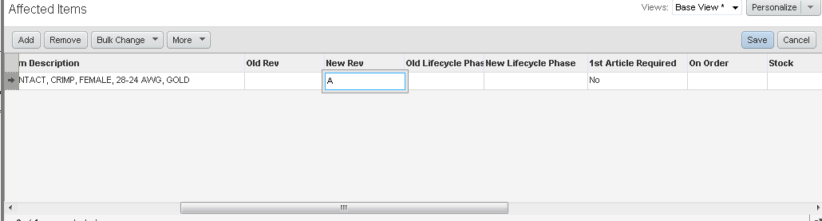
Figure 23: ECO Affected Items Fields

Item Description – Defaults to the Old Item Description but can be edited for the new revision, if needed.

This description must match the title as it appears in the attachment content exactly (when attachments present).

Recommend this text to match the SAP description field, but not required. This field allows for additional character space for enhanced search capabilities in Agile. If desired, enter a more detailed title, description, or spell out abbreviations. If text does not match the SAP Description field, the two fields must at least be cohesive.

Do not include Manufacturer names or Manufacturer Part Numbers (MPNs) in the description for Off-the-Shelf (OTS) Manufacturer parts where alternates from different manufacturers can be added. The Description can only be changed with an ECO, not an MCO.

Abbreviating is acceptable.

Enter on one line; do not hit enter for multiple lines/rows (causes export issues).

See SOP 016087 Item Numbering and Naming and RECORD 1089757 Accuray Acronyms and Definitions for guidance.

New Rev – Must be entered manually.

Use numbered revisions for Prototype/Development lifecycle phases.

Use alpha revisions (all caps) for Pre-Production/Production/Released lifecycle phases.

Increment 1 per revision (e.g., A à B). In cases where a revision needs to be skipped, justification is required on the ECO Cover Page tab.

PWBs do not always follow these same rules because ECOs require a revision change. See Section 5.5.10.4 and SOP 016827 Change Control for PWB MCO exception.

New Lifecycle Phase –

Parts: Select Prototype, Pre-Production, Production, or Inactive (only select Inactive via ECO when changes are needed; otherwise, use MCO).

Documents: Select Development or Released.

Prototype/Development – only numeric revisions.

Pre-Production/Production/Released – only lettered revisions.

Do not select Obsolete. Items can only be made obsolete with an MCO.

Do not select a New Lifecycle Phase that is earlier than the Old Lifecycle Phase, e.g., if the Old Lifecycle Phase is Released, the New Lifecycle Phase cannot be Development.

1st Article Required –

Yes – Accuray Buy-level items and items that are used on other Accuray Buy-level items. First article inspections may need to be performed at a different level of the product structure than the affected items on the ECO.

No – Items that are not part of any Buy-level items. Justification must be documented in the design transfer section of the ECO for items affecting an Accuray Buy-level item where first article is indicated as not being required. Consult Supplier Quality Engineering for first article inspection guidance as required.

See WI 028094 First Article Inspection.

Dispositions (On Order, Stock, Work In Progress, Finished Goods, and Install Base fields) –

Dispositions are required for revisions to existing items (already released). Dispositions are not required and should be left blank for new items (not yet released) and documents.

Risk evaluation shall support dispositions, if applicable.

When selecting dispositions, answer the question “what if” (i.e., assume there is stock, product on order, WIP, Finished Goods, and Install Base). If needed, contact Materials for assistance.

On Order – Material not yet received but committed to at a Supplier on an open PO.

Stock – Raw material in inventory (typically requires production processing to become Work in Progress or completed picking and packaging, and/or production processing for Finished Goods).

Work in Progress – Applies to an internally produced item on an open manufacturing work order. If Rework removes a picked item from the BOM, the picked item will be dispositioned per its affected item disposition.

Finished Goods – Applies to Accuray inventory and service inventory (have completed picking and packaging, and/or production processing), which may include service distribution network and unconsumed field service inventory.

Install Base – Customer-owned equipment, including finished goods that have been shipped on a customer sales order. Unless disposition of installed base is use-as-is, a field notification through field action, if applicable, service procedure and/or technical tip, shall be included or notification item referenced within ECO and disposition of Rework shall be selected. Install base disposition should be used as-is unless risk assessment indicates a field action/notification is warranted.

Disposition Determination
Disposition Options | Guidance
Not Applicable | No action required. Applies to non-inventory items. Where additional implementation actions are suggested, “See Notes” may apply.
Rework | Rework from old rev to new rev or from one item number to a different item number is required. Rework should be used when safety or efficacy issues exist with the old rev. Refer to SOP 1053314 for Rework guidance.  - On Order: requires rework from the Supplier and/or Purchase Order (PO); the PO requires updating.  - Stock, WIP and Finished Goods: requires FRM 021105 Rework Instructions Form to be attached in the ECO Attachments tab per WI 021197 Rework. Required approvers per the form must be added as approvers on the ECO.  - Install Base: requires a field notification through field action, if applicable, service procedure and/or technical tip shall be included, or notification item referenced within ECO. Follow WI 1046213 Product Surveillance Committee.
Scrap | Material must be scrapped. An estimate of scrap cost may be entered in the Disposition Notes to facilitate downstream review and approval.
See Notes | May only be used when dispositioning affected items that do not apply to the other dispositions and should be used to aid in implementation and design transfer activities, where applicable.  Notes must appear in the Disposition Notes field.
Use As Is/Phase In | No action required. Material may be used without modification. Use-as-is material shall consume old rev first according to FIFO rules. If changes impact F/F/F, provide justification in the ECO Cover Page Change Solution and Material Plan field why down revision material is acceptable for use. See Section 5.4.11.4 for additional information.
Return to Vendor | Material shall be returned to the vendor upon ECO release.

Disposition Notes – If a disposition is “See Notes”, notes are required to appear in this field. Only required examples:

An estimate of scrap cost may be entered to facilitate downstream review and approval.

If changes impact F/F/F, provide justification as to why down revision material is acceptable for use.

Other affected items cannot be dispositioned in notes. They must be a separate affected item.

Click Save.

Redline Fields

Item Title Block, BOM, and Manufacturers redline fields are accessed by clicking on the gray box to the left of each item number. The redline-able fields will appear in the lower pane.

See Sections 5.1, 5.2, or 5.3 for field details.

If changes are needed, click Edit and Save when finished.

Item Attachments Tab

From the Affected Items tab, click each Item Number, and go to its Attachments tab.
Or click Navigator so the ECO number and all affected items appear in the Navigator pane.

Documents require attachments.

If a BOM or MPN is not included, parts require a viewable file attachment. Exceptions are:
- Outsource Process
- Z Numbers
- Marketing Numbers/Sales Materials
- Prototypes
- Service/Partnership Agreements
- -1 Part Numbers
- Legacy -01 Part Numbers (doesn’t apply to new -01 Part Numbers)

Both release copy (PDF) and native (Word, Excel, Visio, SLDDRW, etc.) files are required for most parts and ECO documents.

Manuals only require a PDF. A native can be attached, if available.

If anything else only requires a PDF as dictated by another procedure, a native should be attached (if available) if the document may need to be revised in the future.

Product Document Forms only require a native.

When the PDF is the native, only the PDF is required.

Preference is clean PDF, not scanned, unless it is a scan with signatures. If a scan is attached, it must be legible.

A zip file can be used to combine multiple attachments into one attachment.

Tools may only contain a zip file. Since these tools have zip files attached without a main document (several attachments that make up the whole tool), titles are not required to match the Agile title Description, and 3rd party datasheets and manuals can be included in the zip file. However, any Accuray generated documents are required to have the Accuray PN and Rev.

Some attachment files cannot be opened without specialty software. In these cases where none of the attachments are in a generally viewable format, we recommend a note in the ECO and/or File Description field providing an explanation.
Examples:
Programming file only.
Phantom assembly, no stand-alone drawing
File supporting upper level assembly
3-D file only; no drawing at this level

Attachment filenames must be formatted as the item number with no further data (e.g., “#######.pdf” or “#######.docx”).

If needed, additional supporting documentation can be added. This does not include redlines, verification, or validation records that should be attached to the ECO instead. The supporting documentation can be identified by the item number, underscore, and description of what it is (e.g., #######_Description.pdf).

Certain programming files can be attached with a special filename that does not follow a specific convention (e.g., drs_intf.mcs).

Certain software image files have an exception to allow the use of the revision level in the filename (e.g., 104729_C.iso).

File Descriptions cannot contain revisions.

Part attachments are automatically attached when checking CAD files into Agile. See WI 1063971 Using SolidWorks with Agile and WI 1003688 Engineering Drawing Standards.

Design output documents should be added for custom designs. Include drawings, specifications, datasheets, documents, native tables, and/or certifications that define the item.

Documents must contain minimum requirements per SOP 1004376 Document Control.

All native source design files (e.g., .brd or .dsn files) should have restricted access for external vendors unless specifically indicated otherwise.

If an attachment is password protected, provide the password to Document Control to securely store it if the originator is no longer with the company or they have moved to a different department.

Emails cannot be attached due to data privacy concerns.

Videos or other similar media cannot be attached due to size limitations and Accuray Agile usage. Agile is solely used for documentation purposes, not for media. Exceptions are product software related media which does not contain videos.

Pricing cannot be attached in Agile. This information could conflict with the Accuray Purchasing ERP system and may be inaccurate. Third parties with Agile access may be able to view competitor pricing.

ECO Relationships Tab

Relationships can be added to other changes associated with the ECO. Do not add relationships to items (parts or documents).

Item and Product Doc Change Types require a relationship to an ECR in Assigned state with reviewed FRM 033017 Initial Change Assessment attached to the ECR or a relationship to a DCR in Approved state (previous change control process) as proof of verification and validation, except when:

Verification and validation have been performed under a project. The Tier 1 or 2 PDP project must be referenced in the Verification Validation and Design Transfer field on the ECO Cover Page. The referenced project cannot be past design transfer. This project must also be added to the Related Project field on the ECO Cover Page.

A language translation certificate is attached and there are no affected items with a BOM.

Navigate to each affected item, and click their Changes tab.

Approved Change Requests

Approved (Assigned, Released) ECRs will appear in Change History.

The ECO Originator must incorporate all approved change requests with their changes to the document. Prior to submittal, add the change requests to the ECO Relationships tab and create rules (when appropriate) to close them upon ECO release. If an ECR is not being incorporated for this revision, this must be noted in the ECO Cover Page tab.

ECR-Archive Hold Change Requests
Hold ECR-Archives will appear in Pending Changes.
Any change requests on Hold should be addressed before submitting the ECO.

Pending Change Requests
Pending ECRs will appear in Pending Changes.
Any change requests in a status before Assigned (ECRs) or Released (ECR-Archives) should be addressed or deleted/canceled before submitting the ECO.

ECO Attachments Tab

Attach any redlines, design reviews, validation, and/or verification documents pertinent to the ECO. Final native and PDF files attached to the item number cannot be attached to the ECO Attachments tab.

There are no filename or File Description requirements for ECO Attachments. However, confirm the filename or File Description is accurate (e.g., revision is correct, item number is correct, etc.).

Redlines are not required. It is acceptable to list the changes on the ECO Cover Page in lieu of redlines (at a minimum a comprehensive summary of the changes). If redlines are attached, they must compare the current released revision to the new proposed revision. Any exceptions must be explained on the ECO Cover Page.

FRM 021105 Rework Instructions Form is required for any ECO that has Rework populated in the Stock, Work in Progress, and/or Finished Goods disposition fields. See Section 5.4.12.7.9 Disposition Determination and WI 021197 Rework for further details.

A language translation certificate is required for any external translations (e.g., translated manuals). Internal translations require either a memo attached to the ECO Attachments tab from the internal SME or acknowledgement in Agile confirming translations are accurate.

Emails cannot be attached due to data privacy concerns. If email content is needed, it can be pasted into a memo and attached instead.

Videos or other similar media cannot be attached due to size limitations and Accuray Agile usage. Agile is solely used for documentation purposes, not for media.

Pricing cannot be attached in Agile. This information could conflict with the Accuray Purchasing ERP system and may be inaccurate. Third parties with Agile access may be able to view competitor pricing.

ECO Workflow Tab

Click Submitted or Next Status > Continue.

If there are errors or warnings, make the corrections needed until all are resolved. Errors must be resolved, while warnings should be addressed.

If there are no errors or warnings or they have been resolved, a Notification screen will pop up. This is the originator’s chance to email the change to whomever they wish to include. Do not delete the Change Analyst Group. There is an option to add comments as well.

Click Finish.

If additional reviewers are needed, they can be added after submittal.

The Change Analyst (Document Control) will review and route the change to CCB or return to Pending for additional changes.

Creating MCOs

Create New > Changes > Manufacturer Orders.
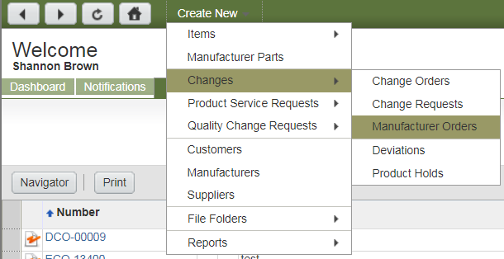
Figure 24: Create New MCO
Or navigate to the item and click Actions > Create New > Changes. This will automatically add the item to the Affected Items tab of the MCO.
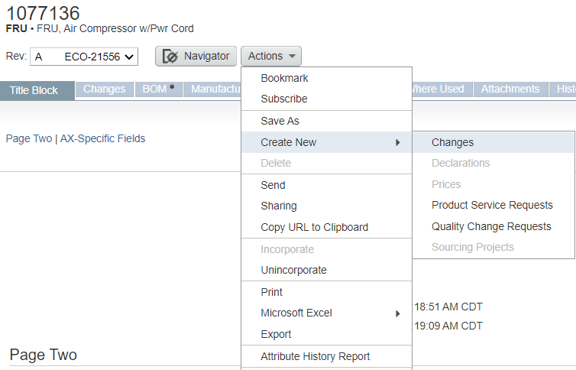
Figure 25: Create New MCO for Specific Item

Type (equivalent to change Subclass) – Select MCO from the dropdown.
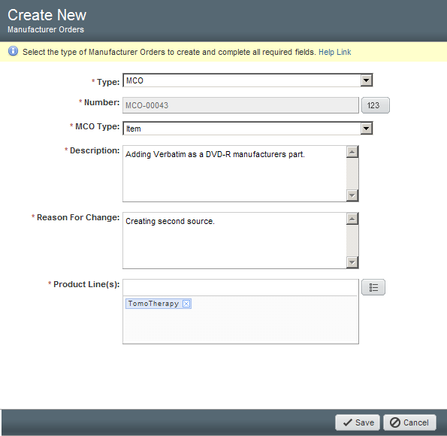
Figure 26: Create New MCO Pop-up

Number – Do not click the increment button. It is auto generated.

MCO Type – Choose from the dropdown. This contributes to the auto-selection of minimum required reviewers per RECORD 1052622 Change Reviewer Matrices.
Engineering/Proto | Only changes to items being released to Prototype/Development. Numbered revisions only; no lettered revisions.
Item | Only changes to parts beyond Prototype (Pre-Production/Production).  Product Docs can be included with parts on this type (Released).  (Includes Software)  Lettered revisions only; no numbered revisions.
Product Doc | Only changes to Product Docs released beyond Development (Released).  Parts cannot be included.  Lettered revisions only; no numbered revisions.
Product Builder | Only changes to Marketing Numbers.  SAP Material Type must be FERT, KMAT, SERV, or UNBW-B.

Description – Describe what is being changed. Cannot have N/A or none.

Reason for Change – Provide reason why it is necessary. Cannot have N/A or none.

Product Line(s) – Select the correct value(s) for the change per the affected item(s) Product Line selections. This may contribute to the auto-selection of minimum required reviewers per RECORD 1052622 Change Reviewer Matrices.
Robotics | At least one affected item is Robotics  (used to be CyberKnife).
Helical | At least one affected item is Helical  (used to be TomoTherapy).
Software Applications | At least one affected item is Software Applications.

Click Save and complete the remaining applicable fields.

MCO Cover Page Tab

Change Analyst – Only edited by Document Control. Contact the assigned Change Analyst for any questions regarding the change.

Originator – Defaults to the user that created the MCO. This user must have the following role in their user profile: 02 ECO Creator.

Accessible By (optional) – Grants access for third party user groups to view the change, when needed. See WI 1041758 Third Party Access to Agile.

Test Results (Validation/Verification Evidence) – Not required for general changes such as item attribute field changes. Required when:

Changing Lifecycle Phase to Production. Reference validation/verification item number or change number. If an item number or change number does not exist, add validation/verification to the Attachments tab.

Introducing new part alternates that are F/F/F equivalent to an existent Manufacturer’s part (original component). Component verification evidence must be provided for any changes made to manufacturer parts with part alternates via Engineering study, memo letter to support part equivalency, peer review, slide deck review, etc.

Implementation Notes (optional) – Actionable notes to ensure reviewers implement the change per intent.
If the item Subclass needs to be changed, include instructions for Document Control to make these changes for you. Existing items will not be changed by Document Control until after the MCO has been approved and before release.

Click Save.

MCO Affected Items Tab

At least one Affected Item is required. The item Subclass can only be a part or ECO document Subclass. It cannot be a DHF document Subclass.

Once added, populate appropriate fields for each item (scroll to the right, if needed). Any fields that are not applicable will have a gray dash.
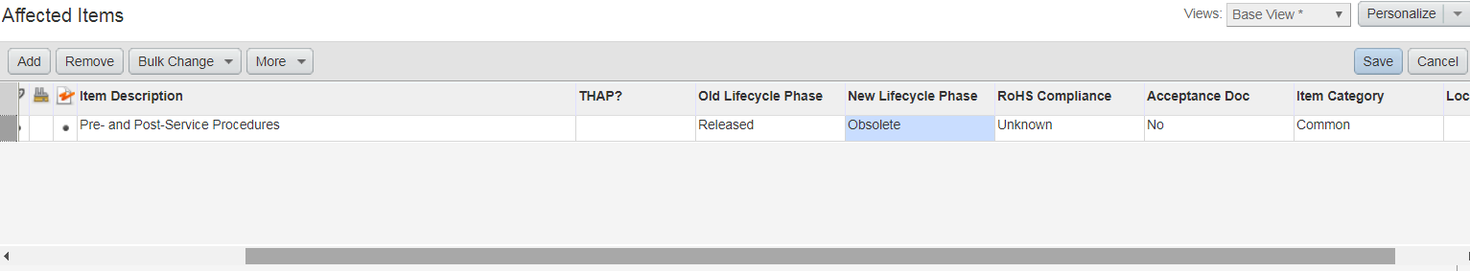
Figure 27: MCO Affected Items Fields

Item Description – Cannot be edited with an MCO; only ECO can edit.

New Lifecycle Phase – MCOs can change the lifecycle phase of an item to:
- Obsolete
- Inactive
- Pre-Production to Production
- PWBs only from Prototype to Pre-Production or Production

Originators are required to review the Where Used tab of each item and remove from any released BOMs via CO before it can be made obsolete.

If a parent BOM is being made obsolete with children that are being made obsolete, those obsolete children do not need to be removed. Children do not need to be removed when making the parent obsolete.

Items that are made obsolete can no longer be revised via ECO or modified via MCO, and the attachments are restricted.

Do not select a New Lifecycle Phase that is earlier than the Old Lifecycle Phase, e.g., if the Old Lifecycle Phase is Released, the New Lifecycle Phase cannot be Development.

Click Save.

Redline Fields

Item Title Block and Manufacturers redline fields are accessed by clicking on the gray box to the left of each item number. The redline-able fields will appear in the lower pane.

See Sections 5.1 and 5.2 for field details.

If changes are needed, click Edit and Save when finished.

MCO Relationships Tab

Relationships can be added to other changes associated with the MCO. Do not add relationships to items (parts or documents).

Navigate to each affected item, and click their Changes tab.

Approved Change Requests

Approved (Assigned, Released) ECRs will appear in Change History.

The ECO Originator must incorporate all approved change requests if the changes can be made via MCO. Prior to submittal, add the change requests to the MCO Relationships tab and create rules (when appropriate) to close them upon MCO release.

ECR-Archive Hold Change Requests

Hold ECR-Archives will appear in Pending Changes.

Hold change requests should be addressed prior to submittal if the changes can be made via MCO.

Pending Change Requests

Pending/Unassigned ECRs will appear in Pending Changes.

Any change requests in a status before Assigned (ECRs) or Released (ECR-Archives) should be addressed or deleted/canceled before submitting the MCO if the changes can be made via MCO.

MCO Attachments Tab

Attach any supporting documentation pertinent to the MCO, if applicable. Final native and PDF files attached to the item number cannot be attached to the MCO Attachments tab.

There are no filename or File Description requirements for MCO Attachments. However, confirm the filename or File Description is accurate (e.g., revision and item number are correct, etc.).

If a part is being promoted to Production, reference to objective evidence that this specific revision was validated can be attached.

Emails cannot be attached due to data privacy concerns. If email content is needed, it can be pasted into a memo and attached instead.

Videos or other similar media cannot be attached due to size limitations and Accuray Agile usage. Agile is solely used for documentation purposes, not for media.

Pricing cannot be attached in Agile. This information could conflict with the Accuray Purchasing ERP system and may be inaccurate. Third parties with Agile access may be able to view competitor pricing.

MCO Workflow Tab

Click Submitted or Next Status > Continue.

If there are errors or warnings, make the corrections needed until all are resolved. Errors must be resolved, while warnings should be addressed.

If there are no errors or warnings or they have been resolved, a Notification screen will pop up. This is the originator’s chance to email the change to whomever they wish to include. Do not delete the Change Analyst Group. There is an option to add comments as well.

Click Finish.

If additional reviewers are needed, they can be added after submittal.

The Change Analyst (Document Control) will review and route the change to CCB or return to Pending for additional changes.

Records
Refer to SOP 016824.

Appendices

Appendix A – Item Type/Subclass Values
Not all Type/Subclass values are listed below, only those that could be ambiguous.
Value | Guidance for Use
Accessory | Item that is not a service part or higher level assembly. This is for items that need to be tracked by the PLM system, but not part of a product BOM.
Component | Can be used for a variety of items that contribute to the product BOM.
Label | For label creation.
Marketing Number | Any part number that can be sold to a customer (price book).
Other Electrical Component | Use for items that do not have a category in the Type list, but can be considered electronic hardware, electronic misc., schematic notation, or thermal management items.
Packaging | For any packaging material.
Service Part | For FRUs, Installation Parts, Service Manuals, Service Tools, or Service Upgrade Kits.
Shippable Part | Any item that is not considered a marketing or service part but could be shipped from the factory.
Tool / Fixture / Equipment | Any tool/fixture/text fixture/equipment for use in engineering or manufacturing. Any tool/fixture/equipment for service use should be categorized as a Service Part.

Appendix B – SAP Material Type Options for Parts and Decision Tree
The SAP Material Type helps facilitate several fields in SAP that make an item function correctly. Having the correct SAP Material Type is essential for a smooth transition of information from Agile to SAP.
This field cannot be changed after Pre-Production release because it cannot be changed in SAP. In those instances, a new part number would be required.
SAP Material Type | Definition
Document | A document that needs to be present on BOM (i.e., work instructions, forms, etc.).
FERT | Finished Good. Shippable part. Can be Make or Buy.
HALB | Subassembly built in-house by Accuray manufacturing. Must be a Make part upon initial Rev A release. Manufacturing may decide to outsource a part and change to Buy on a future revision.
KMAT | Configurable, shippable part. Must be a Make part.
ROH | Raw material, part, or assembly that is purchased. Purchased item, with or without a BOM, that usually reports into a higher level BOM. Must be a Buy part upon initial Rev A release. Manufacturing may decide to insource a part and change to Make on a future revision.
SERV | Customer services such as warranty, de-install, training, etc. Should be a Buy part to avoid unnecessary part setup routing in SAP.
UNBW-B | Non-stocked, non-valued parts such as floorstock, non-tracked licenses, software, etc. Low-cost, high-usage inventory items stored near the shop floor, which the production staff can use at will without a requisition, and which are expensed at the time of receipt, rather than being accounted for through a formal inventory database. Examples include Manufacturing tools, zip ties, nuts, washers, screws, labels, etc. Should be a Buy part to avoid unnecessary part setup routing in SAP.
UNBW-X | Stocked, non-valued parts such as FSE tools that are shippable. Can be Make or Buy.

Appendix C – ECO Workflow
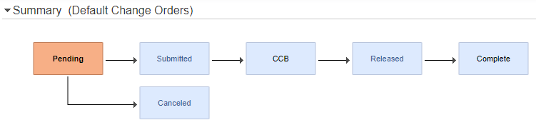

Appendix D – MCO Workflow
