

Global Product Registration

SOP 1062120

REV C

Accuray Confidential
Copyright © 2025 Accuray Incorporated

Revision History

Rev | Change # | Description of Change | Revised By | Date
A | ECO-10107 | Initial release | Shweta Kaushik | 29-Dec-2017
B | ECO-03068 | Clerical updates, added reference to TMPLT 1050238 Global Regulatory Plan, WI 1065259 Regulatory Submissions and Establishment Registration US, Technical File/STED (TMPLT 1064261, modifications to sections 6.2.2.2 and 8.2 (formerly 8.3) | Mike Preto | 13-Dec-2018
C | CHG-01821 | Updates made per CAPA-2025-0001 to reference new Product Specification Catalog WI DOC-01289. Updated the document throughout to replace the term License Tracker with the Global Regulatory View. Updated Reference Documents section. Updated Section 5 (Procedure) to reflect current practices. Updated Section 7 (Appendix) section. | Colleen Burdel | See DMS
Table of Contents
1 Purpose 4
2 Scope 4
3 Reference Documents 4
4 Definitions 5
5 Procedure 6
5.1 Create Global Product Registrations 6
5.2 Product Support and Change Management 9
6 Records 10
7 Appendices 11
7.1 Appendix A – Procedure Flowcharts 11
7.2 Appendix B – Examples of changes that may have regulatory impact 13

Purpose
This procedure defines the process for providing guidance on global medical device regulatory requirements applicable to Accuray products in order to support global product registrations. This procedure also describes how regulatory inputs for Accuray product development are communicated and disseminated to business process owners (BPOs) to help them design and implement global market strategies.

Scope
This procedure applies to all Product Development Teams (PDT) responsible for all Accuray projects including development of new products, changes to existing products or options and product enhancements using Accuray’s Product Development Process (PDP).
The PDT is a cross-functional team composed of representatives across multiple functional areas and departments such as Engineering (Product Integration, Software, System, etc.), Manufacturing Engineering, Product Strategy, and ARQ (Accuray Regulatory and Quality).
This procedure defines the inputs required by Regulatory Affairs (RA) to provide regulatory guidance and create and maintain regulatory registrations. It defines the outputs that RA will produce to support PDT and other functions related to product registrations. It also applies to change management and maintenance of product registrations after their initial approval.
The PDT provides the scope and definition for a project and the target markets. Based on these inputs, the RA team develops the plans and guidance for the PDT to achieve its goals. The RA team identifies the applicable requirements for the PDT to enter markets, which PDT can choose to elect or not elect to implement.
The RA team obtains product registrations for the global markets based on the outputs provided by PDT. After the PDT completes the PDP for a project, the Global Marketing team determines the additional market priorities and works with RA team to achieve product registrations in those markets.

Reference Documents
- SOP 016824 Quality Records and Records Retention
- SOP 016827 Change Control
- SOP 018981 Technical File
- SOP 1049123 Product Development Process
- SOP 1060489 Regulatory Intelligence Process
- WI 1028729 Regulatory Submissions and Registrations in Canada
- WI 1058532 Shonin Application Procedure
- WI 1065259 Regulatory Submissions and Establishment Registration, US
- WI 1067989 Medical Device Registration, China
- WI 1072016 Regulatory Submissions and Registrations in Singapore
- WI 1072038 Regulatory Submissions and Registrations in South Korea
- WI 1074764 Regulatory Submissions and Registrations in Australia
- WI DOC-00780 Market Access
- WI DOC-01289 Product Specification Catalog
- TMPLT 1050238 Regulatory Strategy
- TMPLT 1064261 Technical File/STED
- TMPLT 1067357 Technical File/STED for MDR
- RA DOC-00295 Global Registration View

Definitions
See Accuray Acronyms and Definitions (1089757).

Procedure

Create Global Product Registrations
Global Product Registrations will generally be initiated by a PDT for a new product or major changes to an existing product. Product registrations are pursued and obtained by RA team following an assessment of the PDT goals and the requirements of the target markets determined by PDT.
The Global Regulatory Strategy (refer to TMPLT 1050238) identifies the requirements of the target markets and expected outputs from the PDT needed to obtain the product registrations. The RA team, consisting of Program RA and Region RA, work together to build and execute the Global Regulatory Strategy to secure market access for new and changed products.
The following activities performed by RA team throughout the global product registration process are defined relative to the PDP phases (Appendix A).

P0: Advance Development

The Program RA may participate in the Advance Development Phase of the PDP but is not required. Program RA will lead interactions for the development phase and may seek input from Region RA as necessary to assess the business strategy and advise the business on available options.

There are no required Regulatory outputs from PDT for Advance Development Phase.

P1: Concept Phase
The PDT develops the product definition and business plan, which includes target markets, and provides detailed information to the assigned Program RA to prepare for regulatory planning.

Program RA advises the PDT on the implications of their product and market decisions as the PDT concept matures.

There are no required Regulatory outputs for Concept Phase.

P2: Definition and Planning Phase

The PDT defines the product and provides the Program RA at a minimum, with the following documents:
Product Needs Document (PND), User Requirements Specification (URS), Business and Marketing Plan including identification of marketing claims for the project, Project Management Plan (PMP), Concept of Operations (ConOps) and design descriptions for product hardware and software. (For a more specific list of inputs, refer to the PDP SOP 1049123).

The PDT provides the prioritized list of the target global markets to Program RA in the Planning phase.

The PDT defines the timeline of respective projects, including any dependencies on other PDT projects.

Determining Product Registration Pathways

Based on PDT inputs, the Program RA working with global Region RA determines the product classification in the target markets and appropriate regulatory actions required, based on the scope of the product or change for each target market: new product registration, amend existing product registration, or rationale for no registration activity required.

Program RA provides the regulatory actions and selected pathway to the PDT as part of a consolidated Global Regulatory Plan, using Regulatory Strategy (TMPLT 1050238).

Regulatory Design Inputs

Program RA provides a list of project activities necessary to meet regulatory requirements and open access to markets for products. This may include labeling, standards, onsite or offsite type testing, clinical trials or QMS changes.

Program RA, working with Region RA, develops a consolidated list of standards required by regulators for the product in the target markets, using SOP 1060489 Regulatory Intelligence Process.

Program RA creates the Global Regulatory Strategy that describes:

The scope of the plan in terms of the product and target markets requested and time frame relative to milestones.

As applicable, the product classification and rationale for the classification for the target markets.

The regulatory pathway for the target markets.

P3: Development

Program RA will advise and provide guidance to the cross-functional development team in the implementation of regulatory requirements identified in the Global Regulatory Strategy.

Program RA will manage the creation/ approval of the necessary product development documents to execute the Global Regulatory Plan. Specifically, Program RA shall assist in providing the applicable Design History File documents needed for the Technical File/STED (TMPLT 1064261/1067357) to Region RA to initiate the actual product registration planning.

Region RA, in collaboration with Program RA, shall concurrently develop the planned product registrations in parallel to the PDT as information and deliverables become available.

P4: Verification
Program RA shall provide the Verification deliverables needed for the Technical File/STED (TMPLT 1064261/1067357) to Region RA.

P5: Validation

Program RA shall provide the Validation deliverables needed for the Technical File/STED (TMPLT 1064261/1067357) to Region RA.

Program RA shall provide the available Design History File documents needed for the Technical File/STED (TMPLT 1064261/1067357) to Region RA at the completion of Design Controls (P3, P4, and P5) to execute the actual product registrations.

P6: Design Transfer

Program RA shall provide the applicable Design Transfer deliverables needed for the Technical File/STED (TMPLT 1064261/1067357) to Region RA at the completion of Design Transfer.

Region RA shall execute and submit the actual product registrations using region specific work instructions such as:
- SOP 018981 Technical File
- WI 1028729 Regulatory Submissions and Registrations in Canada
- WI 1065259 Regulatory Submissions and Establishment Registration, US
- WI 1058532 Shonin Application Procedure
- WI 1072038 Regulatory Submissions and Registrations in South Korea
- WI 1072016 Regulatory Submissions and Registrations in Singapore
- WI 1067989 Medical Device Registration, China
- WI 1074764 Regulatory Submissions and Registrations in Australia
Note: Product submissions must be supported by technical details and product specifications documented in the Design History File. If the required information is not present in the Design History File, it must be verified by the appropriate subject matter experts (e.g., Systems Engineering) and formally added to the Product Specification Catalog in accordance with WI DOC-01289 prior to inclusion in the submission.

P7: Ramp & Monitor

Program RA shall ensure the Global Regulatory Strategy is completed, and the committed licenses and product registration submissions are executed.

Region RA shall complete registrations as committed in the Global Regulatory Strategy.

Region RA shall ensure that the Global Regulatory View (DOC-00295) is updated with all active registrations. Remaining submissions for the PDT that are not started during the PDT program will be prioritized and executed during annual RA planning.

Regulatory Affairs program support ends at the end of P7 Ramp & Monitor, and existing licenses and open license request are managed as part of an Engineering Change Request within the Change Control process (SOP 016827) and/or a Market Access Request within the Market Access work instruction (WI DOC-00780).

Product Support and Change Management
After the initial product registration and its associated licenses are completed, they may require regular maintenance such as reporting or renewal filings. Additionally, changes may occur to the product or the desired target markets that may impact regulatory registrations.
Regulatory Affairs is responsible for maintaining existing licenses and continues to support the product strategy after the PDT is complete (Appendix A).

Product Support

Region RA shall maintain existing regulatory licenses unless otherwise notified through a change management process.

Program RA is responsible for understanding the marketing priorities for their product lines. Region RA is responsible for understanding the commercial needs of their regions. Region RA, in collaboration with Program RA, determines the priority and timing for executing open product registration requests in their respective markets.

Region RA shall update the Global Regulatory View (DOC-00295) at least monthly with completed licensing activity.

Change Management

Changes to product may be initiated by Engineering projects, Product Marketing decisions for target markets/ priority, or smaller PDT projects that do not require all the planning deliverables.

Upon notification of change, Program RA evaluates the change and documents a change assessment regarding its impact on regulatory filings. The global change assessment includes consideration of impacted MDSAP countries.
For changes to existing products introduced under the Change Control Process (e.g., Engineering Change Orders), Program RA documents the assessment in the initiating record, such as an Engineering Change Order (ECO) considering the examples of changes that may have regulatory impact (Appendix B).
Note: Program RA may notify and consult Region RA for input when assessing the change and its impact on regulatory filings.

Program RA collaborates with Region RA to implement the changes to regulatory filings, if indicated by the product changes described above or by a market change.

Region RA completes any required new licenses, registrations or amendments/ notifications. Region RA may also end a registration upon request through a change management process.

Region RA also notifies their respective regulatory authorities, if needed, depending on the scope of the changes.

Records
Refer to SOP 016824.

Appendices

Appendix A – Procedure Flowcharts
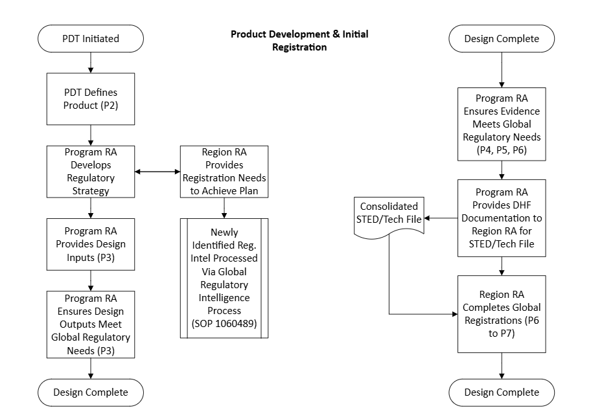
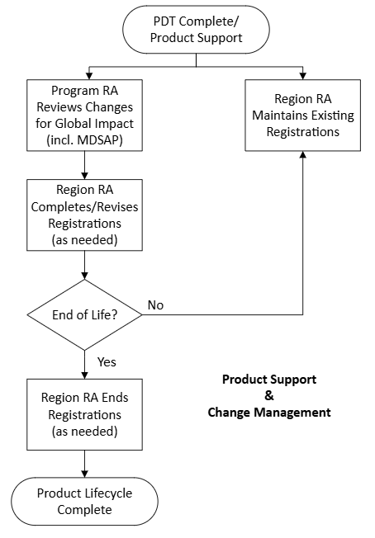

Appendix B – Examples of changes that may have regulatory impact

 | Category of Changes | Examples
1 | Labeling changes | Changes to Intended Use/ Indications for Use, Instructions for Use (user manuals), product labels.
2 | Technology, Engineering and Performance changes | Changes to design and performance characteristics including technical specifications, principles of operation, critical components or accessories including part number changes, human factors of patients or user interface.
3 | Software changes | Modifications to software support system, architecture and core algorithms. Introduction of new features.
4 | Manufacturing changes | Changes to manufacturing process/ facility, legal manufacturer.
5 | Risk Analysis and Control changes | Any changes mentioned in above categories (1-4) that can introduce a new risk or modify an existing risk which can result in significant harm to user and that is not effectively currently mitigated or may necessitate a new or modified mitigation/ risk control measure.

