=> To initialize the openstack repo:

[root@mypc /]#

[root@mypc /]#

[root@mypc /]# cd /openstack_software/

[root@mypc openstack_software]#

[root@mypc openstack_software]# createrepo -v .

Spawning worker 0 with 532 pkgs

Spawning worker 1 with 532 pkgs

Spawning worker 2 with 531 pkgs

Spawning worker 3 with 531 pkgs

Worker 0: reading Packages/389-ds-base-1.3.7.5-24.el7_5.x86_64.rpm

Worker 1: reading Packages/389-ds-base-libs-1.3.7.5-24.el7_5.x86_64.rpm

Worker 2: reading Packages/NetworkManager-1.10.2-16.el7_5.x86_64.rpm

Worker 3: reading Packages/NetworkManager-adsl-1.10.2-16.el7_5.x86_64.rpm

Worker 0: reading Packages/NetworkManager-bluetooth-1.10.2-16.el7_5.x86_64.rpm

Worker 1: reading Packages/NetworkManager-config-server-1.10.2-16.el7_5.noarch.rpm

Worker 2: reading Packages/NetworkManager-config-server-1.4.0-20.el7_3.x86_64.rpm

Worker 3: reading Packages/NetworkManager-glib-1.10.2-16.el7_5.i686.rpm

Worker 0: reading Packages/NetworkManager-glib

.......

.......

continues

==> Try to install openstack without cleaning yum repo cache.

[root@mypc openstack_software]#

[root@mypc openstack_software]#

[root@mypc openstack_software]# yum install openstack-packstack

Loaded plugins: langpacks, product-id, search-disabled-repos, subscription-manager

This system is not registered with an entitlement server. You can use subscription-manager to register.

No package openstack-packstack available.

Error: Nothing to do

[root@mypc openstack_software]#

[root@mypc openstack_software]#

=> To counter this issue:

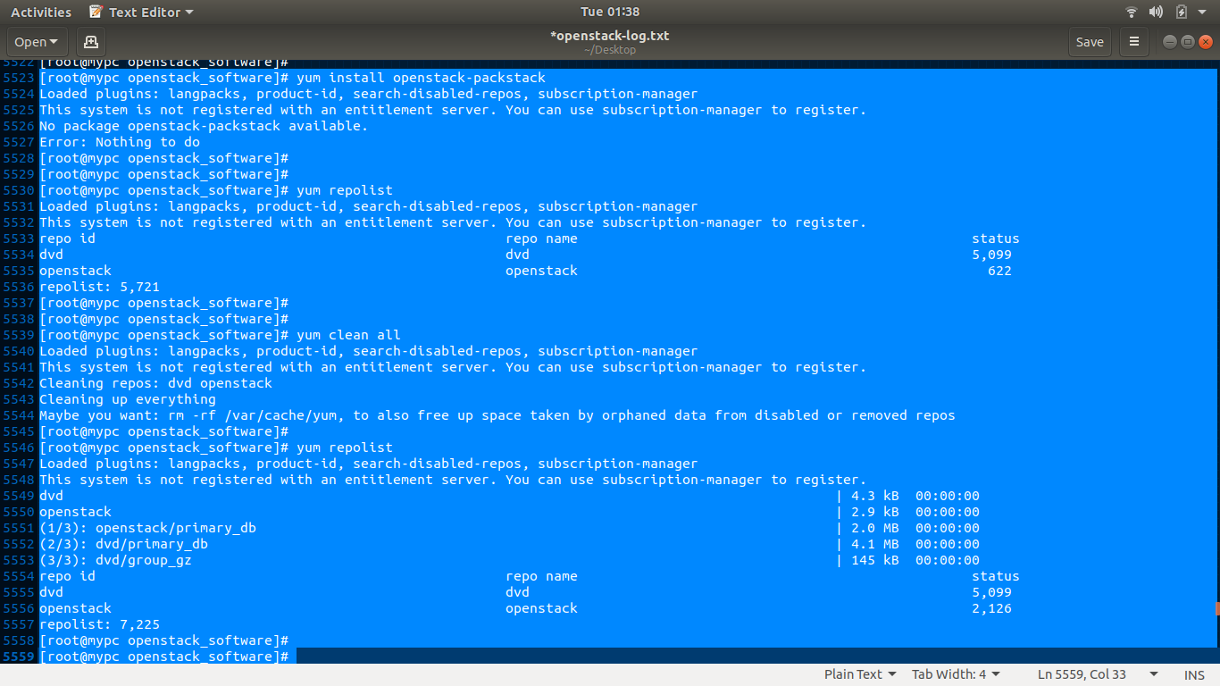

=> Now, install openstack: it will work properly.

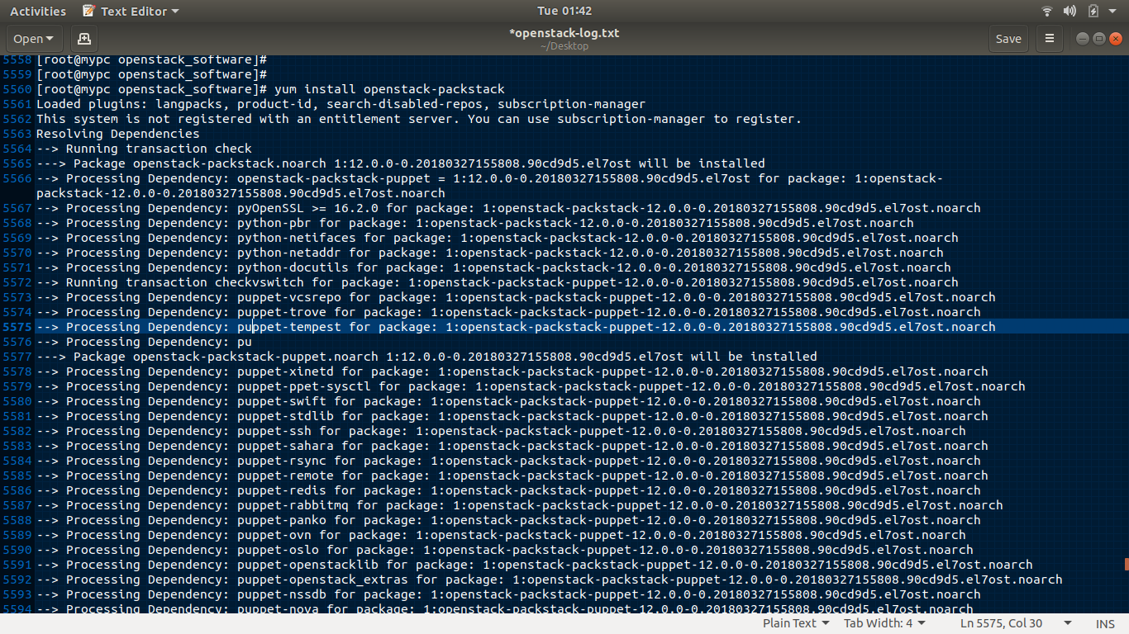

=> Generating openstack-configuration file.

[root@mypc openstack_software]#

[root@mypc openstack_software]# packstack --gen-answer-file=a.txt

Packstack changed given value to required value /root/.ssh/id_rsa.pub

[root@mypc openstack_software]#

=>Setting up host

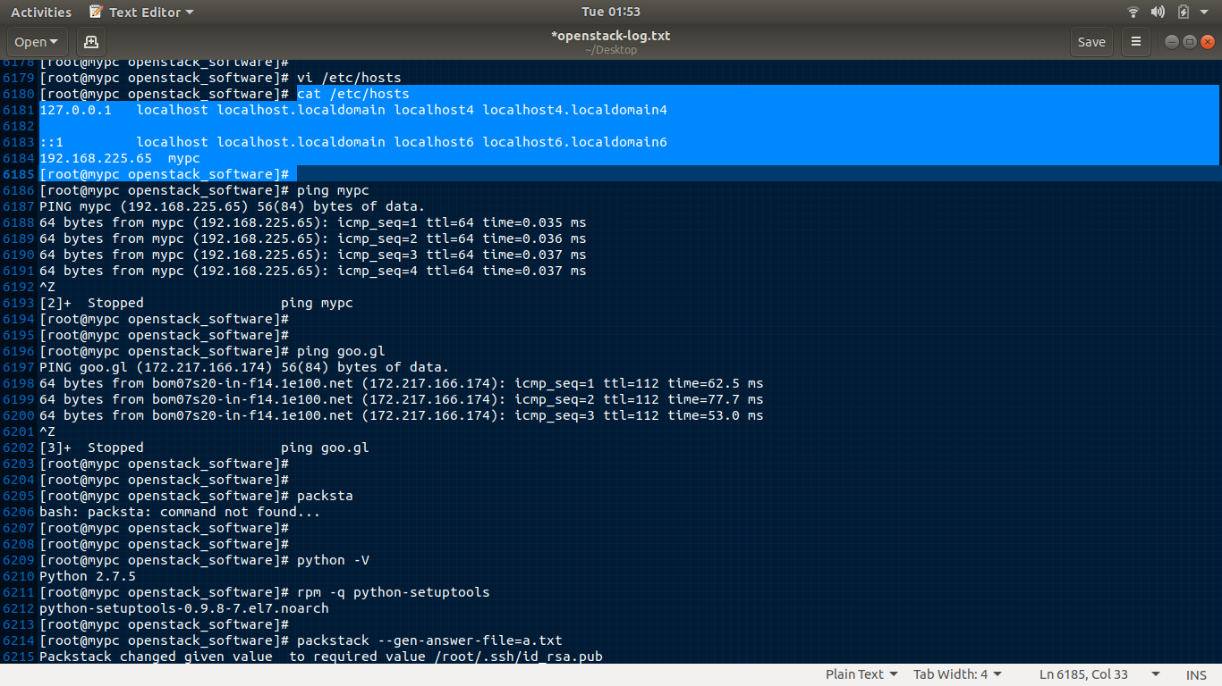

=> Starting openstack cloud:

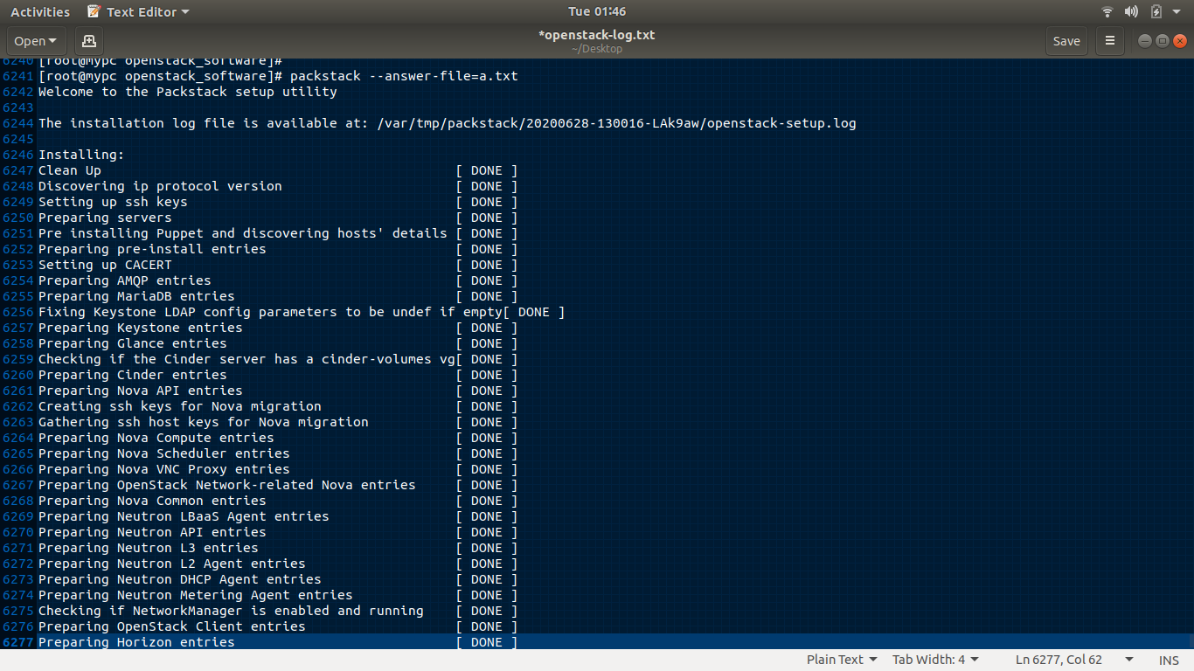

**** Installation completed successfully ******

Additional information:

* Time synchronization installation was skipped. Please note that unsynchronized time on server instances might be problem for some OpenStack components.

* File /root/keystonerc_admin has been created on OpenStack client host 192.168.225.65. To use the command line tools you need to source the file.

* To access the OpenStack Dashboard browse to http://192.168.225.65/dashboard .

Please, find your login credentials stored in the keystonerc_admin in your home directory.

* The installation log file is available at: /var/tmp/packstack/20200628-130016-LAk9aw/openstack-setup.log

* The generated manifests are available at: /var/tmp/packstack/20200628-130016-LAk9aw/manifests

[root@mypc openstack_software]#

[root@mypc openstack_software]#