Relay Human Centred Design Report
Project report
Relay Android interface for remote coding work
CSE4453 Human Computer Interface
Team members and roll numbers to be supplied

1. Introduction

1.1 Project Overview
Relay is an Android interface prototype for people who direct coding agents while away from their main computer. It brings conversations, pull requests, usage information and settings into one mobile navigation system. The prototype focuses on the moments when a developer needs to check progress, understand an agent response or prepare the next instruction without opening a laptop.
The current build is a visual and navigational mockup. A user can move between screens, type a draft, open model settings and save a model choice. It does not run agents, connect to a remote project or store data. The report therefore evaluates the structure and interaction of the interface rather than the reliability of a live coding service.

1.2 Problem Statement
A coding task may continue after its owner leaves a desk. When that person later checks a phone, they need to locate the right conversation, identify the project and understand what the agent has already done. They may also need to decide whether to send a follow-up instruction, review a proposed change or wait for more progress.
Desktop-oriented development tools assume wide screens, keyboard input and sustained attention. Those assumptions do not hold on a phone. Long messages, similar thread names and hidden state can make it hard to tell the difference between a suggestion, a requested edit and a completed build. Relay addresses this problem by keeping thread status, project context and the message composer easy to find.

1.3 Objectives
The main objective is to make active work easy to find and understand on a small screen. The interface should help a user recognize the current thread, see which project it belongs to and review the latest exchange before writing a response. Project context and model selection should remain available at the point where a user prepares a prompt.
A second objective is to give supporting activities predictable locations. Pull requests, usage and settings each have a permanent destination in the bottom navigation. The prototype also aims to use familiar Android controls and readable labels so that users do not have to learn a custom interaction pattern for common actions.

1.4 Scope
This assessment covers the Android interface and its navigation. It includes thread lists, thread detail, a new-thread composer, model settings, pull requests, usage and settings pages. It also covers the visible state needed to demonstrate typed draft text and a saved model choice.
Remote execution, account connection, notifications, data synchronization, authentication and repository access are outside the implemented prototype. The Send control is intentionally nonfunctional. These exclusions keep the project focused on interaction design and prevent the report from presenting a mockup as a working remote-development product.

2. Understanding the Context of Use

2.1 Target Users
The primary users are software developers who already work with coding agents and need to monitor or steer a session from a phone. They are likely to return to the application for short checks between longer desktop work sessions. They need enough context to decide whether a task is progressing, whether an answer needs follow-up and whether the selected conversation is the correct one.
A secondary user is a reviewer who wants to inspect a proposed code change or the history of a request. This user may not write the original prompt, but still needs to understand the project, the thread and the present state of the work. These user descriptions are design assumptions. No participant sample has yet confirmed their frequency of use, experience level or priorities.

2.2 User Environment
The likely setting is a phone used between longer desktop work sessions, such as during a commute, a break or while away from a workstation. Attention may be interrupted, network quality may vary and the available screen area is limited. The user is more likely to scan status, read a short part of a conversation and prepare a response than to inspect source code in detail.
The design treats the remote machine as the place where code and builds remain available. The mobile interface therefore emphasizes orientation rather than dense development controls. Familiar Android navigation, visible labels, plain rows and standard touch controls help the user scan titles, status and project information without needing to remember hidden gestures.

2.3 User Tasks
A typical user opens an existing conversation, checks the latest request and response, then decides whether a follow-up is needed. They may compare several threads for the same project, inspect the current project and branch context, or determine whether an agent has only advised a change or has completed it. These tasks require a clear thread list and a detail view that preserves message order.
When starting work, the user chooses or confirms a project, environment, checkout and branch before writing a prompt. They may change the model used for the thread, save that choice and return to the composer with their draft still visible. They can also move to pull requests, usage or settings through the bottom navigation.

3. User Research

3.1 Personas
The provisional persona is a developer working in a code repository who uses an agent for a focused maintenance task. In the recorded work sequence used for this project, the developer first asked for a header naming rule, reviewed the explanation and later requested a specific header move. The work then required an update to repository guidance. This sequence shows why a thread needs to preserve the relationship between advice, a requested edit and a verified result.
The persona is useful for evaluating whether the interface keeps enough context visible during a short mobile visit. It is not a research-validated representation of all developers who use coding agents. Future interviews should test whether these goals, concerns and task sequences match the experience of developers with different projects, devices and levels of agent use.

3.2 User needs and concerns
The developer may see several conversations for the same project and needs to identify the current one quickly. A useful thread row therefore needs more than a title. It needs a project cue, a recent time or age marker and a state that helps the user decide whether to open it. In the detail view, the order of messages should make it clear what was asked, what was proposed and what later changed.
On a short mobile screen, the difference between advice, a requested edit and a verified build result can be easy to lose. The developer also needs confidence that a new prompt will be sent with the intended project and model. The interface should make these stages and settings visible before the user commits to the next instruction.

4. User Requirements

4.1 Functional Requirements
Users should be able to open a thread from a plain list, return to the list and read the thread detail. They should be able to type into a composer, open model settings from the downward arrow, select a model and save that choice. After saving, the application should return to the composer without discarding the draft text used in the mockup.
The new-thread context should show the project, environment, checkout and branch so that the user can check where a prompt will apply. The four main destinations are Chats, Pulls, Usage and Settings. Each destination should be reachable from the bottom navigation, while detail and settings pages should provide a back action to return to their parent screen.

4.2 Non-Functional Requirements
Text, icons and touch targets should remain legible on a phone at normal viewing distance. Status and selection should be understandable without relying on color alone, because color may be missed in poor lighting or by users with color-vision differences. Bottom-navigation labels should remain visible so that users can recognize destinations without memorizing icons.
The interface should follow common Android expectations where possible. Lists use rows rather than cards so that a list of conversations can be scanned without repeated visual containers. Where Android provides a standard Material control, such as a radio button or switch, the prototype uses it instead of an invented substitute.

4.3 Prioritization
The first priority is the thread list, thread detail and composer because these screens support the core mobile task: finding work, understanding its context and preparing the next instruction. If these three screens are unclear, the rest of the application cannot compensate for the loss of orientation.
Project context and model selection have the next priority because a well-written prompt can still be misleading if it is associated with the wrong project, checkout or model. Pull requests, usage and settings complete the navigation structure and support later checks, but they are less central to the first mobile interaction.

5. Design Solutions

5.1 Information Architecture
The bottom navigation has four destinations: Chats, Pulls, Usage and Settings. Chats contains the thread list and a New thread action. Working and Settled groups organize the list, with Settled collapsed initially to reduce distraction from current work. A selected thread opens a detail page with its conversation and composer.
The composer can lead to Thread settings for model selection. The New thread page also exposes project, environment, checkout and branch controls before prompt entry. Pulls, Usage and Settings are separate top-level destinations rather than hidden tabs inside Chats. Secondary pages use a back action so that the user can retrace where they came from.

5.2 User Flow
To continue work, the user opens Chats, scans the working threads, selects one and reads the most recent exchange. They then type a reply in the composer. This flow keeps the conversation visible before the prompt is prepared, which reduces the chance that the user responds to an outdated or unrelated message.
To begin work, the user taps New thread, confirms the project context, types a prompt and opens the model picker if a different model is needed. The user saves the selection and returns to the composer. The Send control is shown only as part of the mockup and does not contact an agent. Figma was used to arrange this sequence as an editable task-flow map before it was reflected in the prototype.

5.3 Low-Fidelity Sketches
The first layout divided each main screen into a header, a scannable content area and a fixed bottom navigation bar. This arrangement gave the thread list most of the available height while keeping the main destinations in a predictable position. The first version also tested whether a compact row could show a project cue, a conversation title and a state marker without becoming visually crowded.
The new-thread sketch reserved the center of the page for project context and the bottom of the page for checkout information and prompt entry. This made the pre-send context visible before the user reached the composer. These arrangements were carried into the Compose prototype. Separate paper sketches are not part of this submission, so the report treats the early layouts as low-fidelity screen planning rather than a formal paper-prototyping study.

5.4 Wireframes
The implemented screens act as navigable wireframes with realistic typography, spacing and screen hierarchy. Thread rows show project initials, a title, an age marker and a status mark. The detail page separates the user message from the agent response so that the user can follow the sequence of a request and its result.
The new-thread wireframe presents project, environment, checkout and branch information above the composer. Model settings uses radio buttons in a flat list and a Save action. The selected model remains a pending choice until Save is tapped, which gives the user a clear point to confirm or abandon the change.

5.5 High-Fidelity Prototype
The Android prototype uses Material 3 components, standard Android typography, rounded surfaces for the composer and page edges, a blue primary action and persistent navigation labels. The visual treatment separates context, content and actions without turning thread lists into cards. The design keeps list rows compact because the user may need to compare several conversations quickly.
The prototype stores local draft text and model selection state only to demonstrate the interaction. It does not persist work, execute code or load remote data. Figures 1 and 2 show the prompt-context and model-selection screens. They illustrate the screen hierarchy and controls that were considered during the design review.
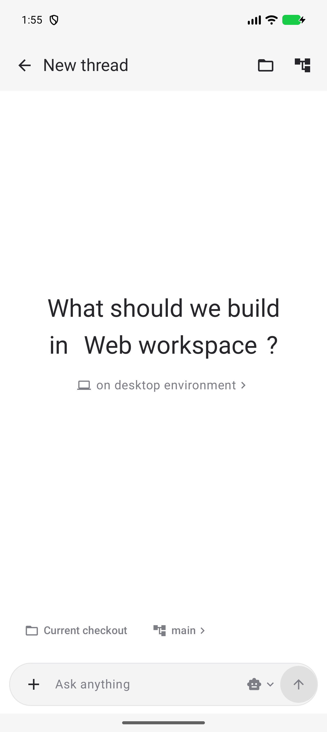  Figure 1 New thread | 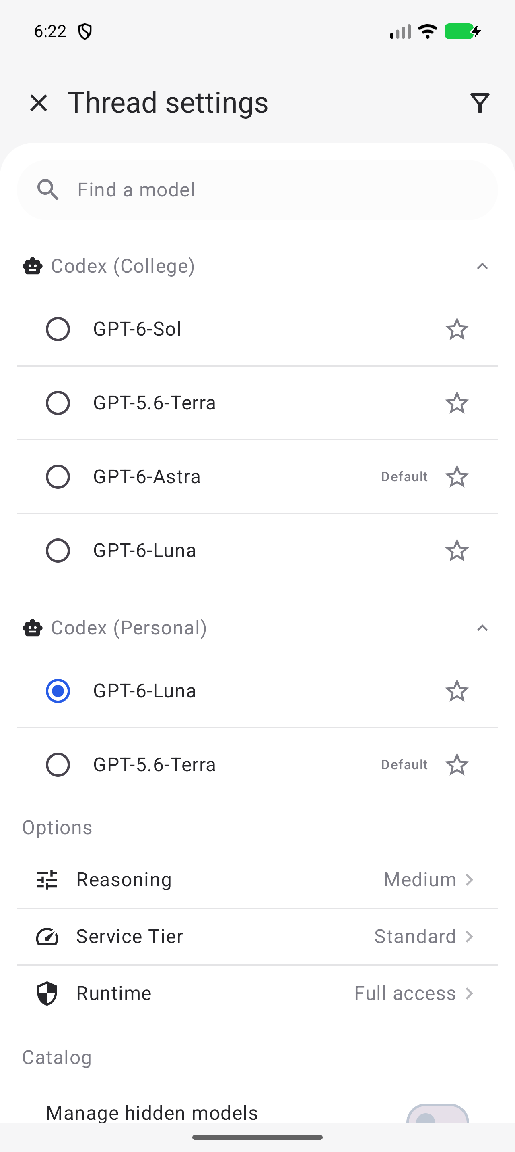  Figure 2 Model settings

6. Human-Centred Design Principles Applied

6.1 Understand Users
The design is based on tasks visible in an existing coding conversation and on the constraints of mobile use. The recorded task moved from a general naming question to a specific change in a C++ repository. The user needed to understand advice, request an edit and later see that the repository guidance had changed. This made thread continuity and clear project identity important inputs to the design.
The project did not treat the recorded conversation as proof that every user behaves in the same way. Instead, it used the sequence to identify interface questions that need validation, such as how much status should be visible in a list row and whether the context shown before a new prompt is sufficient.

6.2 User Involvement
Direct feedback changed the prototype during development. The user requested a Settled section that starts collapsed, permanent bottom-navigation labels, a dedicated Pulls destination, standard Android controls and an editable text field. Each request pointed to a specific place where the initial screen behavior or control choice did not match the user's expectation.
The design was revised in response. The settled group now opens only when requested, the navigation uses visible labels, and settings use familiar Material controls. This feedback is valuable design review because it occurred while the prototype was being changed. It is not a formal user study, so the report does not make general claims about satisfaction or efficiency.

6.3 Iterative Design
The first mockup was revised after review of the screen layout and navigation. The bottom area changed from a floating treatment to a standard Android navigation bar. The second destination was narrowed to Pulls rather than a broader project area, and extra headings that repeated the destination label were removed. These changes reduced visual noise and made the navigation match its intended purpose.
The new-thread screen later gained a centered project prompt, an environment link and a checkout row. The model arrow now opens settings, while a selection remains pending until Save. The thread example was also replaced with material from the C++ header-path session so that the interface demonstrates a coherent task rather than an unrelated placeholder.

6.4 User Evaluation
Build and emulator checks confirm that the main screens open, the composer accepts text, the model picker opens and a saved choice returns to the composer with the draft intact. These checks verify that the intended navigation and visible state are present in the prototype. They also helped detect issues such as an unclear composer hint and the need for an explicit model-settings action.
The checks do not measure usability. No timed task study, participant observation, error analysis or satisfaction survey has been run. A later evaluation should use representative developers and realistic prompts before the project claims that the flow is efficient, understandable or preferred over another arrangement.

6.5 Whole User Experience
The prototype treats a coding task as a sequence across screens: discover a thread, read its context, prepare a prompt, check the project and model, then send when ready. The screen structure avoids treating each page as an isolated feature. For example, the model setting returns to the composer because the user needs that decision while composing an instruction.
Consistent bottom navigation supports movement among ongoing work, review, usage and settings. The prototype does not yet cover the entire end-to-end experience. Remote connection, notification behavior, error recovery, offline use and the presentation of live task progress still need design and testing.

7. Design Evaluation

7.1 Heuristic Evaluation
A limited inspection checked visibility of system state, consistency with Android conventions and recognition rather than recall. Visible tab labels, selected radio buttons and a dedicated Save action help the user understand where they are and what will change. The thread list exposes titles, project cues and age markers so that users do not have to remember a thread only from its icon.
The inspection also checked whether controls communicate their purpose. The composer is editable rather than a static label, and the downward arrow leads to model settings. The main limitation is that several secondary screens are illustrative and cannot demonstrate live remote-task states, loading behavior or error messages.

7.2 Usability Testing
No participant usability test has been completed. The existing build and emulator checks should not be interpreted as a substitute for observing people use the interface. They only show that the current mockup can present the planned screens and retain local interaction state.
A future study should ask developers to find a particular thread, explain whether an edit was completed, compose a follow-up and change the model. The study should record task completion, wrong turns, hesitation and comments about missing context. Comparing those observations across participants would show which parts of the flow require revision before making claims about ease of use.

7.3 Issues Identified
Earlier versions treated the prompt hint as if it were a static label, which did not communicate that the user could type there. The down arrow also did not clearly indicate that it led to model settings. The revised build uses an editable field and a clear model-selection action, then returns to the composer after the model choice is saved.
Other issues concerned information hierarchy. The settled list initially competed with active work, the bottom navigation labels were not always visible, and an unrelated thread example weakened the realism of the prototype. The current version addresses these points, but placeholder secondary pages and nonfunctional send behavior remain visible limits.

8. Design Improvements
The thread list no longer starts with an unrelated example. It now uses a real header-path conversation that moves from naming advice to a specific header relocation and a documentation update. This provides a clearer example of how a developer may return to a thread and distinguish an early discussion from later completed work.
The Settled group starts closed so that active conversations receive attention first. Bottom-navigation labels remain visible, and Pulls has its own destination. Appearance uses standard radio controls. The new-thread page places project and environment context above the composer, while the model picker shows that a selection is pending until Save confirms it.

9. Final Prototype
The final artifact is a navigation-only Android mockup named Relay. The main flow can be explored on the emulator, including text entry and model choice. The application presents the key screens that a developer would use to check ongoing work, review a conversation and prepare a new request while away from the main development machine.
The conversation example follows a real sequence: header naming advice, a requested move to kernel/interrupts/exceptions.hpp and an update to repository coding guidelines. This gives the thread detail enough specificity to evaluate its message hierarchy. The prototype should still be treated as a design artifact until live remote behavior and usability have been tested. Figures 3 and 4 show the conversation list and thread detail. Figures 5 and 6 show the Usage and Settings pages.
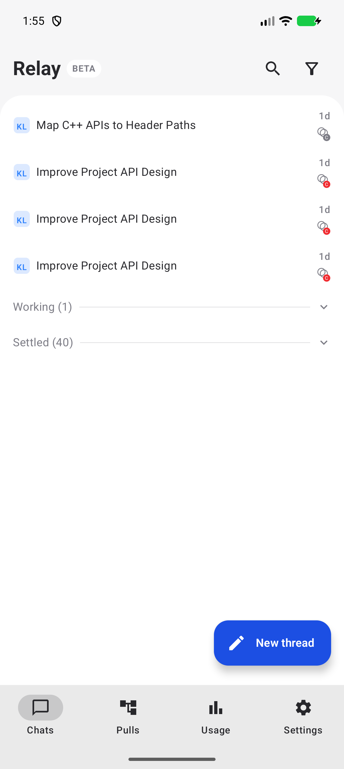  Figure 3 Chats | 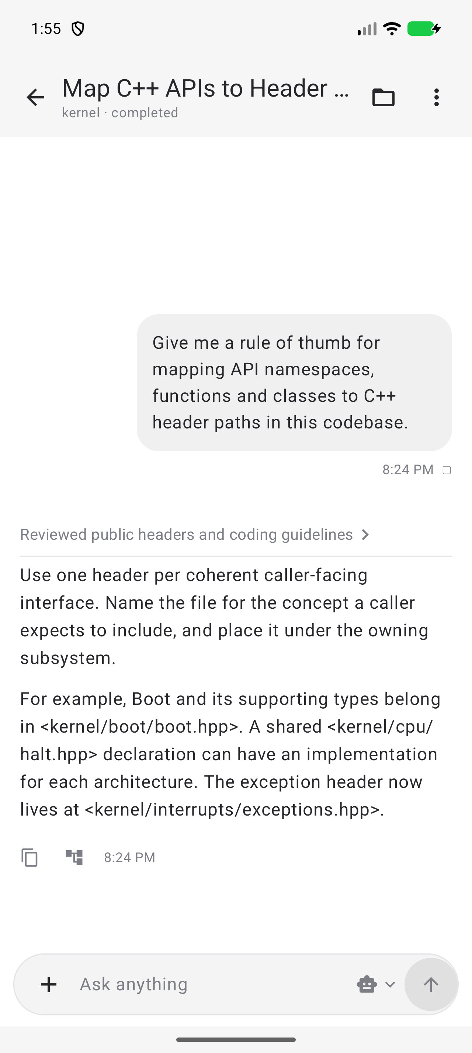  Figure 4 Thread detail

9.1 Usage and settings screens
The Usage page gives the user a short view of cost, token and limit information over a selected time period. The Settings page groups account, environment, notification, appearance and chat controls so that configuration tasks do not interrupt the conversation flow. Both pages remain available through the labelled bottom navigation.
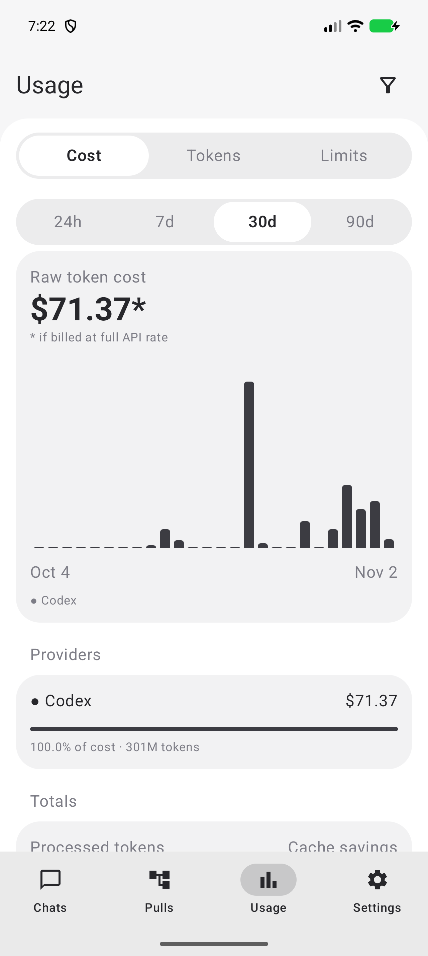 | 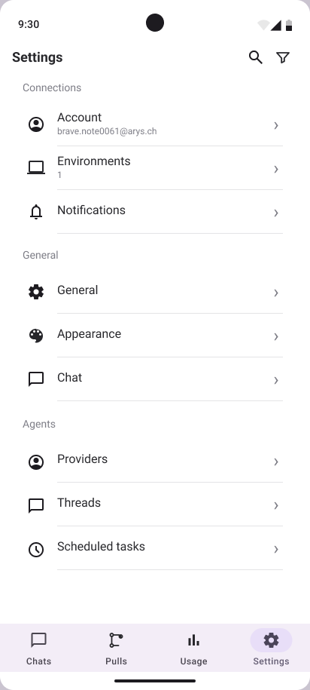
Figure 5 Usage page | Figure 6 Settings page

10. Conclusion
Relay makes a mobile coding-agent workflow concrete enough to review. The current screens show how a developer can find work, inspect project and conversation context, prepare a prompt and change the selected model. The design uses visible navigation labels, compact list rows and familiar Android controls to support brief mobile interactions.
The strongest evidence so far is successful emulator interaction and direct design feedback. This evidence supports the feasibility of the screen flow, not a claim that the interface has been proven easy to use. The next step is a participant study with realistic tasks, followed by revisions to remote-state presentation, error recovery and notifications.
A practical next iteration should connect the interface to representative remote-task states, including queued work, completed work, failures and requests for clarification. It should also explain what happens when the phone has no connection or when a model selection cannot be saved. These cases are part of the user experience because they affect whether the user can trust the status shown on a small screen.
This report documents the present design decisions, the evidence that informed them and the limits of that evidence. It provides a basis for a more formal evaluation rather than a final claim of usability. Testing the next prototype with developers will show whether the current hierarchy, labels and context cues support the intended mobile tasks.

