**Experiment -7**

**Sequence Diagram**

Sequence Diagram and collaboration diagram are called INTERACTION DIAGRAMS. An interaction diagram shows the interaction consisiting of set of objects and their relationship including the messages that may be dispatched among them.

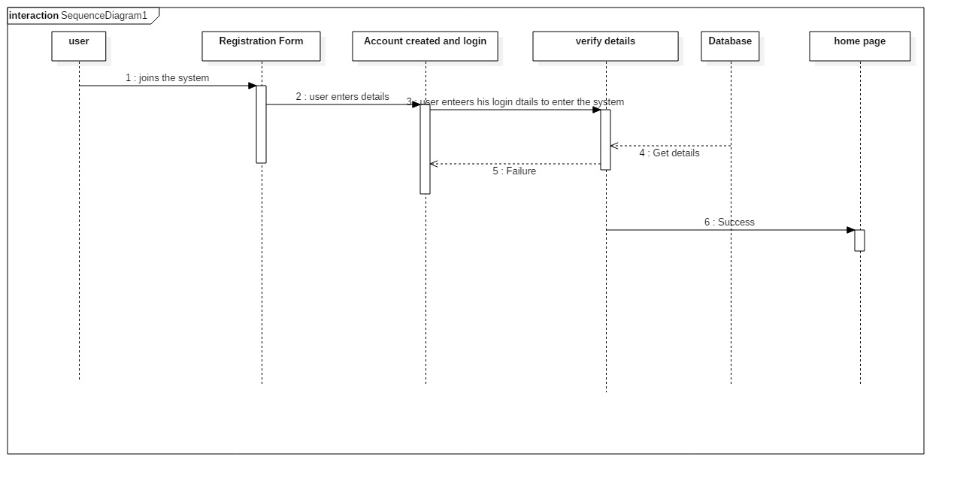sequence diagram for Login and registration

**Diagram Description:**

The user is directed to the registration page on entering the system. He creates his account which gets verified. Now to login, the user enters his details, the verifier module verifies them and if correct user is directed to the home page.

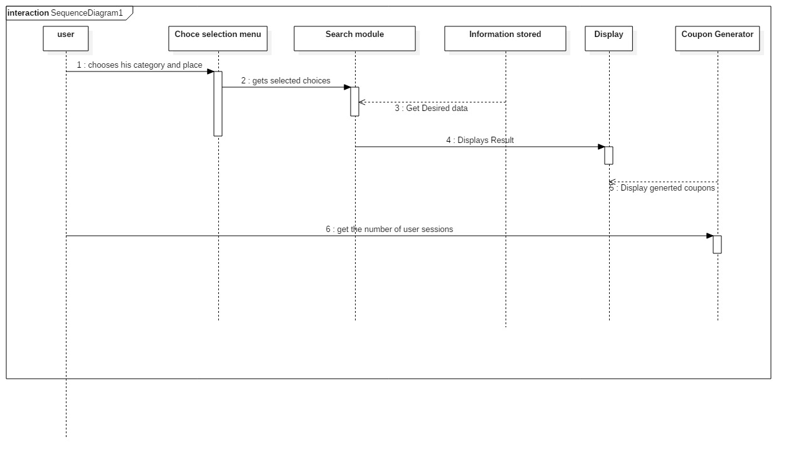Sequence diagram for City Guide System

**Diagram Description:**

The user selects his choice and area. The database is searched for the desired results. The results are displayed on the Display screen. Session tracker counts the number of user sessions and if he is an old user then he is granted coupons.