**No WMC**

Complete cases N = 395

D'Agostino Normality Test

Age: omnibus sig. because of kurtosis – do not transform

WA: omnibus sig. – transform

LWID: omnibus sig. – transform

WASI MR: omnibus sig. – transform

WASI vocab – omnibus n.s. – do not transform

\*\* but, no transformations now!

M1: m1 <- lm(wj3.rcomp.ss~age+wj3.watt.raw+wj3.wid.raw+wasi.matr.raw+wasi.vocab.raw, data=sct\_data)

Coefficients:

Estimate Std. Error t value Pr(>|t|)

(Intercept) 102.7949 0.4083 251.789 < 2e-16 \*\*\*

age -0.2045 0.4346 -0.471 0.638

wj3.watt.raw 0.2257 0.6265 0.360 0.719

wj3.wid.raw 3.7025 0.7978 4.641 4.75e-06 \*\*\*

wasi.matr.raw 2.3293 0.5045 4.617 5.29e-06 \*\*\*

wasi.vocab.raw 4.7696 0.6073 7.853 3.99e-14 \*\*\*

---

Signif. codes: 0 ‘\*\*\*’ 0.001 ‘\*\*’ 0.01 ‘\*’ 0.05 ‘.’ 0.1 ‘ ’ 1

Residual standard error: 8.114 on 389 degrees of freedom

Multiple R-squared: 0.5798, Adjusted R-squared: 0.5744

F-statistic: 107.4 on 5 and 389 DF, p-value: < 2.2e-16

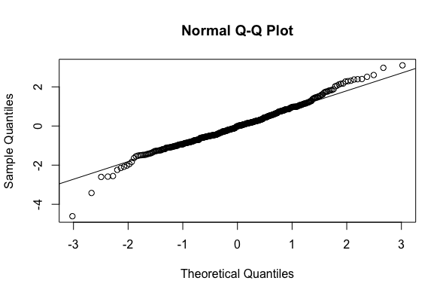

CIs used: 65% below = UPC, within 15% = EAC, 65% above = UGC

Group quantities:

EAC: 67

UPC: 62

UGC: 65

NSC: 201

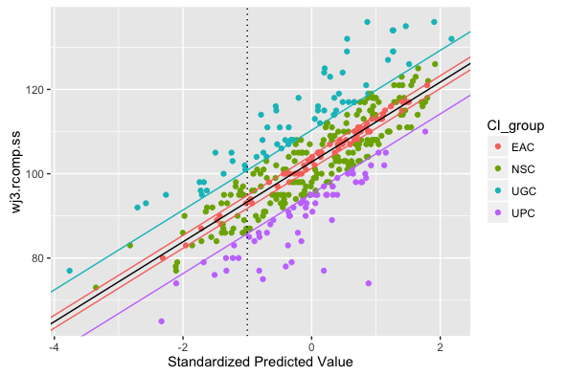

By Grant:

|  |  |  |  |
| --- | --- | --- | --- |
|  | **A182** | **A197** | **A40-4** |
| **EAC** | 23 | 32 | 12 |
| **NSC** | 50 | 113 | 38 |
| **UGC** | 17 | 32 | 16 |
| **UPC** | 9 | 31 | 22 |

Characteristics:

|  |  |
| --- | --- |
| **Passage comp**  UPC lower than EAC, *p*  <.001 | **Word Attack**  UPC = EAC, *p* = .43 |
| **Macintosh HD:Users:Kayleigh:Dropbox:Misc Analyses:Definition_of_PCs:Classifier:passagecomp_may11.png** | Macintosh HD:Users:Kayleigh:Dropbox:Misc Analyses:Definition_of_PCs:Classifier:WA_may11.png |
| **Matrix Reasoning**  UPC marginally lower than EAC, *p* = .06 | **Letter-word**  UPC lower than EAC, *p*  = .048 |
| **Macintosh HD:Users:Kayleigh:Dropbox:Misc Analyses:Definition_of_PCs:Classifier:MATR_May11.png** | Macintosh HD:Users:Kayleigh:Dropbox:Misc Analyses:Definition_of_PCs:Classifier:LWID_may11.png |
| **WASI Vocab**  UPC lower than EAC, *p* = .046 | **Age**  UPC = EAC, *p* = .29 |
| Macintosh HD:Users:Kayleigh:Dropbox:Misc Analyses:Definition_of_PCs:Classifier:vocab_may11.png | Macintosh HD:Users:Kayleigh:Dropbox:Misc Analyses:Definition_of_PCs:Classifier:age_may11.png |

**With WMC**

Complete cases N = 357

D'Agostino Normality Test

Age: omnibus sig. because of kurtosis – do not transform

WA: omnibus sig. – transform

LWID: omnibus sig. – transform

WASI MR: omnibus sig. – transform

WASI vocab – omnibus n.s. – do not transform

SSpan – omnibus sig. -- transform

\*\* but, no transformations now!

M1: m1 <- lm(wj3.rcomp.ss~age+wj3.watt.raw+wj3.wid.raw+wasi.matr.raw+wasi.vocab.raw+sspan.raw, data=sct\_data)

Coefficients:

Estimate Std. Error t value Pr(>|t|)

(Intercept) 1.028e+02 4.173e-01 246.300 < 2e-16 \*\*\*

age 9.454e-03 4.433e-01 0.021 0.98300

wj3.watt.raw 2.587e-01 6.523e-01 0.397 0.69192

wj3.wid.raw 3.350e+00 8.454e-01 3.963 8.97e-05 \*\*\*

wasi.matr.raw 1.550e+00 5.409e-01 2.866 0.00441 \*\*

wasi.vocab.raw 4.186e+00 6.553e-01 6.387 5.38e-10 \*\*\*

sspan.raw 2.030e+00 5.668e-01 3.582 0.00039 \*\*\*

---

Signif. codes: 0 ‘\*\*\*’ 0.001 ‘\*\*’ 0.01 ‘\*’ 0.05 ‘.’ 0.1 ‘ ’ 1

Residual standard error: 7.886 on 350 degrees of freedom

Multiple R-squared: 0.6024, Adjusted R-squared: 0.5956

F-statistic: 88.38 on 6 and 350 DF, p-value: < 2.2e-16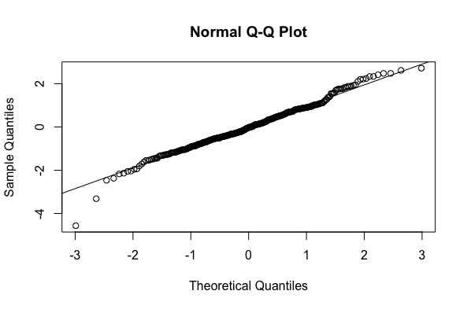

CIs used: 65% below = UPC, within 15% = EAC, 65% above = UGC

EAC: 51

UPC: 56

UGC: 52

NSC: 198

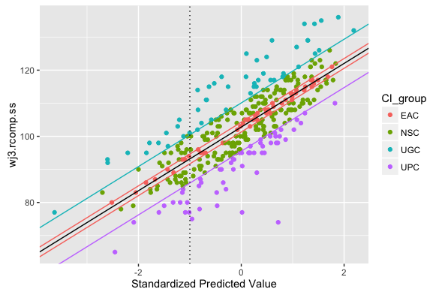

By Grant:

|  |  |  |  |
| --- | --- | --- | --- |
|  | **A182** | **A197** | **A40-4** |
| **EAC** | 11 | 31 | 9 |
| **NSC** | 45 | 109 | 44 |
| **UGC** | 12 | 29 | 11 |
| **UPC** | 6 | 34 | 16 |

Characteristics:

|  |  |
| --- | --- |
| **Passage comp**  UPC lower than EAC, *p*  <.001 | **Word Attack**  UPC = EAC, *p* = .32 |
| **Macintosh HD:Users:Kayleigh:Dropbox:Misc Analyses:Definition_of_PCs:Classifier:passage comp_may11_2.png** | **Macintosh HD:Users:Kayleigh:Dropbox:Misc Analyses:Definition_of_PCs:Classifier:WA_may11_2.png** |
| **Matrix Reasoning**  UPC = EAC, *p* = .18 | **Letter-word**  UPC = EAC, *p*  = .26 |
| **Macintosh HD:Users:Kayleigh:Dropbox:Misc Analyses:Definition_of_PCs:Classifier:MATR_may11_2.png** | **Macintosh HD:Users:Kayleigh:Dropbox:Misc Analyses:Definition_of_PCs:Classifier:LWID_may11_2.png** |
| **WASI Vocab**  UPC = EAC, *p* = .17 | **Age**  UPC = EAC, *p* = .60 |
| **Macintosh HD:Users:Kayleigh:Dropbox:Misc Analyses:Definition_of_PCs:Classifier:WASI_Vocab_may11_2.png** | **Macintosh HD:Users:Kayleigh:Dropbox:Misc Analyses:Definition_of_PCs:Classifier:age_may11_2.png** |
| **Sentence Span**  UPC = EAC, *p* -.20 |  |
| **Macintosh HD:Users:Kayleigh:Dropbox:Misc Analyses:Definition_of_PCs:Classifier:span_may11.png** |  |