


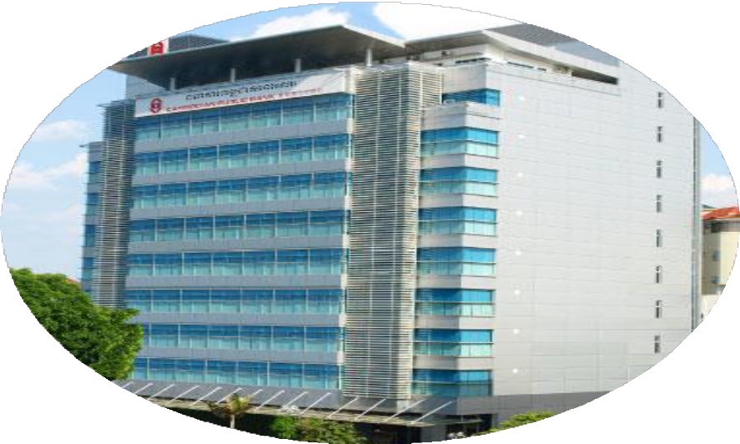
F I N A L

R E P O R T 2 0 2 3

PREPARED BY SOPHAL VANDA WEB 2023 A

Passerelles numériques Cambodia Street 371 Phum Tropeang Chhuk (Borey Sorla), Sangkat Tek Thla Khan Sek Sok P.O. Box 511 Phnom Penh, Cambodia
Tel: +855 23.99.55.00
info.cambodia@passerellesnumeriques.org

INTERNSHIP FINAL REPORT

Name: Sophal Vanda WEB 2023 A
Tutor: Him Hey

Supervisor: Khim Kuntha
Email: khimkuntha@gmail.com Tell: 099300007

Internship performed at Cambodian Public Bank



Date: 01 August 2023 to 30 November 2023

Table of Contents
Acknowledgment II
- INTRODUCTION..................................................................................................... - 1 -
- COMPANY OVERVIEW ............................................................................................ - 1 -
  - COMPANY HISTORY..........................................................................................- 1 -
  - company DESCRIPTION .......................................................................................- 2 -
  - Team roles .........................................................................................................- 2 -
- INTERNSHIP EXPERIENCES ................................................................................... - 4 -
- .1 ACTIVITIES ...........................................................................................................- 4 -
  - INTERNSHIP DETAILED DESCRIPTIONS .....................................................................- 5 -
  - TECHNICAL SKILLS LEARNED/APPLIED DURING INTERNSHIP .......................................- 6 -
- PERSONAL REFLECTION ........................................................................................ - 6 -
  - SKILLS LEARNED/APPLIED DURING INTERNSHIP ........................................................- 6 -
  - PROBLEM SOLVING .................................................................................................- 7 -
  - FUTURE CAREER ....................................................................................................- 7 -
- CONCLUSION......................................................................................................... - 8 -
  - FIVE YEAR PLAN......................................................................................................- 8 -
  - RECOMMENDATION .................................................................................................- 8 -
  - FEEDBACK AND SUGGESTION ..................................................................................- 9 -
- APPENDIX ............................................................................................................. - 9 -
  - WEEKLY WORKLOG .............................................................................................- 9 -
  - THANK LATER ................................................................................................... - 10 -
  - Organization chart................................................................................................. - 11 -

Acknowledgment
I would like to express my heartfelt gratitude and appreciation to all those who have contributed to the success of my internship. It has been an incredible learning experience, and I am truly grateful for the support and guidance I have received throughout this journey.
The first, I want to take a moment to express my heartfelt thanks for everything you have done for me. Your love, sacrifices, and unwavering support have shaped the person I am today. I am forever grateful for the opportunities you have provided and the values you have instilled in me. Your belief in me has given me the confidence to pursue my dreams. Thank you for being my heroes and for always being there for me.

Secondly, I want to express my heartfelt thanks to PNC for the study program that provide me 100% of scholarship include allowance, living, transportation, food, professional skills and internship opportunities that have played a vital role in shaping my educational and professional growth. The knowledge, skills, and experiences gained during my time at the school have prepared me for future endeavors and have laid a strong foundation for my career. I am incredibly grateful for the dedication, support, and guidance of the faculty and staff who have made this possible.

Third, I would like to thank Cambodian Public Bank for providing me with the opportunity to be a part of their team and for allowing me to gain practical knowledge and hands-on experience in my field of interest. I am grateful for the trust and confidence placed in me during my time as an intern.
I would like to extend my sincere appreciation to my supervisor, Mr. Khim Kuntha and my tutor, Mr. Him Hey, for their constant guidance, mentorship, and support. Their expertise, patience, and willingness to share their knowledge have been invaluable in enhancing my understanding of the industry and developing my professional skills. I am grateful for the time they invested in me and for their constructive feedback, which has helped me grow both personally and professionally.

Finally, I would like to thanks to all of them that help me during internship I have descript and mention above.

- INTRODUCTION [5 points] – 1 page max.

Write an introduction of your internship including:
- A short description of your company
- The duration and location of your internship
- Your personal objectives and expectations of the internship? What did you want to accomplish and learn from your internship when you started it?
Cambodian Public Bank Plc (Campu Bank) commenced its business in Cambodia on 25 May 1992. It presently has 32 branches: 20 in Phnom Penh, 2 in Siem Reap, 1 each in Battambang, Bavet, Kampong Cham, Kampong Speu, Kampot, Koh Kong, Paoy Paet, Preah Sihanouk, Suong and Takhmao. Campu Bank is a wholly-owned subsidiary of Public Bank Group which is one of the largest and strongest domestic banking groups in Malaysia. For my internship program at Campu Bank is four months that start from 1 August 2023 to 30 November 2023 and stay at Sangkat Phsar Thmey 2, Khan Daun Penh, 23 Kramuon Sar St. (114), Phnom Penh. For this internship program, I want to know the real workflow and the process of working at company about how they do and learn the new programming language to increase my skills
more in a real working environment and become a real programmer.

- COMPANY OVERVIEW [15 points] – 2 pages max.

  - COMPANY HISTORY [5 POINTS]

Describe the history of your company: Where, When, Why, and How was your
company created?
Cambodian Public Bank is stay at Sangkat Phsar Thmey 2, Khan Daun Penh, 23 Kramuon Sar St. (114), Phnom Penh that its Head office. Campu Bank created in Cambodia on 25 May 1992 that in Banking industry. Campu Bank is committed to be the premier bank in providing the most courteous and efficient service in every aspect of its business, and by being innovative in providing financial solutions to its customers, and the development of new banking products and services. Campu Bank
created to help people in Cambodian by saving, load and solve their financial that

make many branches to make it easy for all customers in 32 branch that they can to go Campu Bank that near their house or their area.

  - COMPANY DESCRIPTION [5 POINTS]

- What is the sector of your company?
- Which problems is it solving?
- Which services/products does it offer?
- Who are its customers?
Campu Bank is a wholly owned subsidiary of Public Bank group, which is one of the largest and strongest domestic banking groups in Malaysia. Which problems that it’s solving such as Core banking, financial, Insurance, Loan, Credit Card, remittance and ODT and make many branches in Cambodia that stay nearby customer to make customers easy to find and help customers on time. Public Bank group offers a wide range of banking and financial services. And their customer is providing for people
around Cambodia and around oversea.

  - TEAM ROLES [5 POINTS]

- Describe 3-4 important people and their roles/tasks in your company or/and your team
- How did you work with them?
Cambodian Public Bank has a big environment and has a lot of staff. All staffs of Cambodian Public Bank need to wear uniforms properly it’s a part of their role Staff need to respect that they need the environment look like professional and get trust from customers because it’s very import that all staff at the bank need to build and collaborate with bank policy. One more thing, all staffs at Cambodian Public Bank need to work hard that go to office early and leave from office late as much as possible because in there has a lot of tasks or work to complete it on time and submit to Head of IT and other branches or customers. All staffs working by focus on their tasks and very work hard that they don’t care about the time arrive and time to leave from work. They always stay late to complete their tasks even though they know it’s time
to go home. They have responsibilities on their tasks and try to complete it faster as

much as they can. There is the part of their responsible that they need to do every day. Especially, they have their own role and responsible in the company. The important people in Cambodian Public Bank of IT Department there are:
    - Mr. Ung Mongheng (Head of ITD): He is a manager of the IT department that manages all IT staff at Campu Bank, he works with other branches and with Public Bank in Malaysia and divides tasks or work among IT staff related to their role. Especially, he checks and observe to all team in IT Department which they complete tasks on time or not and he is an approver for all tasks before and after team will do or done.
    - Mr. Huy Bonda: He is assistant manager. He responded to the works after head of ITD. He does on IT security and he is an approver also when Head don’t stay at office or absence from work. One more thing, he needs to check my weekly worklog before I submit to my tutor to make sure the content or the word is correct with the meaning.
    - Mr. Khim Kuntha: He is a Senior Application Support Officer. He needs support when application is meet the problem and get the phone from others department call to tell the problem with application and then he must to check and fix it and update the application also.
    - Mr. Rath Sopha: He is a Web Programmer at Cambodian Public Bank. He response his tasks that provide my supervisor.
Mr. Ung Mongheng
Head of ITD
Mr. Huy Bonda
Assistant Manager

Mr. Khim Kutha
Senior Application Support Officer

Mr. Rath Sopha
Web Programmer
Mr. Sophal Vanda
Internship
Mr. Bet Chamnan
Internship

- INTERNSHIP EXPERIENCES [30 POINTS] – 3 pages max.
- .1 ACTIVITIES [5 POINTS]

List down all activities you carried out during your internship
The activities I was do during the internship there are:
- Kick off meeting: I need to join a kick-off meeting with Head of IT Department and my supervisor that he explained about the project that I will do it to know the requirement and know the purpose of project. Especially, he explained the step to complete a project.
- Analyze project: Before I start to do my project, I need to analyze the project again first. In these activities, I need to write a description of the project about what this project does. One more thing, I must to find the content that will contribute with this project and list down in a document to make it easy to update and create timeline on it.
- Analyze Database: The database is an important part in this project because I need to do it with a database for storing data of those project. I had analyzed database by read the description of project that I wrote it before this step to find table name, attribute of each table and make relationship of each table as ERD.
- Design mock up screen: Before I start the project by coding, I need to design the mock up screen first because it’s very important for programmers. I had done all mock up screen and all feature that contribute with this project there are login page, home page, dashboard page that those are the big page in this project.
Start Coding:
- Research how to use Microsoft Visual Studio: Because it’s a new tool for me to write
code.
- Research how to create project C# on Microsoft Visual Studio and created the project for my coding.
- Research how to add new folder and file that related with process of MVC in
Microsoft Visual Studio’s tool and C# (Programming language).
- Research how to use Microsoft Sql Server.

- Research how to create database name, table name and make relationship of each table on Microsoft Sql Server.
- Research how to connect database in C# to Microsoft Sql Server.
- I start coding of my project by the tasks that I list down before.

  - INTERNSHIP DETAILED DESCRIPTIONS [20 POINTS]

Focus on 1 main activity and describe it in details based on information below.
- What problems/needs does the activity resolve?
- What steps are needed to complete the activity above? (Ex : analysis, design, implementation, presentation)
- What is the result of the activity?
During my internship, I have done many activities that I list down above and the main activity is coding by using C# that it’s a new language that I need to do it in my project provide by supervisor. The problem is don’t know how to start coding with using C# language and don’t know the folder structure of C# project that it’s very important for me know the process of MVC and which file for what. Event thought, it’s the problem for me but have commitment to start with them by research first to find any solutions from internet by read document that has on internet and one more thing I start watch video from YouTube to see the creator teach for beginner and especially I asked to senior Sopha and supervisor for help. For steps are needed to complete the activity that I descript above there are I need to research for find any document to read for guiding me from internet and after finished research on each, I need to create two projects in C# that one for test before coding according to requirement. After I created two projects C#, in one project I need to write any code to test and make sure it can run on browser, can write as html code with display style CSS and can add more folder and file match with MVC that have file for View, Controller and Model. When I already test code on project test is working and success, I need to start coding in real project that I got from my supervisor and already analyze it. After that I need to connect it with database for store all data in database that it can insert, update, delete, etc. When my code as html and style CSS and connection with
database is working and success, I need to continue it by follow my task that already

list before start it. During my coding if I have the problem or any errors that can’t display data or show message errors, I need to fix by review my code to find the place that it errors, read the message errors because it can help me easy to find the problem and try to research to find the other way to resolve problem or do it again in other way that I had found from internet. One more thing, I asked my supervisor to get sample code to review it and follow his code. Those the steps that I need to complete my activity is coding. Exactly, after I’m coding by my descript above, I can did it on what I want.

  - TECHNICAL SKILLS LEARNED/APPLIED DURING INTERNSHIP [5 POINT] -
80 – 120 WORDS

Which technical skills did you learn and/or apply during your internship? Describe how
you learnt and applied your skills during your internship. (Use your real example)
During my internship, I have applied some skills that I learned from school to
the company such as analyzing projects by writing the descriptions for problems and solutions like proposals in VC that I have done with team. One more thing I wrote the user stories that I have learned at PNC before start the VC project that train by teacher in PNC. In addition, I have applied one more skill about analyze database and create mock up screen before start project also. I have applied it in my project that provide by supervisor and he provide the workflow for do a project success and correct with the real work in company, so I applied the point that I descript about to my project. On the other hand, I have an opportunity to learn new programming language. Those programming language is C# that I didn’t learn it before and I have a project to do by
using C#. This project talks about Control link System project.

- PERSONAL REFLECTION [15 POINTS] - 80 – 120 words

  - SKILLS LEARNED/APPLIED DURING INTERNSHIP [5 POINT]
What professional skills did you learn and/or apply during your internship? Describe how you learnt and applied your skill during your internship. (Use your real example)

During my internship at Cambodian Public Bank, I learned soft skills there are time management and task management. I always go to work early and commit to completing tasks following the timeline that I already set in a document and learn how to create a timeline effectively that is guided by Head of ITD to increase my soft skills that it’s a step before tasks become successful. One more thing, I always complete my tasks with responsibilities and follow by tasks that I already analyze with user story of each task. Especially, I have learned and applied my communication with team work and supervisor by ask them when I don’t understand something and don’t clear the purpose of project want. And one more thing, I have applied my communication in the workplace by non-verbal communication and verbal communication.

  - PROBLEM SOLVING [5 POINT] - 80 – 120 WORDS

What difficulties have you encountered during your internship? And how did you solve
them? (Use your real example)
The problem that I encountered during my internship was learning C# that it’s a new programming language I never meet. The big problem in C# is login with window authenticate (AD) and compare login with data in database ft AD also. In this problem I have solve it by try to research on internet to find any document that talk about it and read it to get the idea for guide me to do it. One more thing, I watched video in YouTube to look the developer do it and get the step to do it. After I already explore it, I need to do it on my project. During I’m coding about that and it didn’t work, I try to explore it again from internet and especially I asked to my supervisor to get sample
code about those function.

  - FUTURE CAREER [5 POINTS] - 80 – 120 WORDS

- Before starting your first job, what technical and professional skills do you need to develop?
- How do you plan to develop them?
Before starting my first job, I needed to develop both of my skills there are technical
skills and professional skill. For technical skills, I need to improve PHP, JavaScript, Vue JS, CSS, C# and Node JS because it’s very popular that many company use it include

Campu Bank (use PHP). I have improved technical skills above by review the lesion on each language and try to practice it more and more. For my professional skills, I need to improve task management because I have commitment to complete tasks on time and can complete tasks effectively.

- CONCLUSION [5 points] maximum 1 page
  - FIVE YEAR PLAN

What is your five-year plan after PNC? (Education, and Career Plan)
My five-year plan after PNC is I have a plan for education and my career in the future. For my education I set, I need to continue my studying for a bachelor’s degree in Web programming at a university in Cambodia or other countries (if I get a scholarship) and finish it successfully to get certification for update my background it is very important. For my career, I have plan and commit to develop myself every day on technologies and
learn new technologies and get high level as Senior Web Developer at a company.

  - RECOMMENDATION

Would you recommend the next generation of PNC students to intern at this company?
If yes, why? Or if no, why not?
I would like to recommend to the next generation to do an internship at Cambodian Public Bank because this company has a comfortable environment and has a professional personal disk and wear the professional uniform to work at those company. Especially, manager of IT at Campu Bank always provides good advice and encourage us to learn new thing and let us know the real process of working at company or at Campu Bank. One more thing, each supervisor always helps us when we need him/her event thought
he too busy.

  - FEEDBACK AND SUGGESTION

Do you have any suggestion or feedback to improve the internship program for next
year?
I want to suggest that teachers continue to send student in Web Programming more than this year to internship at Cambodian Public Bank because it has project and has a new programming language to learn to increase more knowledge about programming language. One more thing, Manager at Campu Bank always encourage us to self-study and he give advice to us become a real programmer by learning the main programming
language like C# or PHP. Especially, teamwork always helps us when we need their help.

- APPENDIX [3 points]
  - WEEKLY WORKLOG
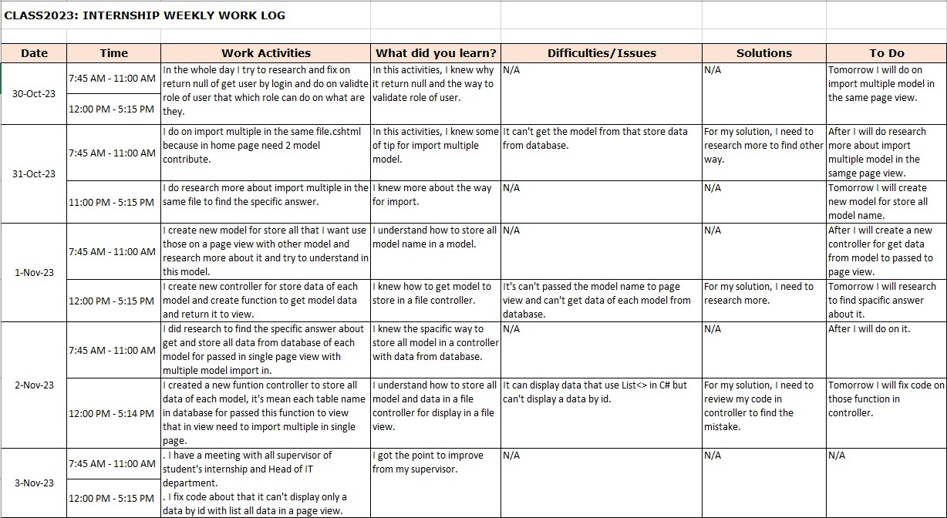

  - THANK LATER

November 30,2023 Cambodian Public Bank

Vanda SOPHAL Phum Tropeang Chhuk (Borey Sorla),
Sangkat Tek Thla Khan Sen Sok P.O Box 511 Phnom Penh vanda.sophal@student.passerellesnumeriques.org
Tell: 0712540816

#Sangkat Phsar Thmey 2, Khan Daun Penh, 23 Kramuon Sar St. (114), Phnom Penh, Khan Chamkar Morn, Phnom Penh, Cambodia.
Email : it@campubank.com.kh

Dear Mr. Ung Mongheng/Mr. Khim Kuntha,
I wanted to take a moment to express my deepest gratitude for the incredible opportunity to be part of the internship program at Cambodian Public Bank. This experience has been truly transformative, and I am immensely grateful for the knowledge and skills I have gained during my time here.

Throughout my internship, I have been fortunate to work with an exceptional team of professionals who have not only mentored me but also inspired me to reach new heights. Your guidance, support, and willingness to share your expertise have been invaluable, and I cannot thank you enough for investing in my growth and development.

Thank you for believing in me and for providing me with an internship experience that will undoubtedly have a lasting impact on my professional journey.

Sincerely yours, Sophal Vanda

  - ORGANIZATION CHART
Mr. Ung Mongheng
Head Of ITD
Mr. Ngor Lyko COO
Mr. Sor Sokunthea COO
Mr. Khim Kuntha
Senior Application Support Officer
Mr. Rath Sopha
Web Programmer
Mr. Bet Chamnan
Internship
Mr. Sophal Vanda
Internship

Ung Ming Teck CEO

Mr. Bonda Assistant Manager

