Lattice Boltzmann Exercise Report

Exercise 2: Taylor-Green Vortex with LBGK
The vortex remains stable until about time step 50’000. After that it starts to decay as can be seen in Figure 1.
Figure 1: Instability of the Vortex
(Re = 3000, Vmax = 0.05, L = 128 , t ~ 60000)
The expected second order convergence holds as can be seen in Figure 2. The lower t (the simulation time) is, the better the behaviour of the convergence is for smaller values of L.
How to reproduce:
$ tar -xvf LB2D.tar.gz
$ cd LB2D
$ mkdir build
$ cd build/
$ cmake ..
$ ./LB2D taylor_green
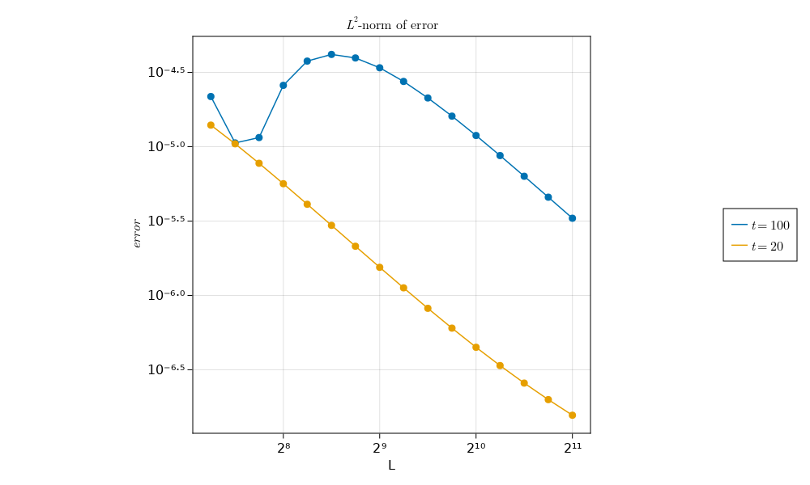 Figure 2: Convergence (Vmax = 0.05, Re = 30000)
or
$ ./LB2D convergence_lbgk
The first mode runs a visual simulation while the latter runs a grid refinement study.
To tweak simulation parameters edit the taylor_green() function in runner.hpp
I tested the the code using clang-13.0.0 on linux using at most C++17 features. The following cmake find_package scripts are assumed to be available:
- GLEW, GLUT, OpenGL, OpenMP
- X11 (Linux only)

Exercise 3: Periodic Shear Layer using KBC
Comparing Figure 5 and 6, we see that KBC-D is unstable (spurious vortices appear along the bottom-right and top-left shocks) at Re=300’000 and L=128, whereas at L=512 it remains stable.
Re=3’000 poses no problem to either resolution.
LBGK simulations at Re=300’000 and L=512 diverge. So the benefits of KBC seem obvious to me.
Figure 4: Re = 3’000, L = 512
Figure 5: Re = 300'000, L = 128
Figure 6: Re = 300'000, L = 512
Figure 3: Re = 3’000, L = 128
Setting gamma = 1/beta produces simulations which look promising at first, but then suddenly diverge after some time.
How to reproduce:
Perform the steps outlined in exercise 2, then run:
$ ./LB2D shear_layer
To tweak simulation parameters edit the shear_layer() function in runner.hpp.

Exercise 4: Flow around a cylinder
As mentioned in the exercise notes, the proposed outflow boundary conditions only work as long as they are far enough downstream. I assume that this is due to instability occurring when relatively large vortices enter the outflow cells.
Figure 7: Kármán vortex street (D = 7.5, Re=100’000)
When just using the default cylinder with the given dimensions, this issue does not arise. However, user-placed walls can lead to turbulence (see Figure 8) occuring too close to the boundary which will lead to divergence. To fix this, I set beta to 0.5 in proximity of the outflow boundary. While this leads to some artifacts downstream the stability issue is mostly mitigated.
Figure 8: Turbulence occuring after a custom wall
(L = 300, Re = 100'000 )

Analysis of the Drag Force
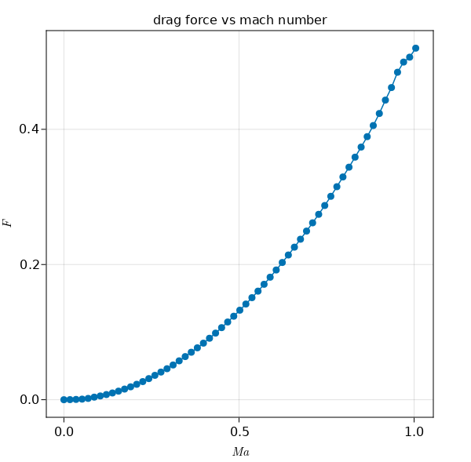Figure 9: drag force, varying Ma at constant Re = 100000, L = 300
To analyze the drag “felt” by the cylinder I implemented the momentum exchange method presented in the exercise notes.
Then I averaged the measured drag over 8000 time steps and plotted it w.r.t. to velocity, yielding Figure 9.
There seems to be a nice quadratic relationship between until some critical mach number around 0.95
As can be seen in Figure 10, the vortices start to clump up for these velocities
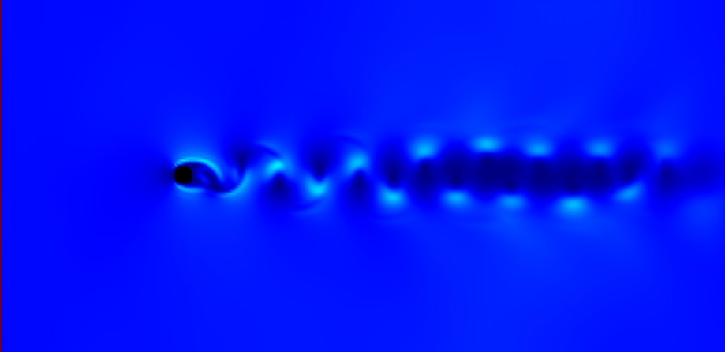Figure 10: Vortices "clumping up" at high velocities
How to reproduce:
Perform the steps outlined in exercise 2, then run:
$ ./LB2D cylinder_flow
To tweak simulation parameters edit the cylinder_flow() function in runner.hpp

Appendix: How to use the new simulation options.
The lb::simulation constructor:
Now takes a new optional last element collisionType. It can be either lb::CollisionType::LBGK, lb::CollisionType::KBC or lb::CollisionType::None. The latter mostly exists for debugging purposes.
Simulation Members to be used after construction:
- bool sim.periodic:
If on, regular periodic boundary conditions are used, otherwise the setup for exercise 4 is enabled.
- bool sim.regularized:
Overrides the calculation of gamma in the KBC collision operator with 1/beta.
- bool sim.calculate_wall_force:
Used for the drag vs mach plot. Increments the simulation’s speed by 0.01 every 10000 steps, measuring the average force and printing it out at the end.
- void initialize(T initializer):
Used to initialize simulations. Expects a lambda with signature
(const lb::simulation& sim, int i, int j) returning a tuple (scalar_t u, scalar_t v, scalar_t rho, bool wall), describing the initial conditions at a given location and whether a wall should be placed or not.
- void calculate_beta(T initializer):
Recalculates the viscosity and beta after a change to velocity.

Exercise 1: 1D-LBM

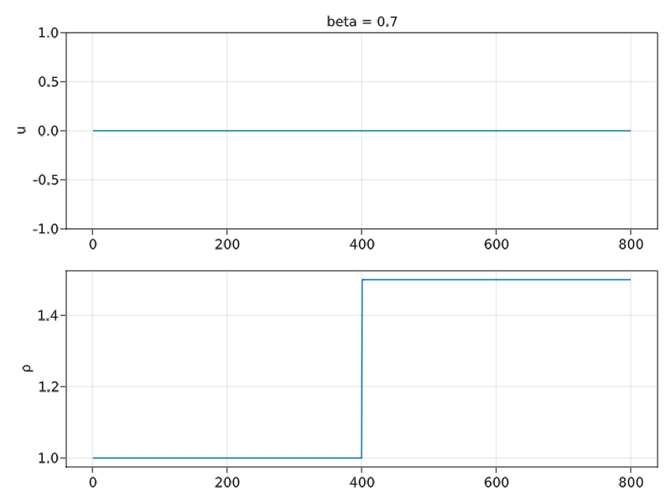Figure 12: Initial Conditions
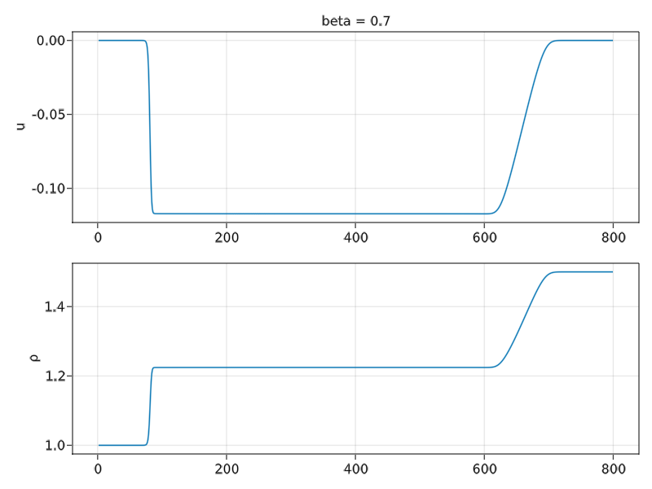Figure 11: beta = 0.7
I only got around to implementing the shock tube part of the exercise:
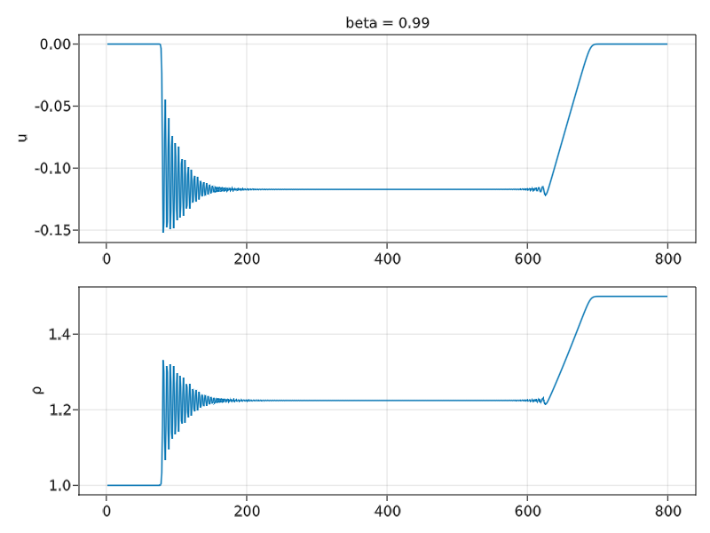Figure 13: beta = 0.99
We can see numerical instabilities for low viscosity (Figure 13) and smooth solutions for higher viscosity (Figure 12).
To reproduce this simulation run:
julia ex1/1d_lbm_shock_tube.jl
Julia will complain about missing libraries, but will give instructions on how to install them.

Infos about the simulation parameters can be found in the appendix.

