Big Five Leagues 2024–25
Player Performance Dashboard
Power BI Dashboard Explanation and Practical Steps

1. Project objective
The objective is to explore player performance across the five major European leagues for the 2024–25 season: Bundesliga, La Liga, Ligue 1, Premier League, and Serie A. The dashboard summarises goals, assists, goals per 90 minutes, player age, leading scorers, position distribution, and the relationship between goals and assists. League slicers let the user compare competitions without creating a separate report page for each league.

2. Dataset and preparation
The table used in the report is named players_clean. The Power Query preview shows fields such as Player, Nation, Squad, League, Pos, PrimaryPos, and Age. The measures also use Goals, Assists, and Nineties.
The screenshots show that a player may appear more than once when they represented different squads during the season (for example, a player listed with two clubs). Therefore, Player alone may not uniquely identify a row. Keep Squad and League available for filtering and tooltips, and check whether the source contains one row per player-season, one row per player-club, or another grain before interpreting totals.
The query is named players_clean, suggesting that a cleaned table was used. Before building visuals, check that numeric columns such as Goals, Assists, Nineties, and Age have numeric data types; remove unwanted blank rows; and confirm that league names and position labels are consistent.

3. DAX measures
Create the following measures from the Modeling / New measure option. They are used by the KPI cards and other visuals.

Total Goals
Total Goals = SUM(players_clean[Goals])
Adds the Goals values for the rows currently in filter context. Selecting a league changes the result.

Total Assists
Total Assists = SUM(players_clean[Assists])
Adds the Assists values for the selected league, squad, position, or other active filters.

Goals per 90
Goals per 90 = DIVIDE([Total Goals], SUM(players_clean[Nineties]))
Divides total goals by the total number of 90-minute equivalents. DIVIDE safely handles a zero or blank denominator.

Avg Age
Avg Age = AVERAGE(players_clean[Age])
Calculates the mean age of the rows included by the current filters.
Formatting note: set Total Goals and Total Assists to whole numbers, Avg Age to two decimal places, and Goals per 90 to two decimal places. The measure named Goals per 90 is a rate, not a percentage.

4. Report canvas and visuals

4.1 Four KPI cards
Add four Card visuals and place them in a row near the top of the page. Assign one measure to each card: Total Goals, Total Assists, Goals per 90, and Avg Age. These cards provide a quick summary of the currently selected league or leagues.

4.2 Top scorers — clustered bar chart
Insert a Clustered bar chart. Place Player on the Y-axis and Goals on the X-axis. In the Filters pane, select Player, set the filter type to Top N, enter 10 under Show items, drag Goals into By value, and select Apply filter. Sort by Goals in descending order so the highest scorer appears at the top. If players can have multiple club rows, consider whether goals should be grouped by player across clubs or displayed by player-club.

4.3 Goals by league — clustered column chart
Insert a Clustered column chart. Put League on the X-axis and Total Goals on the Y-axis. This visual compares the summed goals across the five leagues. If the report is filtered to one league, the chart may show only that league; clear the League slicer selection when you want to compare all leagues.

4.4 Players by position — donut chart
Insert a Donut chart. Put PrimaryPos in Legend and Player in Values, then set the Player aggregation to Count. This displays the number of player records in each broad position group. The chart should be described as a count of records/players according to the dataset grain; if players can appear in multiple rows, it may not be a distinct-player count.

4.5 Goals vs assists — scatter chart
Insert a Scatter chart. Put Goals on the X-axis, Assists on the Y-axis, Player in Values/Details (depending on the Power BI version), and Squad in Tooltips. Each point represents the selected data grain. Hover over a point to inspect its club. Look for players with both high goals and high assists, and for points that sit far from the main cluster.

4.6 Slicers
Add a Slicer visual with League. Add additional slicers for PrimaryPos and, optionally, Squad. Select a league or position and check that the cards and charts respond. Use the eraser/clear-selection control on a slicer to return to the full dataset.

5. Dashboard layout and design
The screenshots show a bright green page background, white visual panels, a bold title at the top left, KPI cards beneath the title, a large Top Scorers bar chart on the left, and the Goals vs Assists scatter chart plus Players by Position donut chart on the right. The League slicer is placed at the left. This layout makes the summary figures visible first while preserving room for detailed charts.
Design improvement: the green background is highly noticeable, but a softer neutral or dark background with one accent colour may improve contrast and readability. Keep chart titles, labels, number formats, and position colours consistent across all selections.

6. Reading the screenshots
The following screenshots show the report filtered to individual leagues, as indicated by the selected League slicer. Values below are transcribed from the displayed cards and are approximate where the screenshot uses abbreviated labels.

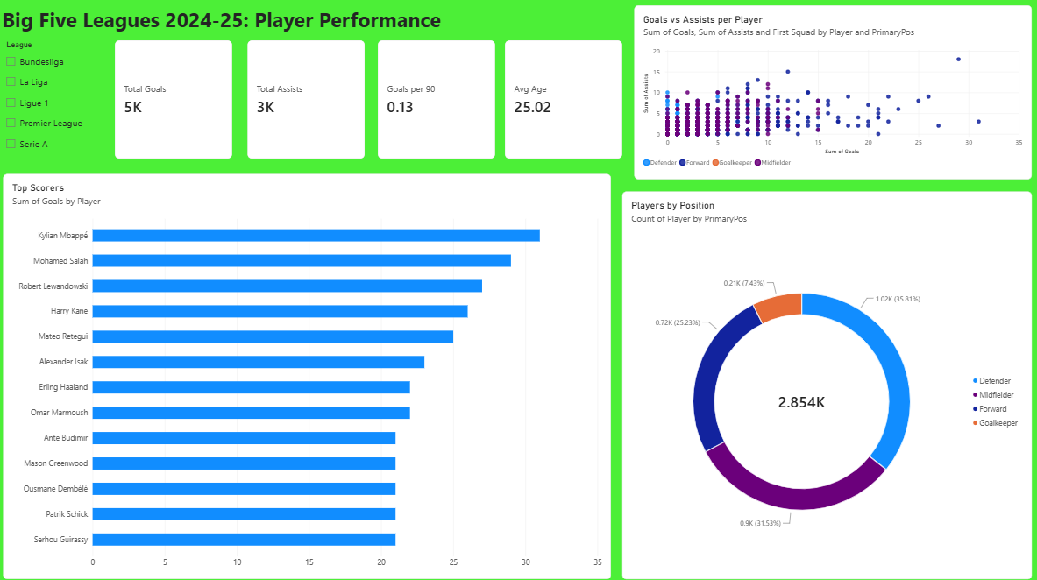
Figure 1. Overall dashboard view with all five leagues selected (overview).
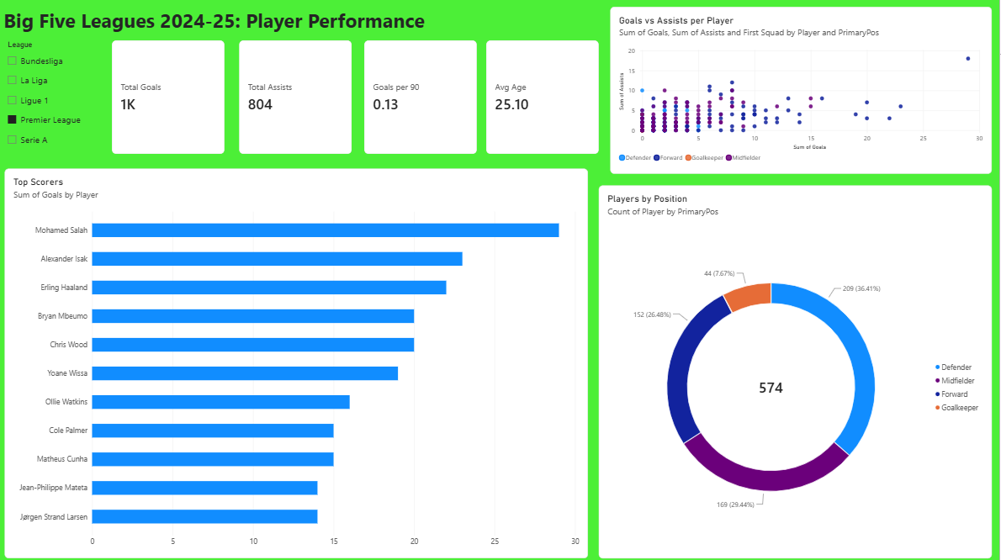
Figure 2. Premier League selected: the KPI cards, top scorers, scatter chart, and position distribution update.
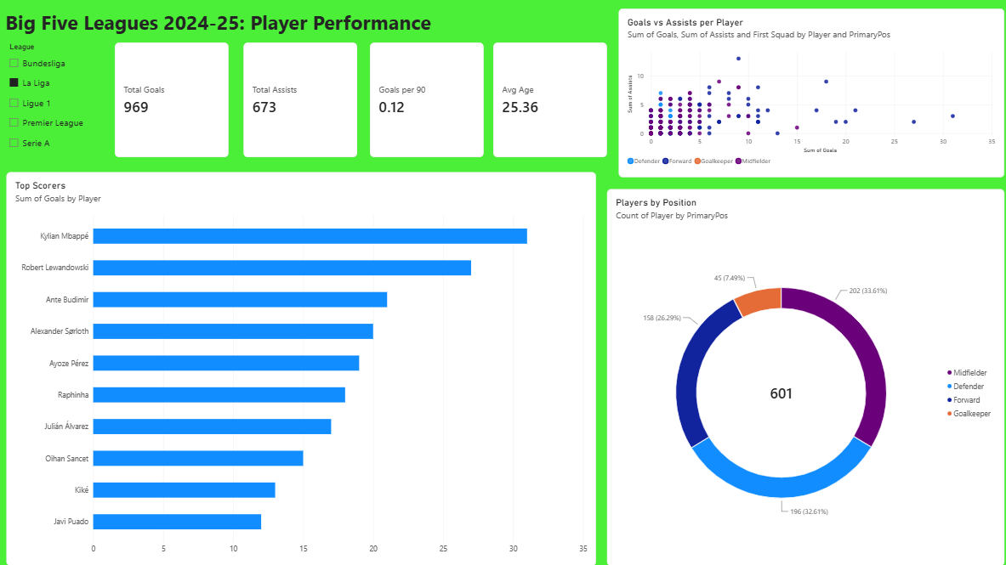
Figure 3. La Liga selected: the leading scorers and position mix differ from the Premier League.

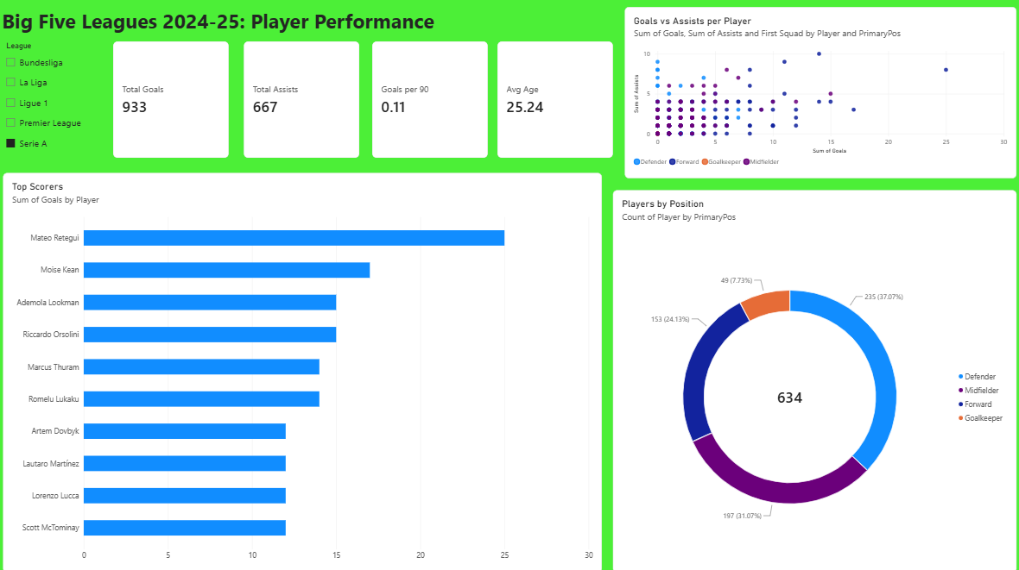
Figure 4. Serie A selected: the KPI values and leading scorers reflect the Italian league selection.
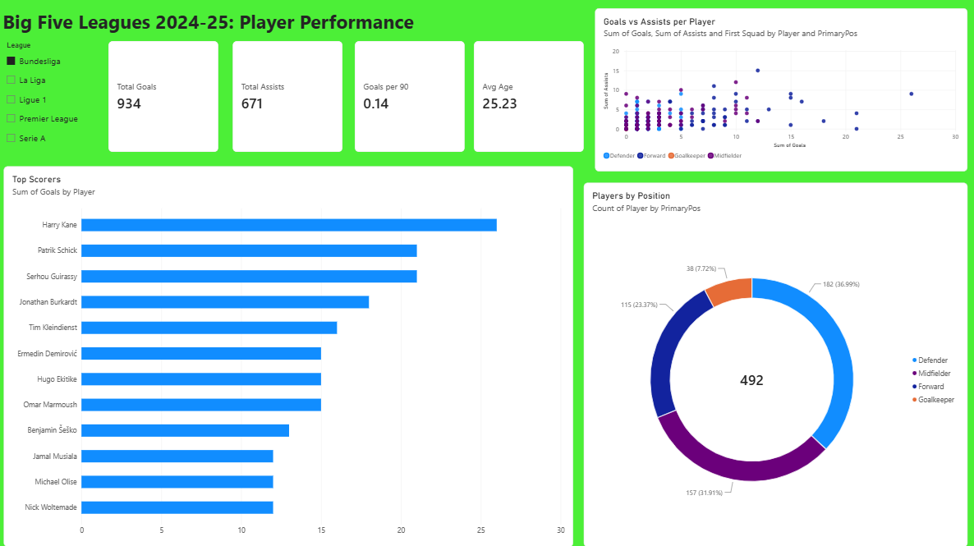
Figure 5. Bundesliga selected: Harry Kane and other leading scorers appear in the Top Scorers visual.
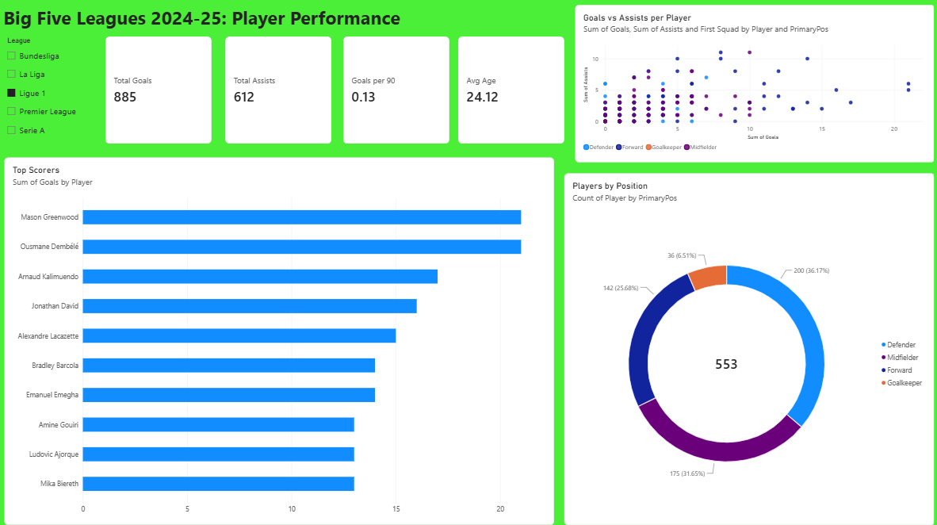
Figure 6. Ligue 1 selected: Mason Greenwood and Ousmane Dembélé appear among the leading scorers.

7. Example observations from the league filters
- Premier League screenshot: the cards show approximately 1K goals, 804 assists, 0.13 goals per 90, and an average age of 25.10. Mohamed Salah is the top scorer shown in this filtered view.
- La Liga screenshot: the cards show 969 goals, 673 assists, 0.12 goals per 90, and an average age of 25.36. Kylian Mbappé and Robert Lewandowski lead the visible scorer ranking.
- Serie A screenshot: the cards show 933 goals, 667 assists, 0.11 goals per 90, and an average age of 25.24. Mateo Retegui is the leading scorer shown.
- Bundesliga screenshot: the cards show 934 goals, 671 assists, 0.14 goals per 90, and an average age of 25.23. Harry Kane is the leading scorer shown.
- Ligue 1 screenshot: the cards show 885 goals, 612 assists, 0.13 goals per 90, and an average age of 24.12. Mason Greenwood and Ousmane Dembélé are tied at the top of the displayed ranking.
These are dashboard readings, not proof that one league is better than another. Raw totals depend on the number of records and minutes represented. For fairer comparisons, use rates per 90 minutes, minutes played, or per-team/per-match measures where appropriate.

8. Data and interpretation checks
- Confirm that the dataset covers the same season and comparable statistics for every league.
- Check whether the data contains player-club rows. A player who moved clubs can appear more than once, so avoid calling a row count a distinct player count unless verified.
- For the scatter chart, ensure each point represents the intended entity. If the goal is one point per player, aggregate goals and assists by player first or use a suitable player identifier.
- For the Top N filter, verify that Goals is the By value field and click Apply filter.
- Test all slicers and confirm visual interactions are enabled.
- Use descriptive chart titles and appropriate decimal places; do not interpret Goals per 90 as a percentage.
- If using a goals-per-90 comparison between players, remember that very low minutes can make rates unstable.

9. Conclusion
The report brings several football performance indicators into one interactive page. Its main value is that users can filter by league and position, inspect top scorers, compare goals and assists, and view the distribution of positions. The measures and visuals should always be interpreted in light of the dataset’s structure and the playing time represented.

10. GitHub: https://github.com/krypsci

