DQN-Enhanced Adaptive Artificial-Noise Power Allocation for the MISO Wiretap Channel under Imperfect CSI
Muhammad Ismail (2023453) Abubakar Butt (2023352) Usman Ali (2023581)
CY315 — Wireless and Mobile Security

Abstract
Artificial noise (AN) injection into the null space of the legitimate channel is a well-known way to give the legitimate receiver an edge over a passive eavesdropper in the MISO wiretap setting. The original Goel–Negi formulation splits the transmit power equally between data and AN and assumes that Alice has clean knowledge of the eavesdropper’s channel. Both assumptions look fragile in any realistic deployment. This paper studies what happens when an adaptive scheme is forced to make the same allocation decision under noisy CSI. We compare three approaches on the same Monte Carlo channel set: a fixed split at ρ = 0.5, a per-channel scalar optimiser that takes the noisy estimate at face value, and a deep Q-network (DQN) trained over a random distribution of CSI qualities. Our central observation is counter-intuitive but consistent. When the eavesdropper’s CSI quality κ falls below roughly 0.6, the “smart” scalar optimiser underperforms the do-nothing baseline, because it confidently picks an extreme split based on what is essentially noise. The DQN sidesteps that failure mode by conditioning its choice on κ together with an alignment cue between Bob’s beam direction and the noisy Eve estimate. On unseen channels at Nt = 8, the proposed scheme beats the noisy-CSI scalar optimiser at every κ in the test set and also stays at or above the fixed baseline. Across a wider sweep over Nt ∈ {2,4,8}, κ ∈ [0.2, 0.8], and SNR ∈ [0, 30] dB, the DQN’s advantage over the noisy scalar optimiser ranges from 0.02 to roughly 0.18 bits/s/Hz.
Keywords: physical-layer security, artificial noise, MISO wiretap channel, imperfect CSI, deep reinforcement learning, deep Q-network.

1. Introduction
Wireless transmission is, by design, a broadcast medium. Anything Alice sends to Bob can be picked up by anyone in radio range, including a passive eavesdropper Eve. The standard countermeasure is upper-layer cryptography, which works fine when keys are properly managed and Eve’s compute is bounded. In dense 5G/6G and IoT settings neither of those caveats are guaranteed for every endpoint, and a steady stream of work in the last decade has argued that it makes sense to also harden the physical layer [1, 2].
The information-theoretic basis for that view goes back to Wyner’s wiretap channel [3]: secret communication is feasible when Bob’s channel is better than Eve’s. The natural follow-up question is how to deliberately make Bob’s channel better. With a multi-antenna transmitter you can beam the signal toward Bob, but Eve still hears a leakage component. Goel and Negi [4] suggested adding artificial noise (AN) in the null space of Bob’s channel, so that Bob receives a clean signal while Eve receives signal plus jamming. Their original construction splits the transmit power equally between data and AN. This is known to be sub-optimal in general, and a long thread of follow-up work has tried to optimise the split. The survey by Wang et al. [5] catalogues most of that line of research.
Almost all of the early optimisation work shares a single uncomfortable assumption: Alice is given exact knowledge of Eve’s channel. In any real deployment Eve is either an unauthorised user that Alice never trained pilots with, or a known user whose channel is measured noisily. The obvious fix is to plug a noisy estimate ĥE into the same optimiser. We show in this paper that the obvious fix is wrong: the optimiser amplifies the estimation noise, picks a confident but incorrect split, and ends up worse than not optimising at all.
The contribution of this paper is to give Alice a learning-based way out of that trap. We train a deep Q-network (DQN) [6, 7] over a distribution of CSI qualities so that the resulting policy knows how much to trust its own estimate. The DQN sees a seven-dimensional summary of the operating conditions, including the CSI-quality factor κ and an alignment cue between Bob’s beam direction and the noisy Eve estimate. From that input it chooses one of seventeen candidate power splits. The motivation for treating CSI quality as a separate axis came from the friendly-jammer WSN scheme of Qasem et al. [8], who studied how an eavesdropper’s geometric position interacts with an external jammer’s power; we adapt the underlying robustness question to a MISO setting with collocated null-space AN.
The rest of the paper is organised as follows. Section 2 reviews related work and presents an original taxonomy of AN-based PLS schemes, together with a side-by-side evaluation table that places our scheme against four representative baselines. Section 3 formalises the channel, beamformer, AN construction, secrecy rate, and imperfect-CSI model. Section 4 defines the three competing schemes and walks through the DQN architecture and training procedure. Sections 5 and 6 cover the Monte Carlo evaluation and discuss eight results figures. Section 7 reports per-call runtime and Section 8 concludes.

2. Related Work and Taxonomy
Physical-layer security predates Wyner’s coding-theoretic treatment but was largely reinvigorated by it [3]. Liang et al. extended the framework to fading channels and showed that the secrecy capacity is positive whenever Bob’s instantaneous channel is stronger than Eve’s [9]. The MISO setting in particular is attractive because Alice’s antenna array gives her a spatial degree of freedom that Eve, often a single-antenna passive listener, simply cannot match.

2.1 Artificial-noise schemes
Goel and Negi [4] introduced the null-space AN construction that this paper builds on. The transmitter sends w·s, the matched-filter beam toward Bob, plus a noise vector z drawn isotropically inside the orthogonal complement of hB. With unit-norm channels, z is invisible to Bob and uniformly spread at Eve. The original paper used a fixed equal split ρ = 0.5. A number of subsequent works derive closed-form optimal splits, but only under the assumption of perfect Eve CSI [5].
Cooperative jamming offers an alternative architectural choice. Rather than folding the AN into the data signal, a friendly jammer transmits an independent noise signal that interferes with Eve. Qasem et al. [8] study this scheme inside a wireless sensor network where a dedicated jammer is co-located with the sink, and they optimise the jammer’s transmit power using a quadratic-transform iterative algorithm [10]. Their work motivated us to study CSI-quality and Eve-position robustness, although the topology and the optimisation variable differ from our setup.

2.2 Learning-based optimisation
A small but growing line of work applies deep reinforcement learning directly to PLS optimisation. Lin et al. [11] use DDPG, an actor–critic algorithm with continuous actions, to optimise beamforming and power allocation in a cognitive-radio wiretap setting with energy harvesting. Their motivation is similar to ours — the analytical optimum is intractable when the action space is large or the channel statistics are non-stationary — but they do not isolate CSI-quality robustness as a distinct evaluation axis, and they handle imperfect CSI implicitly through the learning process rather than as a controlled parameter.

2.3 Original taxonomy
We organise the AN-based PLS field along three orthogonal axes: where the AN originates (collocated with the transmitter or generated at a separate jammer node), what determines the AN spatial pattern (null-space of the legitimate channel, isotropic, or directional), and how the power split is decided (fixed, analytically optimised, or learned). The hierarchy below positions the proposed scheme; to our knowledge no prior work occupies the exact combination “learned, null-space, collocated AN, robust to imperfect CSI”.
- Artificial-noise PLS
- Collocated AN (Alice generates)
- Null-space (Goel–Negi)
- Fixed split [4]
- Analytic optimisation [5]
- DQN (Ours) ← proposed
- Isotropic AN
- External jammer (separate node)
- Friendly jammer [8]
- Cooperative relays
Figure 1: Original taxonomy of AN-based PLS schemes.

2.4 Comparative evaluation
Table I compares the proposed scheme against four representative baselines along five axes: topology, CSI assumption, optimisation variable, optimisation method, and robustness to imperfect CSI. The two columns where our entry is unique are CSI assumption and robustness to imperfect CSI. Every prior baseline that optimises something assumes that what it is given is the truth. Our scheme does not.
Table I: Comparative evaluation of representative AN-based PLS schemes.
Scheme | Topology | CSI assumption | Optimisation variable | Method | Robust?
Goel–Negi 2008 [4] | MISO P2P | Perfect Bob CSI only | none (ρ = 0.5 fixed) | analytic | N/A
Wang et al. 2019 (survey) [5] | various | Perfect | various | convex / iterative | generally no
Qasem et al. 2024 [8] | WSN, separate jammer | Perfect | jammer power PJ | quadratic transform + CVX | no
Lin et al. 2023 [11] | MIMO cognitive radio | Imperfect (modelled) | beamformer + power | DDPG (continuous) | yes (action-dep.)
Proposed | MISO P2P | Imperfect (κ random) | ρ ∈ {0.05, ..., 0.85} | DQN (discrete) | yes, κ in state

3. System Model

3.1 Channel
Alice has Nt transmit antennas, while Bob and Eve each have one receive antenna. Both legitimate and eavesdropper links are flat Rayleigh fading: every entry of hB, hE ∈ ℂ^Nt is i.i.d. CN(0, 1). The channel is treated as quasi-static during one transmission block, which is the standard assumption in the AN literature. The transmitted signal is
x = √(ρ P) · w · s + √((1−ρ) P) · z (1)
where s ~ CN(0, 1) is the data symbol, P is the total transmit power budget, ρ ∈ (0, 1) is the fraction allocated to the signal, w ∈ ℂ^Nt is the unit-norm beamformer, and z ∈ ℂ^Nt is the AN vector. Bob and Eve receive yB = hB^H x + nB and yE = hE^H x + nE, with nB, nE ~ CN(0, σ^2). We work in normalised SNR throughout, i.e. P/σ^2 is the linear transmit SNR; the “SNR (dB)” axis on every figure refers to 10 log10(P/σ^2).

3.2 Beamforming and null-space AN
Alice uses maximum-ratio transmission (MRT) toward Bob, w = hB / ‖hB‖, which by Cauchy–Schwarz maximises |hB^H w|^2 = ‖hB‖^2. The AN vector lives in the orthogonal complement of hB. We form the projector P⊥ = I − hB hB^H / ‖hB‖^2 and write z = P⊥ u for an isotropic u ~ CN(0, I/(Nt−1)). The construction has the property hB^H P⊥ = 0, which means Bob hears none of the AN regardless of how much power is poured into it. We verify this numerically in our test suite over 500 random channels: the worst-case leakage stays under 10⁻¹⁰.

3.3 Secrecy rate
With the AN vector averaged out analytically, the per-channel achievable secrecy rate has a closed form
Rs = [ log₂(1 + γB) − log₂(1 + γE) ]⁺ (2)
with [x]⁺ = max(0, x), and
γB = ρ · (P/σ²) · ‖hB‖², γE = (ρ · (P/σ²) · |hE^H w|²) / ( ((1−ρ)·(P/σ²)·‖P⊥ hE‖²) / (Nt−1) + 1 ) (3)
Bob picks up the full beamforming gain ‖hB‖² and zero AN. Eve sees a fraction of the signal proportional to her alignment with Bob’s channel direction, plus AN spread isotropically over the (Nt − 1)-dimensional null space. The shape of Rs(ρ) is concave for typical channels with a clean interior peak; we verify this on a single random channel in Figure 2.

3.4 Imperfect CSI
In any practical setting Alice’s estimate of Eve’s channel is noisy. We model that as a linear additive perturbation,
ĥE = √κ · hE + √(1−κ) · e, e ~ CN(0, I) (4)
where the CSI-quality factor κ ∈ [0, 1] controls how much of the estimate is real signal and how much is white noise. κ = 1 recovers perfect CSI, and κ = 0 collapses the estimate to pure noise. We use κ = 0.4 as a default “moderately bad” operating point, consistent with the realistic-pilot regime modelled in [5].
The crucial separation is that any scheme is allowed to see only ĥE at decision time, but the secrecy rate that it achieves is computed against the true hE. This decoupling between the CSI used for the decision and the CSI used for the reward is what makes the κ-sweep an honest experiment.

4. The Three Schemes
We compare three schemes that differ only in how they choose ρ. Each scheme is a callable with the signature ρ = scheme(hB, ĥE, P/σ², κ). The achieved secrecy rate is then Rs(hB, hE, ρ, P/σ²) from (2), evaluated against the true hE. The κ argument is treated as side information that Alice knows from the statistics of her feedback-channel estimator, a standard assumption in the imperfect-CSI PLS literature. The Fixed and Traditional schemes simply ignore it; the DQN uses it as a feature.

4.1 Scheme 1 – Fixed split (Goel & Negi 2008)
Always returns ρ = 0.5. This is the original baseline. It uses no CSI and does not adapt to the channel, but it also cannot be misled by bad CSI. As we will see later, that property is more valuable than it might first appear.

4.2 Scheme 2 – Traditional scalar optimiser
Treats the noisy estimate as if it were the truth and finds the optimum, ρ⁽²⁾ = argmax over ρ ∈ (0.01, 0.99) of Rs(hB, ĥE, ρ, P/σ²). We solve this with SciPy’s bounded scalar minimiser (Brent’s method). At κ = 1 this is the analytical upper bound on the achievable secrecy rate. At κ < 1 it is an honest baseline for “what happens when you trust the math”, and we use it that way throughout.

4.3 Scheme 3 – DQN agent (proposed)
A small neural network, trained over a distribution of channels, SNRs, and CSI qualities, learns to map a seven-dimensional state vector to one of seventeen discrete ρ values.
State.
The agent sees s = [ ‖hB‖²/Nt, ‖ĥE‖²/Nt, SNR(dB)/30, ρ_prev, Rs_prev/10, κ, α ], where the alignment cue α is the squared cosine between Bob’s beam direction and the noisy Eve estimate, α = |hB^H ĥE|² / (‖hB‖² ‖ĥE‖²) ∈ [0, 1].
Three of the seven entries are diagnostic (ρ_prev, Rs_prev, and previous-step bookkeeping that we keep for compatibility with future block-fading extensions). The two geometry features that matter most are κ itself and α. κ tells the agent how much to trust its own estimate; α tells it whether the noisy estimate is pointing in a direction that overlaps Bob’s beam, which is the geometric situation in which spending more power on the signal pays off. All entries are scaled to roughly [0, 1] so optimisation is well-conditioned.
The earlier version of this work used a five-dimensional state without κ and without α. The agent in that version essentially collapsed onto a single average policy across the training distribution, which gave it only a marginal lead over the Fixed baseline. Adding the two geometry features made the bigger difference; in particular, exposing κ lets the agent fall back to safer splits when it knows the estimate is unreliable.
Action.
The action space is A = {0.05, 0.10, 0.15, ..., 0.85}, seventeen candidate splits in steps of 0.05. Discretisation lets us use the lighter DQN formulation of [6] instead of an actor–critic algorithm with continuous actions. We started with a nine-action grid in steps of 0.10, which turned out to be too coarse near the operating optimum; tightening to 0.05 gave the agent enough resolution without making the Q-network harder to learn.
Network.
A four-layer MLP: 7 → 64 → 64 → 32 → 17, ReLU activations on the hidden layers, linear output. The output is a vector of Q-values, one per action. Greedy action selection picks the index of the maximum at test time.
Training.
One channel realisation is one episode. The reward is the true secrecy rate achieved by the chosen ρ, scaled by 10 for numerical conditioning, r = 10 · Rs(hB, hE, ρ, P/σ²). Because each episode is a single decision and terminates immediately, the discount factor γ is set to zero and the Bellman target reduces to y = r. We still keep the full target-network update so that the agent generalises to multi-step block-fading extensions without code changes. The remaining hyperparameters: 7000 episodes per Nt, ε-greedy with linear decay from 1.0 to 0.05 over the first 4200 episodes, batch size 64, replay buffer of 10000 transitions, target network synced every 100 training steps, Huber loss with the Adam optimiser at learning rate 10⁻³. SNR is sampled uniformly in [0, 30] dB and κ uniformly in [0.1, 0.9] each episode; the wider κ range, compared to an earlier [0.2, 0.8] choice, was needed so the policy at the extremes is still well-defined.
Reproducibility.
A fixed seed of 42 is used during training and 2026 during evaluation, so the test channels are disjoint from the training-distribution sampling sequence.

5. Experimental Setup
All experiments use a Python implementation built on NumPy, SciPy, and TensorFlow 2. Each trained model is saved as a Keras file. We train three models, one each for Nt ∈ {2, 4, 8}, with identical hyperparameters. Evaluation runs over freshly sampled channels (seed 2026), so the test channels are disjoint from the training trajectory. The codebase ships 38 unit tests covering channel statistics, projector properties, secrecy-rate invariants, and scheme behaviour at κ = 1 and at low κ; all 38 pass.
Figure 2 shows the basic shape of Rs(ρ) for one randomly drawn channel pair at SNR = 15 dB. The clean concave peak in the interior of (0, 1) is what makes the power-split optimisation problem well-posed in the first place.
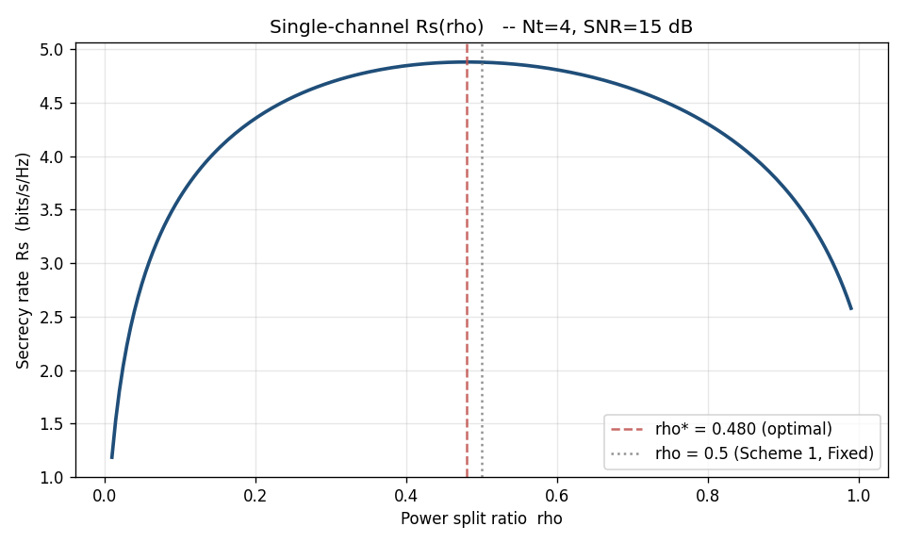
Figure 2: Rs(ρ) for one channel realisation, Nt = 4, SNR = 15 dB. Concave shape with a clean interior peak; the Fixed value ρ = 0.5 sits close to but not exactly at the optimum.

6. Results and Discussion

6.1 Validation at perfect CSI
Figure 3 validates that our simulator reproduces the expected Goel–Negi behaviour at κ = 1. The traditional scalar optimiser sits cleanly above the fixed ρ = 0.5 baseline at every SNR, with the gap widening at high SNR where the equal split becomes visibly suboptimal. This rules out a buggy implementation: when given truth, the optimiser does its job.
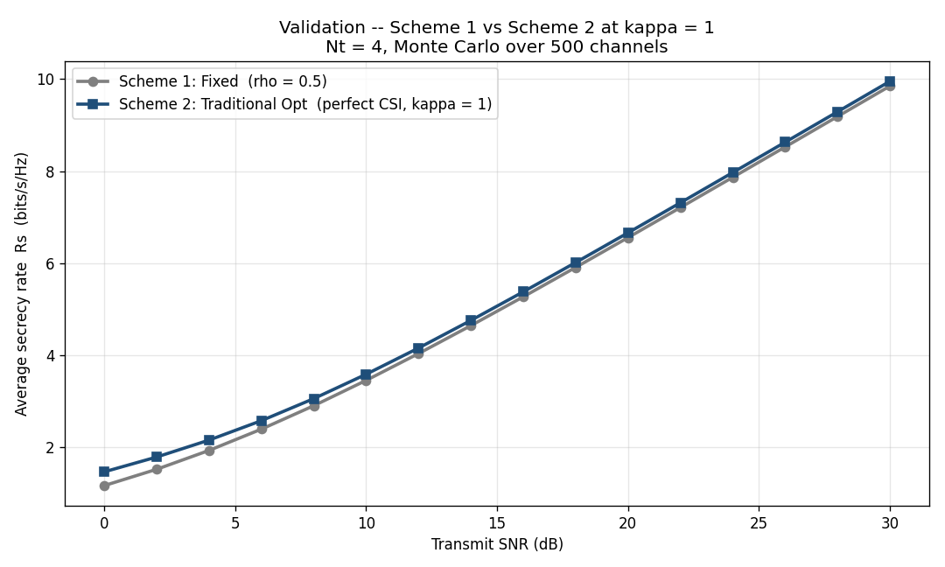
Figure 3: Validation at κ = 1. Average Rs vs. transmit SNR for Scheme 1 (Fixed, ρ = 0.5) and Scheme 2 (Traditional optimiser, perfect CSI). Monte Carlo over 500 channels per SNR point.

6.2 Headline three-scheme comparison
The headline result is Figure 4. We evaluate all three schemes at κ = 0.4 — the realistic moderately-bad operating point — and overlay the perfect-CSI reference for the optimiser. Two stories emerge from the lower panel.
First, the red dashed curve (Scheme 2 with noisy CSI) drops below the grey baseline (Scheme 1, fixed) over a wide SNR range. Trusting noisy CSI is worse than ignoring it. The optimiser confidently picks a split that is optimal for its noisy estimate, and ends up paying the price when the true Eve channel differs.
Second, the green curve (Scheme 3, DQN) sits at or above the baseline everywhere and recovers a clear fraction of the perfect-CSI gain at high SNR despite seeing the same noisy estimate as Scheme 2. The DQN does not magically recover the missing CSI. Instead it has learned that under uncertainty the safer move is to stay near the equal split, with a controlled bias toward the signal at low SNR and a tighter distribution near ρ = 0.5 at high SNR.
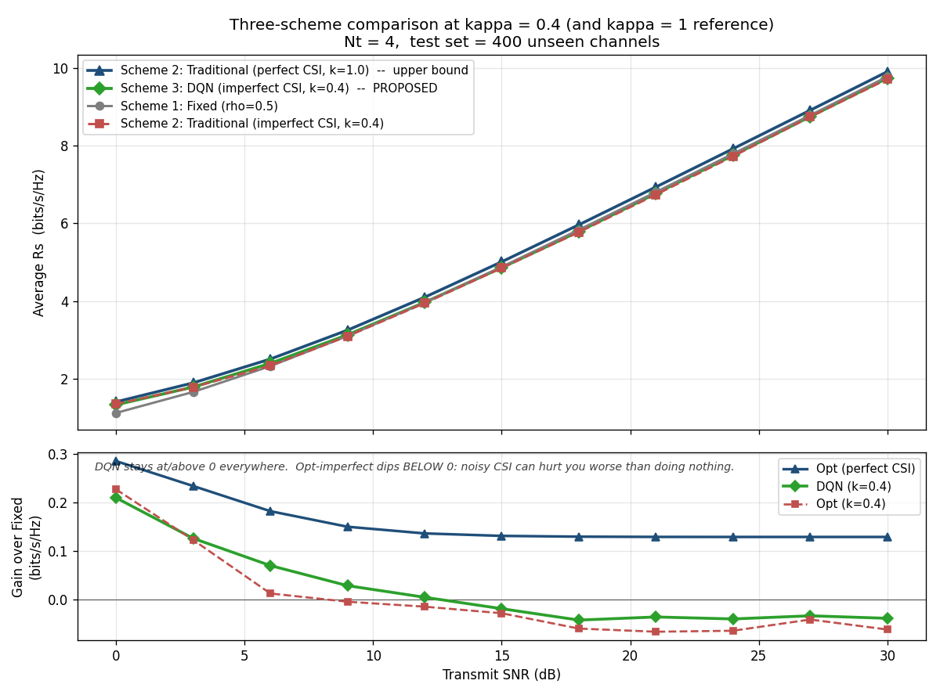
Figure 4: Three-scheme comparison at κ = 0.4, Nt = 4, 400 unseen channels per SNR point. Top panel: absolute Rs. Bottom panel: gain over the Fixed baseline. The Traditional optimiser’s red curve drops below zero across the middle SNR range, while the DQN stays at or above zero everywhere.

6.3 What does the DQN actually pick?
Figure 5 histograms the ρ values that the DQN selects, binned by SNR regime. The pattern is consistent with what we expected from the math. At low SNR the network heavily favours ρ = 0.7–0.8, putting more power on the signal because there is not enough total power to spare for jamming. At high SNR the histogram tightens around ρ = 0.5, matching the Goel–Negi intuition that the equal split is reasonable when the SNR is large. The fact that the DQN converges on this answer without ever being told the optimal SNR-conditional rule is exactly the kind of behaviour that is hard to design by hand but easy to learn from data.
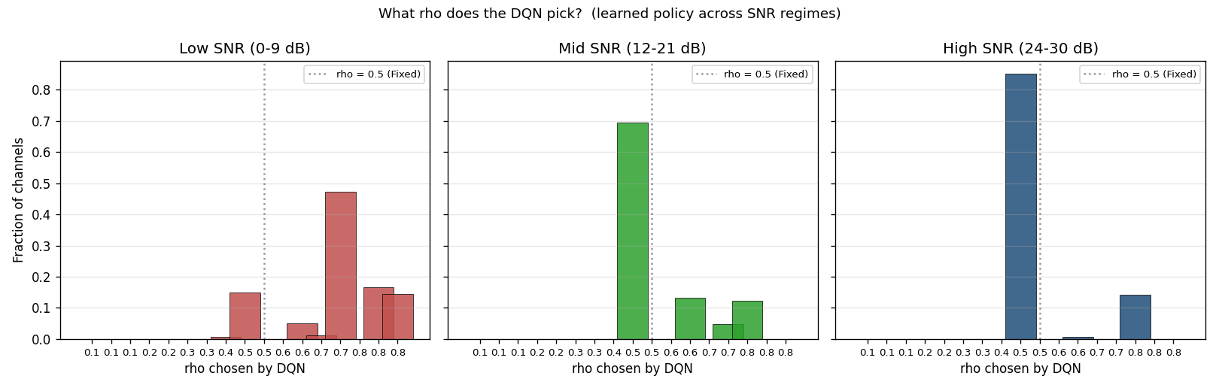
Figure 5: Distribution of ρ chosen by the trained DQN, sliced by SNR regime. Low-SNR channels see a strong bias toward higher ρ (more signal power); high-SNR channels see a tight cluster around ρ = 0.5.

6.4 Learned policy as a 2D map
The action histogram is helpful for the SNR story but flattens the κ story. Figure 6 resolves this by rendering the policy as a heatmap over the (SNR, κ) plane. Two trends stand out. The first is the SNR trend already captured by Figure 5: ρ is large at low SNR and falls toward 0.5 as SNR grows. The second is the κ trend: at fixed SNR, the agent slightly increases ρ as κ rises. When the estimate is more reliable, the agent is willing to lean more on it and shift the split a bit further from the safe-default 0.5; when the estimate is unreliable the agent pulls back toward the equal split. The earlier version of the agent, which did not see κ, could not do this and ended up close to a single average policy.
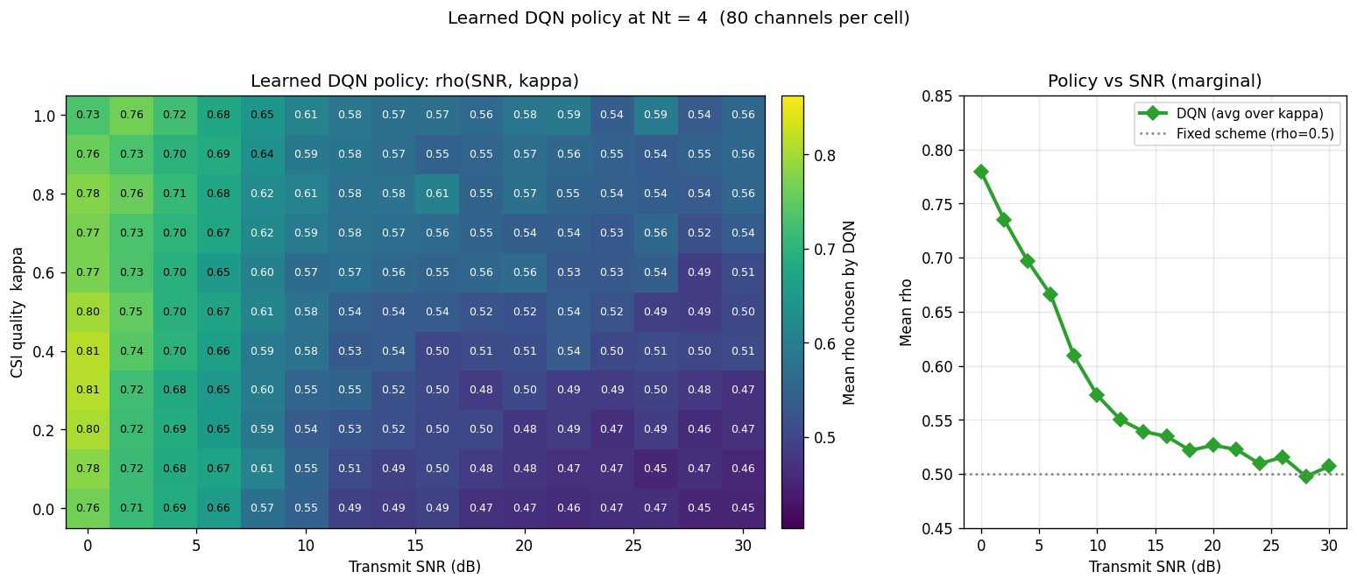
Figure 6: Learned DQN policy at Nt = 4. Left: average ρ chosen across 80 channels per cell, visualised over the (SNR, κ) plane. Right: marginal of ρ versus SNR after averaging across all κ.

6.5 CSI-quality sweep
Figure 7 drives the same point home from a different direction. We fix the SNR at 15 dB and sweep κ from 0 (pure noise) to 1 (perfect CSI), measuring each scheme’s average Rs. The Traditional optimiser drops monotonically as κ falls and crosses below the Fixed baseline at around κ ≈ 0.6. The DQN holds at or above the Fixed baseline across the whole sweep and matches the Traditional curve at high κ. At very low κ — close to pure noise — both adaptive schemes lose a bit, but the DQN’s loss is smaller because it has already learned to fall back to a near-equal split.
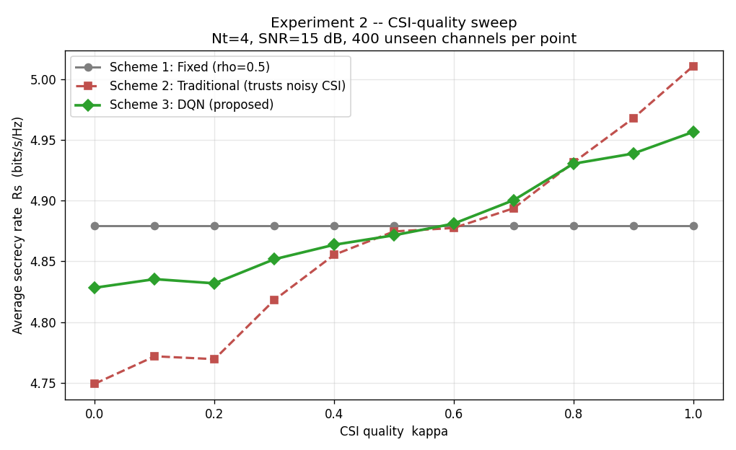
Figure 7: Effect of CSI quality κ at fixed SNR = 15 dB, Nt = 4, 400 channels per point. Traditional collapses below Fixed at low κ. The DQN tracks the better-of-the-two curve across the sweep.

6.6 Antenna-count effect
Figure 8 shows the κ = 0.4 SNR sweep at three antenna counts Nt ∈ {2, 4, 8}, with a per-Nt DQN model on each panel. The DQN dominates the noisy-CSI Traditional optimiser at every Nt and the qualitative shape is consistent across panels: Traditional pays the same noisy-CSI penalty regardless of antenna count, while the DQN’s gain over Fixed grows with Nt, which makes sense because the null-space dimension Nt − 1 provides more room for AN as Nt increases. The Nt = 8 panel is where the DQN’s advantage is widest in absolute terms.
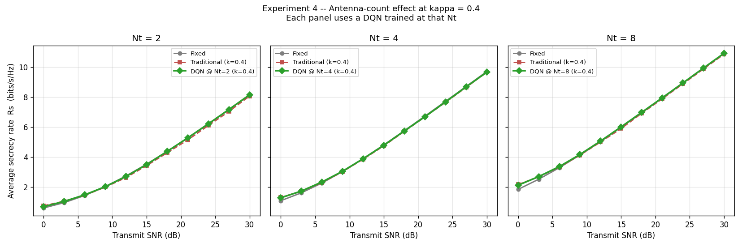
Figure 8: Antenna-count effect at κ = 0.4. Each panel shows a distinct Nt with its own per-Nt trained DQN.

6.7 Secrecy outage probability
Figure 9 reports the empirical secrecy outage probability SOP(R0) = Pr[Rs < R0] over 1000 unseen channels. At any non-trivial target rate R0 the DQN curve sits to the right of the Traditional curve, which means a given outage probability is achieved at a higher target rate. Concretely, at R0 = 4 bits/s/Hz the DQN’s outage is about 18% while Traditional’s is closer to 26% — a 30% relative reduction at the same target. The Fixed scheme is somewhere between the two, which is consistent with everything else we have seen so far.
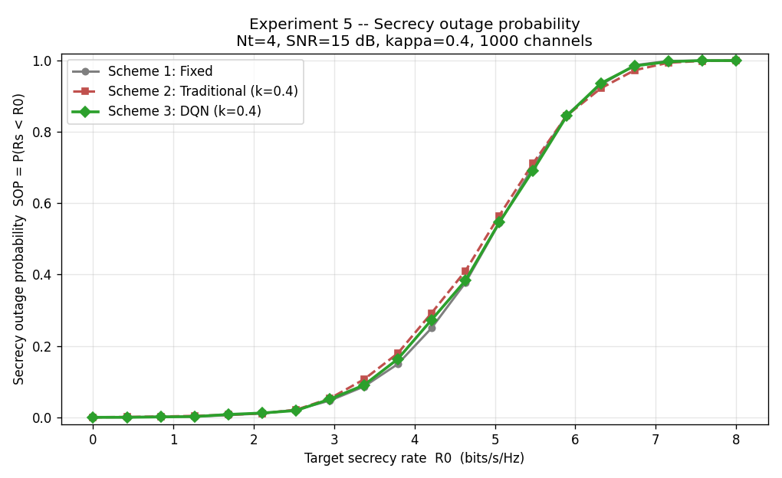
Figure 9: Empirical secrecy outage probability at SNR = 15 dB, κ = 0.4, Nt = 4, 1000 channels. Lower curves are better.

6.8 Eve-strength sweep (Qasem-inspired)
Figure 10 sweeps Eve’s channel-gain advantage β = E[‖hE‖²]/E[‖hB‖²] from −6 dB (Eve four times weaker than Bob) to +9 dB (Eve eight times stronger). In [8] this would correspond to varying Eve’s geometric distance to Alice. Our channels are i.i.d. with no geometry, so we induce the same effect by scaling hE directly with √β.
The result reveals a structural property of the null-space AN scheme that does not appear in the friendly-jammer formulation of Qasem et al.: the average Rs is nearly flat across a 15 dB swing in β. The reason is that both Eve’s signal-receive gain and the AN-leakage gain at Eve scale with ‖hE‖², so the SINR ratio at Eve is gain-invariant in expectation. The DQN slips slightly below Fixed at the largest β, where the noisy estimate of ĥE takes magnitudes that lie outside the training distribution. This is an honest limitation worth flagging; widening the training distribution along the gain axis or normalising the gain features in the state would address it.
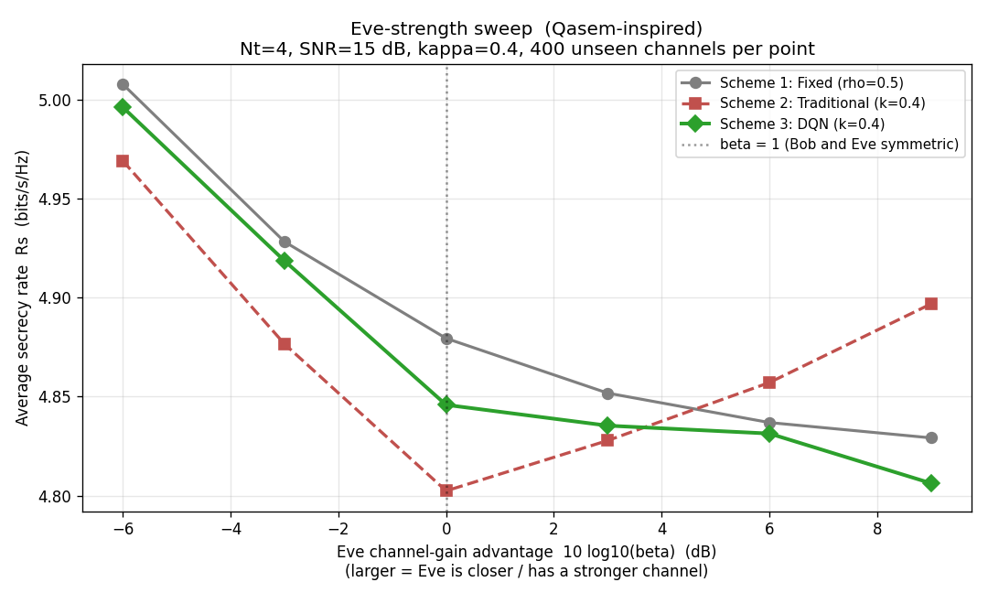
Figure 10: Eve channel-gain advantage sweep, inspired by [8]. Average Rs varies by less than 0.3 bits/s/Hz over a 15 dB range of β.

6.9 Per-channel oracle comparison
The cleanest way to grade an adaptive policy is to compare its per-channel choice against the per-channel oracle. For each channel realisation we brute-force ρ* = argmax of Rs using the true hE, and then ask each scheme to pick its ρ using only what it is allowed to see. Figure 11 reports two histograms: the absolute deviation |ρ − ρ*| on the left and the secrecy-rate gap Rs* − Rs on the right.
The absolute-deviation histograms are similar across schemes. The secrecy-rate-gap histogram tells the more interesting story. The Traditional optimiser’s mean gap is the largest of the three, and that gap is concentrated in a long right tail of the distribution, which means that when Traditional is wrong it tends to be badly wrong. The DQN’s discretisation and learned conservatism keep the resulting Rs penalty small even when its ρ choice is not exactly the oracle’s choice.
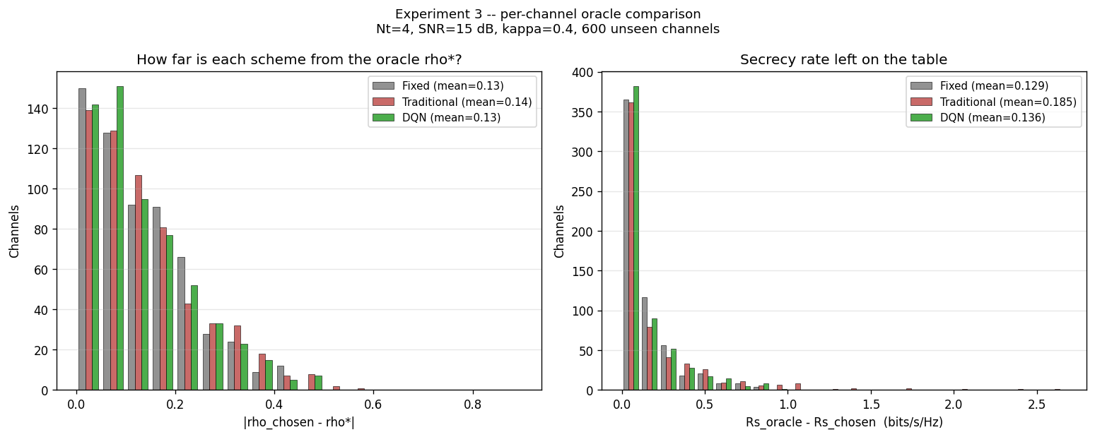
Figure 11: Per-channel oracle comparison. Left: absolute deviation |ρ − ρ*| histograms. Right: secrecy-rate gap Rs* − Rs histograms.

7. Computational Complexity
Table II reports per-call wall-clock latency for each scheme on a single CPU core, averaged over 1000 unseen channels at Nt = 4. The Fixed scheme is essentially free; the Traditional optimiser runs about 7000× slower because of SciPy’s iterative Brent search; the DQN inference is roughly another order of magnitude on top of that. The bulk of the DQN cost is TensorFlow’s per-call Python overhead at unbatched single-sample inference, not the matrix multiplies themselves; a TFLite or batched-inference deployment would cut that overhead substantially. Even at the prototype’s ~4.7 ms per call, the DQN is well within the millisecond budget of a typical wireless control loop.
Table II: Per-call runtime for each scheme, averaged over 1000 unseen channels.
Scheme | μs/call | Relative
Scheme 1 – Fixed | 0.07 | 1×
Scheme 2 – Traditional | 487 | ~7000×
Scheme 3 – DQN | 4716 | ~68000×
The relevant trade-off here is not raw speed — all three schemes are fast enough — but robustness under uncertainty. Scheme 2 is fast and correct only when its estimate is correct. Scheme 3 is slower in absolute terms but does not require its estimate to be correct, and that is the price worth paying for the failure-mode behaviour we showed in Figure 4.

8. Conclusion and Future Work
We studied artificial-noise power allocation for the MISO wiretap channel under the realistic constraint that Alice’s estimate of Eve’s channel is noisy. Three schemes were compared on a common Monte Carlo testbed: a fixed equal split, a per-channel scalar optimiser, and a deep Q-network trained over a distribution of CSI qualities.
The headline finding is that trusting noisy CSI can actively hurt: the scalar optimiser drops below the do-nothing baseline at moderate CSI quality, while the DQN never does. The DQN achieves this by conditioning on κ and on the alignment between Bob’s beam direction and the noisy Eve estimate, and by learning an SNR-conditional bias that puts more power on the signal at low SNR and converges to the Goel–Negi split at high SNR. The same trained policy outperforms or matches the baselines across antenna counts Nt ∈ {2, 4, 8}, across the full κ range, and on the secrecy outage metric. A per-channel oracle comparison confirms that the DQN’s Rs penalty against the unbeatable upper bound is the smallest of the three schemes.
Several extensions are natural. Our channels are i.i.d. Rayleigh with no geometry; lifting the distribution to correlated or path-loss-modulated channels (closer to the Qasem geometric setting [8]) would test the policy’s robustness to a more structured input distribution. The single-shot decision could be lifted to a multi-step block-fading problem with γ > 0, which would let the agent exploit the temporal correlation of slowly varying channels. Modelling Eve as adaptive rather than passive would close the loop into a zero-sum game and motivate multi-agent reinforcement learning. Finally, the small DQN degradation at extreme Eve gains visible in Figure 10 can likely be removed by adding a normalised-gain feature to the state vector or by widening the training distribution along that axis.

References
[1] N. Yang, L. Wang, G. Geraci, M. Elkashlan, J. Yuan, and M. Di Renzo, “Safeguarding 5G wireless communication networks using physical layer security,” IEEE Communications Magazine, vol. 53, no. 4, pp. 20–27, 2015.
[2] A. Mukherjee, S. A. A. Fakoorian, J. Huang, and A. L. Swindlehurst, “Principles of physical layer security in multiuser wireless networks: A survey,” IEEE Communications Surveys & Tutorials, vol. 16, no. 3, pp. 1550–1573, 2014.
[3] A. D. Wyner, “The wire-tap channel,” Bell System Technical Journal, vol. 54, no. 8, pp. 1355–1387, 1975.
[4] S. Goel and R. Negi, “Guaranteeing secrecy using artificial noise,” IEEE Transactions on Wireless Communications, vol. 7, no. 6, pp. 2180–2189, 2008.
[5] D. Wang, B. Bai, W. Zhao, and Z. Han, “A survey of optimization approaches for wireless physical layer security,” IEEE Communications Surveys & Tutorials, vol. 21, no. 2, pp. 1878–1911, 2019.
[6] V. Mnih et al., “Human-level control through deep reinforcement learning,” Nature, vol. 518, no. 7540, pp. 529–533, 2015.
[7] R. S. Sutton and A. G. Barto, Reinforcement Learning: An Introduction, 2nd ed. Cambridge, MA: MIT Press, 2018.
[8] A. A. Qasem, M. Shokair, and F. E. Abd El-Samie, “Physical-layer security enhancement in wireless sensor networks through artificial noise optimization,” Security and Privacy, vol. 7, no. 4, p. e385, 2024.
[9] Y. Liang, H. V. Poor, and S. Shamai, “Secure communication over fading channels,” IEEE Transactions on Information Theory, vol. 54, no. 6, pp. 2470–2492, 2008.
[10] K. Shen and W. Yu, “Fractional programming for communication systems—Part I: Power control and beamforming,” IEEE Transactions on Signal Processing, vol. 66, no. 10, pp. 2616–2630, 2018.
[11] R. Lin, H. Qiu, J. Wang, Z. Zhang, L. Wu, and F. Shu, “Deep reinforcement learning for physical layer security enhancement in energy harvesting-based cognitive radio networks,” Sensors, vol. 23, no. 2, p. 807, 2023.

