VYREX
An Air-Gapped Security Operations Center &
Vulnerability-Intelligence Platform
Software Requirements Specification (SRS)
Version 1.0

Bachelor of Science in Cyber Security — Final Year Design Project
Ghulam Ishaq Khan Institute of Engineering Sciences and Technology (GIKI)
Industry stakeholder: Punjab Information Technology Board (PITB)

Project Title | VYREX — Air-Gapped SOC & Vulnerability-Intelligence Platform
Date | July 2026
Supervisor | ____________________
Group Members | kryptbakar (Team Lead) · ____________ · ____________

Revision History
Version | Date | Comments
1.00 | July 2026 | Initial SRS — baselined against the completed VYREX build (Phases 0–8).
1.10 | July 2026 | Added evaluation, benchmarking, threat-model, and connector requirements.

Document Approval
The following document has been accepted and approved by the following:
Role | Name | Signature | Date
Project Supervisor
Co-Supervisor
FYP Committee

Table of Contents
Right-click and choose “Update Field” to build the table of contents.

List of Figures
Figure 1 — SOC Analyst use cases
Figure 2 — Administrator use cases
Figure 3 — System / machine-actor use cases
Figure 4 — Logical view: the four layers
Figure 5 — Development view: repository modules
Figure 6 — Process view: ingestion, scoring and response
Figure 7 — Physical view: air-gapped deployment topology
Figure 8 — Triage view (decision queue)
Figure 9 — Finding detail (XAI / SHAP waterfall)
Figure 10 — Cases view (incidents & audit)
Figure 11 — Sensors & Fusion view (pipeline + tool grid)

List of Tables
Table 1 — Terms, acronyms and abbreviations
Table 2 — Comparison with existing systems
Table 3 — User classes and characteristics
Table 4 — Functional requirements summary
Table 5–24 — Functional requirement traceability tables
Table 25 — Non-functional requirements
Table 26 — Requirements-to-evaluation traceability

1 INTRODUCTION

1.1 Purpose
This Software Requirements Specification (SRS) defines the functional and non-functional requirements of VYREX, an air-gapped Security Operations Center (SOC) and vulnerability-intelligence platform. It is intended for the project supervisors and FYP evaluation committee, the development team, and the industry stakeholder (PITB) as the agreed contract of what the system does. The document follows the IEEE-830 / ISO/IEC/IEEE-29148 recommended practice: it specifies *what* the system must do and the qualities it must exhibit, and traces each requirement to its rationale, source, and verification evidence, while leaving detailed *how* to the design and implementation.

1.2 Product Scope
VYREX is a centralized SOC that runs fully on-premises and air-gapped: it ingests endpoint telemetry from a lightweight agent and normalized detections from ten integrated open-source security tools, enriches every vulnerability from a locally mirrored feed (CVSS + EPSS exploit probability + CISA KEV), and — its original contribution — fuses findings across tools and prioritizes them with an exploit-aware, explainable risk engine (a transparent composite score plus an XGBoost model with per-finding SHAP explanations). Analysts work a single risk-ranked queue and can execute signed, two-person-approved containment actions.
In scope: telemetry collection; multi-tool ingestion and normalization; offline CVE/EPSS/KEV enrichment; CIS compliance evaluation with tamper-evident evidence; cross-tool fusion and risk scoring with explainability; an analyst console and Grafana dashboards; signed active response; and air-gapped deployment (Docker Compose and K3s). Out of scope: automated destructive response (containment only, always analyst-approved); a managed cloud/SaaS offering; and full Windows-agent feature parity in the MVP.
Benefits: it lets budget-constrained government and defence-adjacent organizations — where foreign SaaS SIEMs are a non-starter because data cannot leave the premises — replace ten disjoint tool consoles with one prioritized, explained, and auditable workflow, with zero live internet dependency at runtime.

1.3 Definitions, Acronyms and Abbreviations
Table 1 — Terms, acronyms and abbreviations used in this document.
Term | Description
SOC | Security Operations Center — the team/platform that monitors and responds to threats.
Air-gapped | A deployment with no runtime internet connectivity; feeds are mirrored offline.
CVE | Common Vulnerabilities and Exposures — a public vulnerability identifier.
CVSS | Common Vulnerability Scoring System — technical severity score (0–10).
EPSS | Exploit Prediction Scoring System (FIRST) — probability a CVE is exploited (0–1).
KEV | CISA Known Exploited Vulnerabilities catalog — CVEs exploited in the wild.
Finding | A single security issue on an asset (a matched CVE, a detection, an IOC hit).
Fusion | Clustering findings that describe the same issue across independent tools.
Consensus | A confidence weight rising with the number of independent tools that agree.
SHAP | SHapley Additive exPlanations — per-feature attribution explaining a model score.
dedup_key | A tool-independent key stamped on findings so fusion can cluster them.
mTLS | Mutual TLS — both client and server authenticate with certificates.
MISP / OpenCTI / Sigma | Threat-intel platforms and a detection-rule format, integrated as connectors.
ATT&CK | MITRE ATT&CK — a knowledge base of adversary techniques (e.g. T1071 = C2).
RBAC | Role-Based Access Control — permissions by role (viewer / analyst / admin).
SRS / FR / NFR | This document / Functional Requirement / Non-functional Requirement.

1.4 References
- IEEE Std 830-1998 / ISO/IEC/IEEE 29148:2018 — Recommended practice for Software Requirements Specifications.
- FIRST EPSS model documentation; CISA Known Exploited Vulnerabilities catalog; NIST NVD.
- MITRE ATT&CK framework; CIS Benchmarks (Debian 12).
- VYREX repository docs: ARCHITECTURE.md, DECISIONS.md (49 logged decisions), METHODOLOGY.md, THREAT-MODEL.md, BENCHMARKS.md, VALIDATION-ATTACK-SIM.md, PRODUCTION-DEPLOYMENT.md, CONNECTORS.md.
- Kruchten, P. (1995). Architectural Blueprints — The 4+1 View Model of Software Architecture.

2 OVERVIEW

2.1 The Overall Description
VYREX is organized in four layers: an endpoint agent, an ingestion & assessment pipeline, a data layer, and a presentation layer. Telemetry and tool detections flow up through a stateless, schema-validating edge into a durable message broker and asynchronous workers that enrich, fuse, and score findings; the results are presented to analysts as a ranked, explained queue and as dashboards. Exactly one component may reach the internet — a feed-sync job that mirrors vulnerability intelligence — and it is used offline everywhere else.

2.2 Product Perspective
VYREX is a new, self-contained product that composes best-in-class open-source components (PostgreSQL, TimescaleDB, OpenSearch, NATS JetStream, Suricata, Zeek, Wazuh, Trivy, Nuclei, MISP, OpenCTI, Sigma, Falco) and contributes original value in the intelligence layer. It is not a plug-in to an existing SIEM; rather, tools attach to it as connectors (see §7). The design philosophy — integrate, don't reinvent; spend original effort on fusion, scoring and explainability — is recorded across 49 logged design decisions.
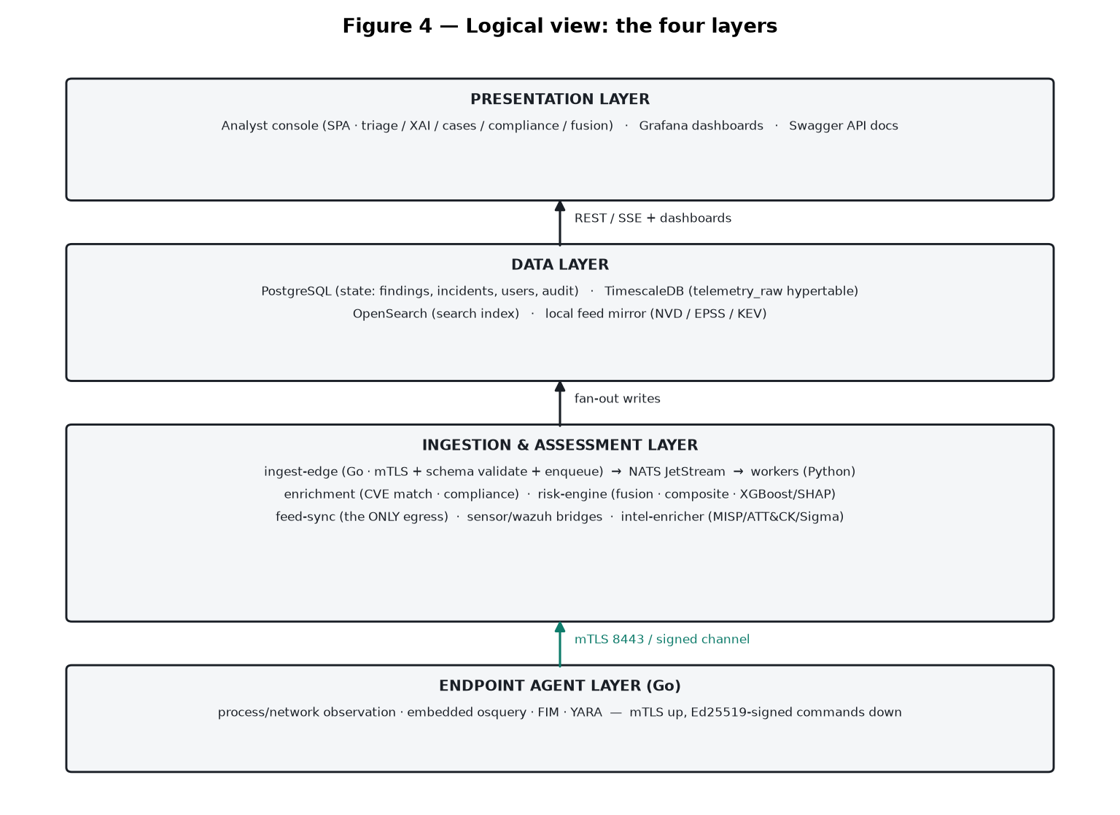
Figure 4 — Logical view: the four architectural layers of VYREX.

2.3 Product Functions
- Collect endpoint telemetry (process, network, file-integrity, osquery host state) over mTLS.
- Integrate ten OSS tools, normalizing every detection to one versioned telemetry envelope.
- Enrich each CVE with CVSS + EPSS + KEV from a local mirror; evaluate CIS compliance with a hash-chained evidence log.
- Fuse findings across tools by a tool-independent dedup key, deriving a consensus confidence weight.
- Prioritize with a transparent 10-factor composite score and an XGBoost model, each explained per-finding by SHAP.
- Respond via an Ed25519-signed command channel with two-person approval and a hash-chained audit trail (containment only).
- Present a real-time analyst console (triage, XAI detail, cases, compliance, fusion) plus Grafana dashboards.
- Deploy fully air-gapped via Docker Compose or K3s, with a verified single-egress boundary and an offline installer bundle.

2.4 User Characteristics
Table 3 — User classes and characteristics.
User class | Type | Characteristics & responsibilities
SOC Analyst | Primary user | Works the triage queue, inspects XAI detail, triages/labels findings, opens cases, requests containment. Security literate; not necessarily a developer.
Senior Analyst | Approver | All analyst abilities plus second-person approval of containment actions (admin role).
SOC Administrator | Operator | Deploys and maintains the stack, manages users/RBAC, rolls out signed agents, retrains the model, sets defense policy, runs backups.
Staging-host Operator | Feed custodian | Runs the only internet-facing jobs (feed-sync / mirror-sync) on a connected DMZ host and carries updates across the gap.
Auditor / Assessor | Read-only | Verifies compliance posture and hash-chained audit integrity; viewer role.

2.5 Constraints
- Air-gap. No runtime internet access is permitted; only feed-sync (on a staging host) may egress, and the boundary is verifiable.
- Linux-first server. The server stack runs on Linux (Ubuntu 22.04 / Rocky 9) via Docker/Kubernetes; agents are cross-platform.
- On-premises only. All data and models remain on site; no third-party SaaS or telemetry egress.
- Open-source licensing. GPL/AGPL components are used at arm's length (never vendored into the product); licenses are verified.
- Explainability. Every risk score must be defensible: composite contributions and SHAP attributions are mandatory.
- Two-person control. No destructive action; containment requires two distinct approvals and is cryptographically signed and audited.

2.6 Assumptions and Dependencies
- A connected staging host of the same CPU architecture is available periodically to refresh the offline feed/tool mirror.
- Network sensors (Suricata/Zeek) are fed by a SPAN/mirror port or TAP — a physical prerequisite that cannot be met in software.
- Endpoints can run the signed Go agent and are issued mTLS client certificates from the site PKI (Vault in K3s).
- Docker Engine + Compose (pilot) or a K3s cluster (production) with sufficient CPU/RAM/SSD per the sizing tables is provided.
- The synthetic training prior is replaced by real analyst-feedback labels as a deployment accrues them (retraining loop).

3 STATE OF THE ART

3.1 Literature Review
Vulnerability management has shifted from severity-only (CVSS) triage toward exploit-aware prioritization. Research and practice (FIRST's EPSS, CISA's KEV catalog) show that CVSS alone over-prioritizes: most high-CVSS CVEs are never exploited, while a small, EPSS/KEV-identifiable subset drives real risk. Modern detection stacks are also multi-tool, producing overlapping, un-correlated alerts; the analyst burden is correlation and prioritization, not detection. Finally, explainable AI (SHAP / Shapley additive attributions) has become the accepted way to make ML-based scoring auditable — essential in a security context where an analyst must justify why a finding was escalated. VYREX synthesizes these threads: exploit-aware scoring, cross-tool fusion, and per-finding explanation, under a hard air-gap constraint that rules out mainstream cloud SIEMs.

3.2 Existing Systems
Table 2 — Comparison with existing systems.
Capability | Wazuh (alone) | Elastic Security | Splunk ES | VYREX
Fully air-gapped, no telemetry egress | Yes | Self-managed only | Self-managed only | Yes — verified
Host+network+vuln+intel in one pipeline | Host-centric | Broad (paid) | Broad (paid) | Yes — 10 OSS tools
Cross-tool consensus as a ranking signal | No | Manual rules | Manual searches | Yes — automatic
Exploit-aware scoring (EPSS+KEV) built in | Partial (CVSS) | Via integrations | Via apps | Yes — native
Per-finding ML explanation (SHAP) | No | Limited | Limited | Yes — TreeSHAP
Signed, two-person active response | Limited | Via connectors | Via SOAR (paid) | Yes — Ed25519
Cost model | OSS | Paid tiers | Licensed | OSS + on-prem
VYREX does not aim to out-feature Splunk on connector breadth or scale-out maturity. Its thesis is that for the air-gapped, budget-constrained, prioritization-overwhelmed SOC, a fusion-and-explanation layer over best-in-class OSS beats both a single heavyweight vendor and ten disjoint consoles.

4 USER / SYSTEM REQUIREMENTS
This section captures the requirements from the users' and the system's viewpoint, then the external interfaces. Actors and their goals are shown in the use-case diagrams (Figures 1–3); the functional requirements of §5 realize these use cases.
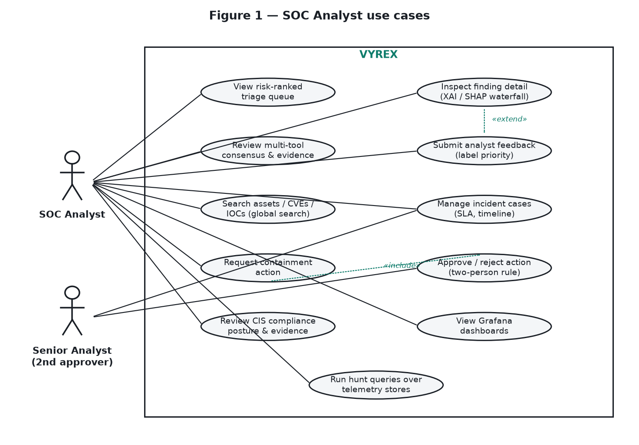
Figure 1 — SOC Analyst and Senior Analyst use cases.
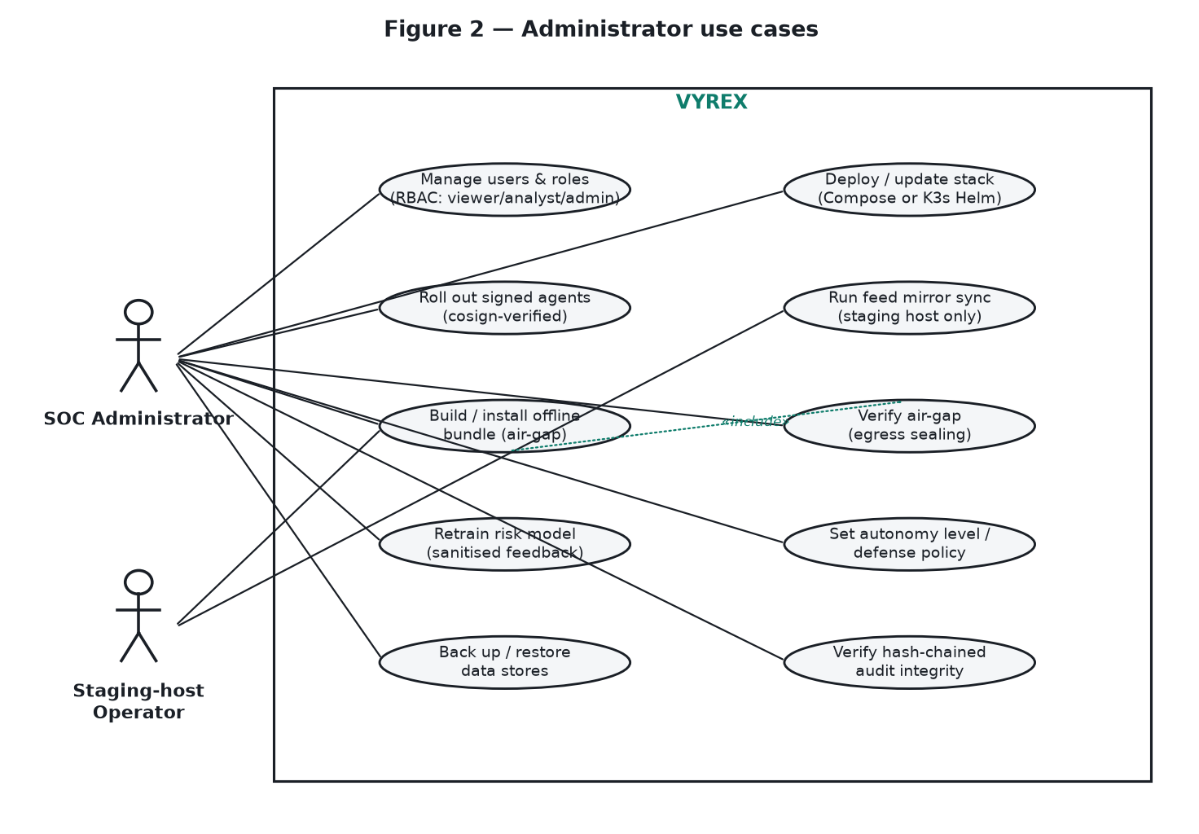
Figure 2 — Administrator and Staging-host Operator use cases.
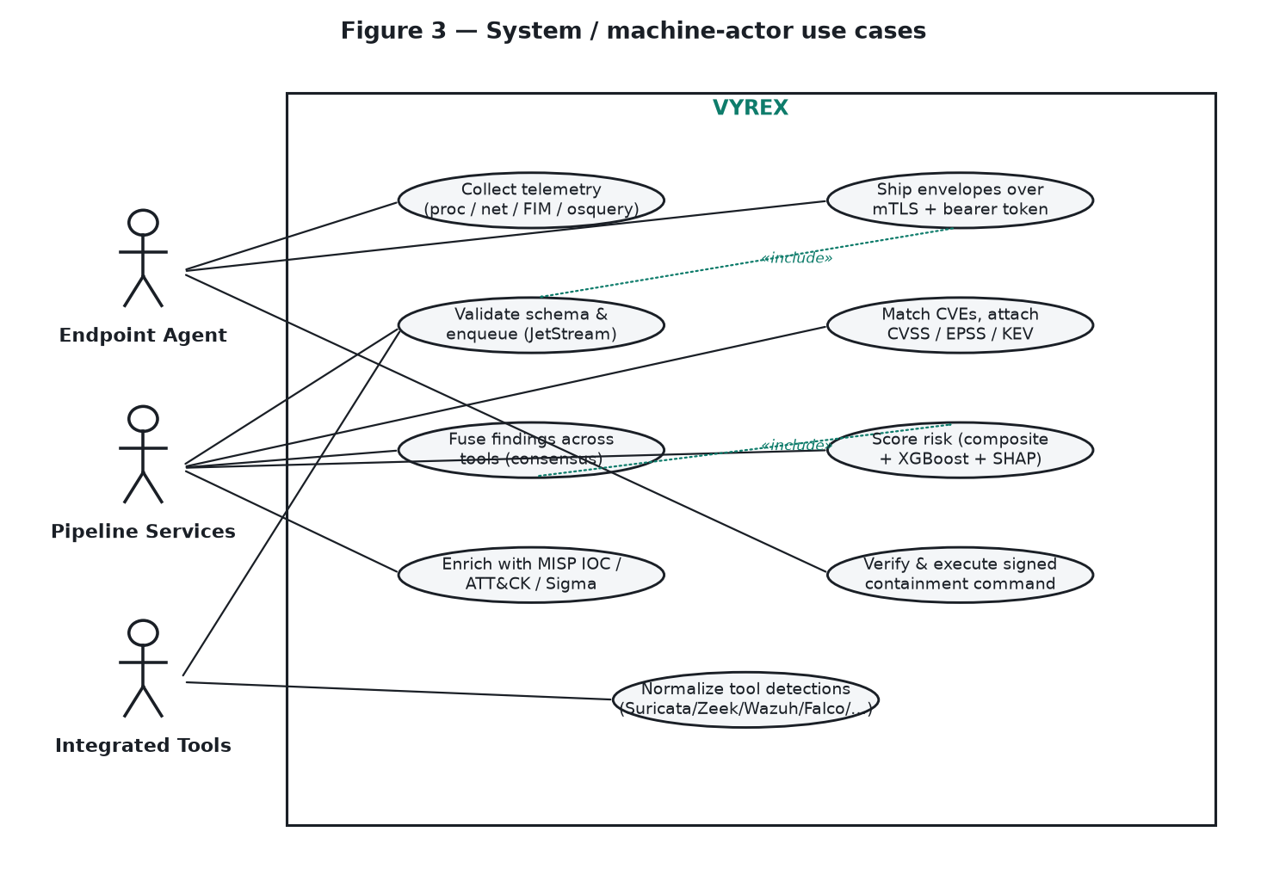
Figure 3 — System / machine-actor use cases (agent, pipeline, tools).

4.1 External Interface Requirements

4.1.1 User Interfaces
- A dependency-free single-page analyst console served over HTTPS with five views: Triage, Finding Detail (XAI), Compliance, Cases, and Sensors & Fusion (see Figures 8–11).
- A conclusion-first, instrument-grade design language (charcoal canvas, single teal accent on interactive chrome only), WCAG-AA severity encoding by shape and label (not color alone), and full keyboard navigation.
- Grafana dashboards for metrics, trends and heatmaps; Swagger UI for the REST API.

4.1.2 Hardware Interfaces
- Endpoint hosts: the Go agent reads process/network activity, file-integrity events and osquery host state; resource-capped (configurable CPU/memory).
- Network sensor host: a NIC in promiscuous mode fed by a SPAN/mirror port or TAP for Suricata/Zeek.
- Server: x86-64 Linux host(s) with SSD/NVMe storage per the sizing tables (pilot 8c/32GB/1TB; production 3+ K3s nodes).

4.1.3 Software Interfaces
- Data stores: PostgreSQL (transactional state), TimescaleDB (telemetry hypertable), OpenSearch (search).
- Broker: NATS JetStream (durable subjects telemetry.v1.<kind>).
- Integrated tools as connectors: Suricata, Zeek, Wazuh, Falco, Trivy, Nuclei, MISP, OpenCTI, Sigma.
- Local feed mirror: NVD, EPSS, CISA KEV; tool feeds (Nuclei templates, Trivy DB, Sigma rules, ET Open).
- Identity: Keycloak (OIDC/RBAC) and HashiCorp Vault (secrets, PKI) in the K3s deployment.

4.1.4 Communication Interfaces
- Agent → ingest-edge: mutual TLS (TLS 1.2+) on port 8443 with a bearer token; the agent_id is cross-checked against the client-cert CN.
- Server → agent: an Ed25519-signed command channel (nonce + expiry) for containment; the agent verifies fail-closed before executing.
- Analyst → console/API: HTTPS with OIDC (Keycloak) or local session tokens; RBAC enforced on every non-public route.
- feed-sync → internet: the single permitted egress, NetworkPolicy-enforced and provable via `make airgap-verify`.

5 FUNCTIONAL REQUIREMENTS
The functional requirements are listed below and then specified individually with traceability information (each in its own table, per the template). Requirement IDs are of the form FR-n; use cases are UC-n as shown in Figures 1–3.
Table 4 — Functional requirements summary.
ID | Requirement | Priority | Use case
FR-01 | Telemetry collection | High | UC-Collect
FR-02 | Secure ingestion | High | UC-Ship / UC-Ingest
FR-03 | Durable queueing & storage | High | UC-Ingest
FR-04 | Multi-tool integration | High | UC-Sensors
FR-05 | Offline CVE enrichment | High | UC-Enrich
FR-06 | CIS compliance evaluation | Medium | UC-Comply
FR-07 | Cross-tool fusion | High | UC-Fuse
FR-08 | Composite risk scoring | High | UC-Score
FR-09 | ML risk scoring | High | UC-Score
FR-10 | Per-finding explainability | High | UC-Detail
FR-11 | Threat-intel & ATT&CK enrichment | Medium | UC-Intel
FR-12 | Risk-ranked triage queue | High | UC-Triage
FR-13 | Analyst feedback loop | Medium | UC-Feedback
FR-14 | Incident case management | Medium | UC-Case
FR-15 | Signed active response | High | UC-Request / UC-Exec
FR-16 | Two-person approval | High | UC-Approve
FR-17 | Authentication & RBAC | High | UC-Users
FR-18 | Air-gap enforcement & verification | High | UC-Airgap
FR-19 | Offline installation & updates | Medium | UC-Bundle
FR-20 | Dashboards & search | Medium | UC-Dash / UC-Hunt

5.1 Functional Requirements with Traceability Information
Each requirement is specified below in its own traceability table.
Requirement ID | FR-01 — Telemetry collection
Status | Baselined · Priority: High
Description | The endpoint agent shall collect process events, network flows, file-integrity events and osquery host-state and ship them as schema-valid telemetry envelopes.
Rationale | Endpoints must be observable to detect and enrich threats.
Source | PITB requirement; ARCHITECTURE §Agent
Use case / Verification | UC-Collect · Verified by: unit tests / evaluation harness / e2e smoke (see §6.2, Table 26)

Requirement ID | FR-02 — Secure ingestion
Status | Baselined · Priority: High
Description | The system shall accept telemetry only over mutual TLS with a valid bearer token, validate each envelope against schema v1, and reject non-conforming or mismatched (agent_id≠cert CN) events.
Rationale | Prevents spoofed or malformed telemetry from poisoning the pipeline.
Source | THREAT-MODEL TB1
Use case / Verification | UC-Ship / UC-Ingest · Verified by: unit tests / evaluation harness / e2e smoke (see §6.2, Table 26)

Requirement ID | FR-03 — Durable queueing & storage
Status | Baselined · Priority: High
Description | The system shall enqueue validated telemetry on a durable broker (JetStream) and persist it to TimescaleDB and OpenSearch idempotently (event_id as key).
Rationale | Decouples ingest from processing and protects stores via back-pressure.
Source | ARCHITECTURE §Ingestion
Use case / Verification | UC-Ingest · Verified by: unit tests / evaluation harness / e2e smoke (see §6.2, Table 26)

Requirement ID | FR-04 — Multi-tool integration
Status | Baselined · Priority: High
Description | The system shall integrate ten OSS tools (Suricata, Zeek, Wazuh, Falco, Trivy, Nuclei, MISP, OpenCTI, Sigma, and the agent), normalizing every detection into findings or envelopes.
Rationale | One normalized pipeline replaces ten disjoint consoles.
Source | Product scope; CONNECTORS.md
Use case / Verification | UC-Sensors · Verified by: unit tests / evaluation harness / e2e smoke (see §6.2, Table 26)

Requirement ID | FR-05 — Offline CVE enrichment
Status | Baselined · Priority: High
Description | The system shall match discovered packages/CVEs and attach CVSS, EPSS and KEV from the local mirror, with no live internet call at runtime.
Rationale | Exploit-aware context is the basis of prioritization; air-gap forbids live calls.
Source | Literature (EPSS/KEV); AIRGAP.md
Use case / Verification | UC-Enrich · Verified by: unit tests / evaluation harness / e2e smoke (see §6.2, Table 26)

Requirement ID | FR-06 — CIS compliance evaluation
Status | Baselined · Priority: Medium
Description | The system shall evaluate assets against CIS-benchmark-style rules producing pass/fail/partial/not-applicable, recording each result with a hash-chained evidence entry.
Rationale | Regulated buyers require auditable hardening posture.
Source | PITB compliance need
Use case / Verification | UC-Comply · Verified by: unit tests / evaluation harness / e2e smoke (see §6.2, Table 26)

Requirement ID | FR-07 — Cross-tool fusion
Status | Baselined · Priority: High
Description | The system shall cluster findings sharing a tool-independent dedup_key into one issue and compute a consensus weight rising with the number of distinct corroborating tools.
Rationale | Independent corroboration is a strong, original prioritization signal.
Source | FUSION.md; original contribution
Use case / Verification | UC-Fuse · Verified by: unit tests / evaluation harness / e2e smoke (see §6.2, Table 26)

Requirement ID | FR-08 — Composite risk scoring
Status | Baselined · Priority: High
Description | The system shall compute a transparent composite risk score (0–100) as a weighted sum of ten normalized factors, recording each factor's point contribution.
Rationale | A defensible, fully explainable baseline score.
Source | scoring.py; METHODOLOGY §FR4
Use case / Verification | UC-Score · Verified by: unit tests / evaluation harness / e2e smoke (see §6.2, Table 26)

Requirement ID | FR-09 — ML risk scoring
Status | Baselined · Priority: High
Description | The system shall additionally score each finding with a trained XGBoost model capturing non-linear factor interactions.
Rationale | Learned interactions (KEV×EPSS, exposure×CVSS) improve ranking over the linear score.
Source | train.py; evaluate.py
Use case / Verification | UC-Score · Verified by: unit tests / evaluation harness / e2e smoke (see §6.2, Table 26)

Requirement ID | FR-10 — Per-finding explainability
Status | Baselined · Priority: High
Description | The system shall produce, for every ML score, an exact TreeSHAP attribution reconciling base + Σ contributions ≈ final, surfaced as a waterfall in the console.
Rationale | Every escalation must be auditable and defensible.
Source | explain.py; CONSOLE §SHAP
Use case / Verification | UC-Detail · Verified by: unit tests / evaluation harness / e2e smoke (see §6.2, Table 26)

Requirement ID | FR-11 — Threat-intel & ATT&CK enrichment
Status | Baselined · Priority: Medium
Description | The system shall enrich findings with MISP IOC matches, MITRE ATT&CK technique mapping, and Sigma detections.
Rationale | Real-world activity and adversary context sharpen prioritization.
Source | intel-enricher; features.py
Use case / Verification | UC-Intel · Verified by: unit tests / evaluation harness / e2e smoke (see §6.2, Table 26)

Requirement ID | FR-12 — Risk-ranked triage queue
Status | Baselined · Priority: High
Description | The system shall present findings as a decision queue ranked by composite risk, filterable by domain, severity, source tool and KEV.
Rationale | Analysts must work the most important findings first.
Source | CONSOLE §Triage
Use case / Verification | UC-Triage · Verified by: unit tests / evaluation harness / e2e smoke (see §6.2, Table 26)

Requirement ID | FR-13 — Analyst feedback loop
Status | Baselined · Priority: Medium
Description | The system shall let an analyst assign a priority label to a finding and shall fold sanitized feedback into model retraining at bounded influence.
Rationale | Turns triage into training signal while resisting label poisoning.
Source | feedback.py; THREAT-MODEL ML
Use case / Verification | UC-Feedback · Verified by: unit tests / evaluation harness / e2e smoke (see §6.2, Table 26)

Requirement ID | FR-14 — Incident case management
Status | Baselined · Priority: Medium
Description | The system shall manage incident cases with status and SLA and a hash-chained audit timeline of all actions.
Rationale | Investigations need tracking and a tamper-evident record.
Source | CONSOLE §Cases
Use case / Verification | UC-Case · Verified by: unit tests / evaluation harness / e2e smoke (see §6.2, Table 26)

Requirement ID | FR-15 — Signed active response
Status | Baselined · Priority: High
Description | The system shall issue containment commands only as Ed25519-signed messages (nonce+expiry) that the agent verifies fail-closed before executing; commands are a fixed containment allow-list, never arbitrary shell.
Rationale | A hijacked response channel is RCE-equivalent; it must be authenticated and bounded.
Source | D-028; THREAT-MODEL TB5
Use case / Verification | UC-Request / UC-Exec · Verified by: unit tests / evaluation harness / e2e smoke (see §6.2, Table 26)

Requirement ID | FR-16 — Two-person approval
Status | Baselined · Priority: High
Description | The system shall require two distinct approver identities before any containment action is authorized, enforced server-side.
Rationale | Prevents unilateral or mistaken destructive action.
Source | D-027/D-028
Use case / Verification | UC-Approve · Verified by: unit tests / evaluation harness / e2e smoke (see §6.2, Table 26)

Requirement ID | FR-17 — Authentication & RBAC
Status | Baselined · Priority: High
Description | The system shall require an authenticated principal (OIDC header or session token) on every non-public route and enforce role permissions (viewer read-only, analyst read+write, admin for response/defense); authentication is mandatory in production.
Rationale | Protects the crown-jewel telemetry and the response channel.
Source | auth_guard.py; THREAT-MODEL TB2
Use case / Verification | UC-Users · Verified by: unit tests / evaluation harness / e2e smoke (see §6.2, Table 26)

Requirement ID | FR-18 — Air-gap enforcement & verification
Status | Baselined · Priority: High
Description | The system shall confine internet egress to feed-sync alone and provide a harness that proves the runtime boundary is sealed.
Rationale | The core promise to an air-gapped buyer must be provable, not asserted.
Source | airgap-verify; NFR air-gap
Use case / Verification | UC-Airgap · Verified by: unit tests / evaluation harness / e2e smoke (see §6.2, Table 26)

Requirement ID | FR-19 — Offline installation & updates
Status | Baselined · Priority: Medium
Description | The system shall build a checksummed offline bundle (images + feed mirror + config) on a connected host and install it inside the air gap with fail-closed integrity verification.
Rationale | Software and feed updates must cross the gap safely and repeatably.
Source | bundle.sh/install.sh; PRODUCTION-DEPLOYMENT §3
Use case / Verification | UC-Bundle · Verified by: unit tests / evaluation harness / e2e smoke (see §6.2, Table 26)

Requirement ID | FR-20 — Dashboards & search
Status | Baselined · Priority: Medium
Description | The system shall provide Grafana dashboards (metrics/trends/heatmaps) and global search over assets, CVEs and IOCs across the stores.
Rationale | Situational awareness and hunting complement the triage queue.
Source | grafana/; search router
Use case / Verification | UC-Dash / UC-Hunt · Verified by: unit tests / evaluation harness / e2e smoke (see §6.2, Table 26)

6 NON-FUNCTIONAL REQUIREMENTS & SOFTWARE SYSTEM ATTRIBUTES

6.1 Performance Requirements
Performance targets are measured with the in-repo benchmark harness (BENCHMARKS.md: ingest throughput, end-to-end latency, API load, footprint). The values below are the target envelope for a single-node pilot; production K3s scales stateless workers horizontally.
Table 25 — Non-functional requirements and software system attributes.
ID | Attribute | Name | Requirement
NFR-01 | Performance | Ingest throughput | Sustain the pilot's measured events/sec through edge→queue→workers→stores without unbounded lag (ramp 5k→200k envelopes).
NFR-02 | Performance | End-to-end latency | Median (p50) telemetry-to-queryable latency within the documented target; p95/p99 reported.
NFR-03 | Performance | API responsiveness | Console hot-path endpoints meet p95 < 400 ms at 20 virtual users, error rate < 1% (k6 gate).
NFR-04 | Security | Confidentiality & authN | mTLS ingestion; mandatory OIDC/session auth + RBAC on every non-public route in production.
NFR-05 | Security | Integrity / tamper-evidence | Compliance evidence and response audit are hash-chained and verifiable; agent supply chain is cosign-signed.
NFR-06 | Security | Air-gap | Zero runtime egress except feed-sync; boundary provable via airgap-verify.
NFR-07 | Reliability | Durability & back-pressure | No telemetry loss under sustained load; broker back-pressure protects the stores; idempotent writes.
NFR-08 | Availability | Recoverability | Scheduled backup/restore of all stores (Velero/backup); tested restore procedure.
NFR-09 | Explainability | Auditable scoring | Every score exposes composite factor contributions and exact SHAP attributions; fixed seeds make ML reproducible.
NFR-10 | Usability | Accessibility | WCAG-AA severity encoding by shape+label (not color alone); full keyboard navigation.
NFR-11 | Maintainability | Tested & CI-gated | Automated tests (91) plus Go vet, image scan, and k3d + Compose e2e smokes run in CI on every change.
NFR-12 | Portability | Deployment footprints | Runs as single-node Docker Compose (pilot) and multi-node K3s via a Helm chart (production).
NFR-13 | Scalability | Horizontal workers | Stateless ingest and workers scale out in K3s to grow ingest capacity for larger estates.
NFR-14 | Extensibility | Pluggable connectors | New tools attach via the documented connector contract (envelope or findings + dedup_key) with no core change.

6.2 Verification & Requirements Traceability
Table 26 — Requirements-to-evaluation traceability (how each requirement is verified).
Requirement(s) | Verification evidence
FR-07/08/09/10 (fusion, scoring, ML, XAI) | ml/evaluate.py + eval_fusion.py + attack_scenario.py; unit tests (fusion, scoring, features, dataset, evaluate, feedback, attack-scenario).
FR-05/06 (enrichment, compliance) | services/enrichment/tests (version→CVE matching; compliance pass/fail/NA).
FR-17 (authN + RBAC) | services/api/tests/test_auth_guard.py (401 unauth, RBAC 403s, production-forces-auth).
FR-01..05,12,20 (end-to-end pipeline) | deploy/smoke/compose-smoke.sh: ingest→assess→score→assert findings carry a risk_score.
NFR-01/02/03 (performance) | tools/fake-producer/e2e_latency.py, make bench-ingest, tools/load/k6-api.js.
NFR-06 (air-gap) | tools/airgap/verify-egress.sh (make airgap-verify).
NFR-11 (CI gates) | .github/workflows/ci.yml: pytest (91), go vet+build, Trivy scan, k3d smoke, compose e2e smoke.

7 PROJECT DESIGN / ARCHITECTURE
The architecture is documented with Kruchten's 4+1 view model. The Use-Case view (Figures 1–3, §4) is the “+1” that ties the others together; the Logical, Development, Process and Physical views follow.

7.1 Use-Case View
Actors and goals are shown in Figures 1–3: SOC Analyst and Senior Analyst (triage, XAI inspection, feedback, cases, containment request and approval); Administrator and Staging-host Operator (deployment, users/RBAC, agent rollout, feed mirroring, offline bundle, retraining, air-gap verification); and machine actors — the Endpoint Agent, the Pipeline Services and the Integrated Tools.

7.2 Logical View
Figure 4 shows the four cooperating layers and the responsibilities and key collaborations of each. The intelligence layer (enrichment + fusion + scoring + explanation) is where the original contribution lives; everything else composes proven OSS.

7.3 Development View
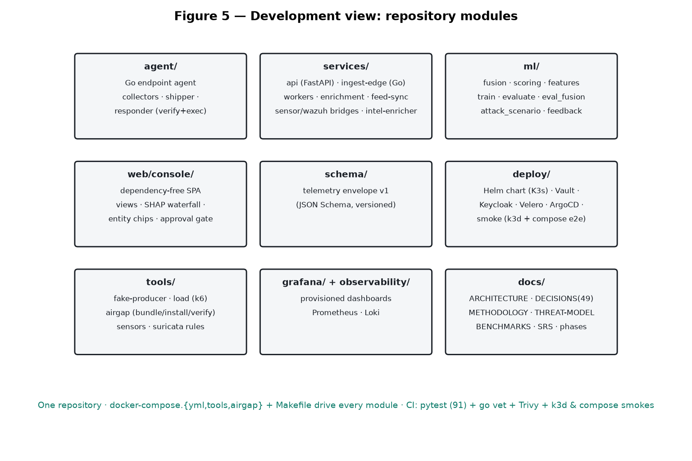
Figure 5 — Development view: repository modules and their roles.
VYREX is a single repository whose modules map cleanly onto the layers: agent/, services/ (api, ingest-edge, workers, enrichment, feed-sync, bridges), ml/ (fusion, scoring, training, evaluation), web/console/, schema/, deploy/ (Helm, Vault, Keycloak, smokes), tools/ (producer, load, airgap), and docs/. Docker Compose files and a Makefile drive every module; CI gates the whole.

7.4 Process View
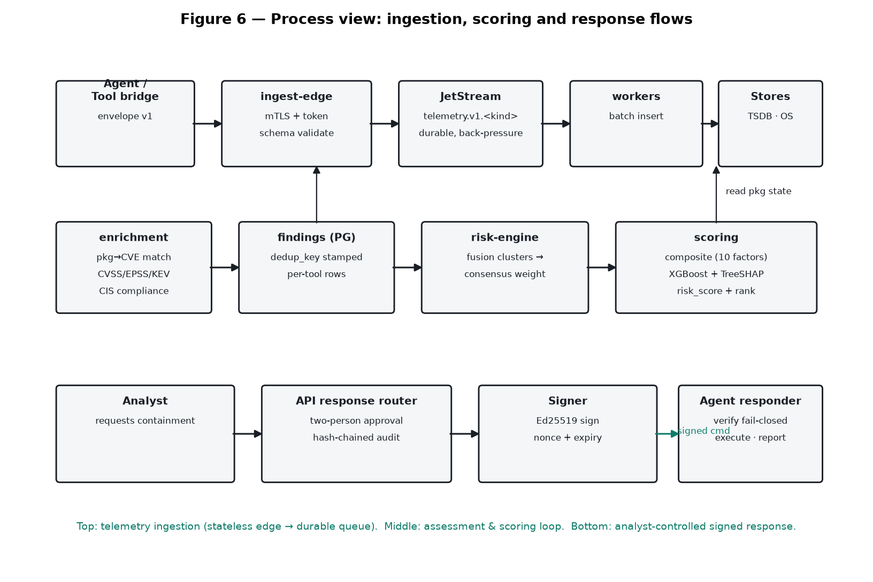
Figure 6 — Process view: the ingestion, scoring and signed-response flows.
Three runtime flows cooperate: (1) stateless telemetry ingestion into a durable queue; (2) the assessment & scoring loop (enrich → fuse → composite + ML + SHAP → rank); and (3) analyst-controlled, two-person, Ed25519-signed containment with a hash-chained audit.

7.5 Physical View
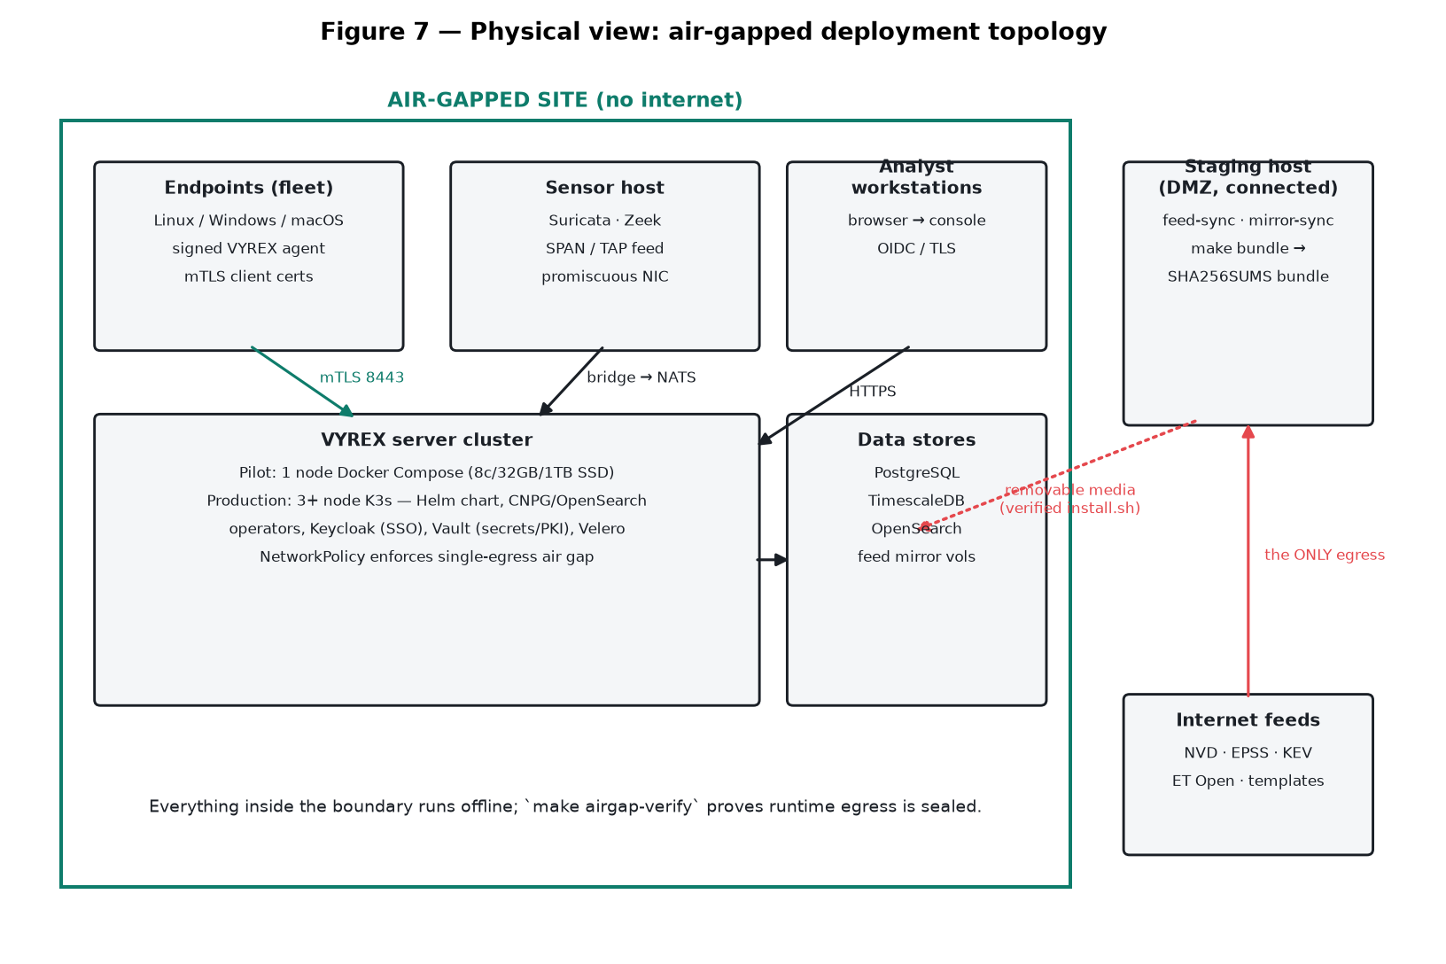
Figure 7 — Physical view: air-gapped deployment topology.
Endpoints, sensor host, analyst workstations, the server cluster and data stores all sit inside the sealed boundary. Only a DMZ staging host reaches the internet to mirror feeds; updates cross the gap on verified removable media via the offline installer bundle. The single-egress invariant is enforced (NetworkPolicy) and proven (airgap-verify).

7.6 User Interface Design
The console realizes the presentation requirements in a conclusion-first, instrument-grade design language (charcoal canvas, one teal accent used only on interactive chrome, severity by shape and label for WCAG-AA). The four wireframes below show the primary screens.
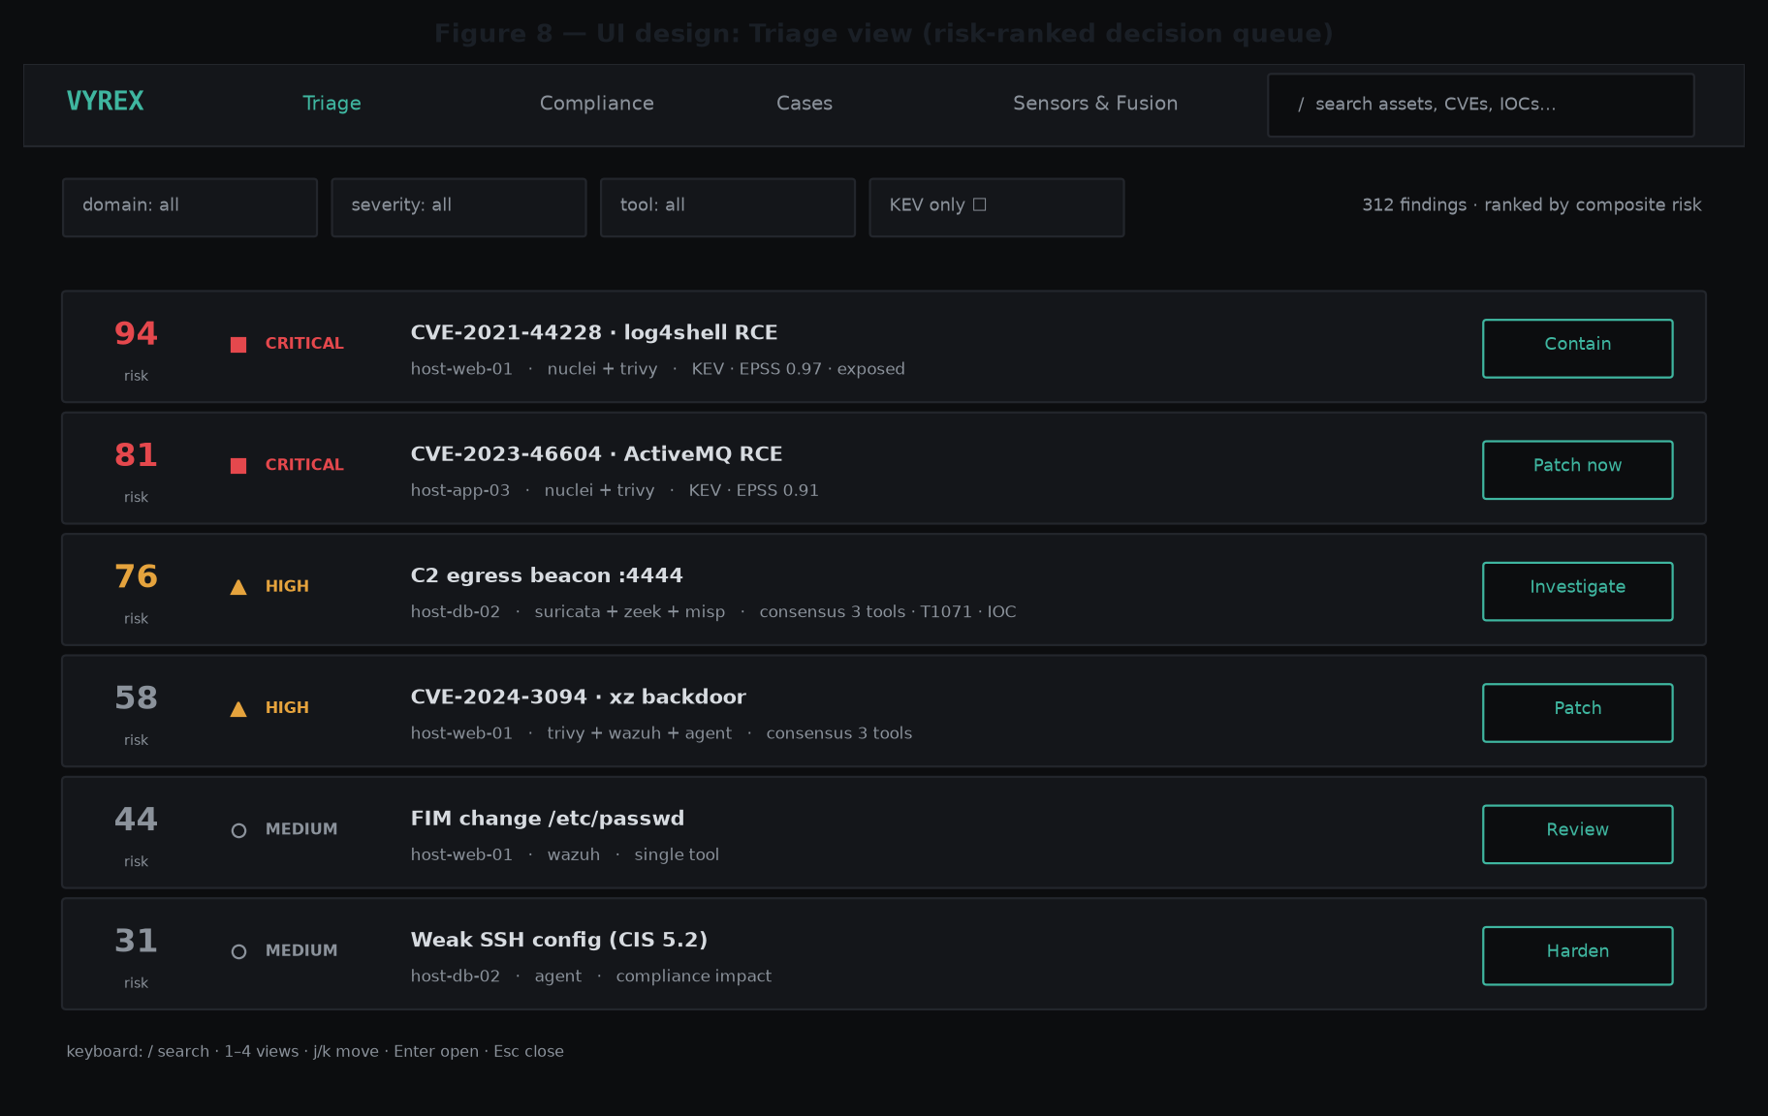
Figure 8 — Triage view: the risk-ranked decision queue (each row = a conclusion + one action).
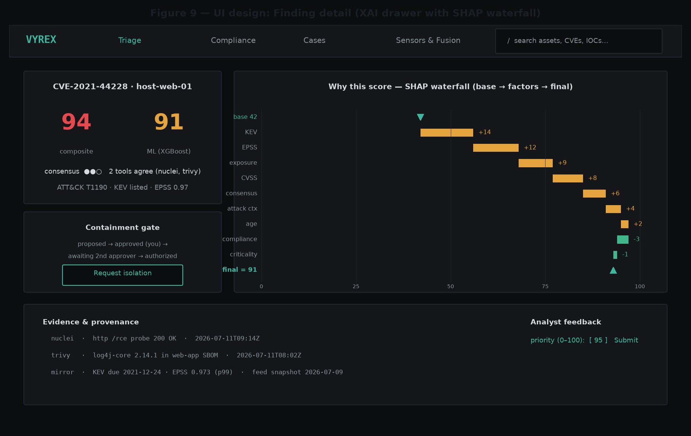
Figure 9 — Finding detail: the XAI drawer with composite + ML scores, the SHAP waterfall, the containment gate and evidence provenance.
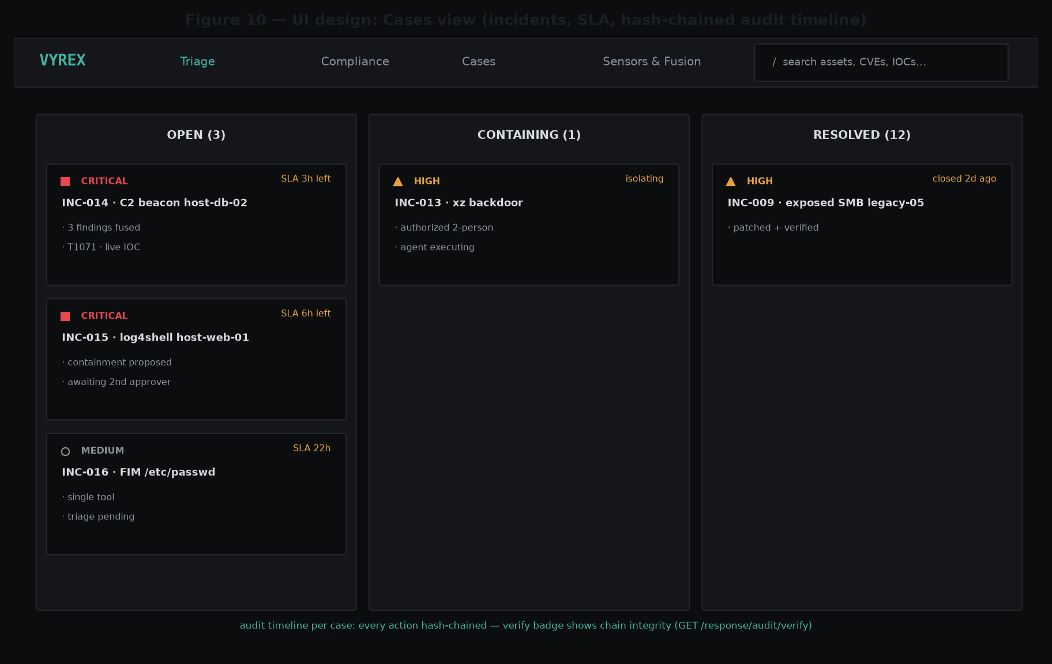
Figure 10 — Cases view: incidents with SLA and a hash-chained audit timeline.
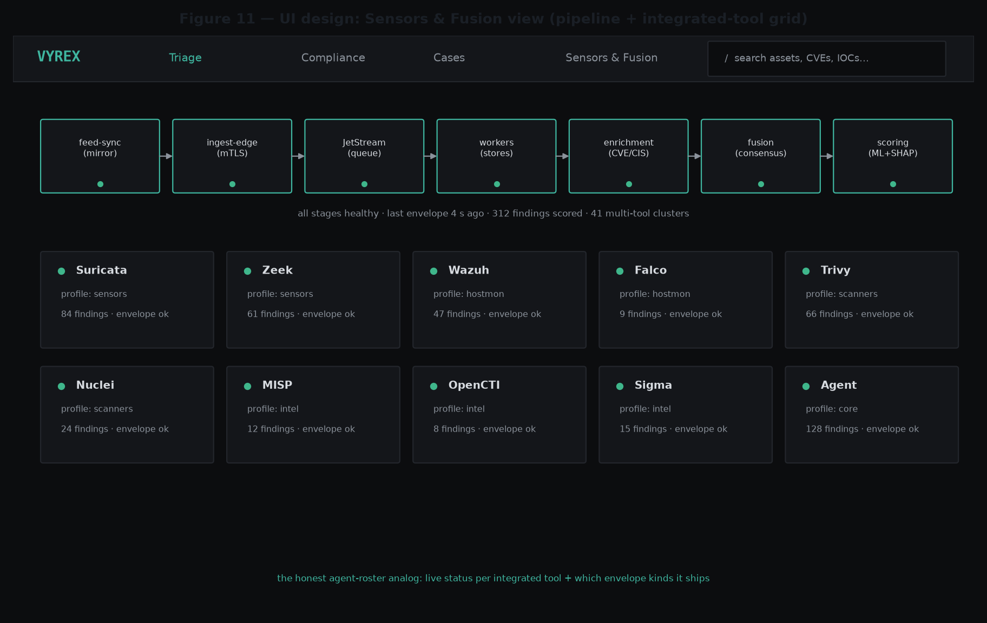
Figure 11 — Sensors & Fusion view: the live pipeline and the integrated-tool grid.

8 CONCLUSION
This SRS specifies VYREX as an air-gapped SOC whose distinguishing value is the intelligence layer: exploit-aware, cross-tool, explainable prioritization over best-in-class open-source detection. The twenty functional and fourteen non-functional requirements are each traceable to a rationale, a source, and — importantly — concrete verification evidence already present in the build (unit and component tests, evaluation and benchmark harnesses, an end-to-end smoke, and air-gap verification). The system is implemented and its claims are measured rather than asserted, satisfying both the academic bar for a final-year design project and the due-diligence bar for a deployable product.

