**Capstone Project**

**(Stage 1)**

[Description](https://docs.google.com/document/d/1gKP6RxykeekNk5bYxXIKjEitKDPdxpRyIaa9t50bLSA/edit#heading=h.sm4ra97uwo11)

[Intended User](https://docs.google.com/document/d/1gKP6RxykeekNk5bYxXIKjEitKDPdxpRyIaa9t50bLSA/edit#heading=h.aws88pzfmqca)

[Features](https://docs.google.com/document/d/1gKP6RxykeekNk5bYxXIKjEitKDPdxpRyIaa9t50bLSA/edit#heading=h.zheq5430xrpq)

[User Interface Mocks](https://docs.google.com/document/d/1gKP6RxykeekNk5bYxXIKjEitKDPdxpRyIaa9t50bLSA/edit#heading=h.giquerrw6g46)

[Screen 1](https://docs.google.com/document/d/1gKP6RxykeekNk5bYxXIKjEitKDPdxpRyIaa9t50bLSA/edit#heading=h.a4jdupabry3k)

[Screen 2](https://docs.google.com/document/d/1gKP6RxykeekNk5bYxXIKjEitKDPdxpRyIaa9t50bLSA/edit#heading=h.dpcbbkx5yry)

[Key Considerations](https://docs.google.com/document/d/1gKP6RxykeekNk5bYxXIKjEitKDPdxpRyIaa9t50bLSA/edit#heading=h.gvcvmae8jn8u)

[How will your app handle data persistence?](https://docs.google.com/document/d/1gKP6RxykeekNk5bYxXIKjEitKDPdxpRyIaa9t50bLSA/edit#heading=h.v8my7nhtvz0m)

[Describe any corner cases in the UX.](https://docs.google.com/document/d/1gKP6RxykeekNk5bYxXIKjEitKDPdxpRyIaa9t50bLSA/edit#heading=h.gw69vjn1ico0)

[Describe any libraries you’ll be using and share your reasoning for including them.](https://docs.google.com/document/d/1gKP6RxykeekNk5bYxXIKjEitKDPdxpRyIaa9t50bLSA/edit#heading=h.6yqqubmw5bs)

[Describe how you will implement Google Play Services.](https://docs.google.com/document/d/1gKP6RxykeekNk5bYxXIKjEitKDPdxpRyIaa9t50bLSA/edit#heading=h.qrxg682nywe6)

[Next Steps: Required Tasks](https://docs.google.com/document/d/1gKP6RxykeekNk5bYxXIKjEitKDPdxpRyIaa9t50bLSA/edit#heading=h.v518bncmggeg)

[Task 1: Project Setup](https://docs.google.com/document/d/1gKP6RxykeekNk5bYxXIKjEitKDPdxpRyIaa9t50bLSA/edit#heading=h.8oe8zpk3qsmp)

[Task 2: Implement UI for Each Activity and Fragment](https://docs.google.com/document/d/1gKP6RxykeekNk5bYxXIKjEitKDPdxpRyIaa9t50bLSA/edit#heading=h.rzllsk6uqztx)

[Task 3: Your Next Task](https://docs.google.com/document/d/1gKP6RxykeekNk5bYxXIKjEitKDPdxpRyIaa9t50bLSA/edit#heading=h.fdmohs7hes)

[Task 4: Your Next Task](https://docs.google.com/document/d/1gKP6RxykeekNk5bYxXIKjEitKDPdxpRyIaa9t50bLSA/edit#heading=h.umfwsvmx7tpn)

[Task 5: Your Next Task](https://docs.google.com/document/d/1gKP6RxykeekNk5bYxXIKjEitKDPdxpRyIaa9t50bLSA/edit#heading=h.kjidlkq4xm3u)

**GitHub Username**: krypten

Paint Pic

Description

Hi all, Paint Pic is a super interesting application that let you paint your Facebook photos by different artists. It is fairly simple. Just log in using your facebook account or google account. Then, click on the photo you want to paint and choose the artist you want. Voila. Within few seconds your painting would be there. Create amazing photos.

Intended User

This is for all users that want to get their photos interesting and post the painted photos on Instagram. The users that want to get their photos painted

Features

Main features of your app. For example:

* Click new Photos
* Get the existing photos in SD card modified into various artistic styles.
* Share those pictures with friends

User Interface Mocks

These can be created by hand (take a photo of your drawings and insert them in this flow), or using a program like Photoshop or Balsamiq.

**Screen 1**

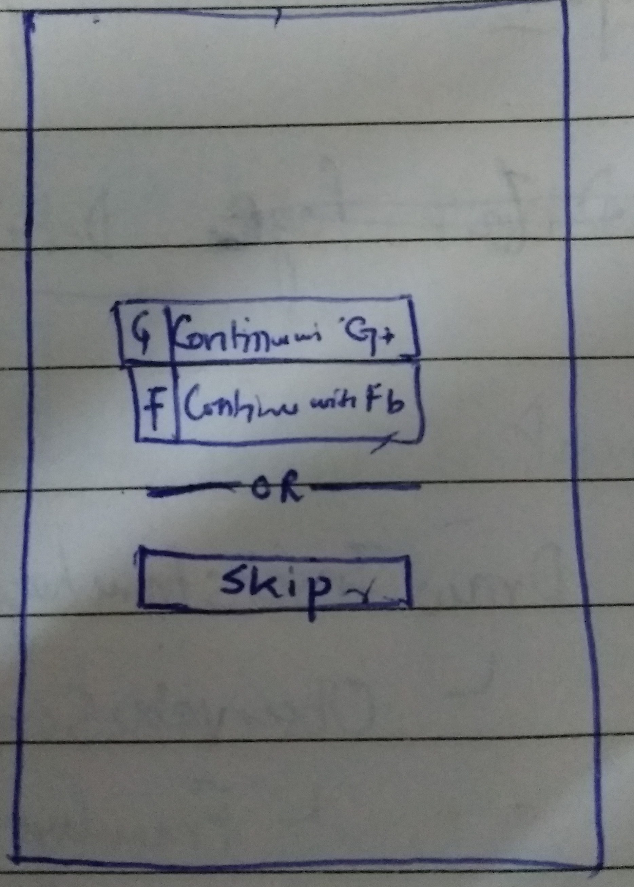

This is the login screen for the application. The user can login through their facebook account or google account or try the application by clicking Skip button. This will take them to a view containing all the photos in grid view. Once they click on the photo, they will be redirected to the following view.

**Screen 2**

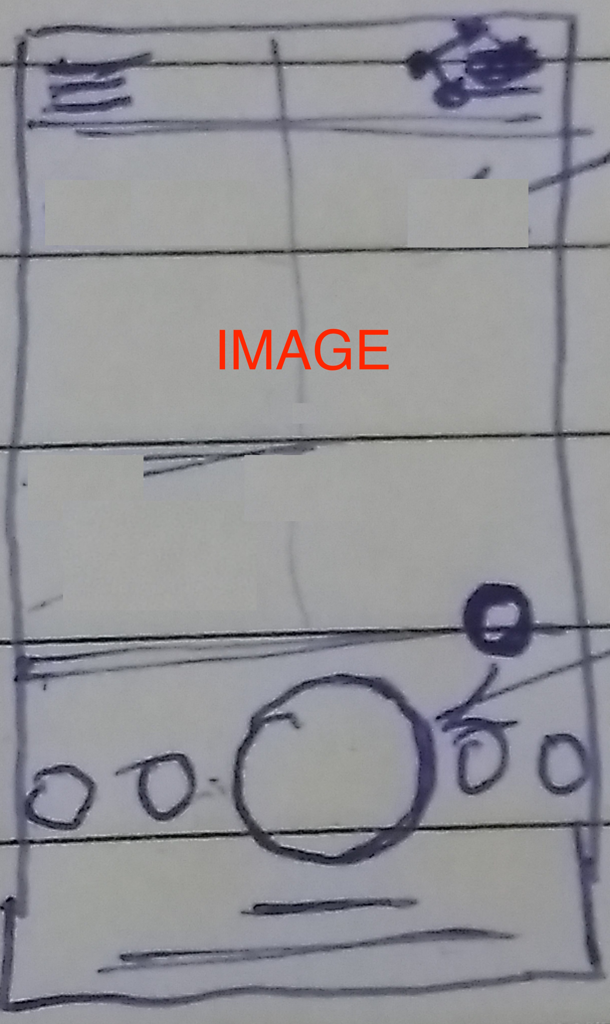 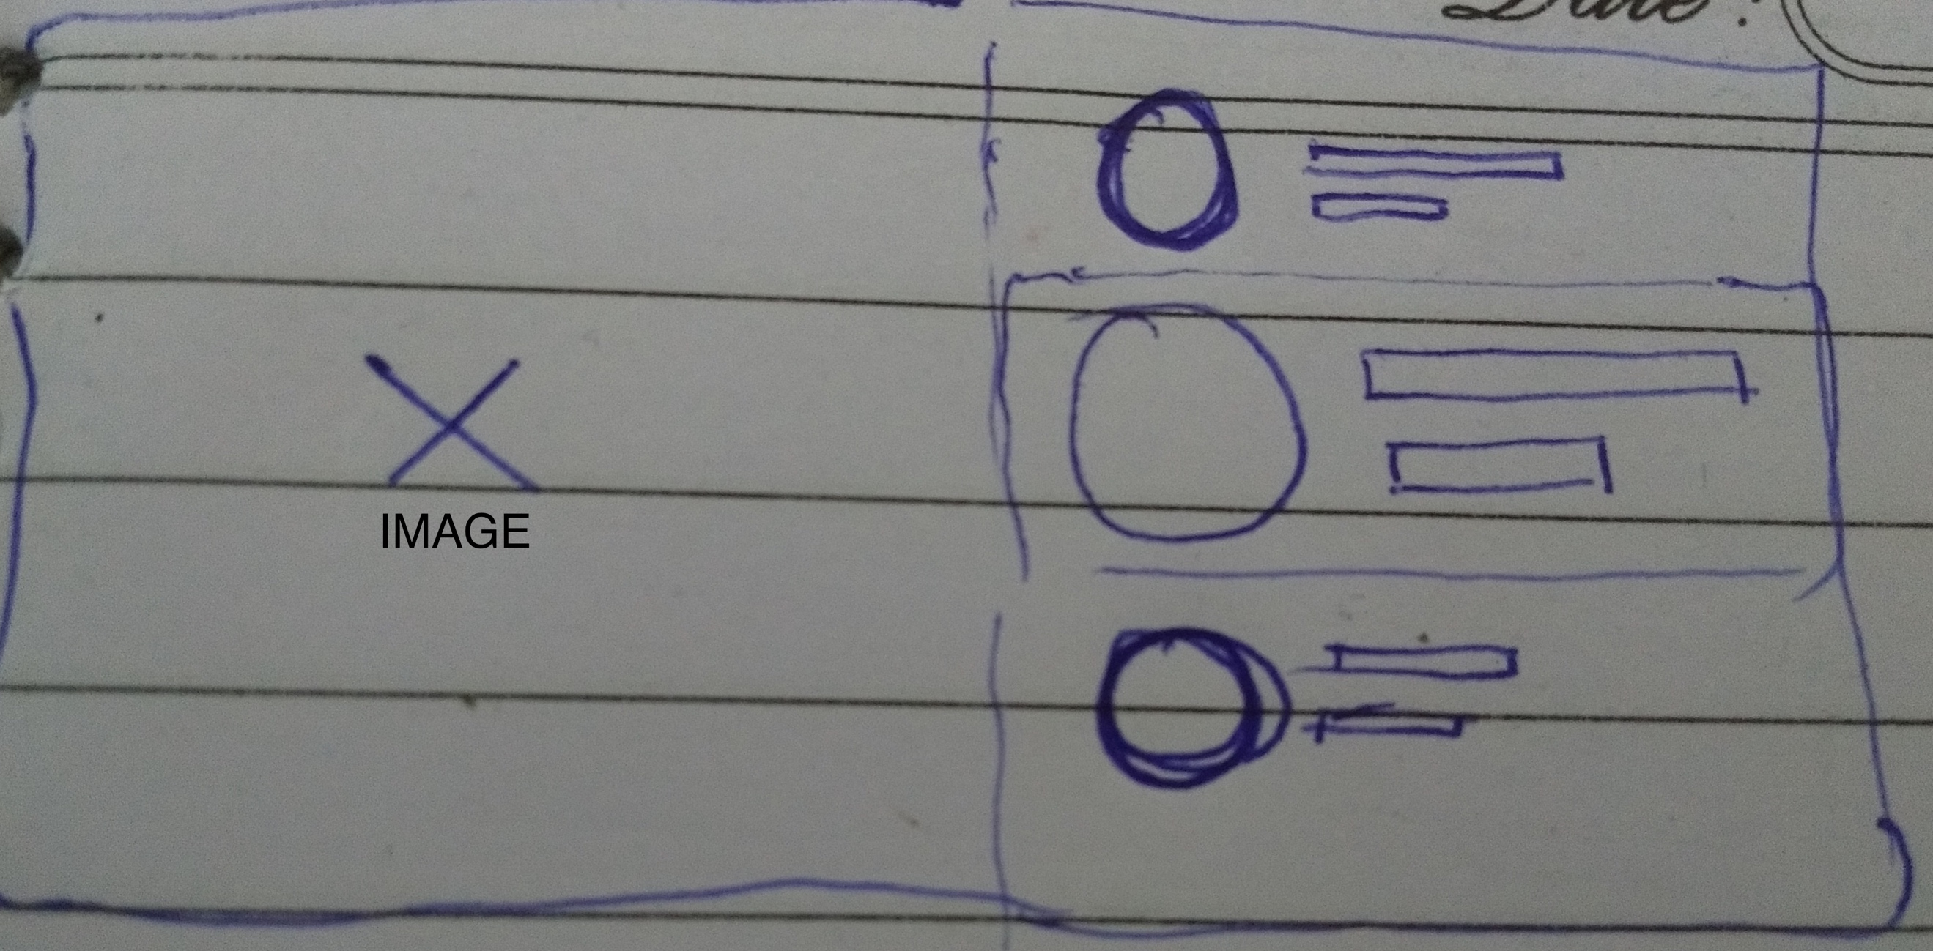

[VERTICAL VIEW] [LANDSCAPE VIEW]

This view will have the image and all the filters listed on the side or below. Filter title would be given in the first text view and its description in the second. The circle would contain a sample view for that filter. Selected filter would be also highlighted using shadow.

Key Considerations

**How will your app handle data persistence?**

I will build a new content provider backed with SQLite database for handling data persistence.

**Describe any corner cases in the UX.**

When the user returns from the image view back to the list of images, the user can return back to the image view by clicking on that image and the last selected filter would be selected for him.

**Describe any libraries you’ll be using and share your reasoning for including them.**

I would be using Picasso to handle the loading and caching of images. Apart from the I would be using facebook and google library for supporting login.

**Describe how you will implement Google Play Services.**

I would be using Google Account Login for letting the user login with their google account into the application. I will implement this using the gms:play-services-auth:11.0.1

Required Tasks

**Task 1: Project Setup**

This task is basically about getting started and configuring the libraries.

* Figuring out the libraries and their versions to be added the build.gradle
* Adding configurations and generating keys if required for the libraries.

**Task 2: Implement UI for Each Activity and Fragment**

This task is to implement the UI for various acitivity and fragments.

* Implementing the Splash Screen with logo
* Implementing the Login Screen
* Implementng the grid view for the images.
* Implementing the image Detail Activity and Fragment for it.

**Task 3: Integration with Facebook and Google Auth system**

This task is to integrate with the facebook and google auth system to provide login functionality for the user.

* Create required credentials for facebook and google auth.
* Integrate the code with required libraries.
* Add permissions and modify the required UI button.

**Task 4: Building And integration with ContentProviders**

This task is to build and integrate the app with the content providers.

* Define the contract for the application
* Create a DB helper to create the database
* Implement the URI mather
* Implement the CRUD operations in the content provider
* Integrate the adapter with content provider.

**Task 5: Adding Share and Filter functionality**

This task is to adding share and filter functionality.

* Add the share button in the UI.
* Implement the image share functionality
* Add the filter button and also add multiple options in it.
* Implement the functionality for each filter option.