Pre-production Planning Document

## Description

For my Capstone Project, I will be building a game in which the user is a character which has few constraints but is blessed with magical powers. Throughout the game, the character experiences multiple magical adventures.

Before we start with the game the user must have menu with certain options. Later, to begin the experience, viewers will see the story board where they will get an option to choose their chapter deciding the path forward.

Storyline

Every story book has multiple chapters. This game is a story of a hero/heroine where there are multiple chapters to their story and their adventure continues;

**Chapter 1: Dark Forest**

Villagers have a debt from the Evil. The user has collect the gold coins from the dark forest to pay the debt to Evil and save the village.

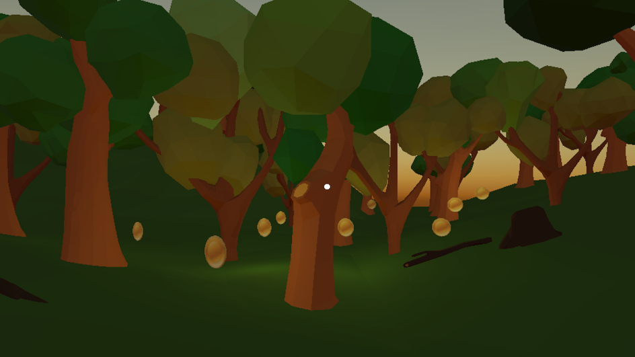

**Chapter 2: Endless Road**

The Evil didn’t like the user saving the villagers and want more coins as interest to the loaned money. Also, evil has sent the bandits behind user and put obstacles to stop him/her from collecting more coins.

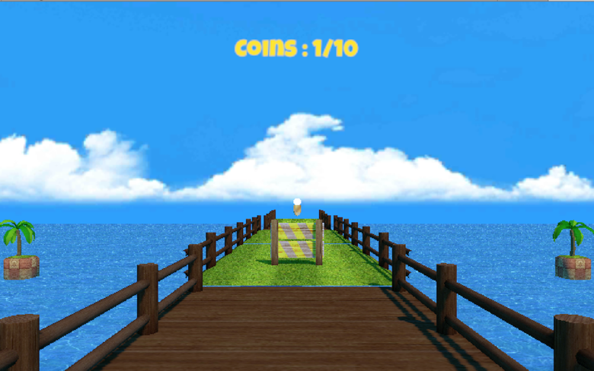

## Features and Dependencies

### 3D Models + Animations (Reference Images)

1. Coin model and animation: Spinning Animation



1. Hurdle



1. Raycast

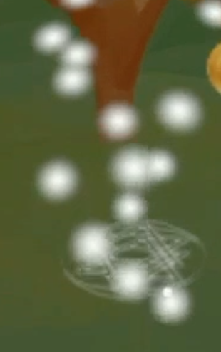

1. Skybox



1. Environment

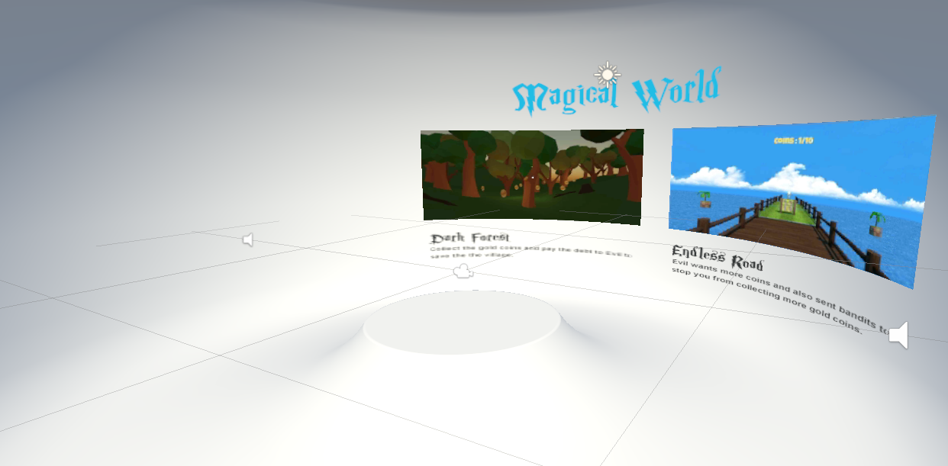

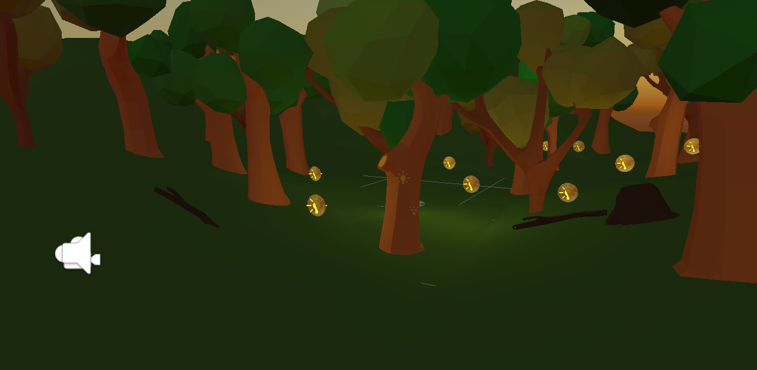

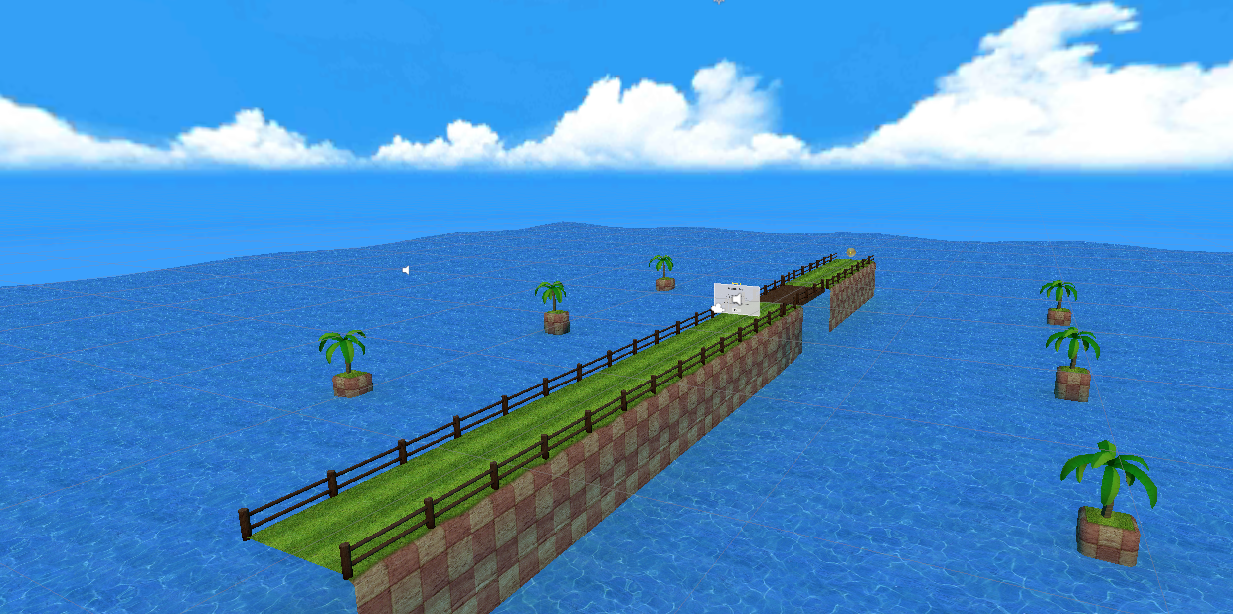

### Game Loop

* 1. User chooses the chapter
  2. Scene is setup.
  3. User moves around the scene and avoid obstacles
  4. Hints to guide user towards the right areas
  5. User collects the desired number of coin to save the village.
  6. Speak Recognition for player crying for help
  7. Depending upon the result of the chapter, corresponding screen with winning or losing text is shown.
  8. Fading to black and restarting if user loses.
  9. User is moved back to the chapter selection scene
  10. Multiplayer mode so for character to play together with other characters

### Other Effects

* 1. Realtime Lighting to make the experience feel more
  2. Particle Effects on the raycast to show the users about its interactivity.
  3. Spatial Sound effects for coin collection, loosing and wining the chapter. And few scenes have spatial ambient sound.
  4. Raycast and Fixed motion for the user to navigate the scenes.
  5. Light cues to make sure that players find the coins.

Scoping

### 3D Models + Animations (Reference Images)

1. **Coin model and animation:** Revised - Created a simple cylinder with coin image and then add a simple slow spinning Animation
2. **Hurdle:** Revised - Creating a simple hurdle is time consuming so will import from Unity assets
3. **Raycast:** Revised – Building simple cylinder raycast system for user navigation.
4. **Skybox:** Revised – Will not be making this and importing asset using unity assets
5. **Environment:** Revised – Will be using multiple freely available low poly models on unity assets for building the environments.

### Game Loop

* 1. **User chooses the chapter**
     1. Would be doing this.
  2. **Scene is setup.** 
     1. Would be doing this as its required.
  3. **User moves around the scene and avoid obstacles**
     1. Revised - Creating a simple cylinder raycast movement would suffice.
  4. **~~Hints to guide user towards the right areas~~**
     1. Revised - It’s a great tool to help user but currently it will be out of scope.
  5. **User collects the desired number of coin to save the village.** 
     1. Revised – Still a go
  6. **~~Speak Recognition for user asking for help by saying “Help Me”~~**
     1. It’s a great interactivity tool but I would focus on more core features
  7. **Depending upon the result of the chapter, corresponding screen with winning or losing text is shown.**
     1. Revised – This is required as this visual feedback to the user about the status
  8. **~~Fading to black and restarting if user loses.~~**
     1. Revised – Skipping this
  9. **User is moved back to the chapter selection scene**
     1. Revised – Will add this once all scenes are made
  10. **~~Multiplayer mode so for character to play together with other characters~~**
      1. Revised – Will not be doing this

### Other Effects

* 1. **Realtime Lighting to make the experience feel more**
     1. Revised – Required as per the rubric
  2. **Particle Effects on the raycast to show the users about its interactivity.**
     1. Revised – Still doing this
  3. **Spatial Sound effects for coin collection, loosing and wining the chapter. And few scenes have spatial ambient sound.**
     1. Revised – Required as per the rubric
  4. **Raycast and Fixed motion for the user to navigate the scenes.**
     1. Revised – Required as per the rubric
  5. **Light cues to make sure that players find the coins.**
     1. Revised – Doing this as this helps the user and make the experience richer