SEARCHING AND SORTING:

1: Bubble Sort:

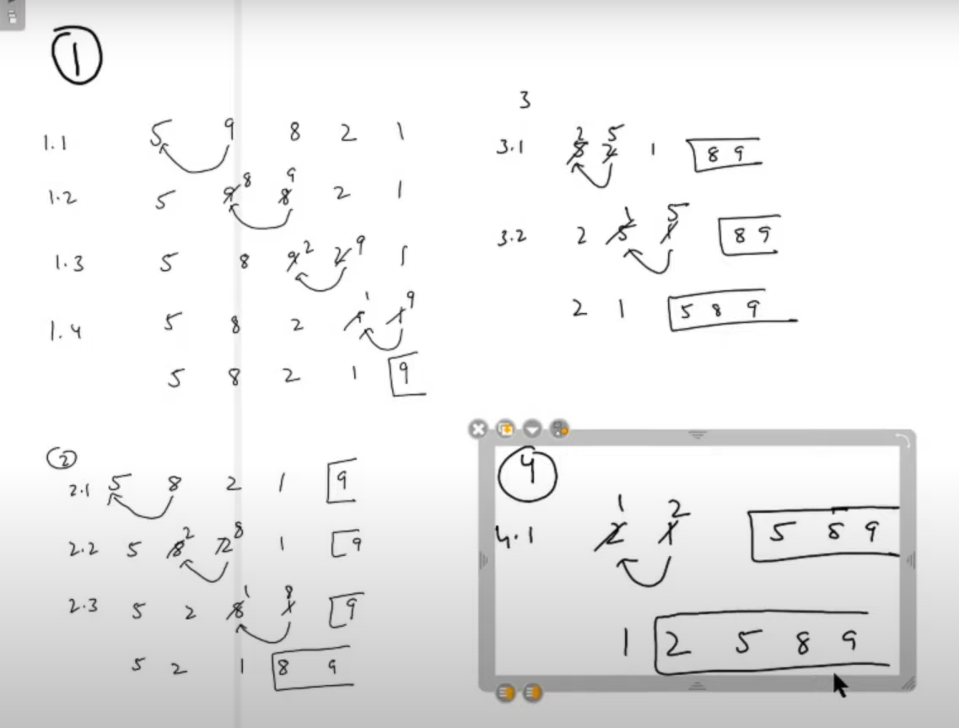

Selection Sort:

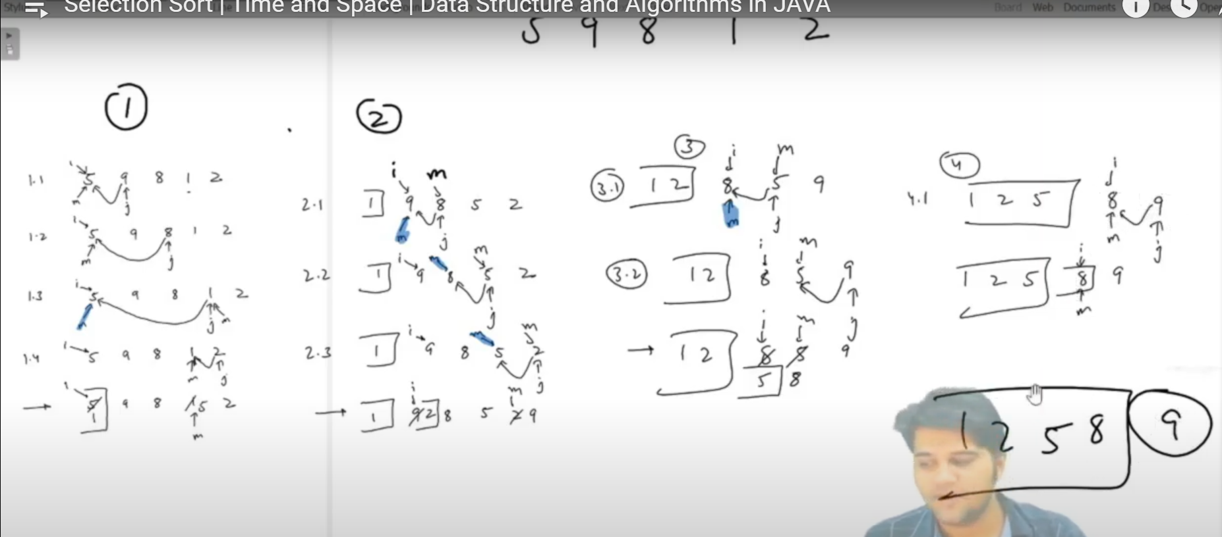

Insertion Sort:

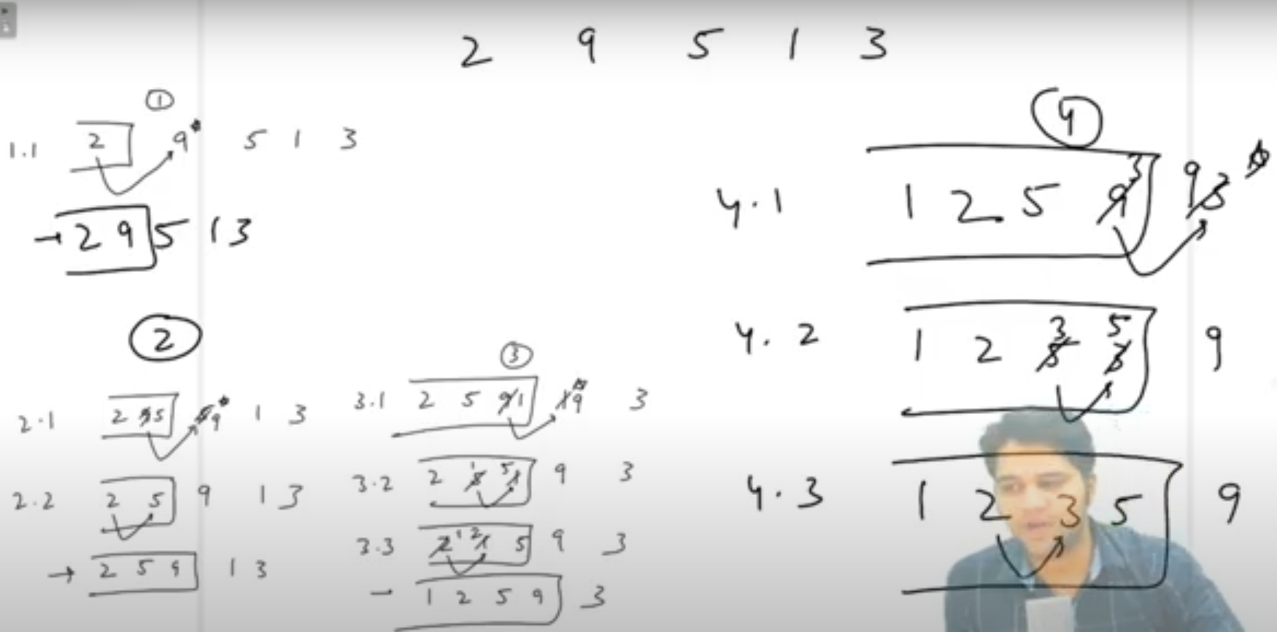

Merge Sort: