* **About Company (Core values, competitors, global presence, market share, product line and services)**
* **What differentiates Tokopedia and its USP**
* **Improvements for Tokopedia**
* **Improvements in WhatsApp (compare it with telegram)**

1. **About Company:**

* Indonesian based E-Commerce Company
* CEO: William Tanuwijaya and Leontinus Alpha Edison
* Tokopedia Employees – Nakama (Japanese name meaning friend)
* Being a Friends like relationship reduces the gap between employer and employee and thus help to achieve common goals

**CORE VALUES:** Friendly, Proactive, Simple, and Trusted.

**3 DNA OF TOKOPEDIA EMPLOYEES:**

* Focus on customers
* Growth mindset (Power of thinking 2 step ahead)
* Make it happen, make it better (Keep dreaming of your life’s dream and make it happen. once achieved, strive to make it better and do not stuck there.)

**5 CHARACTERS OF TOKOPEDIA:**

* Humble like a tree, root to the earth
* Determination like water, flowing relentlessly (Tokopedia is growing and expanding into areas that Tokopedia might be able to pass through.)
* Passion like fire, blazing furiously (Tokopedia's passion to make Indonesia better through the internet)
* Speed ​​like wind, swift and gusty. (Keep up with the pace with the rapid technology)
* Courage like Voyager 1, fearlessly exploring space. (Don't be afraid to dream. Dare to dream)

**ACTIVITIES:**

* Tokopedia Care Culture Fair: Engagement fun activities like games etc to reintroduce the importance of Tokopedia’s DNA, Tokopedia Care’s Core Value, and Tokopedia Care’s Service Vision. Tokopedia Care Culture Fair also offers bazaars from Tokopedia Official Store or Nakama who wants to sell their products.

**PRODUCT LINE AND SERVICES:**

1. **Digital Goods and Market Place**
   * 11 million merchants
   * > 550 million Products
   * Categories: Fashion, Beauty & Care, Electronic, Automotive
2. **Fintech and Payment**

* Services To Meet the Financial Needs, From Investments, Loans to Insurance.
* Financial Products: Mutual Funds, Gold, Online Loans, Capital Loans, Credit Card, Insurance
* Tokopedia Finance, in collaboration with various trusted banks and financial institutions, now provides Loan, Investment and Insurance programs that are officially registered and under the supervision of the Financial Services Authority (OJK).
* providing more than 500,000 payment points across Indonesia, and offering more than 42 digital products that simplify the lives of many.

1. **Logistics and Fulfilment**

* Customers can choose preferred package arrival time
* merchants can store their products in our warehouses
* Free subscription for the 30 days
* Covid: "TokoBranch helps increase online sales during the pandemic, helps with packaging & shipping. All of our warehouse operations have been moved to TokoBranch, so we don't have to worry about it."

1. **Mitra Tokopedia**

* New Retail
* bridges the gap between online and offline.
* It adds value to the traditional physical stores through expanding customer reach onlin and exposing merchants to more options for suppliers with smart prices. See Mitra as the digital partner, while running the same store.
* Benefits: Wholesale shopping and practical credit, The most economical guaranteed price, Fast and free shipping

1. **Tokopedia Salam**
   * Tokopedia Greetings in Sharia
   * Tokopedia Play is a streaming video channel that can make it easier for people to meet their needs through live shopping services.
   * Tokopedia Academy training, seminars, panel discussions and workshops.

**ADVERTISING CAMPAIGNS:**

* BTS as brand ambassador
* Black pink as brand ambassador

**COMPETITOR**

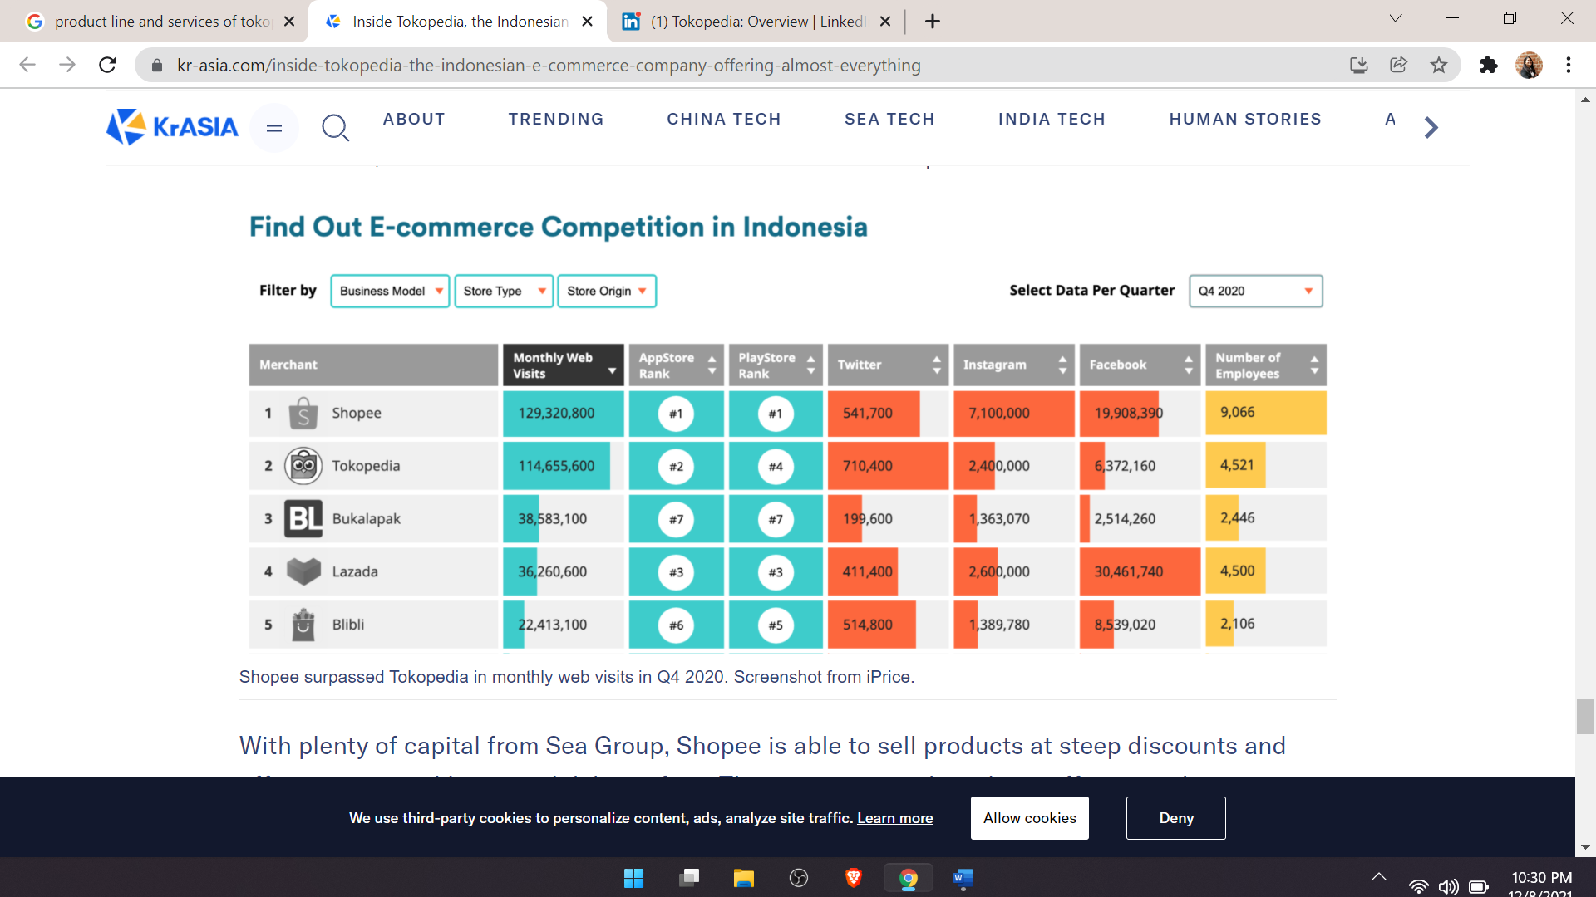

**PRESENCE**:

* reached more than 99% of districts and empower more than 11 million merchants across the archipelago.
* Jakarta, Semarang, and Yogyakarta.

In 2021, Tokopedia and Gojek have united to become GoTo by combining e-commerce, on-demand, and financial and payment services.

In May 2021, the Indonesian company that specializes in online marketplace technology announced that they have merged with leading mobile on-demand services and payments platform, Gojek. The GoTo Group is the result of the multi - billion-dollar merger.

**What differentiates Tokopedia and its USP**

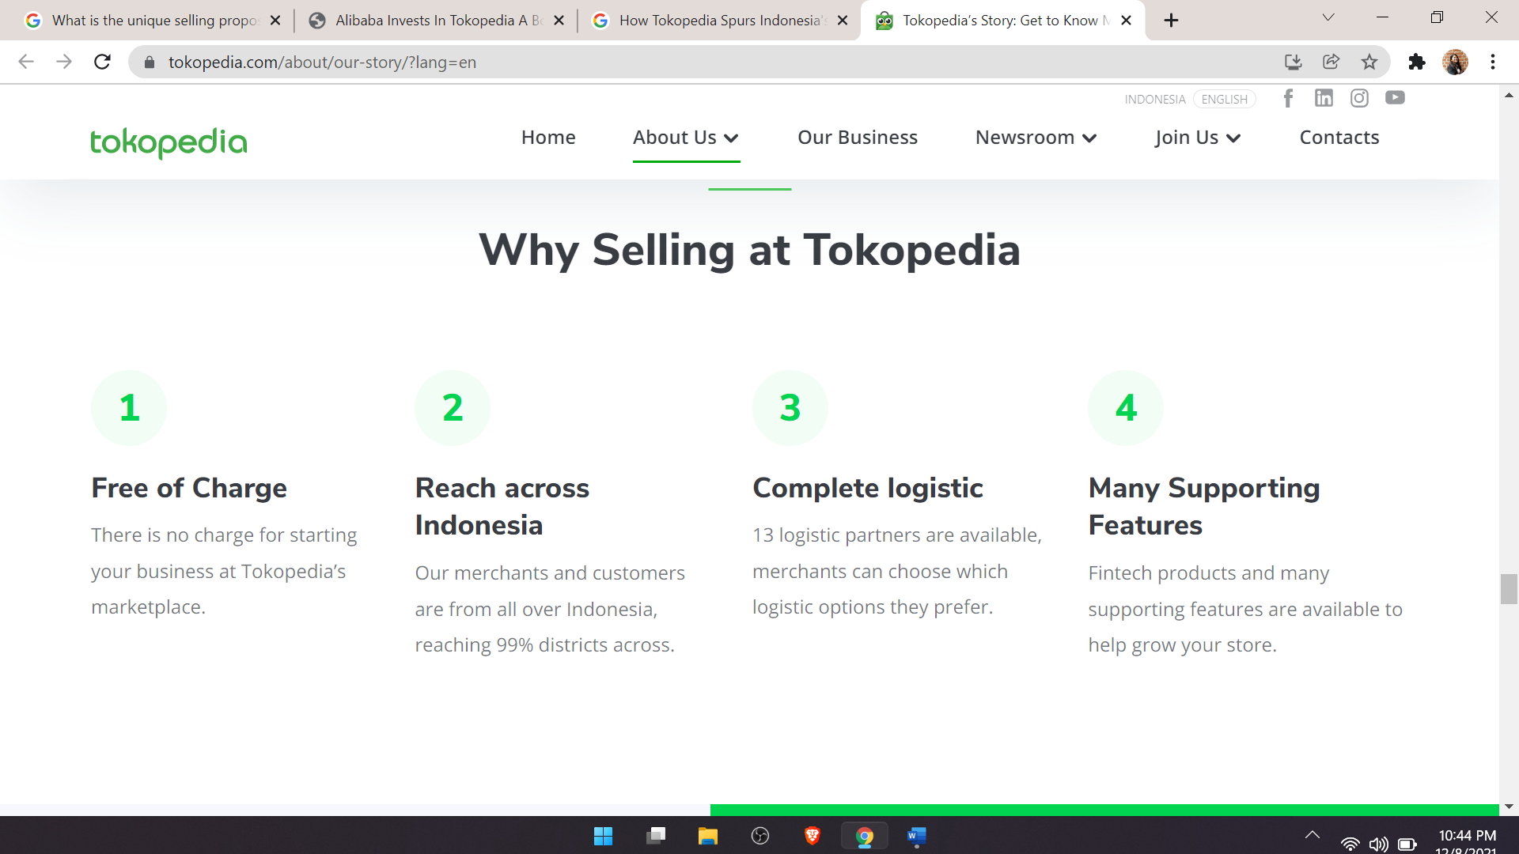

**CHALLENGES OF INDONESIA’S E-COMMERCE INDUSTRY:**

* Logistics-17000 islands
* Slow internet connectivity
* Payment methods: Low financial literacy
* Trust: They prefer to have direct communication with the seller

**Improvements for Tokopedia:**

* **Blockchain in supply chain**
* Search and categorization: More than 100 brands are there in Toko Member. It is difficult to find if not mentioned on the home page. Solution: search with sort and categorization, Search with filter and sort option
* <https://www.forbes.com/sites/googlecloud/2021/05/24/how-to-grow-into-an-ai-first-company/?sh=60c460e51188>
* Tokopedia is more established in mobile and electronics. For Shopee, fashion and beauty are the most popular product categories. Because of this, Tokopedia users are mainly men and the ecommerce platform has been trying to get more women coming into their site. This explains why many of the female Indonesians are going to Shopee instead.
* Shopee is also aggressive with its massive discounts and promotions as compared to Tokopedia. Tokopedia would have to catch up with its new tactics and promotion strategies to appeal to the correct audience. (<https://thelowdown.momentum.asia/a-marketing-battle-shopee-vs-tokopedia/>)

**Improvements in WhatsApp (compare it with telegram)**

* limited server storage on whatsapp:

Telegram provides unlimited cloud storage. This means all your text messages, images media files & documents will be saved on their cloud. You can log out and log in any number of times from any number of devices simultaneously without losing any data, you don’t need to worry about backup & restore. As of today, we can upload a single file of max size up to 2GB. There is no cap on the total number of files that can be uploaded.

Whatsapp: The WhatsApp messaging app relies on more than 700 high-end IBM SoftLayer servers. Facebook plans to move WhatsApp, which is used by more than 1 billion people, from IBM’s SoftLayer cloud to Facebook’s own data centers.

Telegram: Own cloud server through his own investments and donations. Telegram is **a cloud service**. We store messages, photos, videos and documents from your cloud chats on our servers so that you can access your data from any of your devices anytime without having to rely on third-party backups.

* Multiple number support: On Telegram, you can have max 3 accounts on one app
* Note to Self (Signal, Telegram): Saved Messages option missing
* Polls: Polls cannot be run on group or individual chats
* Blur faces before sending images: Available on signal but missing on whatsapp
* Message reactions (Signal)
* Scheduled messages (Telegram)
* Improved photo sharing option: Users can choose whether to compress the image and video or send the uncompressed version.
* Preview voice messages before sending
* File sharing size limitation
* Categorising contacts
* Bookmarking messages and search in chat windows
* In-app image enhancement tools
* Group member capacity: As of today, a telegram group can afford a maximum of 200,000 members. For WhatsApp 256 is the maximum member capacity in a group.
* Username feature: You can communicate with anyone on telegram even if you don't have the contact number of others.