PARABANK AUTOMATION FRAMEWORK – TEST ANALYSIS REPORT

Project Overview
Project Name: Parabank Automation Framework
Application: Parabank Banking Application
Automation Tools Used:
- Java
- Selenium WebDriver
- TestNG
- Maven
- Jenkins
- GitHub
- Log4j2
- Extent Reports
Framework Design Pattern:
- Page Object Model (POM)
- Data-Driven Testing
- Parallel Execution using ThreadLocal WebDriver

Framework Design
╔══════════════════════════════════════════════════════════════════════╗
║ 🚀 PARABANK AUTOMATION FRAMEWORK 🚀 ║
╚══════════════════════════════════════════════════════════════════════╝
┌─────────────────┐
│ GitHub Repo │
└────────┬────────┘
│
▼
┌─────────────────┐
│ Jenkins Pipeline│
│ Jenkinsfile │
└────────┬────────┘
│
▼
┌─────────────────┐
│ Maven Build │
│ mvn clean test │
└────────┬────────┘
│
▼
╔══════════════════════════════════════════════════════════════════════╗
║ TEST EXECUTION LAYER ║
╠══════════════════════════════════════════════════════════════════════╣
║ • RegistrationTest ║
║ • LoginTest ║
║ • AccountOverviewTest ║
║ • OpenNewAccountTest ║
║ • TransferFundsTest ║
║ • BillPayTest ║
╚══════════════════════════════════════════════════════════════════════╝
│
▼
╔══════════════════════════════════════════════════════════════════════╗
║ PAGE OBJECT MODEL (POM) ║
╠══════════════════════════════════════════════════════════════════════╣
║ • RegistrationPage ║
║ • LoginPage ║
║ • AccountOverviewPage ║
║ • OpenNewAccountPage ║
║ • TransferFundsPage ║
║ • BillPayPage ║
╚══════════════════════════════════════════════════════════════════════╝
│
▼
╔══════════════════════════════════════════════════════════════════════╗
║ UTILITIES LAYER ║
╠══════════════════════════════════════════════════════════════════════╣
║ • ConfigReader ║
║ • ExcelUtils ║
║ • DataProviders ║
║ • WaitUtils ║
║ • ScreenshotUtils ║
║ • RetryAnalyzer ║
║ • ExtentManager ║
║ • Log4j Logger ║
╚══════════════════════════════════════════════════════════════════════╝
│
▼
╔══════════════════════════════════════════════════════════════════════╗
║ BASE LAYER ║
╠══════════════════════════════════════════════════════════════════════╣
║ • BaseTest ║
║ • Browser Initialization ║
║ • Cross Browser Support ║
║ • Driver Management ║
║ • Setup & TearDown ║
╚══════════════════════════════════════════════════════════════════════╝
│
▼
╔══════════════════════════════════════════════════════════════════════╗
║ SELENIUM WEBDRIVER ENGINE ║
╚══════════════════════════════════════════════════════════════════════╝
│
▼
╔══════════════════════════════════════════════════════════════════════╗
║ PARABANK WEB APPLICATION ║
╚══════════════════════════════════════════════════════════════════════╝
╔══════════════════════════════════════════════════════════════════════╗
║ TEST DATA MANAGEMENT ║
╠══════════════════════════════════════════════════════════════════════╣
║ Excel (Apache POI) ║
║ ║
║ • Registration Sheet ║
║ • Login Sheet ║
║ • Transfer Sheet ║
║ • BillPay Sheet ║
║ • TestCases Sheet ║
╚══════════════════════════════════════════════════════════════════════╝
╔══════════════════════════════════════════════════════════════════════╗
║ REPORTING LAYER ║
╠══════════════════════════════════════════════════════════════════════╣
║ • Extent Reports ║
║ • Screenshots on Failure ║
║ • Log4j Execution Logs ║
║ • TestNG Reports ║
╚══════════════════════════════════════════════════════════════════════╝
╔══════════════════════════════════════════════════════════════════════╗
║ DEVOPS & PROJECT TOOLS ║
╠══════════════════════════════════════════════════════════════════════╣
║ • Git & GitHub ║
║ • Jenkins CI/CD ║
║ • Docker Containerization ║
║ • JIRA Defect Tracking ║
╚══════════════════════════════════════════════════════════════════════╝
Execution Flow
═══════════════════════════════════════════════════════════════════════
GitHub
↓
Jenkins Pipeline
↓
Maven Build
↓
TestNG Suite
↓
Test Cases
↓
Page Objects
↓
Selenium WebDriver
↓
Parabank Application
↓
Extent Reports + Screenshots + Logs
↓
JIRA Defect Tracking

Package Explorer Design:
Capstone-framework
│
├── src/test/java
│
│ ├── base
│ │ └── BaseTest.java
│ │
│ ├── pages
│ │ ├── LoginPage.java
│ │ ├── RegistrationPage.java
│ │ ├── AccountOverviewPage.java
│ │ ├── OpenNewAccountPage.java
│ │ ├── TransferFundsPage.java
│ │ └── BillPayPage.java
│ │
│ ├── testcases
│ │ ├── RegistrationTest.java
│ │ ├── LoginTest.java
│ │ ├── AccountOverviewTest.java
│ │ ├── OpenNewAccountTest.java
│ │ ├── TransferFundsTest.java
│ │ └── BillPayTest.java
│ │
│ ├── utilities
│ │ ├── ConfigReader.java
│ │ ├── ExcelUtils.java
│ │ ├── DataProviders.java
│ │ ├── WaitUtils.java
│ │ ├── ScreenshotUtils.java
│ │ ├── RetryAnalyzer.java
│ │ └── ExtentManager.java
│ │
│ ├── listeners
│ │ └── TestListener.java
│ │
│ └── reports
│ └── ExtentReportGenerator.java
│
├── src/test/resources
│
│ ├── config
│ │ └── config.properties
│ │
│ ├── testdata
│ │ └── ParabankData.xlsx
│ │
│ └── log4j2.xml
│
├── screenshots
│ ├── LoginFailure.png
│ ├── TransferFailure.png
│ └── BillPayFailure.png
│
├── logs
│ └── automation.log
│
├── test-output
│ ├── ExtentReport.html
│ ├── emailable-report.html
│ └── index.html
│
├── pom.xml
├── testng.xml
├── parallel-testng.xml
├── Jenkinsfile
├── Dockerfile
├── docker-compose.yml
├── README.md
└── .gitignore

Tools used:
- Java
- Selenium WebDriver
- TestNG
- Maven
- Jenkins
- GitHub
- Docker

Test Approach:
The framework follows the Page Object Model (POM) design pattern. Test scripts are created for positive test scenarios and known defect scenarios are maintained separately.
Test Environment:
- Operating System: Windows
- Browser: Chrome, Firefox
- Application URL: https://parabank.parasoft.com/parabank/index.htm/

Modules Automated:
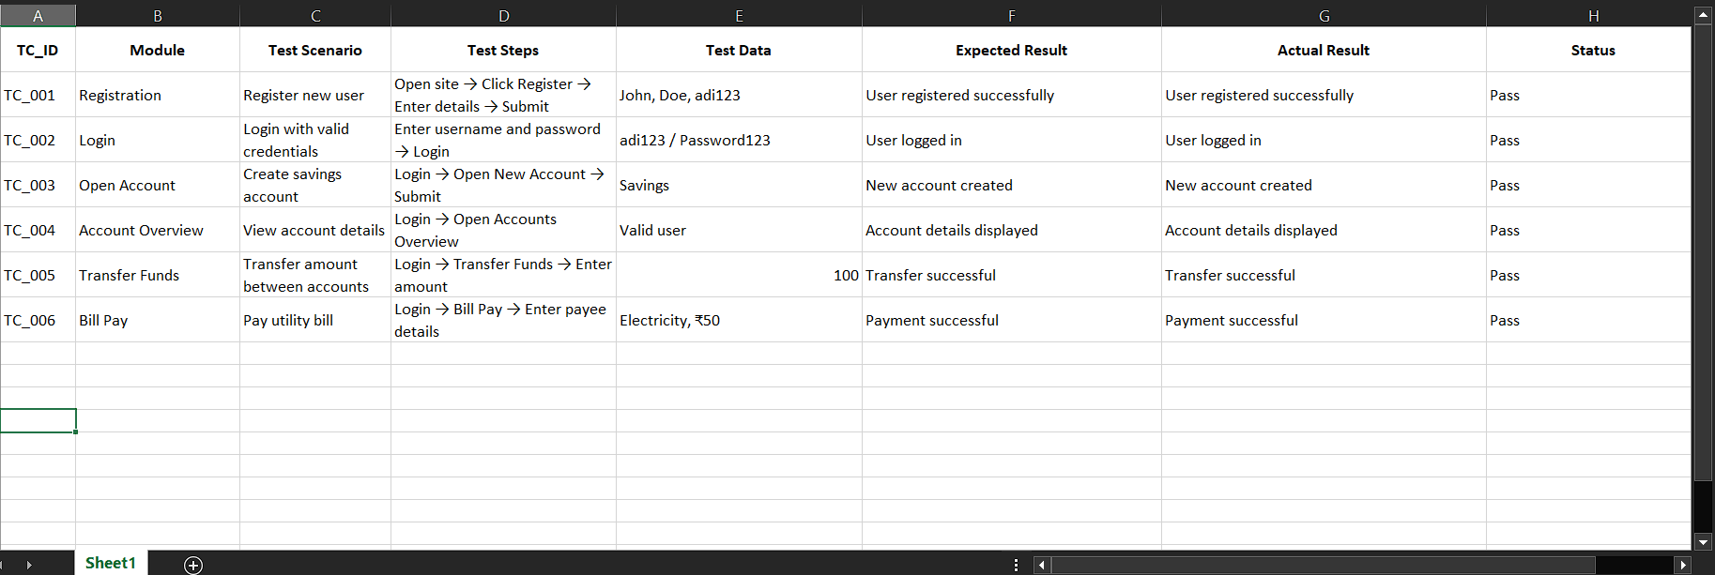
- Registration
- Login
- Open New Account
- Account Overview
- Transfer Funds
- Bill Pay

Test Execution Summary
Metric | Count
Total Test Cases | 6
Executed Test Cases | 6
Passed Test Cases | 6
Failed Test Cases | 0
Blocked Test Cases | 0
Pass Percentage | 100%

Module-wise Execution Status
Module | Status
Registration | Passed
Login | Passed
Open New Account | Passed
Account Overview | Passed
Transfer Funds | Passed
Bill Pay | Passed

Defect Summary:
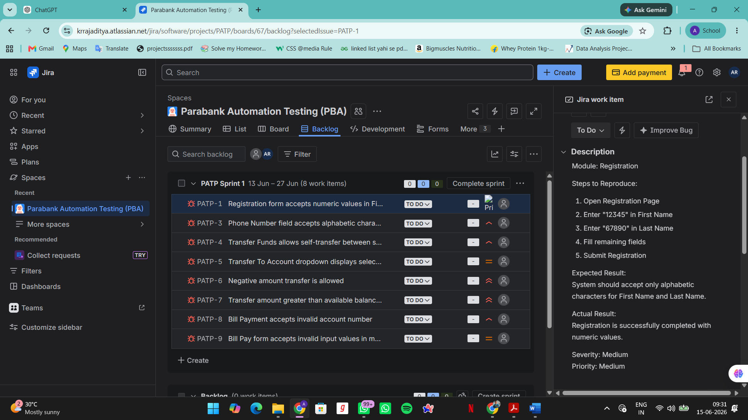
Defect ID | Description | Severity
PATP-1 | Registration form accepts numeric values in First Name and Last Name fields | Major
PATP-3 | Phone Number field accepts alphabetic characters | Major
PATP-4 | Transfer Funds allows self-transfer between same account | Major
PATP-5 | Transfer To Account dropdown displays selected source account | Minor
PATP-6 | Negative amount transfer is allowed | Critical
PATP-7 | Transfer amount greater than available balance is processed successfully | Critical
PATP-8 | Bill Payment accepts invalid account number | Major
PATP-9 | Bill Pay form accepts invalid input values in mandatory fields | Major

Defect Metrics
Severity | Count
Critical | 2
Major | 5
Minor | 1
Total Defects Identified: 8

PARABANK AUTOMATION TESTING – DETAILED DEFECT REPORT

PATP-1

Defect Title
Registration form accepts numeric values in First Name and Last Name fields

Module
Registration

Severity
Major

Priority
High

Preconditions
- User is on Registration page.
- Registration form is accessible.

Test Data
Field | Value
First Name | 12345
Last Name | 67890

Steps to Reproduce
- Launch Chrome browser.
- Navigate to Parabank application.
- Click “Register”.
- Enter “12345” in First Name field.
- Enter “67890” in Last Name field.
- Enter valid values in all remaining mandatory fields.
- Click Register button.

Expected Result
First Name and Last Name fields should accept only alphabetic characters.
Validation message should be displayed.
Registration should not proceed.

Actual Result
Numeric values are accepted and user registration is completed successfully.

PATP-3

Defect Title
Phone Number field accepts alphabetic characters

Module
Registration

Severity
Major

Priority
High

Test Data
Field | Value
Phone Number | ABCDEFGHIJ

Steps to Reproduce
- Open Registration page.
- Enter valid user information.
- Enter “ABCDEFGHIJ” in Phone Number field.
- Complete remaining mandatory fields.
- Click Register.

Expected Result
Phone Number field should accept only numeric values.
Validation message should be displayed.

Actual Result
Alphabetic characters are accepted without validation.

PATP-4

Defect Title
Transfer Funds allows self-transfer between same account

Module
Transfer Funds

Severity
Major

Priority
High

Preconditions
- User must be logged in.
- User should have active bank account.

Test Data
From Account | To Account | Amount
13344 | 13344 | 500

Steps to Reproduce
- Launch application.
- Login with valid credentials.
- Click Transfer Funds.
- Select Account 13344 in From Account dropdown.
- Select same Account 13344 in To Account dropdown.
- Enter amount as 500.
- Click Transfer.

Expected Result
Application should prevent self-transfer.
Error message should be displayed.

Actual Result
Transfer is completed successfully.

PATP-5

Defect Title
Transfer To Account dropdown displays selected source account

Module
Transfer Funds

Severity
Minor

Priority
Medium

Steps to Reproduce
- Login to Parabank.
- Navigate to Transfer Funds page.
- Select an account from From Account dropdown.
- Observe To Account dropdown values.

Expected Result
Source account should not appear as destination account.
Only eligible accounts should be displayed.

Actual Result
Selected source account is displayed in destination account list.

PATP-6

Defect Title
Negative amount transfer is allowed

Module
Transfer Funds

Severity
Critical

Priority
High

Test Data
Amount
-100

Steps to Reproduce
- Login using valid credentials.
- Navigate to Transfer Funds.
- Select valid source account.
- Select valid destination account.
- Enter “-100” in Amount field.
- Click Transfer button.
- Observe transfer confirmation.

Expected Result
Negative values should not be accepted.
Validation message should be displayed.
Transfer should be blocked.

Actual Result
Transfer request is processed successfully.
Negative amount is accepted.

Business Impact
May cause incorrect balance calculations and financial inconsistencies.

PATP-7

Defect Title
Transfer amount greater than available balance is processed successfully

Module
Transfer Funds

Severity
Critical

Priority
High

Preconditions
Source account balance = $500

Test Data
Balance | Transfer Amount
500 | 1000

Steps to Reproduce
- Login into Parabank.
- Open Account Overview.
- Verify account balance is $500.
- Navigate to Transfer Funds.
- Select source account.
- Select destination account.
- Enter amount as 1000.
- Click Transfer.
- Observe transaction status.

Expected Result
System should display:
“Insufficient Balance”
Transfer should not be processed.

Actual Result
Transfer is completed successfully despite insufficient balance.

Business Impact
Can cause overdraft and incorrect banking transactions.

PATP-8

Defect Title
Bill Payment accepts invalid account number

Module
Bill Pay

Severity
Major

Priority
High

Test Data
Account Number
123

Steps to Reproduce
- Login to application.
- Click Bill Pay.
- Enter valid payee details.
- Enter invalid account number “123”.
- Enter payment amount.
- Click Send Payment.

Expected Result
System should validate account number.
Error message should appear.
Payment should not proceed.

Actual Result
Payment request is accepted successfully.

PATP-9

Defect Title
Bill Pay form accepts invalid input values in mandatory fields

Module
Bill Pay

Severity
Major

Priority
High

Test Data
Field | Value
Payee Name | @@@@
Address | 123
City | ####

Steps to Reproduce
- Login into Parabank.
- Navigate to Bill Pay page.
- Enter invalid values in mandatory fields.
- Fill remaining fields.
- Click Send Payment.
- Observe application response.

Expected Result
Validation messages should be displayed.
Form submission should be blocked.

Actual Result
Application accepts invalid values and processes payment request.

Business Impact
Can result in invalid customer and payment information being stored in the system.

Framework Features
- Cross Browser Support (Chrome, Edge, Firefox)
- Parallel Execution using ThreadLocal Driver
- Jenkins CI/CD Integration
- Maven Build Management
- Data-Driven Testing using Excel
- Extent Report Generation
- Log4j2 Logging
- Screenshot Capture on Failure
- GitHub Version Control

Jenkins Execution Summary
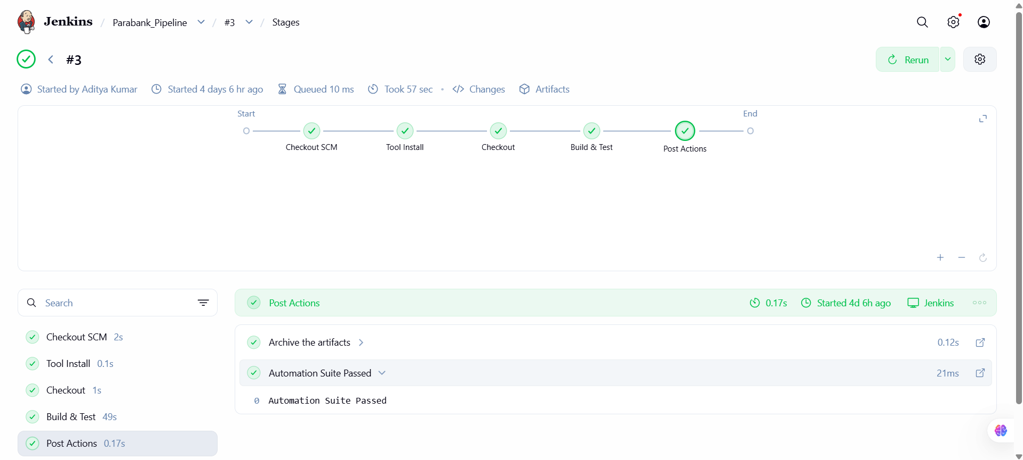
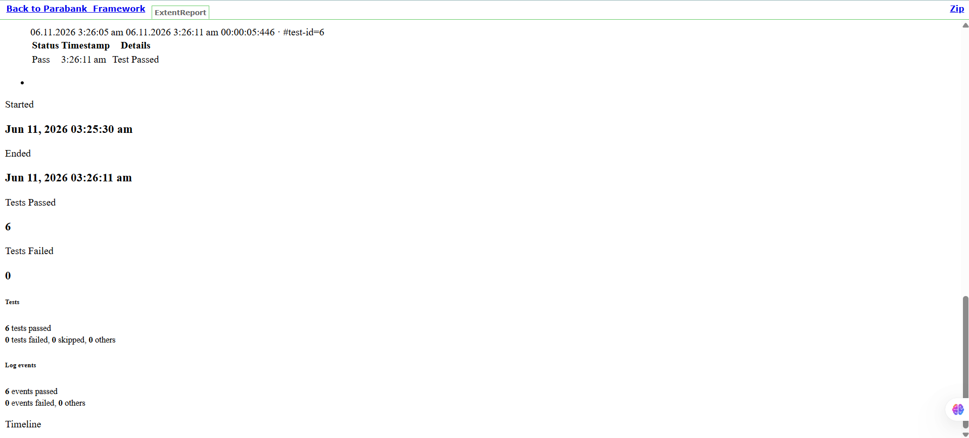
Jenkins Integration  Jenkins was integrated with GitHub to achieve Continuous Integration.  Execution Flow:  GitHub Repository  ↓  Jenkins Pipeline  ↓  Maven Build  ↓  TestNG Execution  ↓  Report Generation  ↓  Build Status  Benefits:  - Automated execution  - Continuous testing  - Faster feedback  - Easy monitoring  - Build history maintenance  Item | Status
Build Triggered | Success
Maven Execution | Success
TestNG Execution | Success
Test Cases Executed | 6
Build Status | Passed
Reports Generated | Yes

Challenges Addressed
- Browser Parallel Execution using ThreadLocal
- Jenkins Pipeline Configuration
- Test Data Management through Excel
- Dynamic Web Element Handling
- Logging and Reporting Integration

Conclusion
The Parabank Automation Framework successfully automated all targeted banking functionalities. All six automated test cases executed successfully with a 100% pass rate. The framework supports cross-browser testing, Jenkins-based continuous integration, Extent reporting, logging, and parallel execution. During testing, eight functional defects were identified and documented in Jira for further resolution.

