ASG Airlines Data Engineering Case Study
This document describes the local end-to-end pipeline, curated data model, data-quality controls, privacy measures, and reporting design created from the supplied airline workbook. The resulting analytical tables are ready to load into Power BI or another BI tool.
Outcome: the pipeline converts 1,020 raw flight rows into 1,005 unique curated flight schedules, corrects one overnight arrival date, and isolates operational anomalies for reporting.

Solution Architecture
The implementation uses a repeatable local Python pipeline. It follows a medallion-style flow that can be mapped directly to cloud storage and orchestration services when the workload grows.
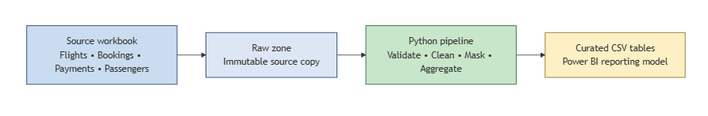

Layer | Component | Purpose
Source | UseCase - Airlines.xlsx | Supplied flights, bookings, payments, and passengers sheets.
Raw | data/raw | Immutable copied source workbook for reproducible ingestion.
Transform | src/pipeline.py | Schema validation, deduplication, standardization, overnight handling, PII protection, and KPI generation.
Curated | data/processed | CSV dimensions, facts, KPI tables, rejected-record output, quality summary, and log.
Consumption | Operations workbook and Power BI | Business KPIs, route performance, airline distribution, and anomaly monitoring.

Data Flow
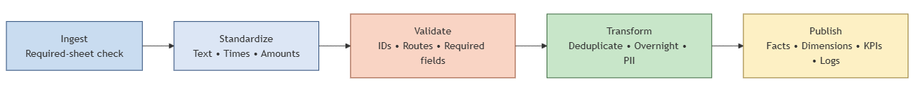
Step | Flow
1 | Read each required worksheet and fail fast if a required sheet is absent.
2 | Normalize identifiers, text values, timestamps, and numeric payment values.
3 | Remove exact duplicate flight rows and direct invalid records to rejected_flights.csv.
4 | Derive airline names from valid flight prefixes and calculate corrected flight durations.
5 | Mask passenger identifiers and remove passport and emergency-contact fields before producing curated outputs.
6 | Create dimensions, facts, business KPI aggregates, a data-quality summary, and the reporting workbook.

Source Dataset
Sheet | Grain | Use in solution
flights | Flight schedule record | Operational duration, route, airline, and anomaly analysis.
bookings | Booking | Booking status, seat, and masked passenger relationship.
payments | Payment | Payment amount and payment method analysis.
passengers | Passenger | Masked passenger dimension with age band and gender retained for permitted analysis.

Data Cleaning and Transformation Logic
Rule | Implementation
Flight identifiers | Trim whitespace, uppercase values, validate AI, 6F, SJ, or UK followed by three digits. Invalid records are rejected rather than silently changed.
Airline standardization | Replace blank and UNKNOWN values using flight prefix mappings: AI Air India, 6F IndiGo, SJ SpiceJet, UK Vistara.
Duplicates | Drop only exact duplicate flight rows. 15 rows were removed. Repeated flight numbers with different schedule details remain valid records.
Time parsing | Convert departure and arrival to timestamps. Records missing a required timestamp are rejected.
Overnight flights | If arrival precedes departure, add exactly one day to arrival, then recompute duration. This corrected one supplied flight.
Duration | Calculate duration_minutes from corrected arrival minus departure. Source duration text is not used as the reporting metric.
Anomalies | Flag flights under 45 minutes, over 360 minutes, or adjusted for a cross-day arrival. Anomalies are preserved for investigation.
Payments | Convert amount to numeric. Blank values remain null and are counted as a data-quality issue rather than treated as zero.

Data Model
The reporting model uses a star-like structure. dim_flight supports route and duration analysis. fact_booking links operational flight identifiers to booking outcomes. fact_payment links to bookings for revenue analysis. dim_passenger_masked contains no direct passenger identifiers.
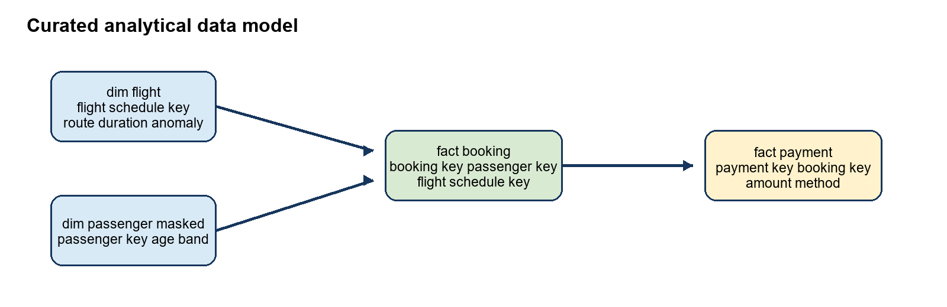
Table | Primary key | Relationships and purpose
dim_flight | flight_schedule_key | One record per distinct flight schedule. Includes route, timestamps, corrected duration, and anomaly fields.
fact_booking | booking_id | Many bookings to a flight number; contains masked passenger key, booking status, and seat number.
fact_payment | payment_id | Many payments to bookings; contains amount, method, and payment status.
dim_passenger_masked | passenger_key | One masked passenger record with age band, gender, and date of birth.

Modeling note: the booking source has flight_id but no scheduled departure timestamp. When a flight number maps to more than one schedule, the pipeline leaves flight_schedule_key blank and labels the booking as Ambiguous flight ID. A production source should carry a unique flight-instance or schedule identifier in bookings.

Data Quality Results
Measure | Result
Raw flight rows | 1020
Curated flight schedules | 1005
Exact duplicate rows removed | 15
Rejected flight rows | 0
Overnight arrivals corrected | 1
Flagged flight anomalies | 49
Missing payment amounts | 78
Ambiguous flight-ID bookings | 2

Business KPIs
KPI | Definition
Average flight duration | Mean duration_minutes from dim_flight after overnight correction.
Route-wise traffic | Count of curated flight schedules by source and destination route.
Flight anomalies | Count and detail of records with short duration, long duration, or corrected arrival date.
Flights by airline | Count of curated flight schedules by standardized airline.
Confirmed bookings | Count of booking records whose status equals CONFIRMED.
Recorded payment amount | Sum of non-null payment amounts. Null amounts remain excluded and visible as a quality issue.

Privacy and Access Control
The raw source includes passenger names, email addresses, phone numbers, Aadhaar IDs, passport numbers, and emergency contact details. These direct identifiers are not included in the curated reporting model.
- Replace passenger_id with a salted SHA-256 passenger_key before writing curated booking and passenger tables.
- Exclude first name, last name, email, phone, Aadhaar ID, passport number, emergency contact name, and emergency contact phone from curated outputs.
- Use a managed secret for ASG_PII_SALT in production and never store the secret with the data or source code.
- Restrict raw-zone access to ingestion and authorized data-steward roles. Grant BI users read access only to curated tables.
- Enable storage encryption, access logging, retention rules, and periodic access reviews in a cloud deployment.

Power BI Reporting Design
Load dim_flight.csv, fact_booking.csv, fact_payment.csv, dim_passenger_masked.csv, and the KPI files from data/processed. Relate fact_payment to fact_booking on booking_id. Relate fact_booking to dim_flight on flight_schedule_key only after a flight-instance key is available for all booking records.
Page | Visuals and controls
Operations Summary | KPI cards for flights, average duration, overnight flights, anomalies, bookings, and payment amount; donut chart for airline share.
Duration Analysis | Duration-band column chart, average duration card, and airline and route slicers.
Route Performance | Sorted route traffic bar chart, average duration by route, and airline slicer.
Airline Trends | Flights by airline, duration comparison, booking status breakdown, and date slicer.
Delay and Anomaly Insights | Anomaly count card, anomaly-type breakdown, detailed table, and route/airline filters.

Assumptions and Production Extension
- Airport codes are expected to be three-character IATA-like codes and source must differ from destination.
- An earlier arrival timestamp is treated as an overnight flight only once; a resulting duration outside the anomaly thresholds remains visible for review.
- The source does not contain scheduled versus actual timestamps, so delay minutes cannot be calculated. The delivered anomaly metrics are data-quality and duration exceptions, not carrier punctuality measurements.
- For Azure deployment, orchestrate ingestion with Azure Data Factory, store raw and curated data in ADLS Gen2, transform with Databricks or Synapse, govern access through Microsoft Entra ID and Key Vault, and connect Power BI to curated Delta or SQL tables.

