Звіт

Лекція 9

Завдання 1

#include <iostream>

#include <string>

#define STOP “\*”

using namespace std;

struct STUDENT

{

int num;

string name;

int mark;

};

int main()

{

static STUDENT s[25];

int i = 0;

string name;

cout << “Please input array of students struct\n”;

do

{

cout << “Name:” << endl;

cin >> name;

if (name != STOP)

{

s[i].name = name;

cout << “Number:” << endl;

cin >> s[i].num;

cout << “Mark:” << endl;

cin >> s[i].mark;

i++;

}

} while (name != STOP);

int n = i;

int j = 0;

while (j < n)

{

cout << s[j].num << “ “ << s[j].name << “ “ << s[j].mark << endl;

j++;

}

getchar();

return 0;

}

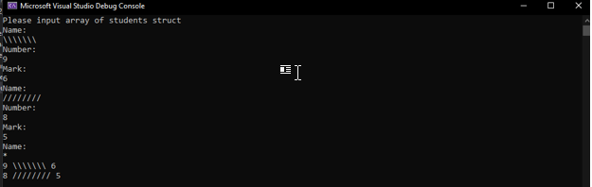

Завдання 2

#include <iostream>

#include <string>

#define STOP "\*"

using namespace std;

struct STUDENT

{

int num;

string name;

int mark;

};

int main()

{

static STUDENT s[25];

int i = 0;

string name;

cout << "Please input array of students struct\n";

do

{

cout << "Name:" << endl;

cin >> name;

if (name != STOP)

{

s[i].name = name;

cout << "Number:" << endl;

cin >> s[i].num;

cout << "Mark:" << endl;

cin >> s[i].mark;

i++;

}

} while (name != STOP);

int count = i;

int j = 0;

double avr = 0;

for (j = 0; j < count; j++)

{

avr += s[j].mark;

}

avr /= count;

j = 0;

while (j < count)

{

cout << s[j].num << " " << s[j].name << " " << s[j].mark << endl;

j++;

}

cout << "Average mark is " << avr << "\n";

getchar();

return 0;

}

