Title: Ellicular galaxies and their supermassive black holes
Authors: Giulia A. D. Savorgnan and Alister W. Graham
Affiliation: Centre for Astrophysics and Supercomputing, Swinburne University of Technology, Hawthorn, Victoria 3122, Australia.

Abstract:
The classification “early-type galaxy” includes both elliptically-shaped and lenticular galaxies, with the latter composed of a spheroid, or “bulge”, of stars encased within a larger, but flatter, stellar disc. Theoretically, the spheroid-to-disc flux ratio can assume any positive value. However, several studies^{1,2,3} only consider spheroid/disc decompositions in which the disc neatly dominates over the spheroid at large galaxy radii – creating an inner bulge – and they reject decompositions if the disc remains embedded within the spheroid, labeling them as unphysical. Here we show that these rejected models correctly reproduce the photometric and kinematic properties of a class of early-type galaxy intermediate between that of elliptical and lenticular galaxies, and which we name ellicular galaxies. Ellicular galaxies have often been confused with lenticular galaxies, and as a consequence their disc luminosities have been considerably overestimated and their spheroid luminosities underestimated. This has recently led to some surprising conclusions, such as the claim that a number of ellicular galaxies (Mrk 1216 [4], NGC 1277 [5], NGC 1271 [6], and NGC 1332 [7]) host a central black hole whose mass is abnormally large compared to expectations from the (underestimated) spheroid luminosity. When ellicular galaxies are properly modeled, they no longer appear as extreme outliers in the (black hole mass)–(spheroid mass) diagram, thereby resolving previous “anomalies”. This not only nullifies the need for invoking different evolutionary scenarios⁸ for these galaxies but it strengthens the significance of the observed (black hole mass)–(spheroid mass) correlation and confirms its importance as a fundamental ingredient for theoretical and semi-analytic models used to describe the coevolution of spheroids and their central supermassive black holes.

Main:
There are currently two well-known types of stellar discs in galaxies. The first are the large-scale discs (with sizes of a few kiloparsecs) that dominate the light at large radii in spiral and lenticular galaxies; the second are the small (tens to a couple of hundred parsec) nuclear discs observed in both early-type galaxies and late-type (spiral) galaxies^{9,10}. The origin of the nuclear discs has been speculated to arise from the infall of small satellite galaxies or gas clouds. The origin, or at least the on-going feeding and growth, of the large-scale discs has been attributed to cold gas flows, gas rich mergers and halo accretion events^{11,12,13}. A puzzling question, which has been unspoken for decades, is why are there not intermediate-sized discs: why are there not accretion events which create discs larger than the typical nuclear discs but which are not large enough to dominate at large radii? Here we report on the existence of these intermediate-sized stellar discs, and the impact this has on the important (central supermassive black hole)-to-(host spheroid) mass ratio which is used to constrain galaxy evolution models.
The majority of stellar discs have some level of inclination with respect to our line-of-sight, and this makes them appear elliptical (rather than round) when seen in projection on the sky. This can help one distinguish them from the more spherically-shaped spheroids. Identifying the extent of these discs with respect to their spheroid can however be subtle. Two-dimensional kinematic maps represent an important diagnostic tool for this purpose. Most early-type galaxies are classified as “central fast rotators”¹⁴, that is, they are rapidly rotating within the radius containing half of their light. However, more extended kinematic maps¹⁵ reveal that some of the “central fast rotators” continue to be fast rotating well beyond one or two half-light radii, which proves the presence of a large-scale disc, whereas other “central fast rotators” become slow rotators in their outer regions, which indicates the presence of an intermediate-scale disc that no longer dominates at large radii. Unfortunately, such extended kinematic maps are not yet available for large numbers of galaxies in the local Universe. Nevertheless, there is another powerful tool that can help identify the extent of stellar discs in early-type galaxies, and it has the advantage of requiring only the galaxy image, which is cheaper to acquire in terms of telescope time than a spatially resolved two-dimensional kinematic map. This tool is the “ellipticity profile” of a galaxy's isophotes.
The isophotes of a galaxy are contours along which the intensity of light is constant, and they can be modeled with a series of concentric ellipses. These ellipses can have varying ellipticity (ε = 1 – b/a, where b/a is the ratio of minor-to-major axis length), which means that they can be more or less “squeezed”: an ellipse with zero ellipticity corresponds to a circle, whereas an ellipse with large ellipticity is similar to a cigar. The toy model shown in Figure 1 illustrates the typical ellipticity profile of (i) a lenticular galaxy, comprised of a large-scale disc and a relatively smaller encased bulge, (ii) an elliptical galaxy with a nuclear stellar disc, and (iii) a galaxy composed of an intermediate-scale disc embedded in a relatively larger spheroid. We refer to the last case as an ellicular galaxy. In general, stellar discs are intrinsically flat and circular; their ellipticity, dictated by their inclination to our line of sight, is fixed. Spheroids are often rounder than the observed projection on the sky of their associated discs, thus their average ellipticity is often lower than that of their disc. An ellipticity profile that increases with radius can be ascribed to an inclined disc that becomes progressively more important at large radii, whereas a radial decrease of ellipticity signifies the opposite case.
Figure 1:
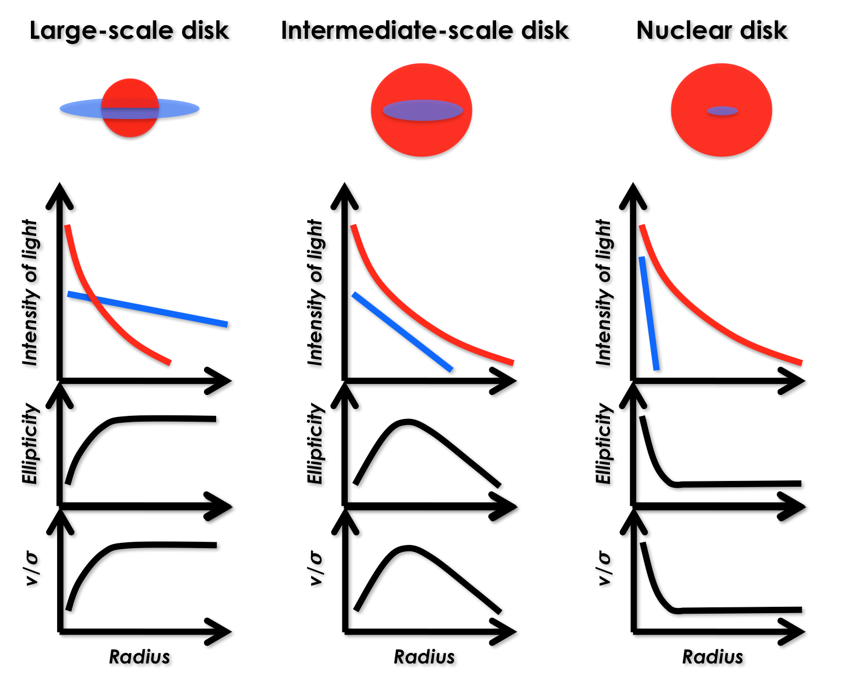
The awareness that many “elliptical” galaxies actually contain embedded stellar discs dates back at least three decades^{16,17,18}. However, the class of ellicular galaxies with intermediate-scale discs has been missed by many galaxy modelers, who have labeled as “unphysical”¹ those spheroid/disc decompositions in which the disc does not dominate over the spheroid at large radii as is observed with spiral galaxies. This unspoken bias has led to the rejection of many spheroid/disc decompositions similar to that illustrated in the middle panel of Figure 1. Unsurprisingly, studies^{19,2,3,20} affected by this bias have not found galaxies with a spheroid-to-total ratio in the range 0.6 < (spheroid/total) < 1.
The existence of intermediate-scale stellar discs reveals a continuum of disc sizes, rather than a dichotomy of nuclear versus large-scale discs. The presence of intermediate-scale discs also blurs the distinction between elliptical and lenticular galaxies and creates the need for a new subclass to help bridge the divide. The existence of such discs is not only important for our understanding of disc growth in general, but accounting for such structure will impact our understanding of galaxy structure and result in the reclassification of many lenticular galaxies as ellicular galaxies, with important consequences (see below). It has recently been argued²¹ that the classification scheme for elliptical galaxies should not be their apparent axis ratio as seen on the plane of the sky, but instead their spheroid-to-total flux ratio, with a continuum from pure elliptical galaxies to disc-dominated lenticular galaxies. In Figure 2 we show the location of the ellicular (ES) galaxies in the Hubble grid²¹. Aside from the pure elliptical galaxies, each galaxy type displays a range of spheroid-to-total flux ratios.
Figure 2:
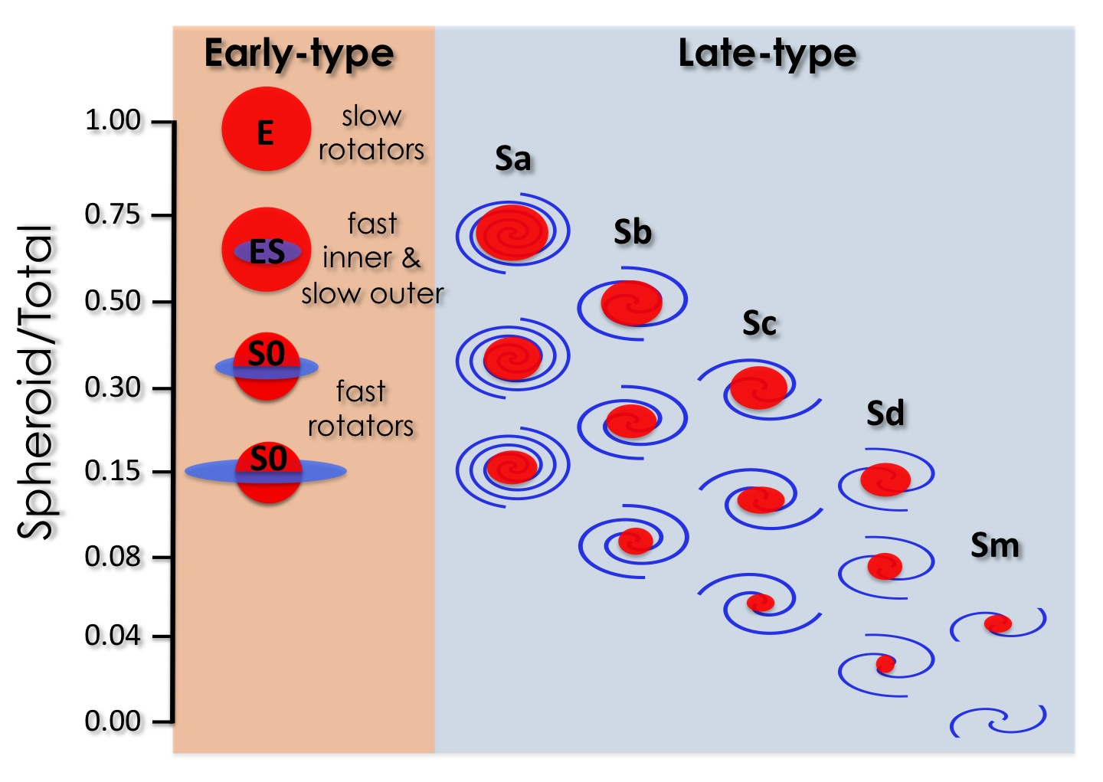

Two examples of ellicular galaxies are Mrk 1216 and NGC 3115. While the presence of a disc in NGC 3115 is obvious due to its edge-on orientation (Figure 3), the disc in Mrk 1216 is not immediately apparent from the image – which is partly why many stellar discs have been over-looked to date. However the radial light profile and the ellipticity profile betray the presence of a disc in both galaxies. The radial light profile of Mrk 1216 and NGC 3115 extend out to almost four times (4 x 7 arcsec) and five times (5 x 50 arcsec) the galaxy half-light radii, respectively. The main distribution of light in both of these galaxies is well described with a Sérsic function²² for the spheroidal component plus an exponential function for the intermediate-sized disc. Moreover, our photometric analysis enables the recovery of an additional nuclear disc in Mrk 1216 and a nuclear ring in NGC 3115. The spheroid/disc decomposition for NGC 3115 is also in excellent agreement with the galaxy’s kinematic properties²³. This comparison cannot be made for Mrk 1216 because no extended kinematic data are available.
Our models with an intermediate-sized disc embedded within a larger spheroidal component, plus an additional nuclear component when one is present, match the observed light distribution, and explain both the kinematic maps¹⁵ (when available) and the ellipticity profiles, of three other ellicular galaxies for which a direct measurement of their central supermassive black hole mass is available: NGC 1271; NGC 1277; and NGC 1332. Past models that ``forcedly'' described these ellicular galaxies with an inner bulge encased within a large-scale disc typically required the addition of an extended envelope or halo to account for the outer portion of the spheroid. Such three-component models (bulge + disc + envelope) reduce the spheroid luminosity by a factor of 2-3, and underestimate the size of the spheroid by a factor of 10.
Figure 3:
a) 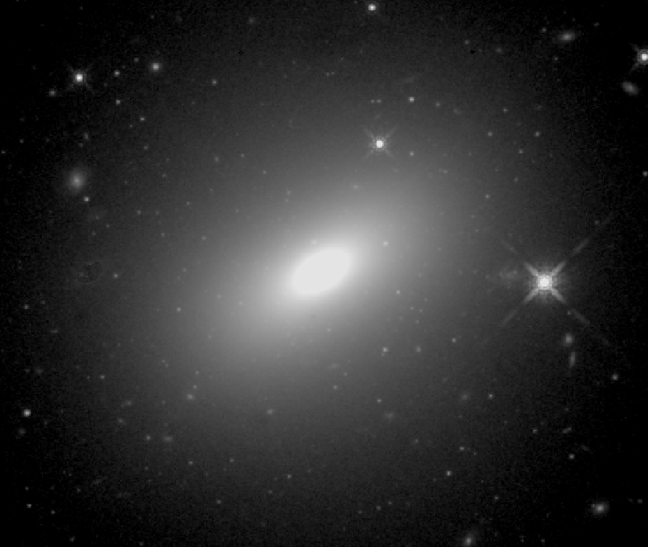 b) 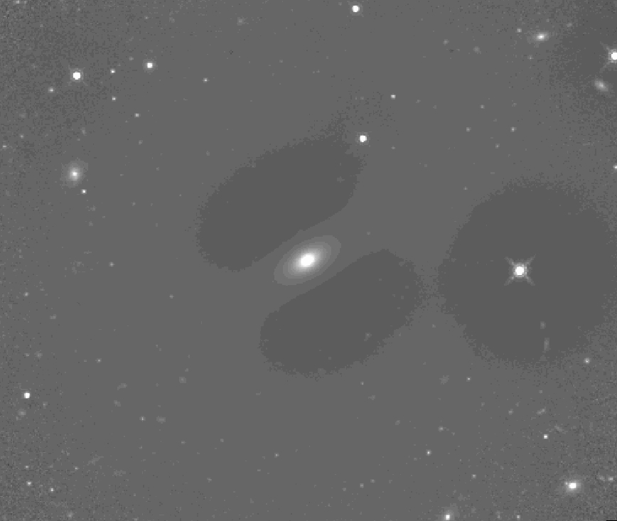
c)

d)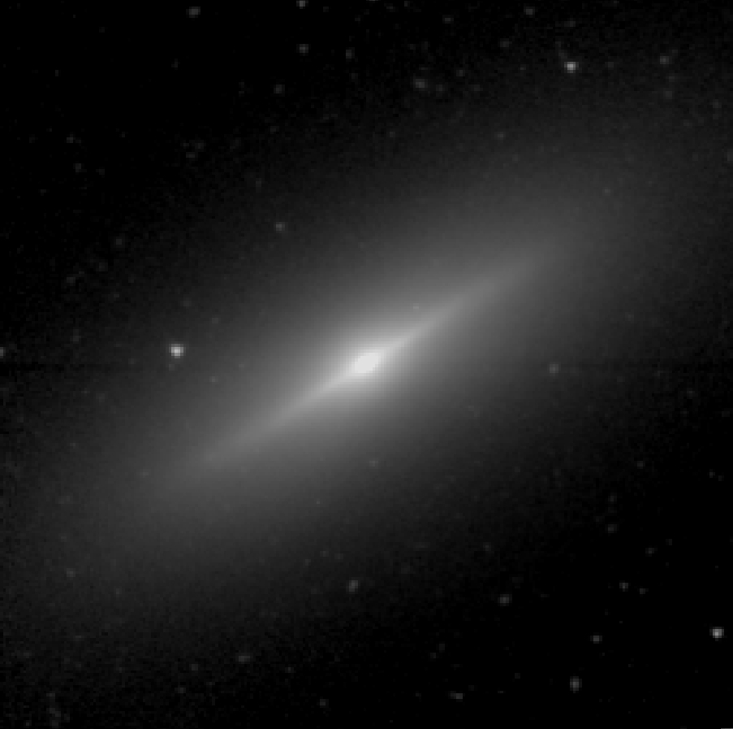 e)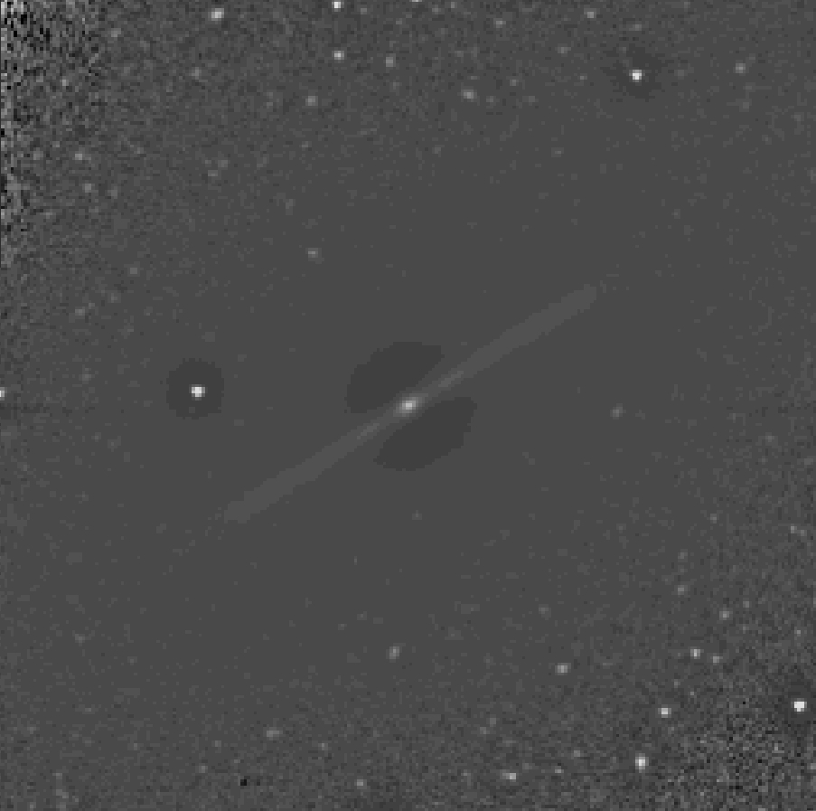

f)

Obviously, having both the black hole mass and the spheroid mass correct is important for placing systems in the (black hole mass)–(spheroid stellar mass) diagram. For early-type galaxies, the spheroid luminosity and the total galaxy luminosity can be used to predict the black hole mass with the same level of accuracy²⁴. If a galaxy hosts a black hole that is over-massive compared to expectations from the spheroid luminosity, but whose mass is “normal” compared to expectations from the total galaxy luminosity, one should wonder whether the spheroid luminosity might have been underestimated due to an inaccurate spheroid/disc decomposition. Indeed, none of the five ellicular galaxies mentioned here is a noticeable outlier in the (black hole mass)–(total galaxy luminosity) diagram²⁴. For the first time, Figure 4 reveals that when ellicular galaxies are properly modeled, they no longer appear as extreme outliers in the (black hole mass)–(spheroid stellar mass) diagram.
Figure 4:

Acknowledging the correct structure of ellicular galaxies is also important to properly understand their origin. According to the current paradigm of cosmological structure evolution, the genesis of massive early-type galaxies is characterized by two distinct phases: “in-situ” and “ex-situ”. The first phase takes place in a young Universe (within its first 4 billion years), when cold gas inflows produced short and intense bursts of star formation that created the cores of galaxies. These naked and compact cores, named “red nuggets”²⁵, have been observed²⁶ at high-redshift with sizes of 1-2 kpc. In the second phase (last 10 billion years), stellar discs and stellar envelopes were accreted around these primordial galaxy cores and assembled the external parts of galaxies on scales of 2-20 kpc. Today’s Universe is populated by an abundance of compact, massive spheroids²⁷, with the same physical properties – mass and compactness – as the high-redshift red nuggets. Some of these local compact massive spheroids are encased within a large-scale disc, that is to say they are the bulges of some lenticular and spiral galaxies. Over the last 10 billion years their spheroids have evolved by growing a relatively flat disc – rather than a three-dimensional envelope – which has increased the galaxy size but preserved the bulge compactness. The other compact massive spheroids of today’s Universe belong to some ellicular galaxies. Indeed, Mrk 1216, NGC 1271, NGC 1277, NGC 1332, and NGC 3115 are all local compact ellicular galaxies with purely old (>10 billion years) stellar populations. These galaxies have undergone the lowest degree of disc growth.
In addition to the observational clues as to the actual physical components in ellicular galaxies, one can reason on other grounds as to why these compact galaxies are not comprised of an inner bulge plus large-scale disc plus outer envelope^{5,28,6}. If they were such three-component systems, then one would have two possibilities. The first possibility is that these galaxies were already fully assembled 10 billion years ago; this would explain their old stellar populations, but it would also imply that their discs and envelopes had already formed during the first 4 billion years of the Universe, in disagreement with the current cosmological picture. The second possibility is that only their inner bulges (with sizes of 0.1-0.2 kpc, according to past decompositions) originated in the first 4 billion years and they subsequently accreted a substantial disc and envelope. If this was correct, then we would observe high-redshift, star-like, naked bulges with stellar masses within a factor of a few times the currently observed red nuggets but sizes which are 10 times smaller. However, a dramatically different expectation is reached if one considers these galaxies as spheroid-dominated systems with an intermediate-scale disc; in this case, both the galaxy size and the spheroid size are compact (1-2 kpc). This implies that, among the local descendants of the high-redshift red nuggets, the compact ellicular galaxies have undergone the lowest degree of disc growth. That is, the bulk of a compact ellicular galaxy quickly assembled “in-situ” in a very young Universe and experienced very little evolution over the last 10 billion years.

Method:
Figure 4 was populated using a galaxy decomposition technique extensively described in ³⁰. Briefly, we obtained Spitzer/IRAC 3.6 μm images for 45 early-type galaxies which already had a dynamical detection of their black hole mass. We then extracted their one-dimensional light profiles and ellipticity profiles. We modeled the light profiles with a combination of analytic functions, using one function per galaxy component. Spheroid luminosities were converted into stellar masses using individual, but almost constant mass-to-light ratios (~0.6) [24]. The ellicular galaxies NGC 1332 and NGC 3115 are included in the sample of 45 early-type galaxies. In addition, we show the ellicular galaxies Mrk 1216, NGC 1271 and NGC 1277, which were not a part of the original sample of 45.
For the galaxy NGC 1271, we use the black hole mass measurement and the mass-to-light ratio obtained by ⁶. The luminosity of the spheroidal component of this galaxy comes from the one-dimensional spheroid/disc decomposition of [Graham+2015, in prep.], who used an archived Hubble Space Telescope (HST) image taken with the Wide Field Camera 3 (WFC3) and the near-infrared F160W filter.
For the galaxy NGC 1277, we use the black hole mass measurement obtained by ⁵ and the mass-to-light ratio obtained by ³¹. The luminosity of the spheroidal component of this galaxy comes from the one-dimensional spheroid/disc decomposition of [Graham+ in prep.], who used an archived HST image taken with the Advanced Camera for Surveys (ACS) and the F550M filter (V-band).
For the galaxy Mrk 1216, we use the upper limit on the black hole mass and the mass-to-light ratio obtained by ⁴. The luminosity of the spheroidal component of this galaxy comes from our one-dimensional spheroid/disc decomposition (Figure 3), using an archived HST image taken with the WFC3 and the F160W filter (H-band).

References
[1] Allen, P. D. et al. The Millennium Galaxy Catalogue: bulge-disc decomposition of 10095 nearby galaxies. Mon. Not. R. Astron. Soc. 371, 2-18 (2006)
[2] Head, J. T. C. G., Lucey, J. R., Hudson, M. J., Smith, R. J. Dissecting the red sequence: the bulge and disc colours of early-type galaxies in the Coma cluster. Mon. Not. R. Astron. Soc. 440, 1690-1711 (2014)
[3] Querejeta, M. et al.. Formation of S0 galaxies through mergers. Bulge-disc structural coupling resulting from major mergers. A&A 573, 23 (2015)
[4] Yildirim, A. et al. MRK 1216 & NGC 1277 - An orbit-based dynamical analysis of compact, high velocity dispersion galaxies. ArXiv e-prints, 1506.06762 (2015)
[5] van den Bosch, R. C. E. et al. An over-massive black hole in the compact lenticular galaxy NGC 1277. Nature 491, 729-731 (2012)
[6] Walsh, J. L. et al. The Black Hole in the Compact, High-dispersion Galaxy NGC 1271. ArXiv e-prints, 1506.05129 (2015)
[7] Rusli, S. P. et al. The central black hole mass of the high-σ but low-bulge-luminosity lenticular galaxy NGC 1332. Mon. Not. R. Astron. Soc. 410, 1223-1236 (2011)
[8] Ferré-Mateu, A., Mezcua, M., Trujillo, I., Balcells, M., van den Bosch, R. C. E. Massive relic galaxies challenge the co-evolution of SMBHs and their host galaxies. ArXiv e-prints, 1506.02663 (2015)
[9] Scorza, C., van den Bosch, F. C. Nuclear stellar discs in early-type galaxies - II. Photometric properties. Mon. Not. R. Astron. Soc. 300, 469-478 (1998)

[10] Ledo, H. R., Sarzi, M., Dotti, M., Khochfar, S., Morelli, L. A census of nuclear stellar discs in early-type galaxies. Mon. Not. R. Astron. Soc. 407, 969-985 (2010)

[11] White, S. D. M., Rees, M. J. Core condensation in heavy halos – A two-stage theory for galaxy formation and clustering. Mon. Not. R. Astron. Soc. 183, 341-358 (1978)

[12] Khochfar, S., Silk, J. On the origin of stars in bulges and elliptical galaxies. Mon. Not. R. Astron. Soc. 370, 902-910 (2006)

[13] Dekel, A. et al. Cold streams in early massive hot haloes as the main mode of galaxy formation. Nature 457, 451-454 (2009)

[14] Emsellem, E. et al. The ATLAS3D project - III. A census of the stellar angular momentum within the effective radius of early-type galaxies: unveiling the distribution of fast and slow rotators. Mon. Not. R. Astron. Soc. 414, 888-912 (2011)

[15] Arnold, J. A. et al. The SLUGGS Survey: Wide-field Stellar Kinematics of Early-type Galaxies. Astrophys. J. 791, 80 (2014)
[16] Capaccioli, M. Distribution of light - Outer regions. Structure and Dynamics of Elliptical Galaxies 127, 47-60 (1987)
[17] Rix, H.-W., White, S. D. M. Disks in elliptical galaxies. Astrophys. J. 362, 52-58 (1990)
[18] Scorza, C., Bender, R. A disk in the elliptical galaxy NGC 3610. A&A 235, 49-54 (1990)
[19] Gadotti, D. A. The structural parameters of bulges, bars and discs in the local Universe. IAU Symposium 245, 117-120 (2008)
[20] Méndez-Abreu, J., CALIFA Team. Deconstructing bulges in lenticular galaxies using CALIFA. Highlights of Spanish Astrophysics VIII, 268-273 (2015)
[21] Graham, A. W. Scaling Laws in Disk Galaxies. Structure and Dynamics of Disk Galaxies 480, 185 (2014)
[22] Sérsic, J. L. Influence of the atmospheric and instrumental dispersion on the brightness distribution in a galaxy. Boletin de la Asociacion Argentina de Astronomia La Plata Argentina 6, 41 (1963)
[23] Arnold, J. A. et al. The Fossil Record of Two-phase Galaxy Assembly: Kinematics and Metallicities in the Nearest S0 Galaxy. Astrophys. J. Lett. 736, L26 (2011)
[24] Savorgnan, G. A. D., Graham, A. W., Marconi, A., Sani, E. Supermassive black hole and host spheroid affairs II. The red and blue sequence in the Mbh-M_{*,sph} diagram. Submitted to Astrophys. J.

[25] Damjanov, I. et al. Red Nuggets at z ~ 1.5: Compact Passive Galaxies and the Formation of the Kormendy Relation. Astrophys. J. 695, 101-115 (2009)

[26] van Dokkum, P. G. et al. Confirmation of the Remarkable Compactness of Massive Quiescent Galaxies at z ~2.3: Early-Type Galaxies Did not Form in a Simple Monolithic Collapse. Astrophys. J. Lett. 677, L5-L8 (2008)

[27] Graham, A. W., Dullo, B. T., Savorgnan, G. A. D. Hiding in plain sight: An abundance of compact massive spheroids in the local Universe. Astrophys. J. 804, 32 (2015)

[28] Läsker, R., Ferrarese, L., van de Ven, G. Supermassive Black Holes and Their Host Galaxies. I. Bulge Luminosities from Dedicated Near-infrared Data. Astrophys. J. 780, 69 (2014)
[29] Bogdán, Á. et al. Exploring the Unusually High Black-hole-to-bulge Mass Ratios in NGC 4342 and NGC 4291: The Asynchronous Growth of Bulges and Black Holes. Astrophys. J. 753, 140 (2012)
-------------------------------------------------------------------------

[30] Savorgnan, G. A. D., Graham, A. W. Supermassive black hole and host spheroid affairs I. True to life, physically motivated galaxy decomposition. Submitted to Astrophys. J.

[31] MartÍn-Navarro, I. et al. The initial mass function of a massive relic galaxy. Mon. Not. R. Astron. Soc. 451, 1081-1089 (2015)

Acknowledgements:
This research was supported by Australian Research Council funding through grant FT110100263. G.A.D.S. is grateful to Matteo Fossati, Luca Cortese and Giuseppe Gavazzi for comments and discussion. This work is based on observations made with the IRAC instrument on-board the Spitzer Space Telescope, which is operated by the Jet Propulsion Laboratory, California Institute of Technology under a contract with NASA, and also on observations made with the NASA/ESA Hubble Space Telescope, and obtained from the Hubble Legacy Archive, which is a collaboration between the Space Telescope Science Institute (STScI/NASA), the Space Telescope European Coordinating Facility (ST-ECF/ESA) and the Canadian Astronomy Data Centre (CADC/NRC/CSA).

Author contribution:
G.A.D.S. collected the data, and performed the data reduction and analysis. G.A.D.S. wrote the Python code used to perform the fitting of the one-dimensional surface brightness profiles. A.W.G. conceived and supervised the project. All authors provided contribution to the interpretation of the results and the writing of the manuscript.

Reprints and permissions information is available at www.nature.com/reprints

The authors declare no competing financial interests.

Corresponding author:
Correspondence to Giulia Savorgnan (gsavorgn@astro.swin.edu.au).

Figure legends:
Figure 1
Illustration of the spheroid/disc decomposition, the ellipticity profile and the v/σ (rotation of the disc / velocity dispersion of the spheroid) profile for the three prototype early-type galaxy sub-classes. In the flux decompositions, the spheroid (or bulge) and the disc are shown with the red and blue color, respectively. The left panel shows a lenticular galaxy, composed of a bulge encased in a large-scale disc. The right panel displays an elliptical galaxy with (an optional) nuclear stellar disc. The middle panel presents an “ellicular” galaxy with an intermediate-sized disc embedded in the spheroid.

Figure 2
The Hubble grid [Graham 2014], which uses the mean pitch angle of the arms in spiral galaxies to define their morphological type. Ellicular (ES) galaxies are intermediate between elliptical (E) and lenticular (S0) galaxies.

Figure 3
The galaxies Mrk 1216 and NGC 3115. a) H-band (F160W) image of Mrk 1216 obtained with the Wide Field Camera 3 on board the Hubble Space Telescope. b) Unsharp mask of Mrk 1216, obtained by dividing the image by a Gaussian-smoothed version of itself. c) Spheroid/disc decomposition of the major axis (R_{maj}) light profile, and ellipticity profile of Mrk 1216. The top panel displays the observed galaxy light profile, μ, with black points, while the colored lines represent the Sersic-spheroid (red) and exponential-disc (blue). A nuclear disc, identified from the change in slope of the ellipticity profile (R_{maj} ~ 1.5 arcsec) and from a clear feature in the fourth harmonic profile (not shown here), is additionally modeled with an exponential function. The residual profile (data – model) is shown as Δμ in the second row. The horizontal gray dashed line corresponds to three times the rms of the image background noise. The bottom panel shows the ellipticity (ε) profile. e) Near-infrared (3.6 μm) image of the galaxy NGC 3115 obtained with the Infrared Array Camera (IRAC) on board the Spitzer Space Telescope. f) Unsharp mask of the galaxy NGC 3115, which reveals the presence of a faint edge-on nuclear ring. g) Galaxy decomposition of the major axis light profile, and ellipticity profile of NGC 3115. A faint nuclear ring, identified in the unsharp mask of the galaxy image, is additionally modeled with a Gaussian function (gray line).

Figure 4
Early-type galaxies: black hole mass plotted against spheroid stellar mass for 42 galaxies (black) plus the galaxies Mrk 1216, NGC 1271, NGC 1277, NGC 1332, NGC 3115, and NGC 4291. The black solid line is the bisector linear regression for early-type galaxies [Savorgnan+2015]. The dashed lines mark the 1σ and 3σ deviations, where σ (0.51 dex) is the total rms scatter about the correlation in the black hole mass direction. The red color is used for five ellicular galaxies, (Mrk 1216, for which only an upper limit on its black hole mass has been reported) [Yildirim+2015], NGC 1271 [Walsh+2015], NGC 1277 [van den Bosch+2012, Yildirim+2015], NGC 1332 [Rusli+2011], and NGC 4291 [Bogdan+2012]), that were claimed to be extreme outliers in this diagram. All reside within a 3σ deviation from the correlation when using their correct spheroid mass. For NGC 1277, we show the previously reported spheroid stellar mass [van den Bosch+2012] in gray.

