**Title: Lentiptical galaxies and their non-extraordinary black holes**

**Authors: Giulia A. D. Savorgnan and Alister W. Graham**

Affiliation: Centre for Astrophysics and Supercomputing, Swinburne University of Technology, Hawthorn, Victoria 3122, Australia.

**Abstract:**

Early-type galaxies include elliptical and lenticular galaxies. Lenticular galaxies are composed of a central spheroid (or bulge) of stars encased in a larger stellar disk. When performing bulge/disk decomposition, the spheroidal component is typically described with a Sérsic profile [Sérsic 1963], while the disk is modelled with an exponential function. Theoretically, the bulge-to-disk ratio, which describes the relative importance of the spheroidal component over the disk component, can assume any positive value. However, several studies have taken into account only bulge/disk decompositions in which the exponential-disk function neatly dominates over the Sérsic-spheroid profile at large galaxy radii, and rejected those decompositions in which the exponential-disk function remains embedded within the Sérsic-spheroid profile. Here we show that these rejected models correctly reproduce the photometric and kinematic properties of a class of early-type galaxies, intermediate between elliptical and lenticular galaxies, that we name *lentiptical*. Lentiptical galaxies have often been confused with lenticular galaxies and, consequently, their bulge luminosities have been largely underestimated. This mistake has led to some wrong conclusions, such as the claim that a number of lentiptical galaxies (MRK 1216 [Yildirim+2015], NGC 1277 [van den Bosch+2012], NGC 1271 [Walsh+2015], and NGC 1332 [Rusli+2011]) host a central black hole whose mass is abnormally large compared to expectations from its (underestimated) bulge luminosity. When lentiptical galaxies are modelled according to our simple prescription, which uses the lowest number of free parameters, they no longer appear as extreme outliers in the (black hole mass) – (spheroid stellar mass) diagram. Previous “anomalies” are explained and eliminated by one simple “rule”. This nullifies the need for invoking different evolutionary scenarios [Ferre-Mateu+2015] for these galaxies and their non-extraordinary black holes.

**Main:**

There are currently two well-known types of stellar disks in galaxies. The first are the large-scale disks (with sizes of a few kiloparsec) that dominate at large radii in spiral and lenticular galaxies; the second are the small (tens to a couple of hundred parsec) nuclear disks observed in both early- and late-type galaxies [Scorza & Van den Bosch 1998, Rest+2001, Balcells+2007, Ledo+2010]. The origin of the nuclear disks has been speculated to arise from the infall of small satellite galaxies or gas clouds [ref??]. The origin, or at least the on-going feeding and growth, of the large-scale disks has been attributed to cold gas flows, gas rich mergers and halo accretion events [Khochfar & Silk 2006, Dekel+2009a,b, Ceverino+2010,2012, Conselice+2012]. A puzzling question, which has been unspoken for decades, is why are there not intermediate-sized disks; why are there not accretion events which create disks larger than the typical nuclear disks but which are not large enough to dominate at large radii? Here we report on the existence of these intermediate-sized stellar disks.

The majority of stellar disks have some level of inclination with respect to our line-of-sight, which makes them appear elliptical, and helps us distinguish them from the more spherical galaxy bulges. Yet, other few disks are close to face-on, making their detection from images difficult. However, their presence can still be discerned in their one-dimensional light profiles. Identifying the extent of these disks with respect to their bulge can be subtle. Two-dimensional kinematic maps represent an extremely powerful instrument for this purpose. However, only kinematic maps that extend beyond ~2 (galaxy) half-light radii can help distinguish which galaxies, among those classified as central (i.e. within ~1 galaxy half-light radius) fast rotators, have increasing or decreasing specific angular momentum profiles at large radii [Arnold+2014]. A specific angular momentum profile that is rapidly increasing at large radii is a signature of a large-scale disk, whereas a profile that declines at large radii is consistent with the presence of an intermediate-scale disk. Unfortunately, such extended kinematic maps are not yet available for a large sample of galaxies in the local Universe. Nevertheless, there is another powerful tool that can help identify the extent of stellar disks in early-type galaxies, and has the advantage of requiring only galaxy images (even photometrically uncalibrated), which are cheaper to acquire in terms of telescope time than spatially resolved two-dimensional kinematic maps. This tool is the ellipticity profile of a galaxy's isophotes.

The toy model shown in Figure 1 illustrates the typical ellipticity profile of a lenticular (S0) galaxy, made of a large-scale disk and a smaller encased bulge, of an elliptical (E) galaxy with a nuclear stellar disk, and of a galaxy composed of an intermediate-scale disk embedded in a larger spheroid. We refer to the last case as *lentiptical* galaxy.

The awareness that many “elliptical” galaxies actually contain embedded stellar disks dates back at least three decades [Capaccioli1987, Carter1987, Rix & White1990, Bender+1990, Scorza & Bender 1990]. However, the class of lentiptical galaxies has been missed by many galaxy modellers, who labelled as “unphysical” those bulge/disk decompositions in which the exponential-disk function does not dominate over the Sérsic-spheroid profile at large radii. Such a concern is appropriate for late-type spiral galaxies, but not for early-type galaxies. This unspoken bias has led them to reject any bulge/disk decomposition with an outcome similar to that illustrated in the middle panel of Figure 1.

Examples of lentiptical galaxies are the galaxies MRK 1216, NGC 1271, NGC 1277, NGC 1332, and NGC 3115. All of these galaxies can be easily described and explained with a simple two-component model: a Sérsic-spheroid plus an intermediate-sized exponential-disk. Our bulge/disk decomposition for the galaxy NGC 3115 is presented in Figure 2. The surface brightness profile extends out to ~5 galaxy half-light radii (1 galaxy half-light radius is equal ~50 arcsec). Not only our photometric bulge/disk decomposition for NGC 3115 matches the galaxy’s ellipticity profile, but it is in excellent agreement with the galaxy’s kinematic properties (the v/σ radial profile [Arnold+2011]).

Forced models that describe a lentiptical galaxy as a combination of an inner Sérsic-bulge encased within a large-scale exponential-disk can match the surface brightness distribution of such galaxy only in two cases. First, if the radial extent of the galaxy image is relatively small (less than or similar to the galaxy half-light radius), the outer rise of the bulge over the disk may not have been noticed, and a model with a large-scale disk can accommodate the “observed” surface brightness distribution. This problem can affect bulge/disk decompositions that use relatively shallow imaging data, such as 2MASS (e.g. [Laurikainen+2010, Vika+2012]). Second, when a more extended galaxy image is available, a model featuring a bulge encased in large-scale disk can only work with the addition of an extra outer Sérsic-envelope (or halo), that accounts for the outer portion of the spheroidal component. Such three-component decomposition will typically result in an outer Sérsic-envelope with a curvature – regulated by the Sérsic index – similar to that of the inner Sérsic-bulge (see the models of [Lasker+2014] for the galaxies NGC 0821, NGC 3115, NGC 4342, NGC 4697; oddly, in these decompositions, the luminosity of the outer Sérsic-envelope is comparable or larger than the luminosity of the inner Sérsic-bulge).

Our two-component models (intermediate-sized disk embedded within a spheroidal component), which require the lowest number of free parameters, match the observed surface brightness distributions, and explain the kinematic maps (when available) and the ellipticity profiles of lentiptical galaxies. Furthermore, when lentiptical galaxies are modelled according to our prescription, they no longer appear as extreme outliers in the (black hole mass) – (spheroid stellar mass) diagram, as shown in Figure 3. That is, when they are incorrectly modeled, they appear as outliers. Obviously, having both the black hole mass and the spheroid mass correct is important for placing systems in the (black hole mass) – (spheroid stellar mass) diagram.

For early-type galaxies, the bulge luminosity and the total galaxy luminosity can be used to predict the black hole mass with the same level of accuracy [Savorgnan+2015, submitted]. The fact that a galaxy hosts a black hole that is over-massive compared to expectations from the bulge luminosity, but is “normal” compared to expectations from the total galaxy luminosity, suggests that the bulge luminosity may have been underestimated due to non-accurate bulge/disk decomposition. Indeed, none of the five lentiptical galaxies mentioned before is a noticeable outlier in the (black hole mass) – (total galaxy luminosity) diagram of [Savorgnan+2015, submitted].

The existence of intermediate-scale stellar disks reveals that a continuum of disk sizes may exist, rather than a dichotomy of nuclear vs. large-scale disks. The presence of intermediate-scale disks also blurs the distinction between elliptical and lenticular galaxies. The existence of such disks is not only important for our understanding of disk growth in general, but accounting for such structure will impact on our galaxy scaling relations and surely see the reclassification of many “disky elliptical” galaxies and lenticular galaxies as lentiptical galaxies.

**Method:**

Our one-dimensional galaxy decomposition technique is extensively described in [Savorgnan & Graham 2015, submitted].

For the galaxy NGC 1271, we use the black hole mass measurement and the mass-to-light ratio obtained by [Walsh+2015]. The luminosity of the spheroidal component of this galaxy comes from the one-dimensional bulge/disk decomposition of [Graham, Savorgnan & Ciambur 2015, submitted], who used an archived Hubble Space Telecope (HST) image taken with the Wide Field Camera 3 (WFC3) and the infrared F160W filter.

For the galaxy NGC 1277, we use the black hole mass measurement and the mass-to-light ratio obtained by [van den Bosch+2012]. The luminosity of the spheroidal component of this galaxy comes from the one-dimensional bulge/disk decomposition of [?????, in preparation], who used an archived HST image taken with the Advanced Camera for Surveys (ACS) and the F550M filter (V-band).

For the galaxy MRK 1216, we use the upper limit on the black hole mass and the mass-to-light ratio obtained by [Yildirim+2015]. The luminosity of the spheroidal component of this galaxy comes from our one-dimensional bulge/disk decomposition, using an archived HST image taken with the WFC3 and the F160W filter (H-band).

**Acknowledgements:**

**Contributions:**

**Competing financial interests:**

The authors declare no competing financial interests.

**Corresponding author:**

Correspondence to Giulia Savorgnan (gsavorgn@astro.swin.edu.au).

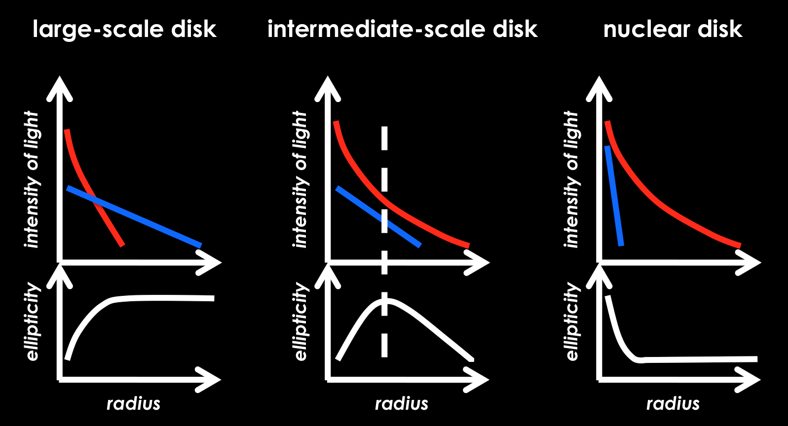

*Figure 1*

Simple illustration of the bulge/disk decomposition and the ellipticity profile of three “template/prototypic” early-type galaxies. In the decompositions, the spheroid (or bulge) and the disk are shown with the red and blue color, respectively. The left panel shows the case of a (bar-less) lenticular galaxy, composed of a small bulge encased in a large-scale disk. The right panel displays the case of an elliptical galaxy with a nuclear stellar disk. The middle panel presents the case of a lentiptical galaxy with an intermediate-sized disk embedded in a larger spheroid. Stellar disks typically have fixed ellipticity, dictated by their inclination to our line of sight. Bulges, instead, can have their ellipticities varying with radius, but they are usually rounder than inclined disks, thus their average ellipticity is lower than that of an inclined disk. If the ellipticity profile of a galaxy increases with radius, this can be ascribed to an inclined disk that becomes progressively more important over the bulge, whereas a radial decrease of ellipticity signifies the opposite case. When the extent of the disk of an early-type galaxy is uncertain, the “shape” of the ellipticity profile can be decisive to distinguish between large- and intermediate-scale disks. Note that, in the case of an intermediate-scale disk, the maximum value of the ellipticity should correspond to the minimum difference between the light profile of the bulge and that of the disk (vertical dashed line). Galaxy modellers that attempt to perform bulge/disk decomposition of early-type galaxies should always check that their model correctly matches the galaxy's ellipticity profile.

Macintosh HD:Users:gsavorgnan:galaxy_vivisection:papers:lentiptical:images:n3115_decomposition.eps

*Figure 2*

Bulge/disk decomposition and ellipticity profile for the galaxy NGC 3115. The left panels refer to the major-axis Rmaj, while the right panels refer to the equivalent-axis Req, i.e. the geometric mean of the major (a) and minor (b) axis (Req = √ab), equivalent to a circularized profile. The top panels display the observed galaxy surface brightness (μ) radial profiles with black points. The color lines represent the individual model components: red = Sérsic (spheroid), blue = exponential (disk). A faint nuclear ring, identified in the unsharp mask of the galaxy image, is additionally modelled with a Gaussian function (gray line). The residual profile (data – model) is shown as Δμ in the second row. The bottom panels show the ellipticity (ε) profiles.

*Macintosh HD:Users:gsavorgnan:galaxy_vivisection:papers:lentiptical:images:mm.pdf*  
*Figure 3*

Black hole mass plotted against spheroid stellar mass. The 42 galaxies shown in black, plus the galaxies NGC 1332, NGC 3115, and NGC 4291 constitute the sample of 45 early-type galaxies presented in [Savorgnan+2015, submitted] and the black solid line is their bisector linear regression. The dashed lines mark the 1σ and 3σ deviations, where σ is assumed to be the intrinsic scatter of the correlation (0.43 dex). The red color is used for five lentiptical galaxies: NGC 1271, NGC 1277, NGC 1332, NGC 3115 and MRK 1216 (for which only an upper limit on its black hole mass has been reported). Five galaxies (MRK 1216 [Yildirim+2015], NGC 1271 [Walsh+2015], NGC 1277 [van den Bosch+2012], NGC 1332 [Rusli+2011], and NGC 4291 [Bogdan+2012]), that were claimed to be extreme outliers in this diagram, all lie within the 3σ deviation from the correlation.