## Import GNS-3 Preconfigured VM and GUI Configurations

1. Download GNS-3 gui from https://www.gns3.com/software/download, version needs to match GNS-3 VM, currently v2.2.53
2. Download GNS-3_A2Labs folder containing GNS-3 VM, SENTRY VMs, and gns3_gui.ini file
3. Install GNS-3 gui, making sure not to install the GNS-3 VM, as this will provide an unconfigured version of the GNS-3 VM
4. Navigate to Edit > Preferences

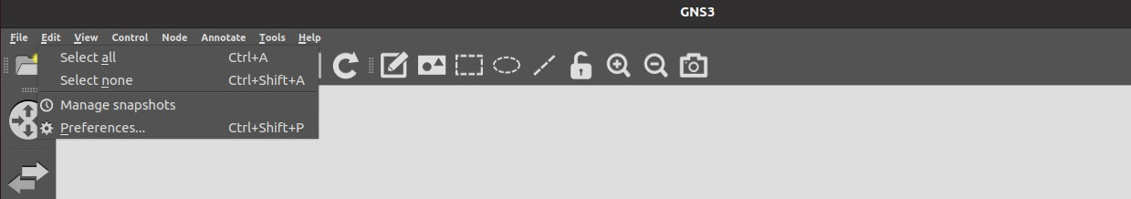

1. In the **Configuration file** section, click: **Import**

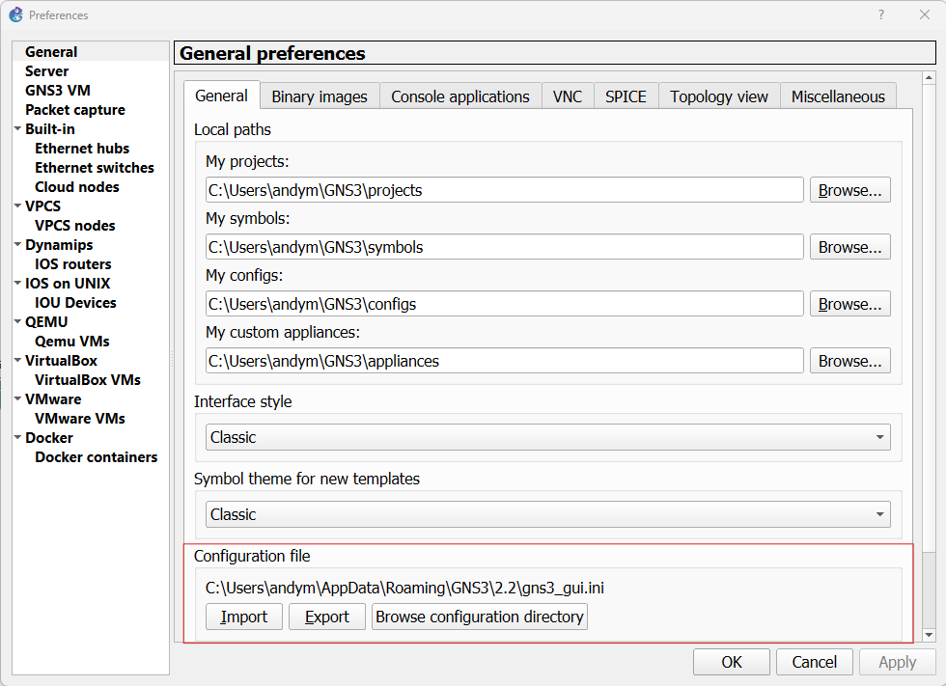

1. Select the gns3_gui.ini file from the downloaded GNS3A2Labs folder

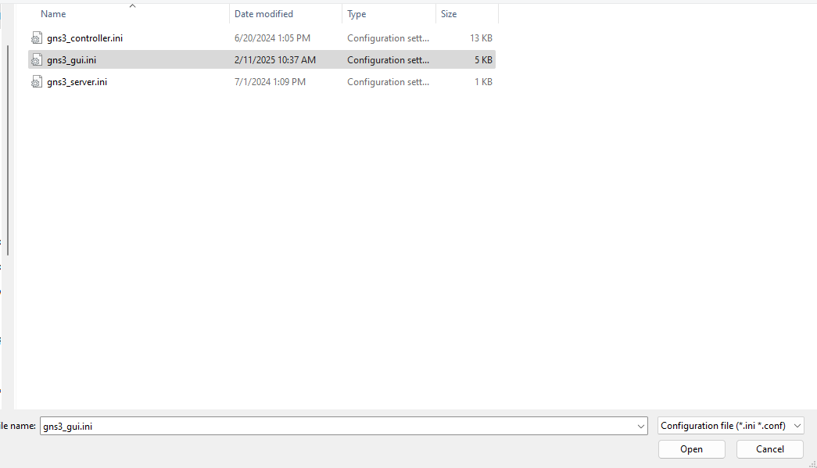

1. Start the GNS-3 VM

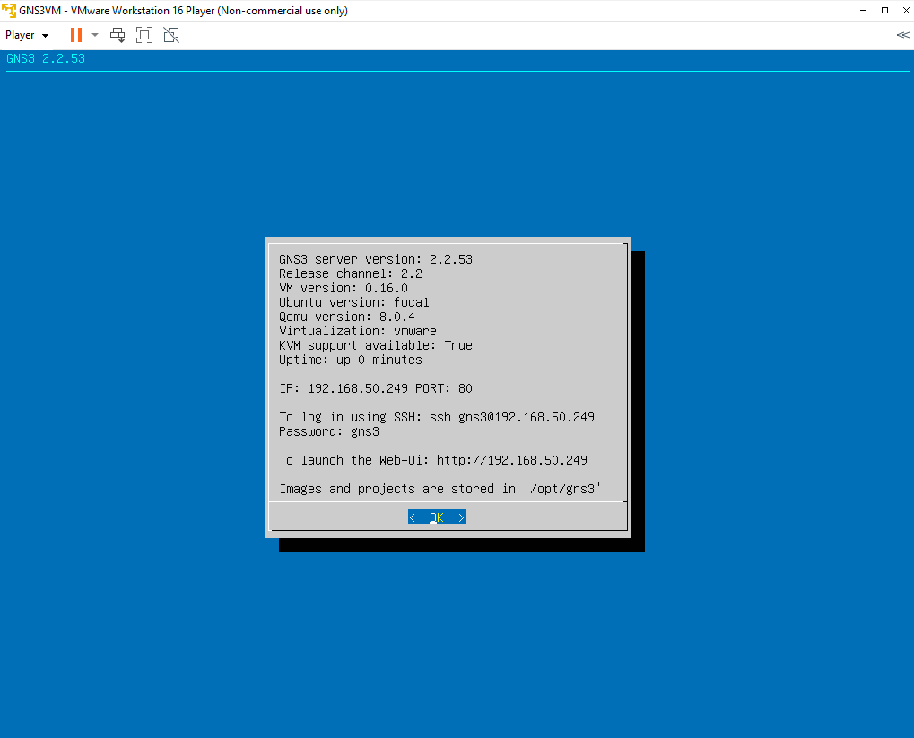

1. Click: **File > Open project** to load the SENTRY project

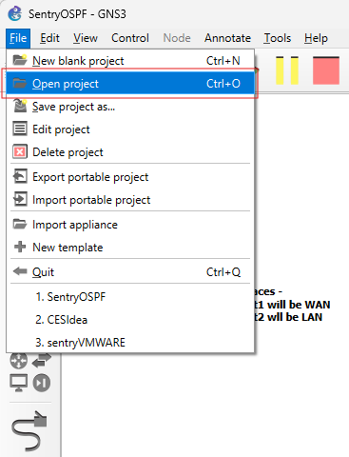

1. Click: **Projects library**

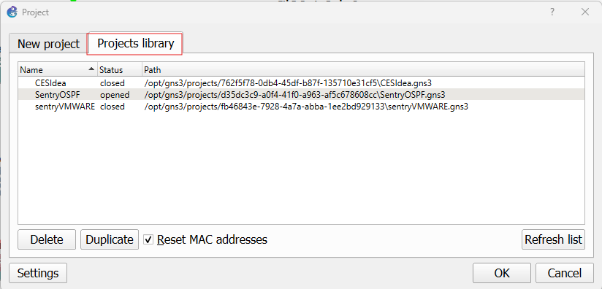

1. Click: **SENTRY Project**

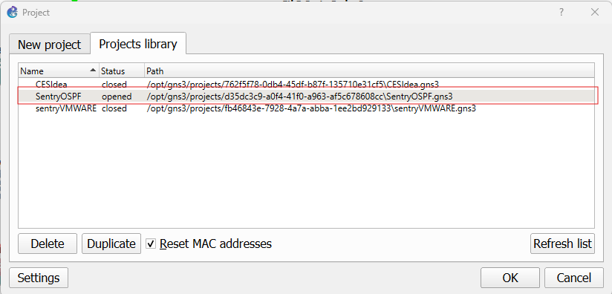

1. Click: **OK**

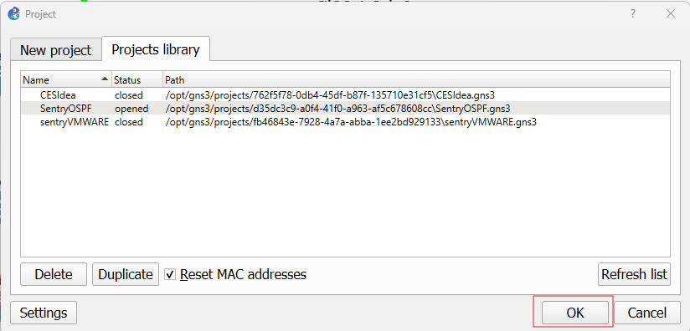

1. The SENTRY project will now load and be accessible from the GNS-3 GUI

## Running the SENTRY topology inside of GNS-3

After completing the Import GNS-3 Preconfigured VM and GUI Configurations, the SENTRY GNS-3 VM and GUI can be used. NOTE: The topology will look different from the demonstration screenshots.

The SENTRY project will load inside of GNS-3 with all appliances turned off.

#### To Run Appliances inside of the GNS-3 topology

1. Right Click: **Appliance in GNS-3 Topology**

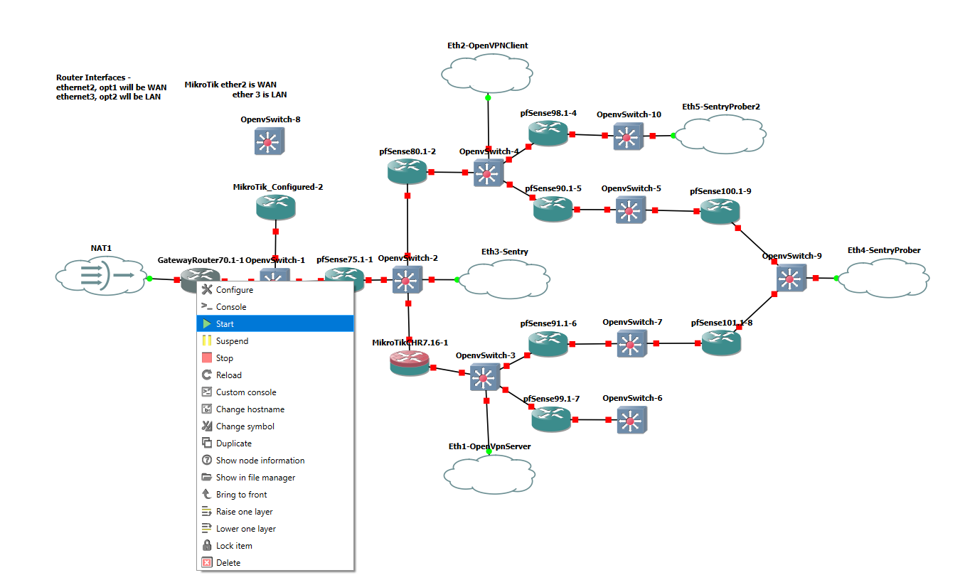

1. Click: **Start**
2. Optional - Double click: **Appliance** or Right Click: **Appliance > Console** to start console

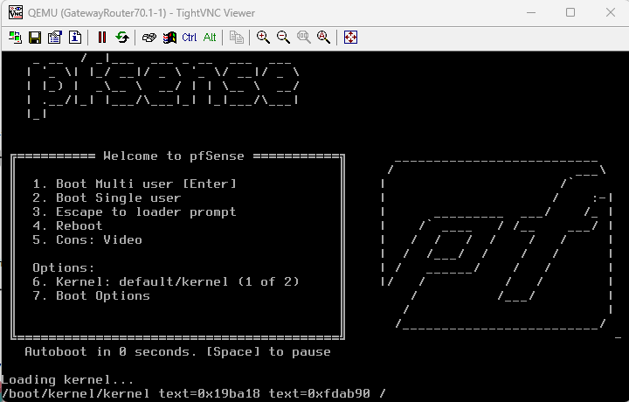

1. Ensure that the appliance is starting, after that the console can be closed and the appliance will continue to run

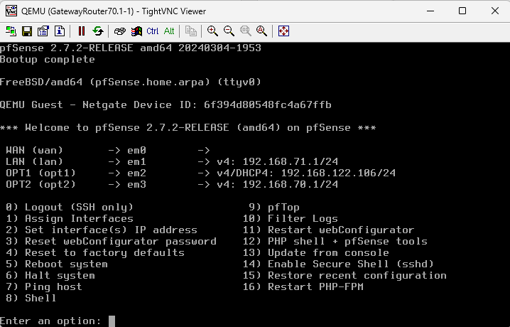

#### Running Wireshark on a link between appliances

Ensure Wireshark is installed on the host machine in which the GNS-3 GUI is installed

<https://www.wireshark.org/download.html>

1. Identify the link between appliances to run Wireshark on

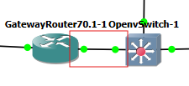

1. Right click: The virtualized ethernet connection

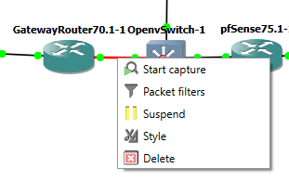

1. Click: **Start capture**

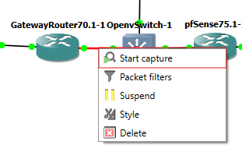

1. Click: **Ok**

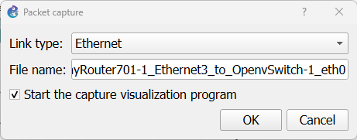

1. Wireshark should start, and automatically begin capturing packets flowing through the link between nodes.

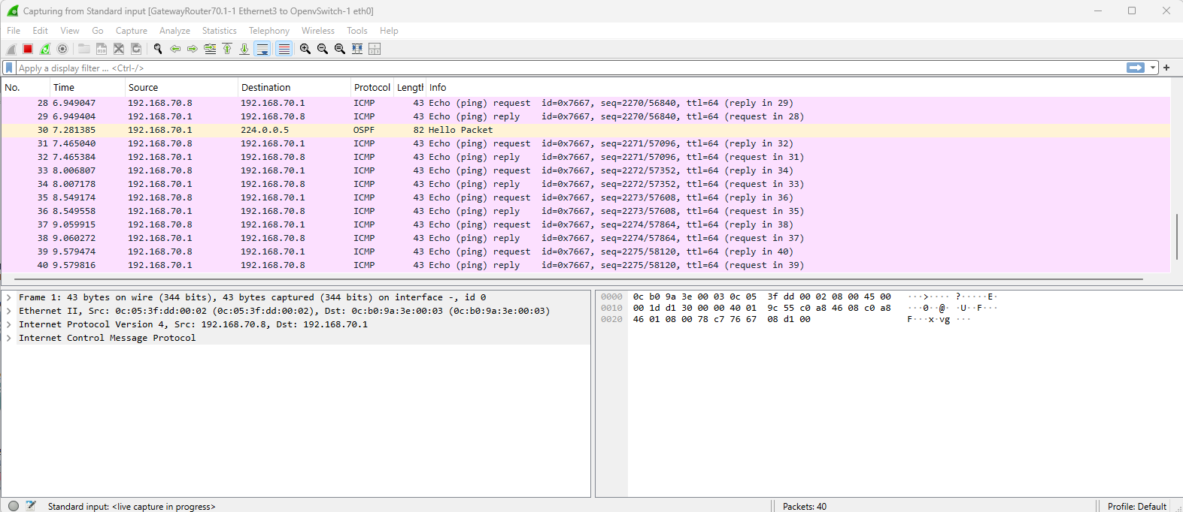

## Configure the local GNS-3 VM to be the “Remote main server”

The GNS-3 VM will be used as the main server, the GUI will be connected to the GNS-3 VM, and the GNS-3 VM will run all of the appliances, including routers, switches, Dockers, nested VMs, etc.

1. Download GNS-3 VM from <https://www.gns3.com/software/download-vm>
2. Import the GNS-3 VM into VirtualBox or VMware, by going to Player > File > Open

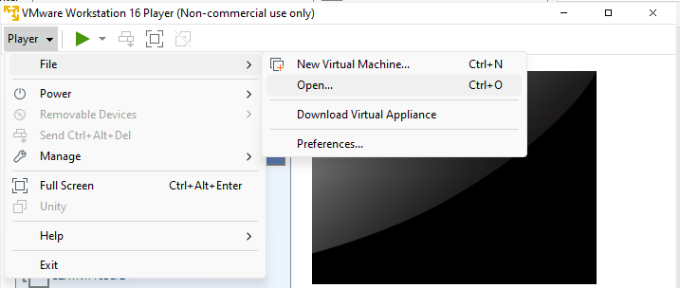

1. Run the GNS-3 VM, note the IP and Port of the GNS-3 VM

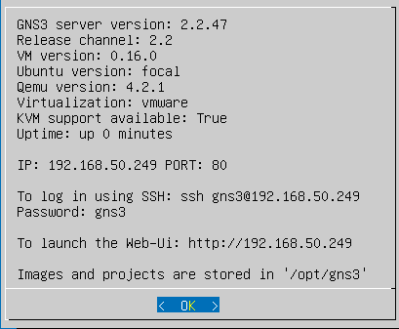

1. Navigate to Edit > Preferences



1. Navigate to Server, do not enable local server, instead put the IP and port into the “Remote main server” section

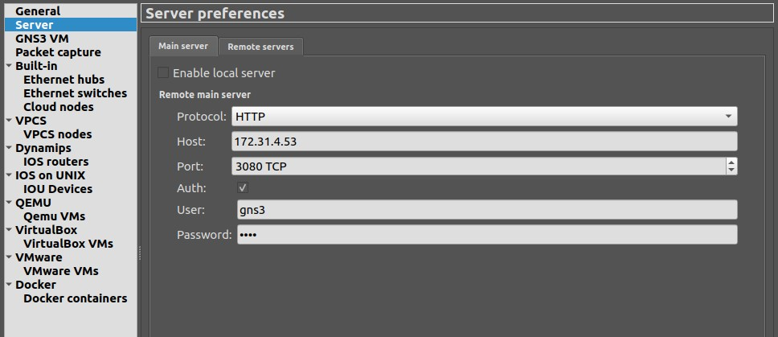

1. Open the GNS-3 GUI, a new project can now be created or loaded

## Using Custom Router Firmware, IOS Routers

This documentation provides details to the user on how to create their own router VM, inside of the GNS-3 VM. The end result will be a fresh, factory set router. Each additional router added will also still contain factory settings, meaning all routers would need to be configured when they are added to the topology. Alternatively, the user can opt to configure the first router added, and use that router to create a new configured router to use. Directions for this process are detailed in the Taking a Configured Router to Use for a New Base Image section.

1. Navigate to Edit > Preferences



1. Navigate to IOS routers
2. Select: **New**

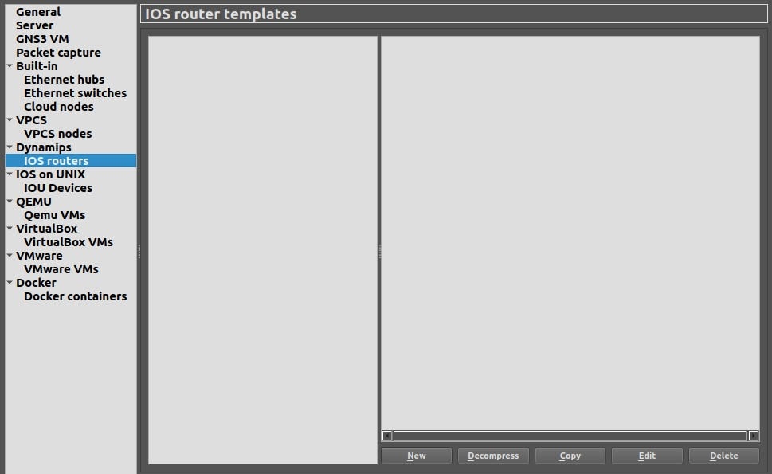

1. Select: **Run device on the main server** to install router firmware as a nested VM into GNS-3 VM

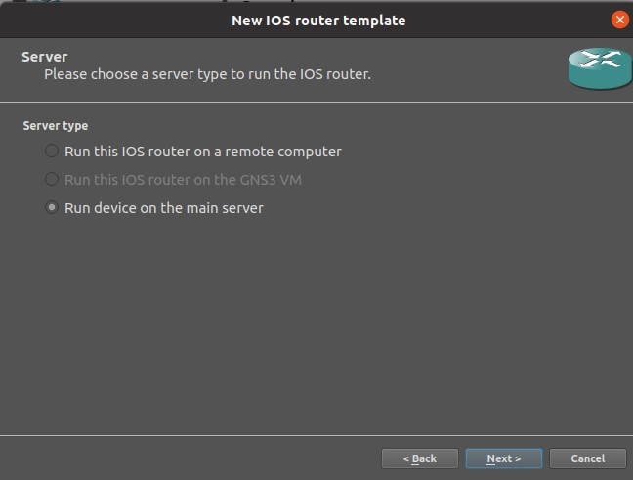

1. Select IOS image of the router firmware:

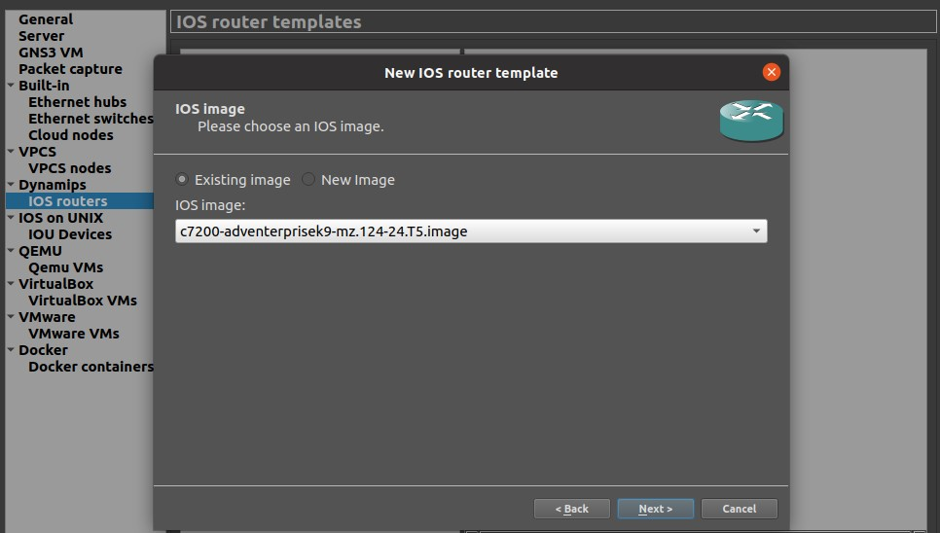

1. Configure the router firmware
   1. **Name:** User entered name to identify the router
   2. **Platform:** Specific to the IOS image selected in the previous steps.

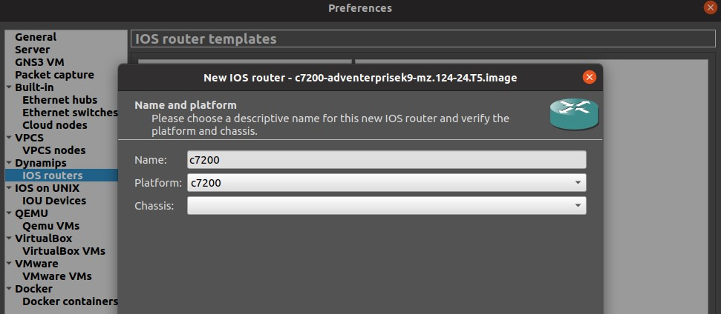

1. Assign to the slots the desired network adapters:

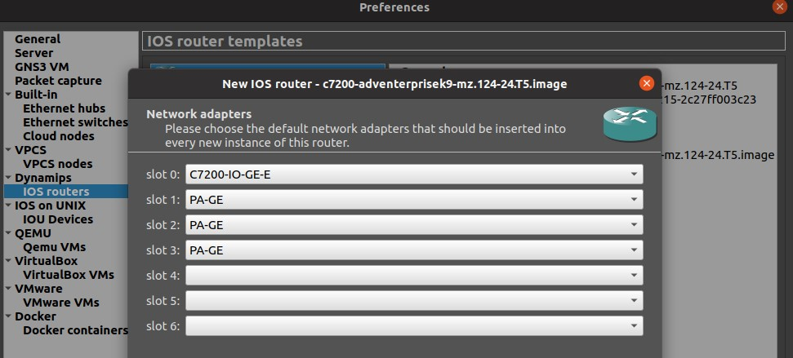

1. Allocate RAM to the appliance:

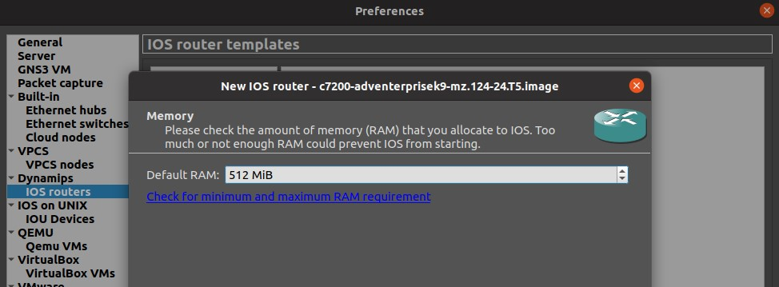

1. Continue with any further modifications to the router, and apply. This router is now ready to be added to a GNS-3 topology.

## Using Custom Router Firmware, QEMU

This documentation provides details to the user on how to create their own router VM, inside of the GNS-3 VM. The end result will be a fresh, factory set router. Each additional router added will also still contain factory settings, meaning all routers would need to be configured when they are added to the topology. Alternatively, the user can opt to configure the first router added, and use that router to create a new configured router to use. Directions for this process are detailed in the Taking a Configured Router to Use for a New Base Image section. This documentation installs a pfSense Router as a demonstration.

1. Select: **New Template** from the main screen on the GNS-3 GUI

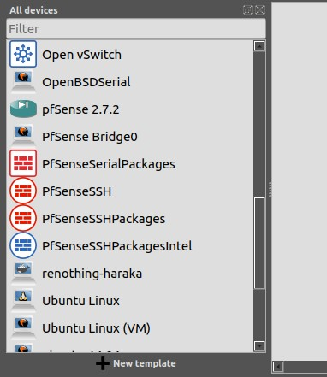

1. Select: **Install an appliance from the GNS3 server** (recommended)

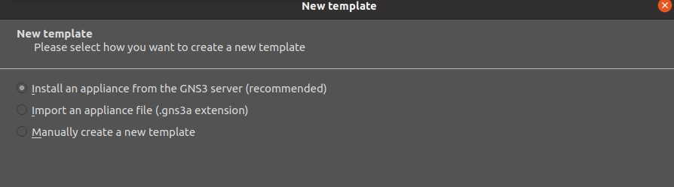

1. Select: **pfSense Qemu**

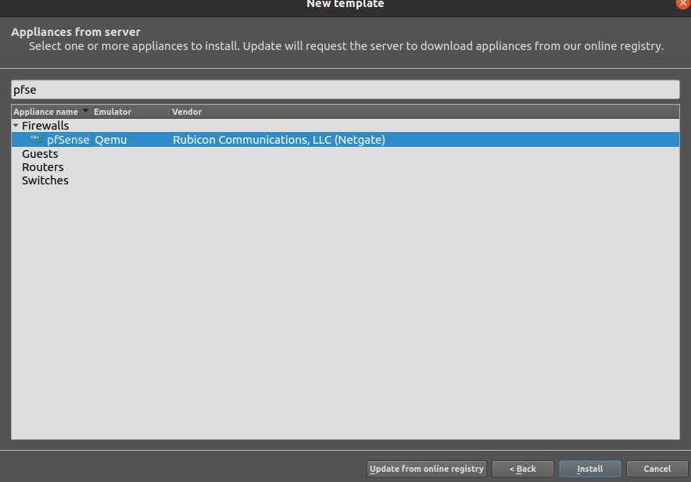

1. Select: **Install the appliance on the main server** to install router firmware as a nested VM into GNS-3 VM

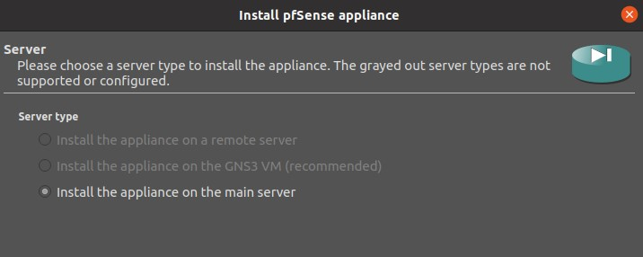

1. Select: **Qemu binary**

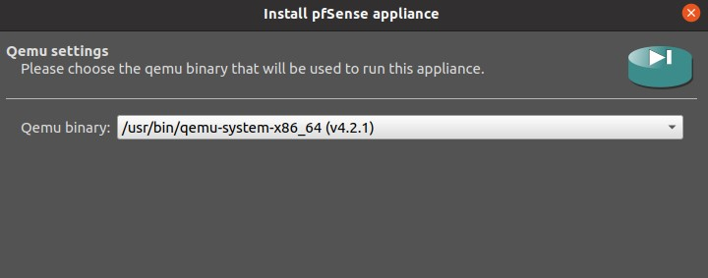

1. Select: **Allow custom files**
2. Click: **Refresh**
3. Select: **pfSense version 2.X**

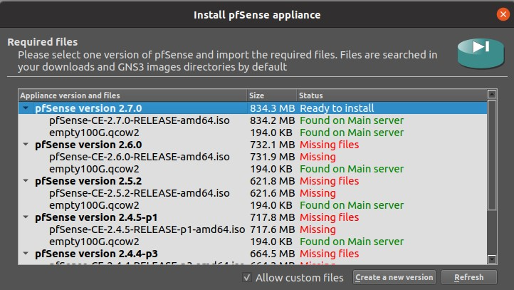

1. Click: **Finish**

## 

1. The pfSense router should now be visible in the “All devices,” and “Routers” sections.
2. Configure the router
   1. Right click router
   2. Click: **Configure template**

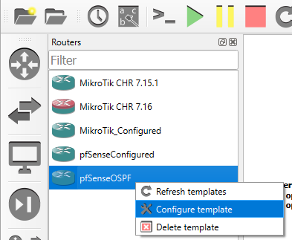

1. Modify settings to meet needs, commonly configured settings include-
   1. RAM
   2. vCPUs
   3. On close behavior
   4. Console type
   5. Network adapter quantity
   6. Network adapter type

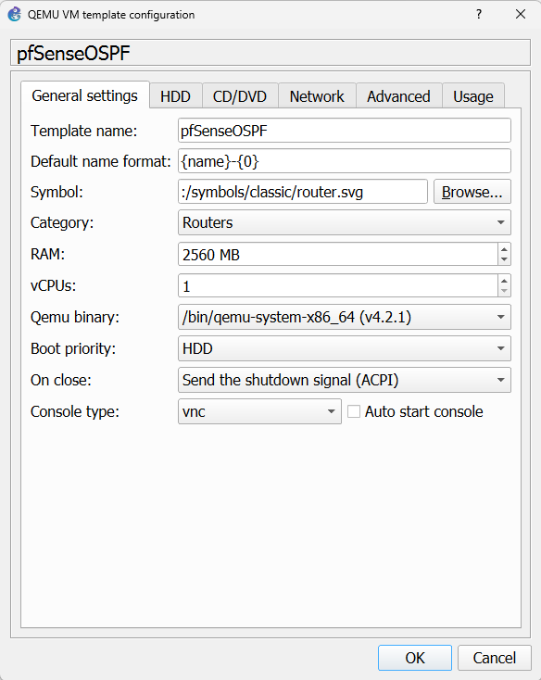

1. The router can now be dragged into a topology, and launched. Base configuration of the new router can be assisted with the Getting Started guide for that specific router firmware.

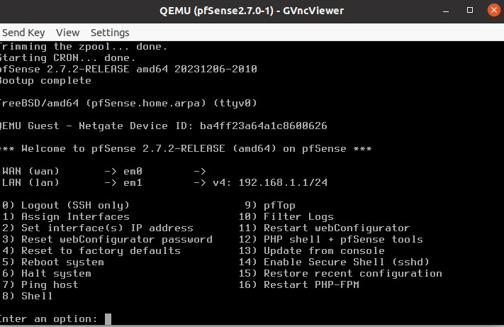

## Taking a Configured Router to Use for a New Base Image

A user may choose to setup a router with various customizations, activating OSPF, setting custom routing tables, etc. This process can be time consuming, and in order to avoid repetitive action, the user can choose to use a router that has already been configured to be used for future routers. The process involved replacing the empty disk drive in the previous configuration with the disk drive of the router to be used as the new base image. This documentation assumes that a router has already been setup and is ready for duplication.

1. Identify the router in the topology to be used as the new base image
2. Right Click and select: **Show in File Manager**

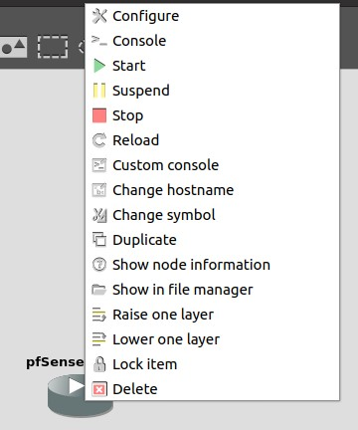

1. Select: **Yes**
   1. The path being shown is the path inside of the GNS-3 VM where the router’s virtual drive can be found.
2. SSH into the GNS-3 VM using preferred terminal

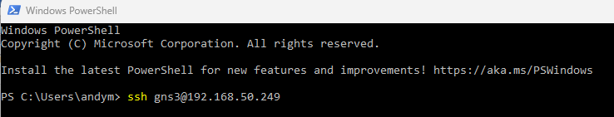

1. Select: **Ok**

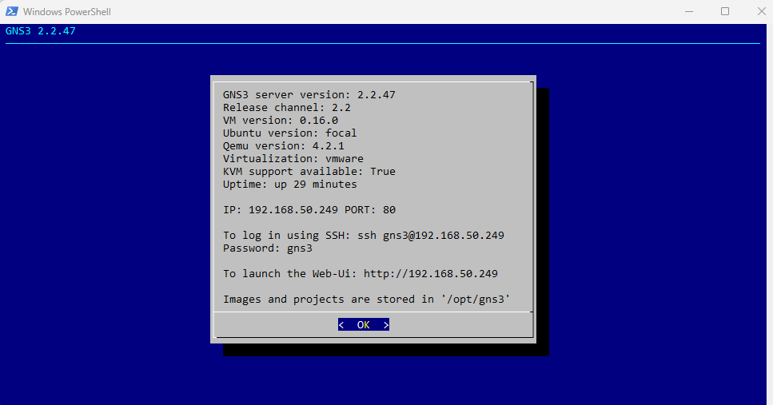

1. Select: **Shell**

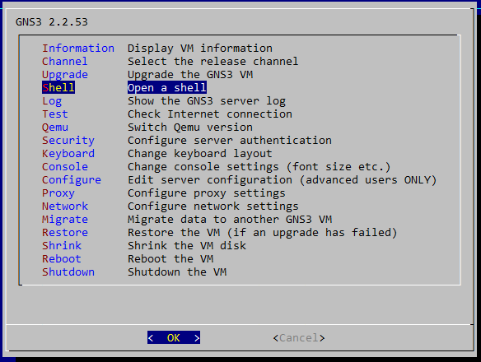

1. Migrate to copied directory



1. hda_disk.qcow2 in this folder is the virtual disk for the router to be used as the base image

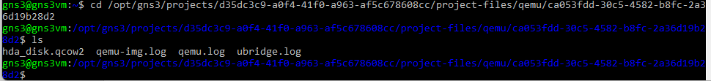

1. cp hda_disk.qcow2 /opt/gns3/images/QEMU/<UNIQUE_NAME_FOR_BASE_IMAGE>.qcow2



1. Return to the GNS-3 GUI, Edit > Preferences

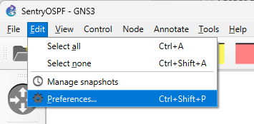

1. Click: **QEMU VMs**

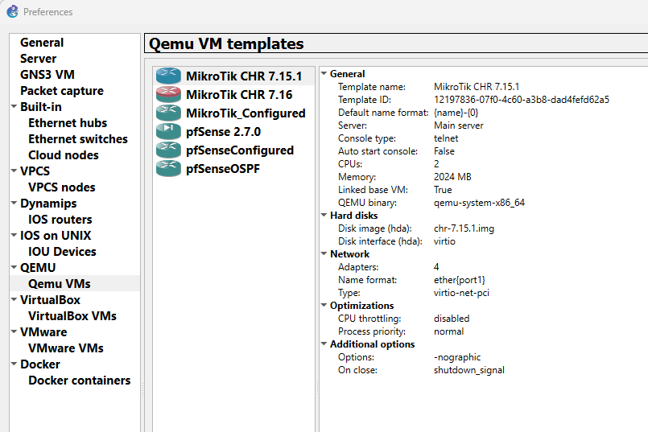

1. Click: **New**
2. Enter: Unique name for the new, configured router image

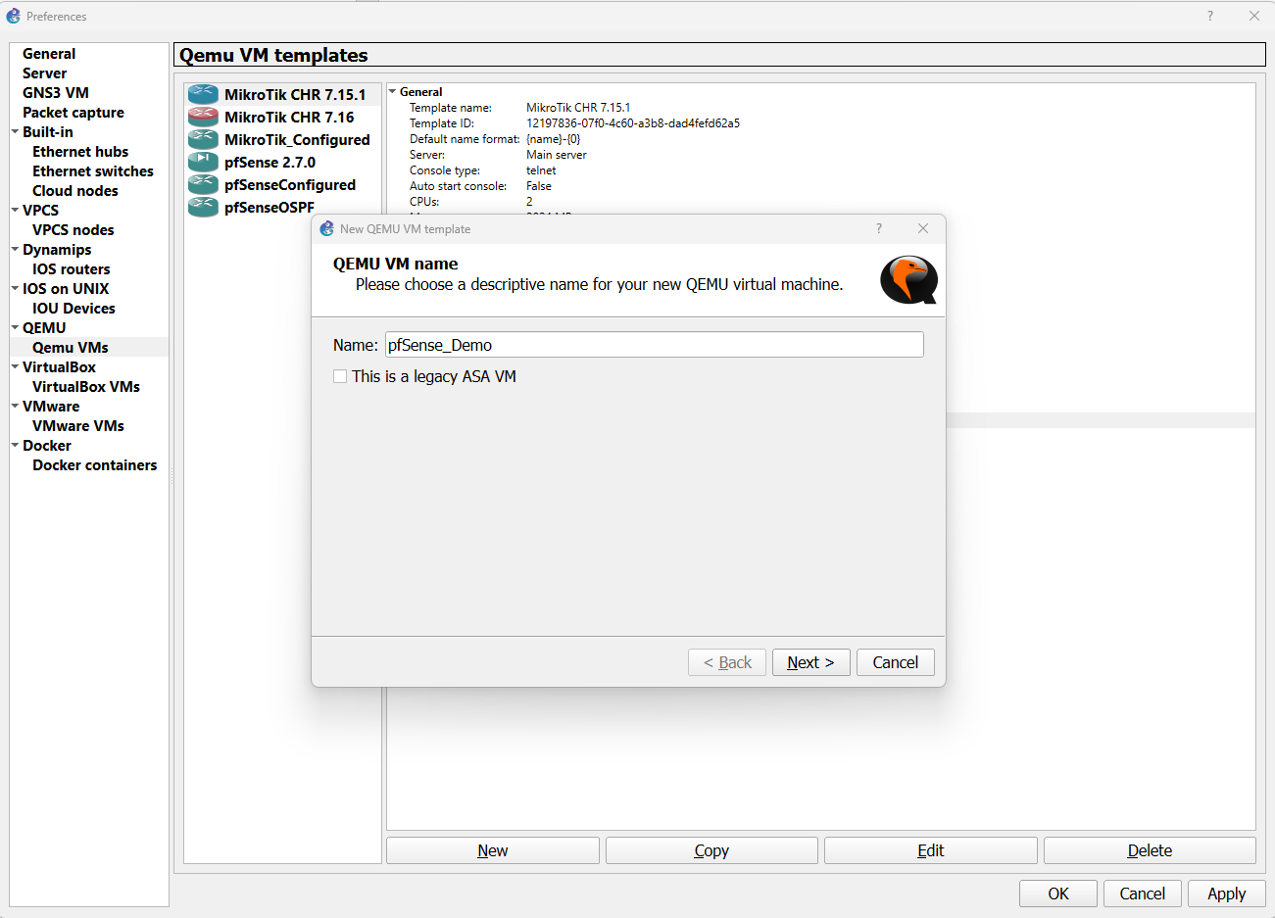

1. Click: **Next**
2. Modify: Ram

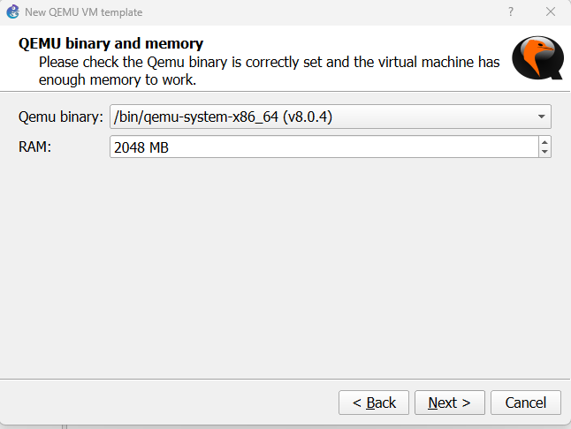

1. Click: **Next**
2. Select console type

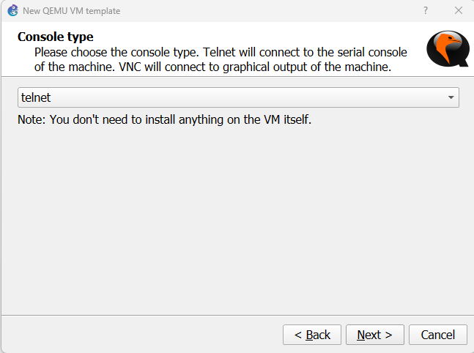

1. Click: **Next**
2. Locate the disk image that was previous given a unique name, BaseImageDemo.qcow2

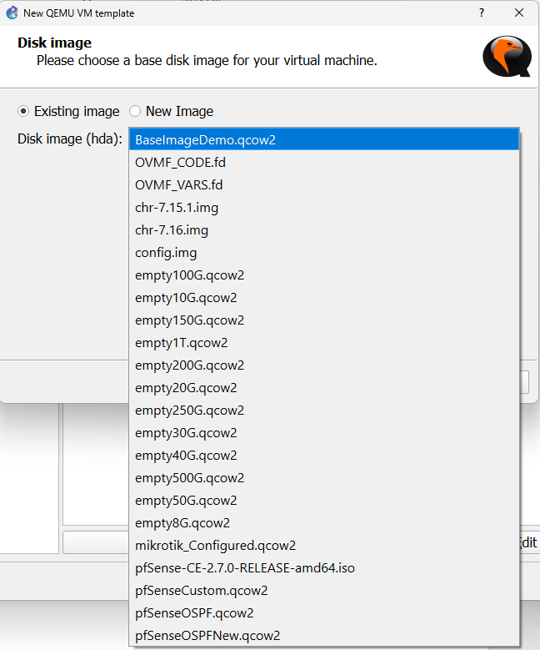

1. Click: **Finish**

The router is now available, listed in all devices. Certain modifications to the first template will not be saved, such as network adapter quantity, and other custom network adapter configurations. Modify the new template to fix this. GNS-3 is also not able to identify what type of device this is, however this can be remedied manually.

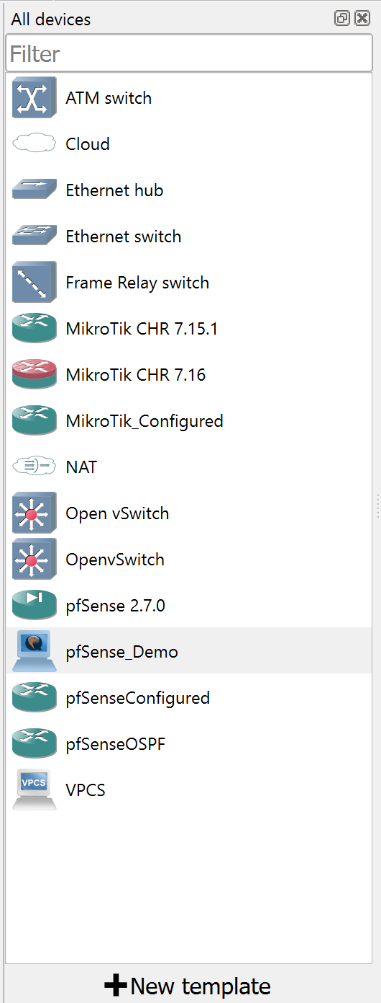

1. Right click the new configured router
2. Click: **Configure Template**
3. Change the category from end devices to **Routers**

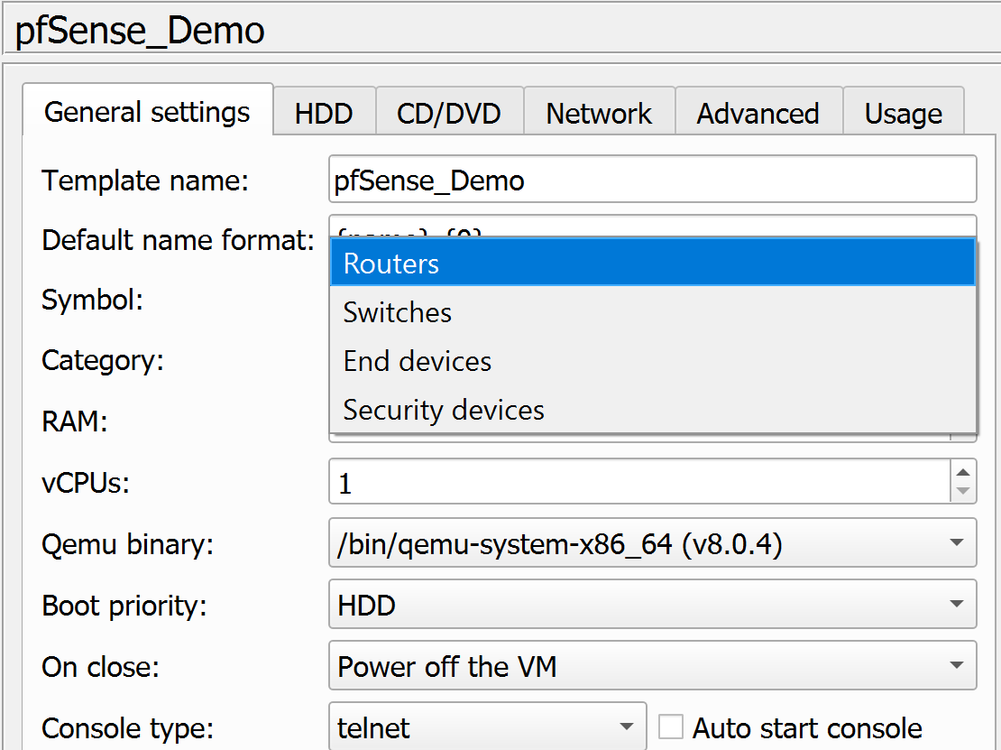

1. Click: **Browse…** next to the Symbol section

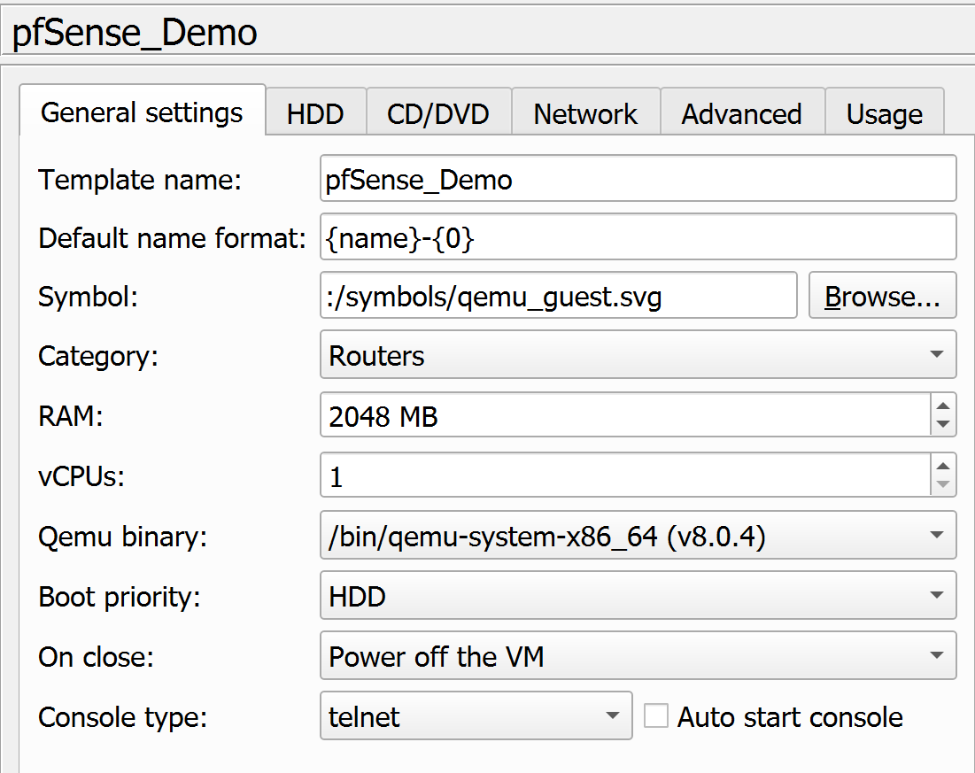

1. Click: **Classic**

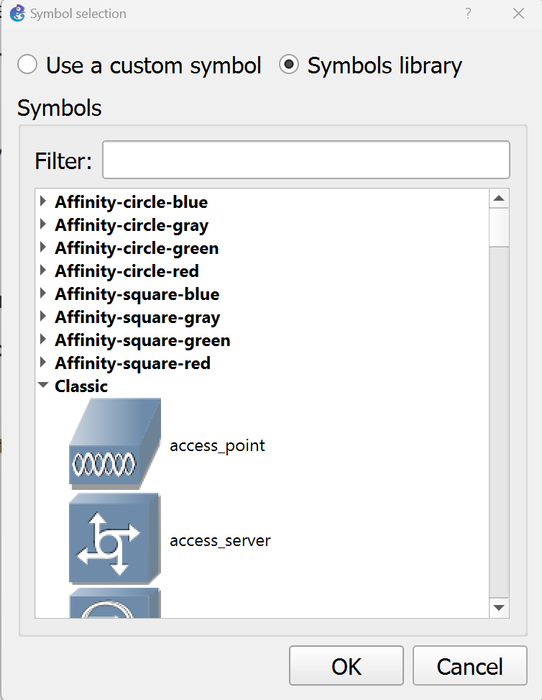

1. Locate and select: **Router**

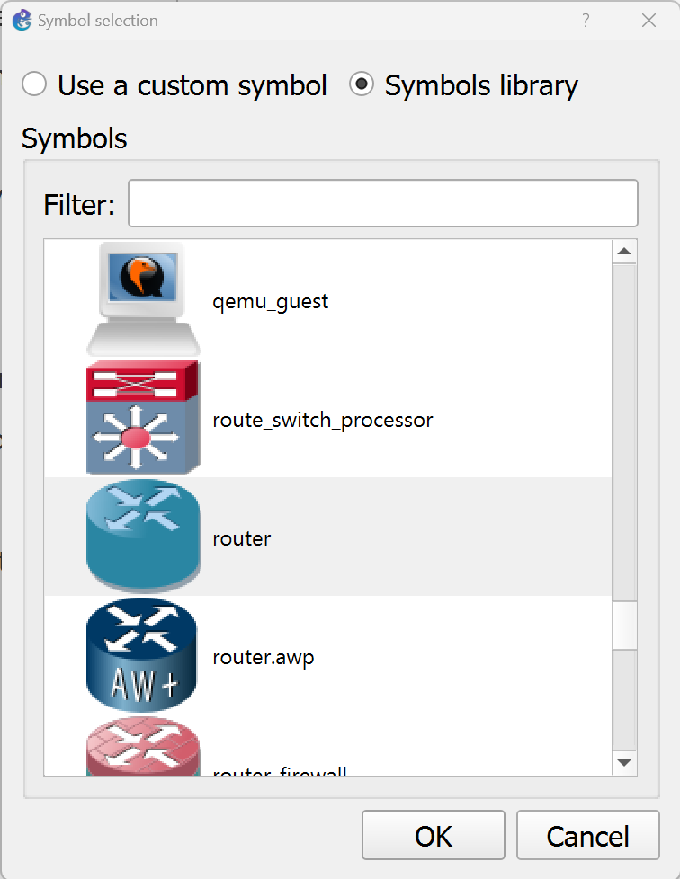

1. Click: **Ok**
2. The router will now show an appropriate icon and will show up in the appropriate location

