ADSALIVE

Compile the Dialog by using the symbol table

1) Go To ADSC

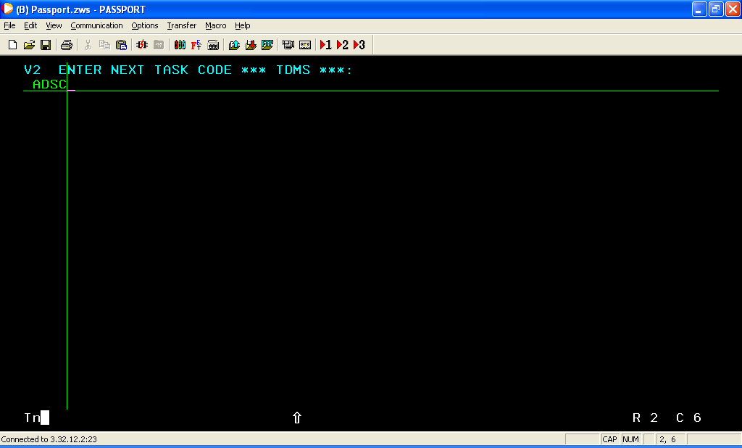

2) Give the dialog details and give option 1 and hit Enter

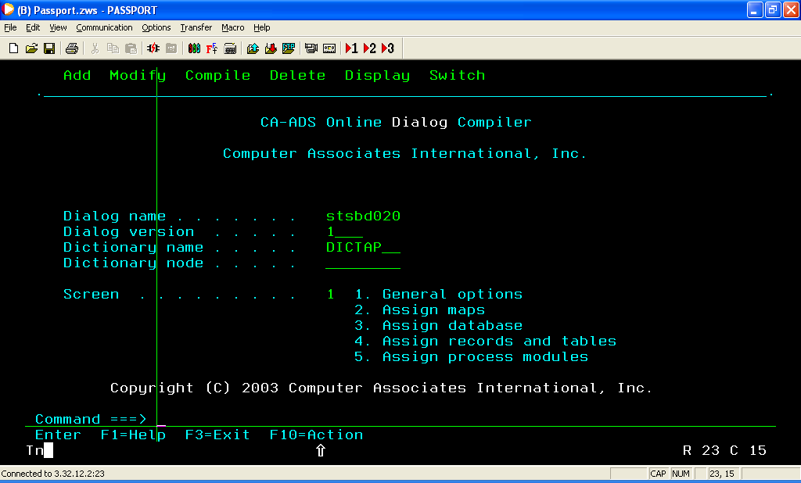
3) Activate the Symbol Table and Daignostic Table options ( By giving / against the option

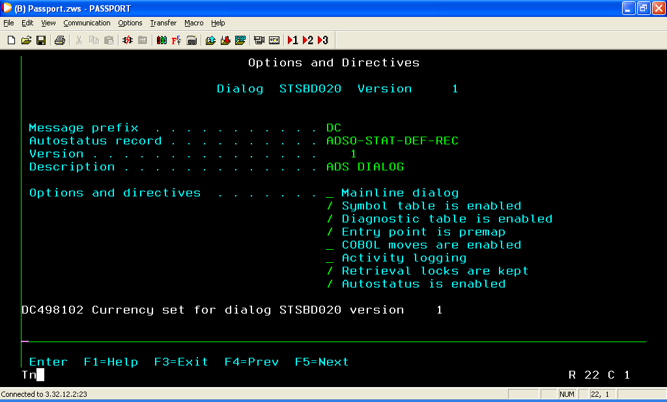

4) Give PF3 and come out to the previous screen and Compile the dialog

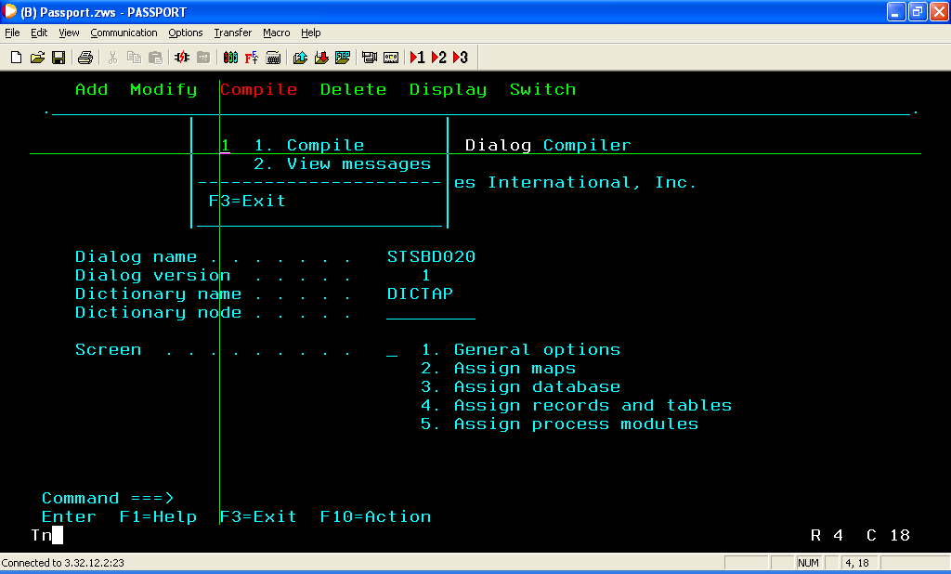

5) After the successful compilation of the dialog come out of ADSC by hitting PF3 and mark the new copy.
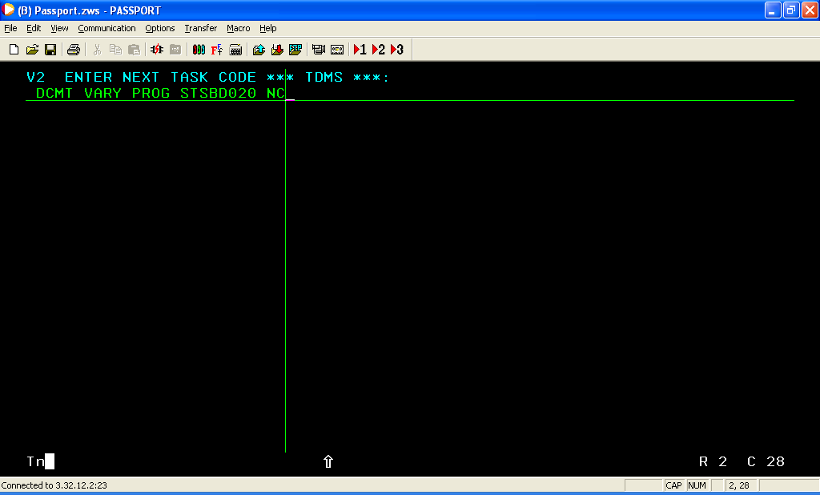

6) Now go to ADSALIVE

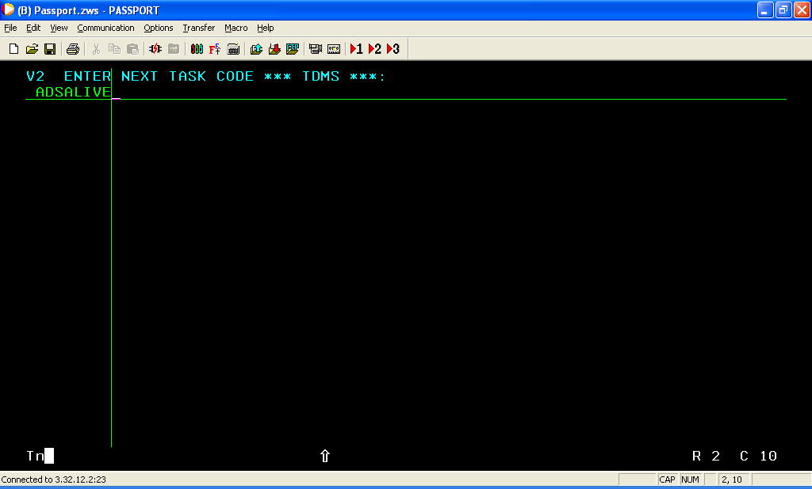

7) Give option 1 and dialog details to animate and Hit Enter

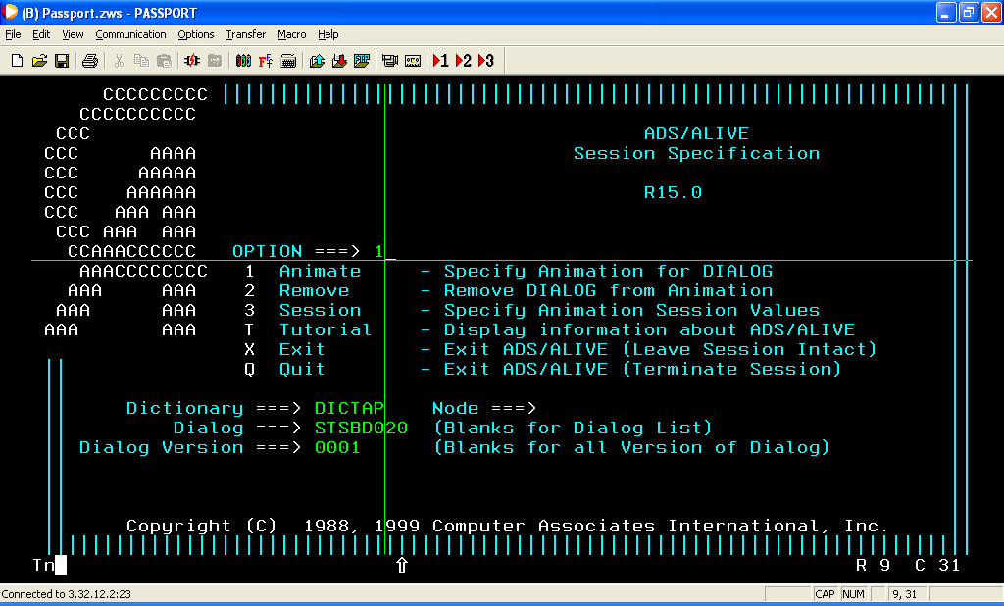

8) Give ‘Y’ to specify process and Hit eneter to select the process you want to animate

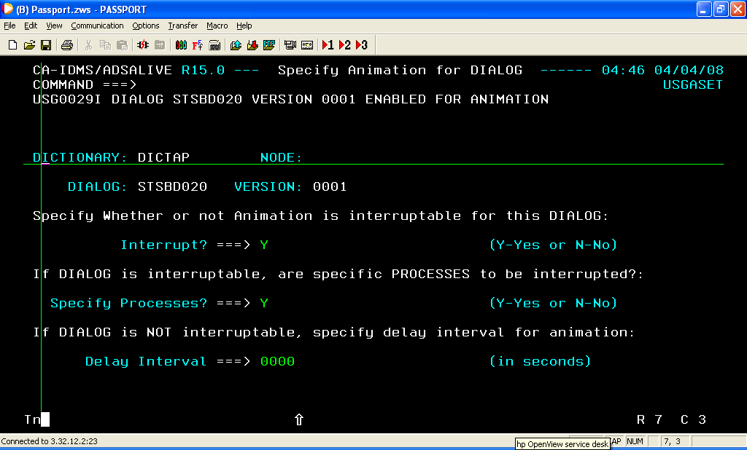

9) Select the process which you want to Animate by giving S against it and then hit Enter

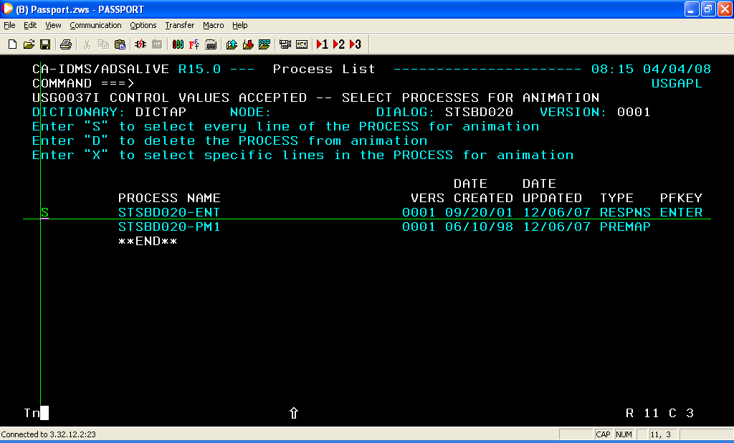

10) Then press Press F3,F3,F3, Clear to go back to Command processor screen and invoke the dialog through the screen ( Run the dialog ).

