Will Kelsey, Nick Krysko

Applied Programming Concepts

Prof. Carpenter Summer 2019

Assignment 7 Databases

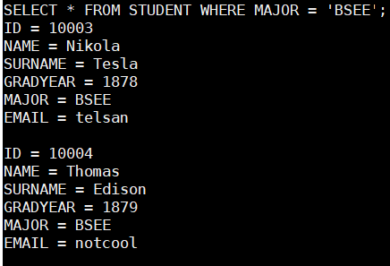 Databases are the godsend for CURSE coders. The implementation of a database within C++ is difficult, however, it can very easily replace linked lists. As a result, it can quickly simplify all functions by replacing insert and pushback, iterators, and some pointers. This simplification takes advantage of SQLite’s ability to interface with C++ and directly interact with a database from a .ccp program.

Creating a course registration program from scratch without a database was complex and not fully featured. Most of the unincluded and powerful features are natively available from a database. In this instance, one issue that was discovered, was the fact that the student database of courses was not visible to the instructors. In order to cross reference both the instructor list and the student list to view students that a single instructor was teaching, significant code was created. With an SQL database used instead, native query functions can join two tables producing the desired output. SQL queries are powerful and can produce the data needed for a registration program.

Insertion of data with SQL does not need to account for order of input or size. Inserting new data merely adds to the database out of order. When queries are done, sorts are conducted without manual search and sort algorithms. Unlike linked lists which live in memory, SQL writes to a database file which can be persistent between program runs. This can be beneficial as originally; the registration program would have been run continuously for all of time. If it were to shut down, all data that was not hard coded in the program would be lost and all student data missing. This is a huge benefit for a proper program to run in a production environment.

Databases are powerful and when implemented originally in a program, can make a fairly robust system with limited effort. The use of databases for CURSE will alter the entire program plus add several new features originally not possible if using linked lists to store data.