Figure : Class Model

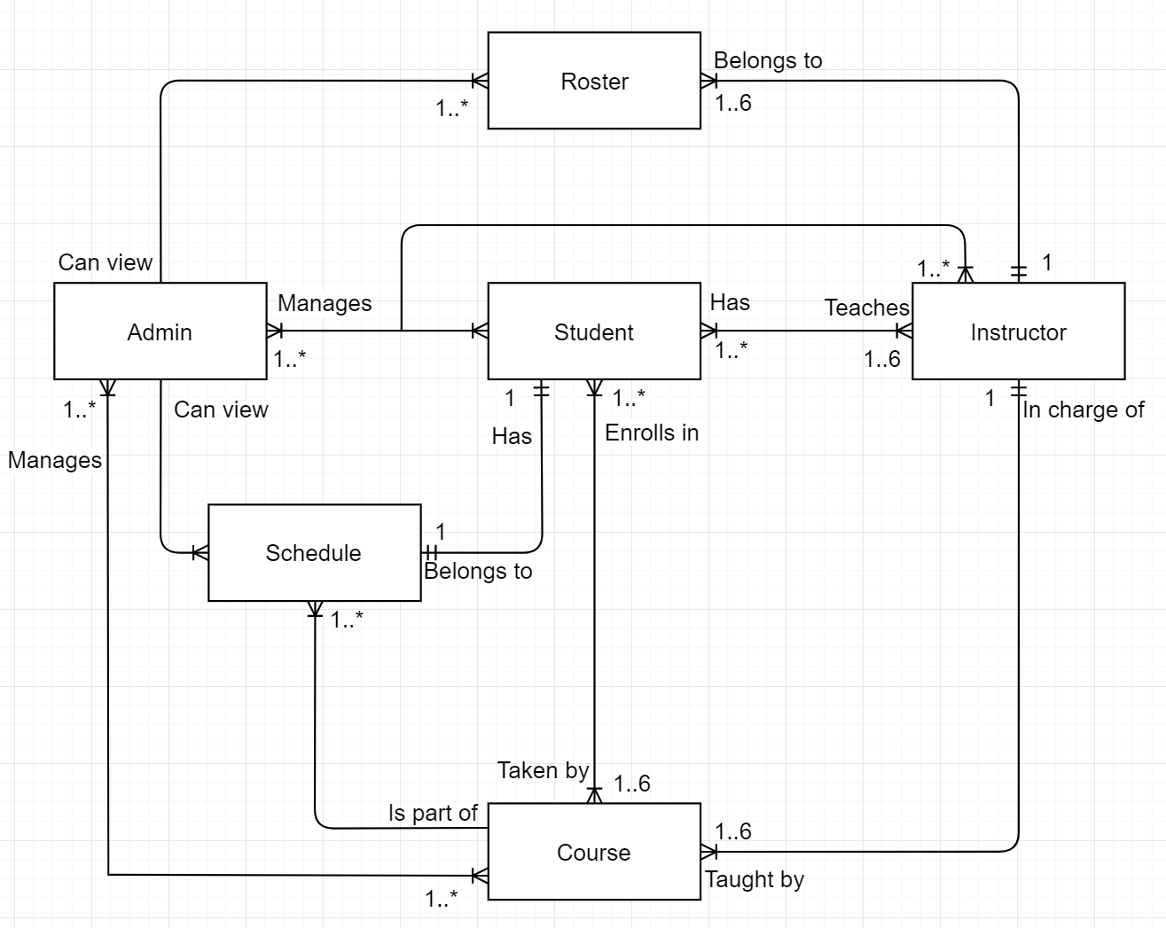

The above diagram is the class model for the CURSE program. There are currently six classes, each depicted with its own box in the model. The purpose of this diagram is to show the relationships between each of the classes. Each Admin object has control over multiple user accounts, course lists, schedules, and rosters. Students have a schedule, are enrolled in up to 6 courses, and have at least one instructor. Instructors have multiple class rosters, are in charge of at least 1 course, and have multiple students in each class. Below are additional tables showing the tree main user classes in more detail:

Figure : User Type Specifications

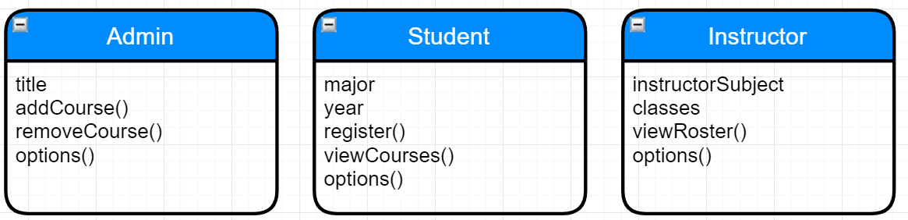

Here, the currently implemented attributes and functions for each user derived class is shown. It is important to note that the “options()” function contains the options each user is presented with after logging in (including the ability to logout).