Experiment Report
1. Objective
The purpose of this experiment is to:
1. Understand the concept of static websites and how they differ from dynamic websites.
2. Learn how to use GitHub Pages as a static website hosting platform.
3. Master the process of creating a GitHub repository for website deployment.
4. Gain basic experience in writing web pages using HTML and CSS.
5. Successfully deploy and access a personal static website.
--------------------------------------------
3. Experimental Principle
GitHub Pages is a static website hosting service provided by GitHub. By creating a repository named “username.github.io” and placing website source files inside the repository, GitHub automatically publishes the website online.
A static website contains fixed content that is delivered directly to users without server-side processing. Static websites are simple, fast, and easy to maintain.
--------------------------------------------
4. Experimental Content
1. Register and log in to a GitHub account.
2. Create a repository named username.github.io.
3. Create an index.html homepage file.
4. Enable GitHub Pages in repository settings.
5. Verify that the website is accessible online.
--------------------------------------------
5. Experimental Procedure
Step 1: Create a GitHub Repository
Log in to GitHub, click “New Repository”, and name it username.github.io. Select Public and initialize with README.
Step 2: Create Homepage
Create a file named index.html and write the following sample code:
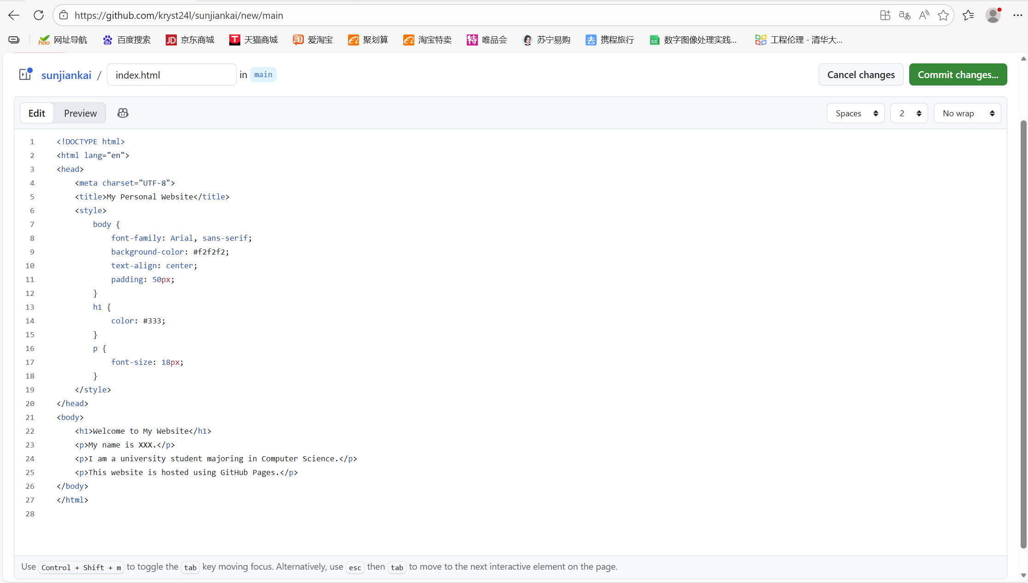
Step 3: Enable GitHub Pages
Go to Settings → Pages, choose branch “main” and root directory.
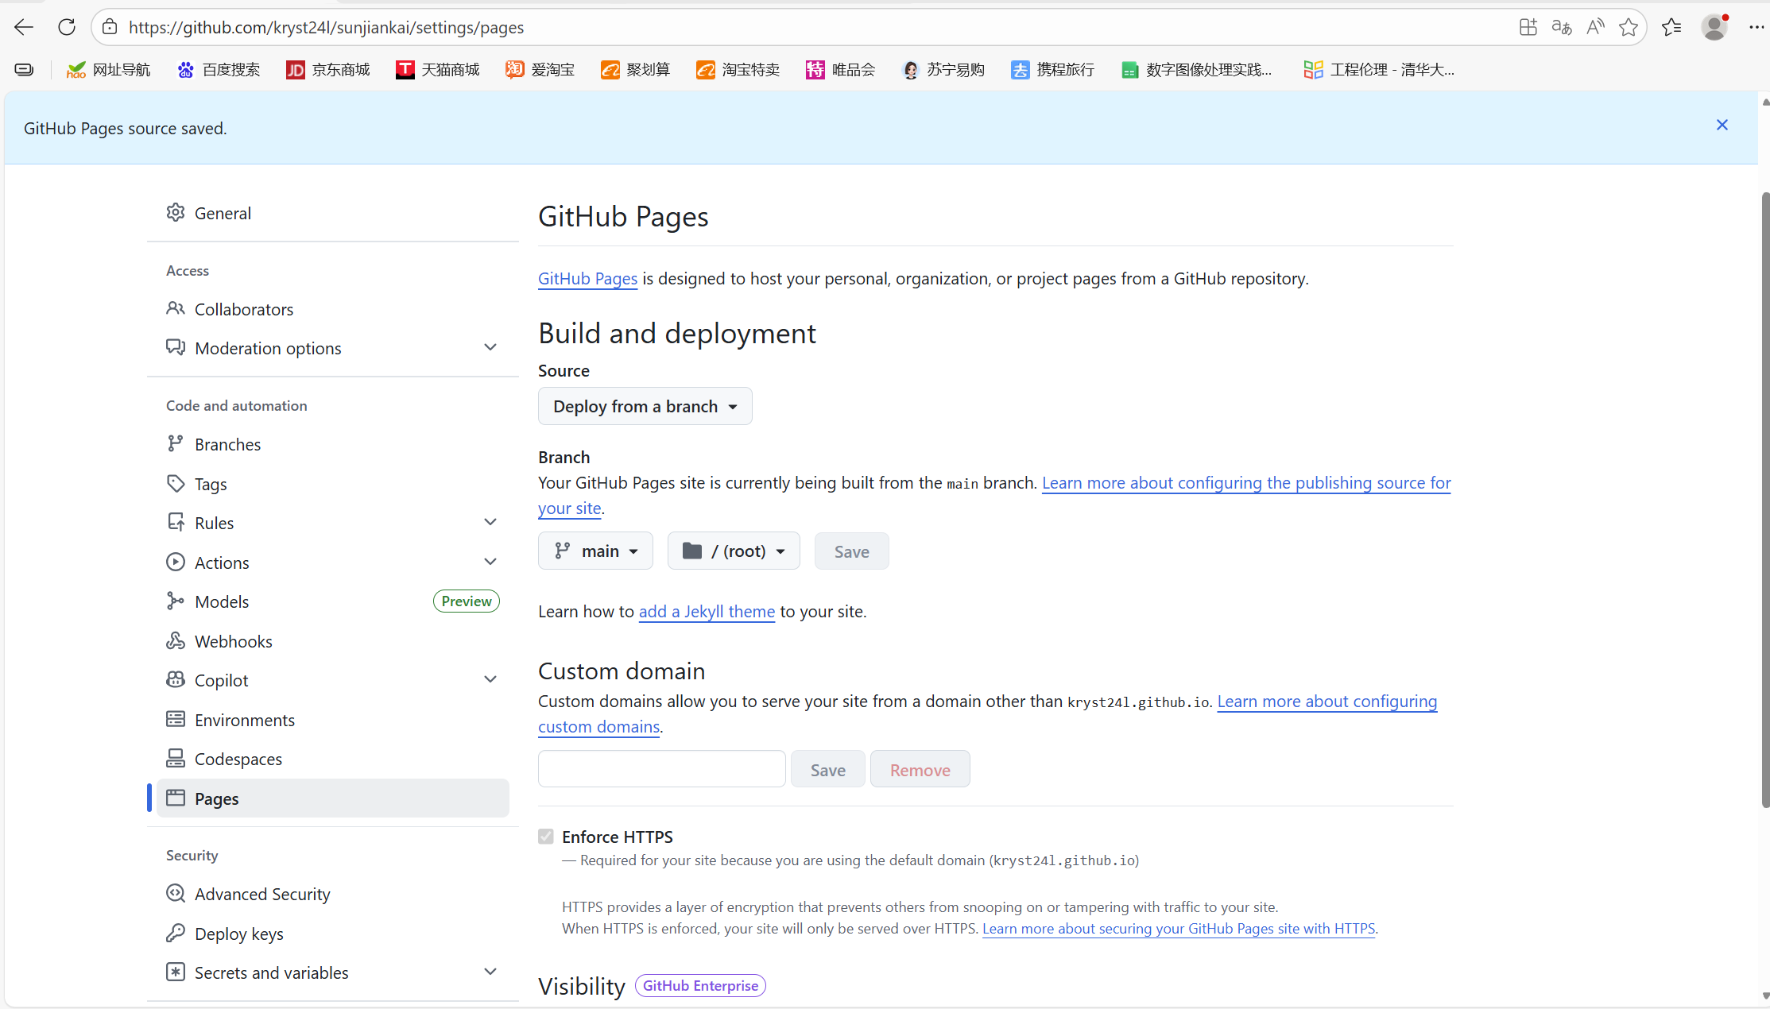
Step 4: Access Website
Visit: https://username.github.io
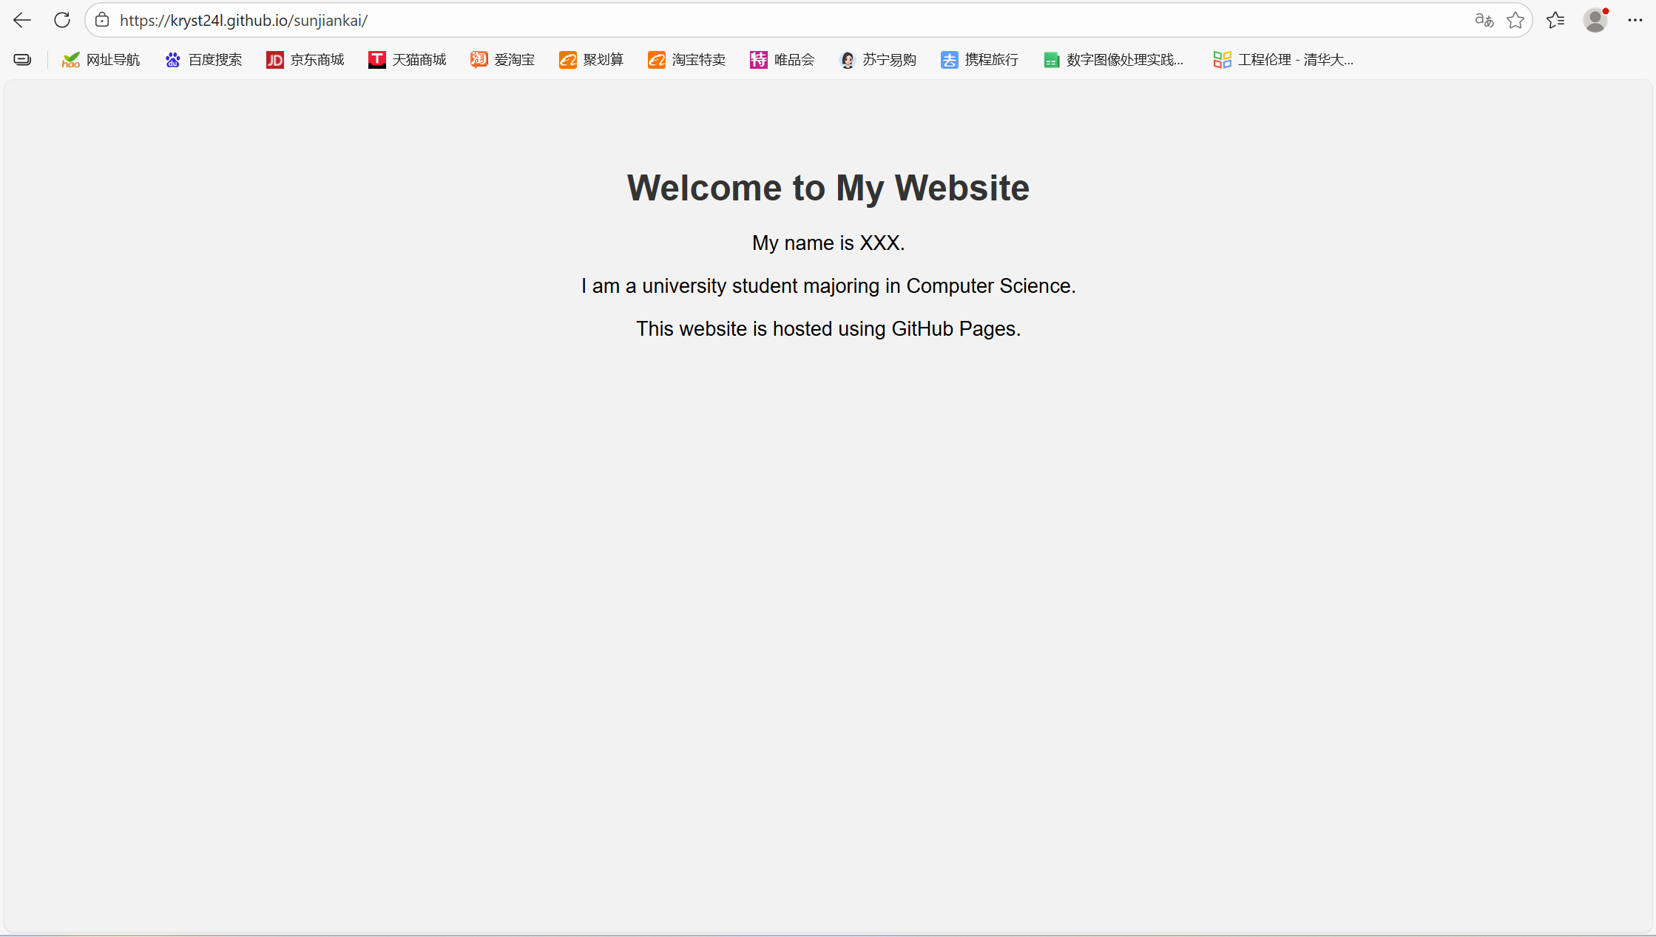
--------------------------------------------
6. Experimental Results
The personal website was successfully deployed and is accessible online. The homepage displays personal information correctly, indicating that GitHub Pages configuration is correct.
--------------------------------------------
8. Conclusion
Through this experiment, I learned how to use GitHub Pages to build and publish a personal static website. I improved my understanding of HTML structure and web hosting concepts. This experiment provides a foundation for building personal portfolios and future web projects.

