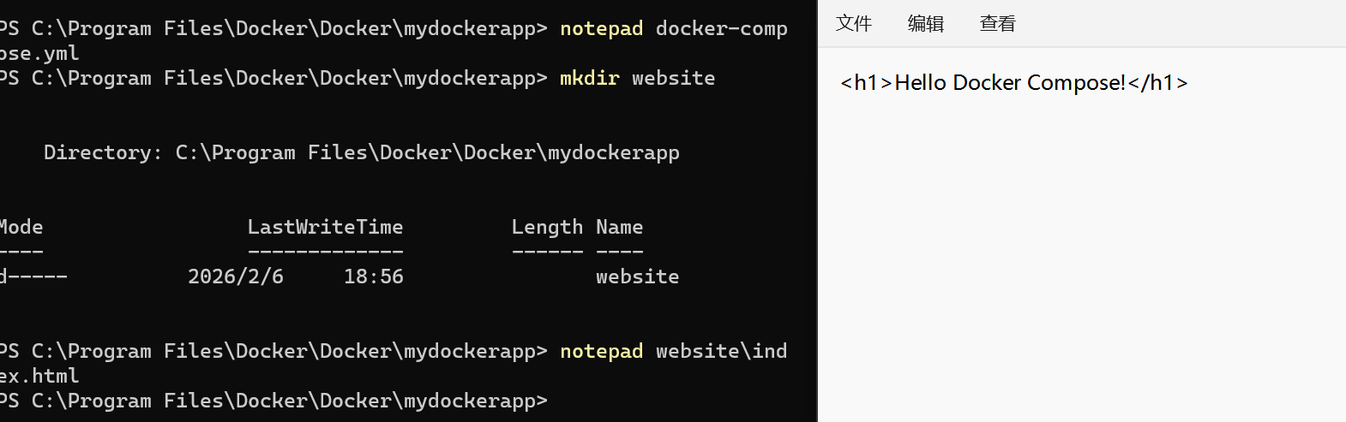
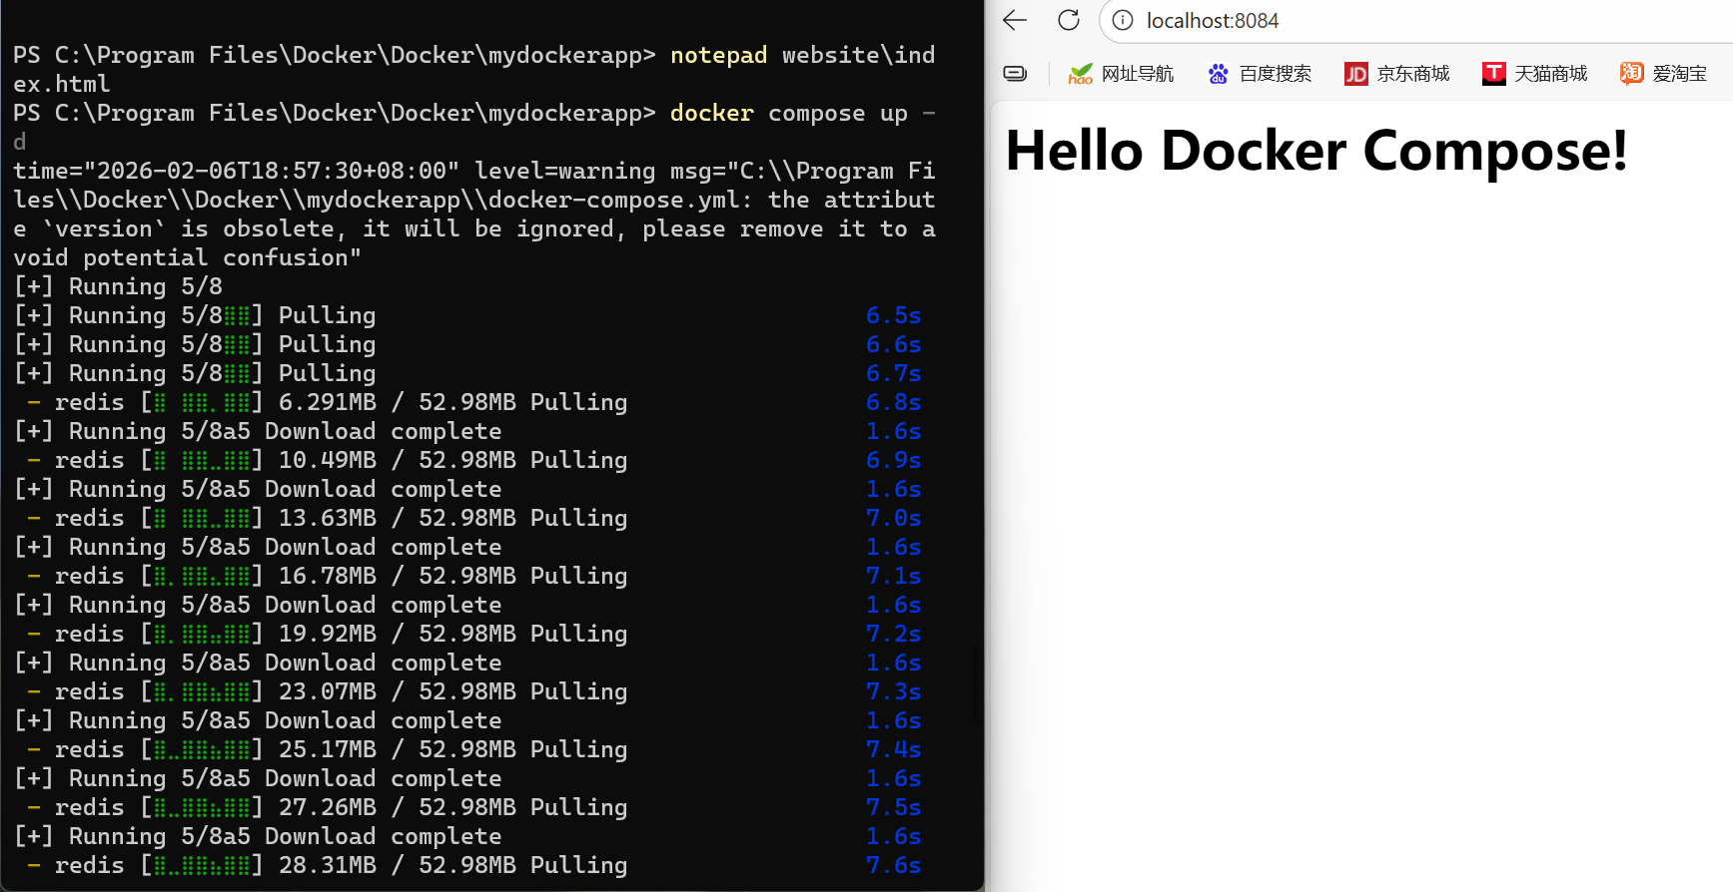

1.Objective
The main objective of this lab was to gain hands-on experience with Docker by learning how to:

Pull and run Docker images as containers.
Publish container ports to access services externally.
Override default container commands.
Persist container data using volumes.
Share local files with containers.
Deploy multi-container applications using Docker Compose.

2.Lab Activities
1. Running Containers and Publishing Ports
Pulled the Nginx image using docker pull nginx.
Ran a container and mapped its internal port 80 to local port 8080:
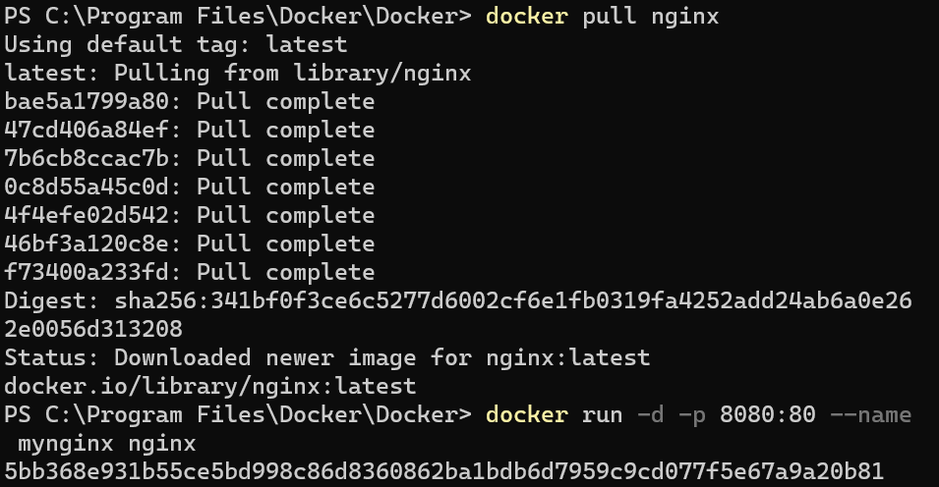
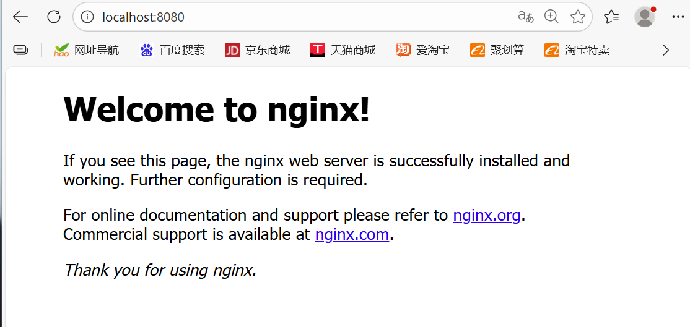
Verified by opening http://localhost:8080 in a browser, confirming Nginx was running.

Notes:
Port mapping allows services running inside a container to be accessible from the host system.
Containers run in isolated environments but can expose selected ports.

2. Overriding Container Defaults
Ran Nginx with a custom command
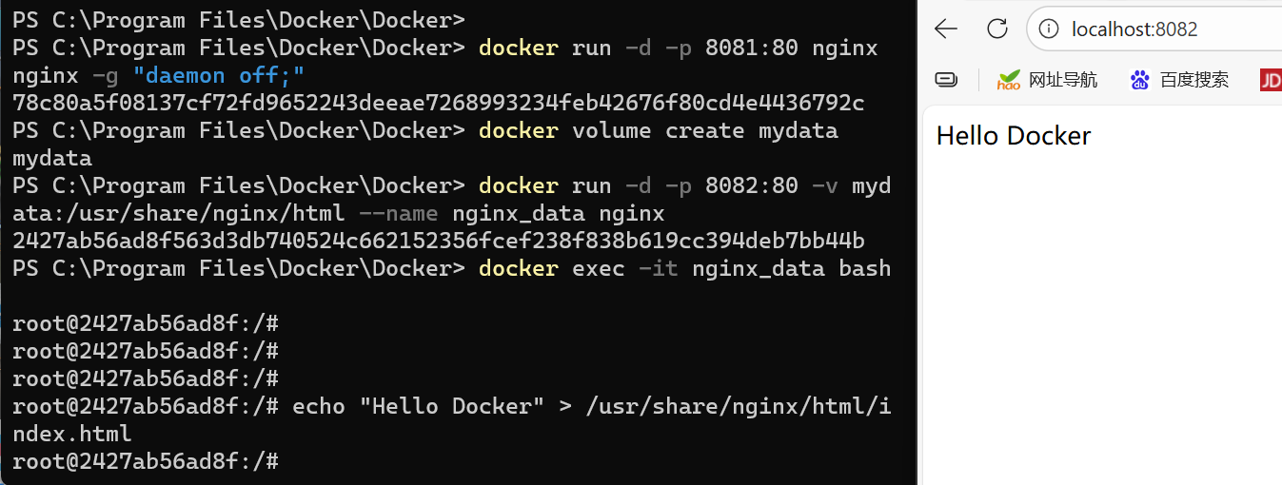
Observation:
Overriding the default CMD or ENTRYPOINT allows temporary or custom configurations without rebuilding the image.
Useful for debugging or testing changes.

3. Persisting Container Data
Created a Docker volume
Mounted the volume to the container
Inside the container, created a test file

Outcome:
Verified that even if the container is stopped or removed, the data in the volume persists
Volumes provide a safe way to manage persistent data in Docker.

4. Sharing Local Files with Containers
Created a local folder C:\Users\YourUser\website.
Mounted it to the Nginx container

Observation:
Changes in the local folder are reflected in the container immediately.
This approach is particularly useful during development, as it avoids rebuilding images for content changes.

5. Multi-Container Applications with Docker Compose

Created a docker-compose.yml file:

version: '3'
services:
web:
image: nginx
ports:
- "8084:80"
volumes:
- ./website:/usr/share/nginx/html
redis:
image: redis

Started all services


Verified Nginx served the local website (http://localhost:8084) and Redis was running as a backend service.

Stopped the services using:

Observation:
Docker Compose simplifies managing multiple services with a single configuration file.
Volumes allow local file changes to reflect in running containers, providing a live development workflow.

6.Conclusion
This lab provided practical experience with Docker basics, container management, data persistence, and multi-container orchestration. By completing this lab, we gained the foundational skills necessary to deploy, manage, and maintain containerized applications efficiently, paving the way for more advanced Docker and DevOps practices.

