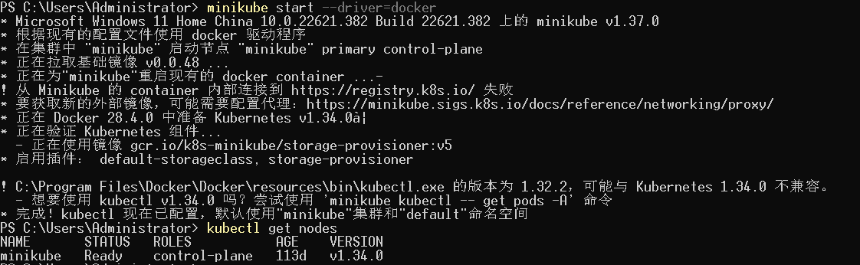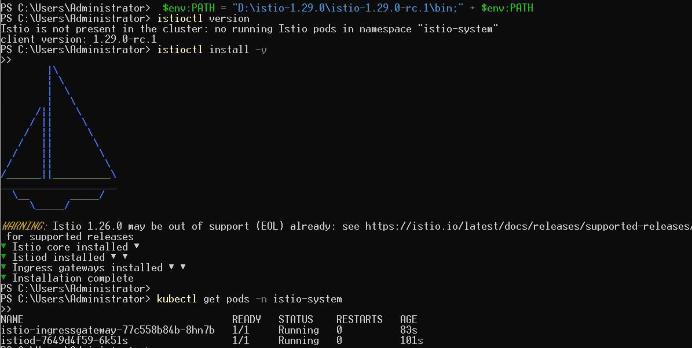

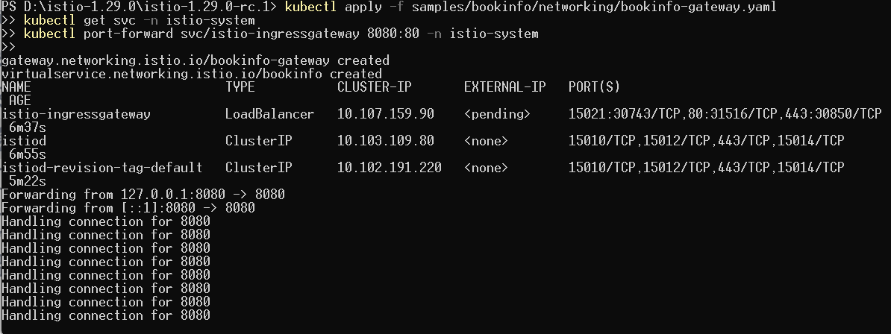
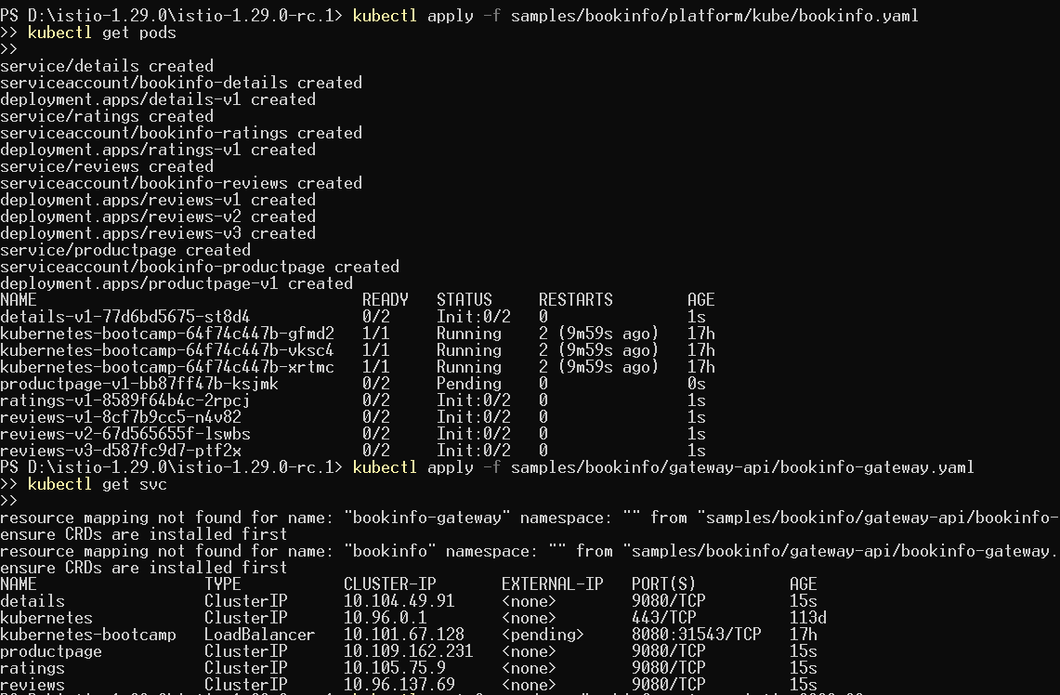
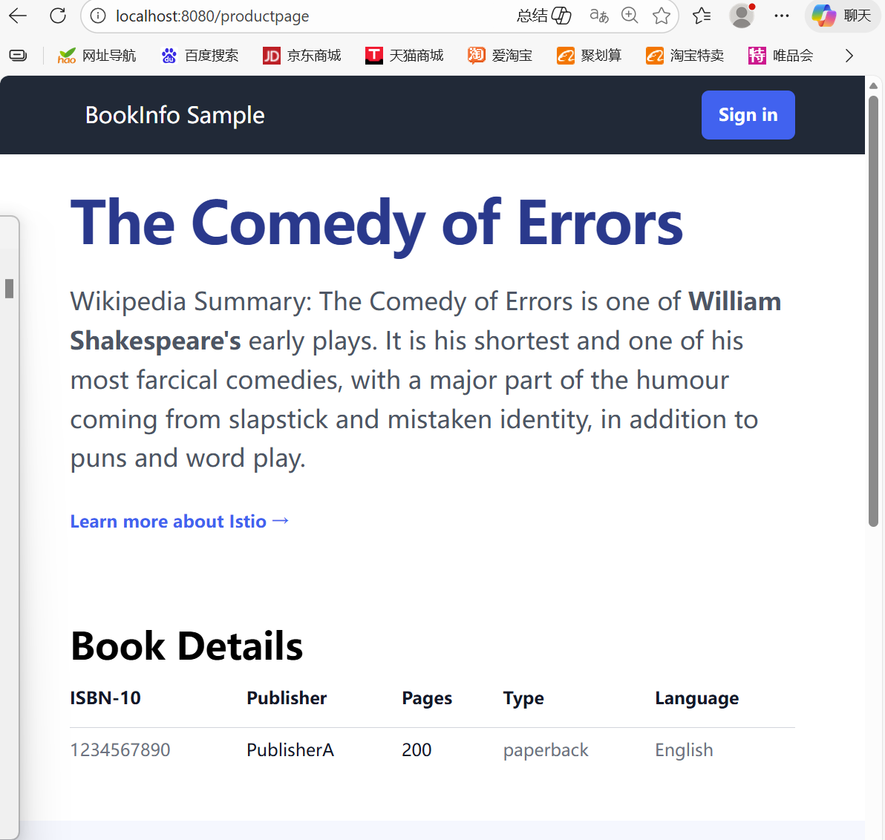
Istio Bookinfo Lab Summary

1.Objective:
Deploy the Istio service mesh and the Bookinfo sample application on a local Kubernetes cluster using Minikube on Windows, and verify traffic routing through Istio Gateway.

2.Environment Setup:
OS: Windows 11 Home
Kubernetes: Minikube v1.37.0 (Docker driver)
Istio: 1.29.0-rc.1
Resources allocated: 2 CPUs, 4GB memory

3.Lab Steps:
Start Minikube cluster

Verified the node status is Ready.

Install Istio Control Plane
Istiod and istio-ingressgateway pods running.
Enabled sidecar injection on default namespace:

Deploy Bookinfo application

kubectl apply -f samples/bookinfo/platform/kube/bookinfo.yaml
kubectl get pods

All Bookinfo microservices (details, productpage, ratings, reviews) deployed.
Pods initially in Init state due to sidecar injection, became 2/2 READY after a short wait.

Deploy Istio Gateway (traditional Gateway, compatible)

Created Gateway and VirtualService for Bookinfo.

Access Bookinfo application locally

Open browser at: http://localhost:8080/productpage
Verified product page and microservices traffic flow through Istio.

4.Key Learnings:
Setting up a local Kubernetes cluster using Minikube on Windows is feasible for Istio experiments.
Sidecar injection automatically integrates microservices with Istio.
Traditional Istio Gateway YAML ensures compatibility when Gateway API CRDs are not installed.
Port-forwarding allows access to services running inside the cluster.
Istio dashboard provides observability for service mesh traffic.

5.Conclusion:
The lab demonstrates deploying Istio on a local Kubernetes cluster, enabling sidecar injection, deploying a multi-service application, and routing traffic through Istio Gateway. The Bookinfo application successfully runs with traffic fully managed by Istio, completing the lab.

