Nebula VPN Lab Summary Report

1. Lab Objectives
Learn and master the basic setup and usage of Nebula VPN.
Build a cross-NAT network to allow secure communication between devices in different networks.
Understand the role of the Lighthouse node and how NAT traversal works.
Gain practical experience in certificate management (CA and node certificates) and configuring the config.yaml files.

2. Lab Environment
Device / Node OS Role IP Address Notes
Cloud VM Ubuntu 22.04 Lighthouse Public IP + 192.168.100.1/24 Responsible for NAT traversal and routing
MacBook Pro (MBP15) macOS 13 Client 192.168.100.15/24 Client behind NAT
Mac Mini macOS 13 Client 192.168.100.10/24 Client behind NAT

Software versions:
Nebula v1.6.3
Brew (MacOS) for installation
Meld / Beyond Compare (for comparing configuration files)

3. Lab Steps
Step 1: Cloud VM Setup (Lighthouse)
Create a cloud VM with a public IP.
Install Nebula and open firewall ports (default: 4242).

Step 2: Install Nebula
MacOS clients:
brew install nebula
nebula-cert -version

Cloud VM (Ubuntu):
curl -sSL https://github.com/slackhq/nebula/releases/download/v1.6.3/nebula-linux-amd64.tar.gz | tar xz
sudo mv nebula /usr/local/bin
nebula -version

Step 3: Generate Certificates
Create the CA:

nebula-cert ca -name "LeiNetwork
Sign the Lighthouse certificate:
nebula-cert sign -name "lighthouse" -ip "192.168.100.1/24"

Sign the client certificates:
nebula-cert sign -name "MBP15" -ip "192.168.100.15/24"
nebula-cert sign -name "mini" -ip "192.168.100.10/24"

Step 4: Configure config.yaml
Lighthouse: set am_lighthouse: true and bind to public IP.
Clients: configure lighthouse.hosts to point to the Lighthouse public IP.
Use Meld or Beyond Compare to compare config files and ensure correct certificate paths, IPs, and ports.

Step 5: Start Nebula
Lighthouse:
sudo nebula -config /path/to/config.yaml
Clients:
sudo nebula -config ~/.nebula/config.yaml

Step 6: Test Connectivity

Client ping Lighthouse:
ping 192.168.100.1
Lighthouse ping client:
ping 192.168.100.15
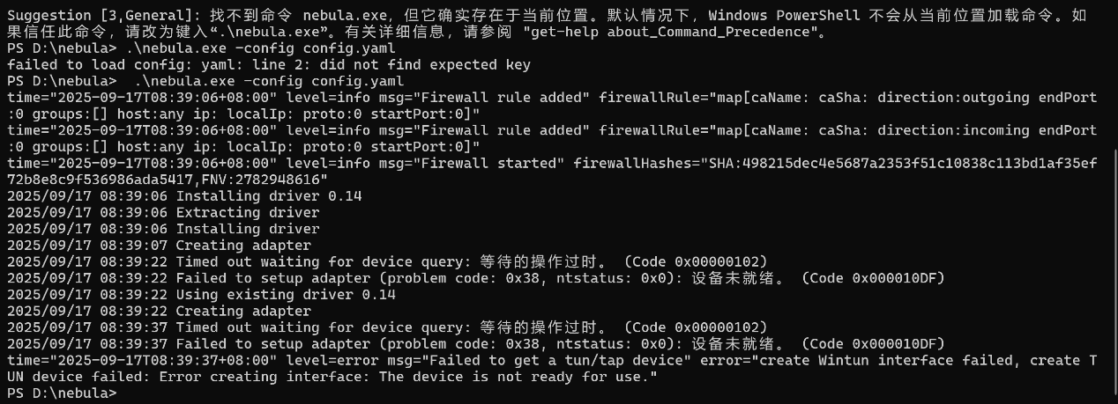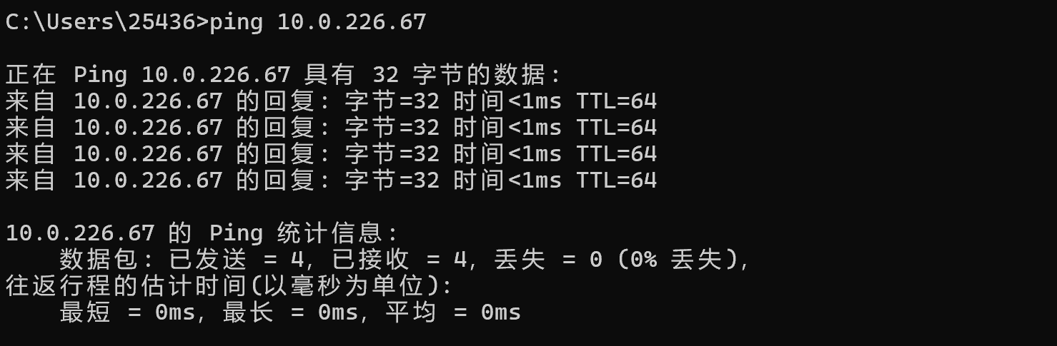
4. Lab Results
Successful secure connections between Lighthouse and clients.
NATed clients can communicate with each other over the 192.168.100.x network.
Nebula automatically traversed NAT, allowing clients without public IPs to reach the Lighthouse.
Comparing configuration files with Meld helped prevent errors in certificate paths, IPs, and ports.

5. Lab Reflections

Nebula is simple and efficient, making it easy to quickly set up cross-NAT secure networks.
Certificate management is critical—names, IPs, and paths must match exactly.
Lighthouse must have a public IP; local VMs cannot replace it.
The lab deepened understanding of NAT traversal and VPN network architecture, providing practical experience for real-world network projects.

