Istio Traffic Management Lab Summary
1. Lab Objectives
The purpose of this lab was to gain hands-on experience in managing traffic in a microservices architecture using Istio. The lab focused on the following capabilities:
Traffic Shifting – Distribute traffic between different versions of a service.
Request Routing – Route requests to specific service versions based on conditions such as headers or paths.
Fault Injection – Simulate service delays or errors to test system resilience.
Circuit Breaking – Protect services from overload by limiting connections and requests.

2. Lab Environment
Operating System: Windows 10

Kubernetes: Minikube 1.30
Istio: 1.29.0
Sample Application: Bookinfo
Tools: PowerShell (for commands), VS Code or Notepad (for creating YAML files)
Note: In Minikube, service access requires NodePort or port forwarding.

3. Lab Steps and Observations
3.1 Traffic Shifting

Steps:
Create a DestinationRule to define subsets (v1, v2).
Create a VirtualService to distribute traffic (e.g., 50% to v1, 50% to v2).
Refresh http://<GATEWAY_URL>/productpage multiple times and observe the results.

Observations:
The reviews section displayed content from either v1 or v2 randomly.
Traffic was split according to the defined weights.
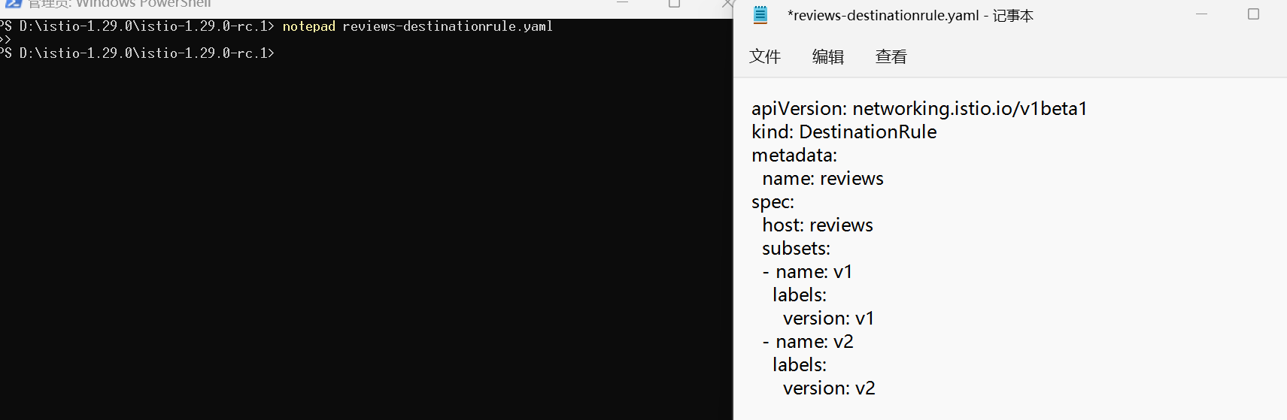
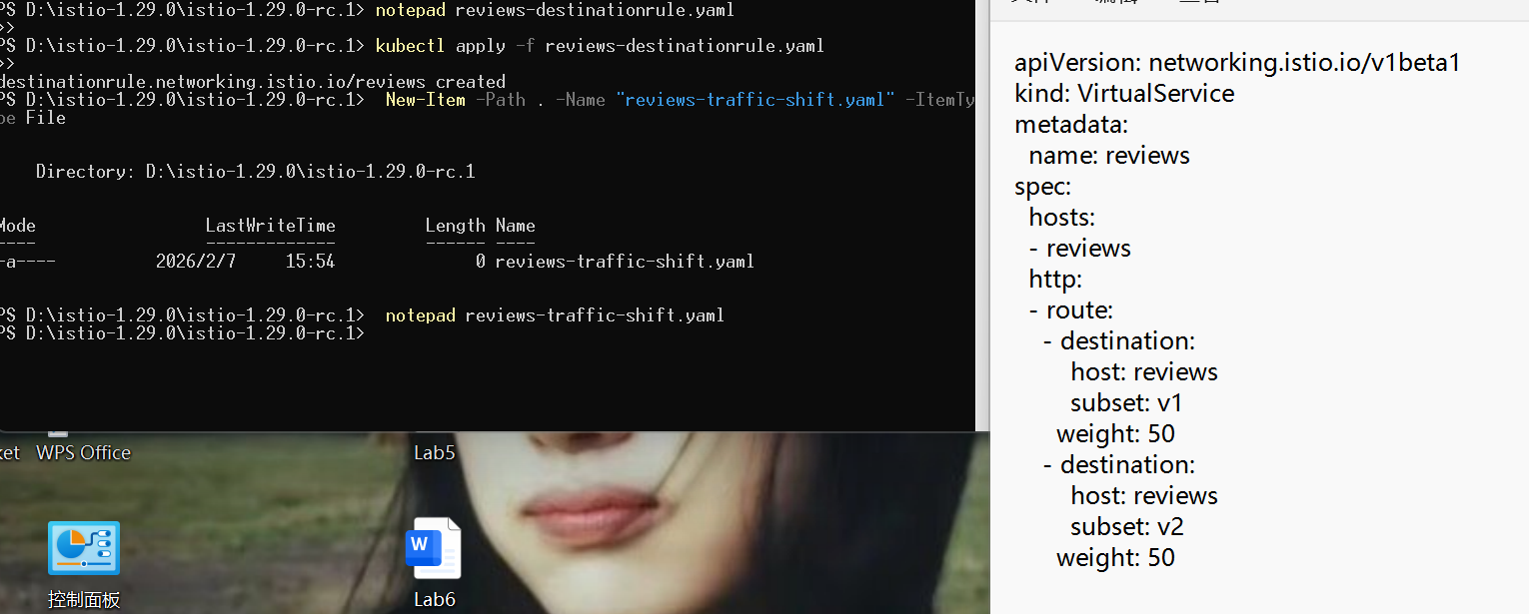
Summary:
Traffic shifting is useful for canary releases and gradual upgrades.
Defining the DestinationRule is mandatory before using subsets in VirtualService.

3.2 Request Routing

Steps:
Create a VirtualService to route requests with the header end-user: jason to reviews-v2.
All other requests are routed to reviews-v1.

Test using PowerShell:
Invoke-WebRequest -Headers @{"end-user"="jason"} "http://<GATEWAY_URL>/productpage"
Invoke-WebRequest -Headers @{"end-user"="alice"} "http://<GATEWAY_URL>/productpage"

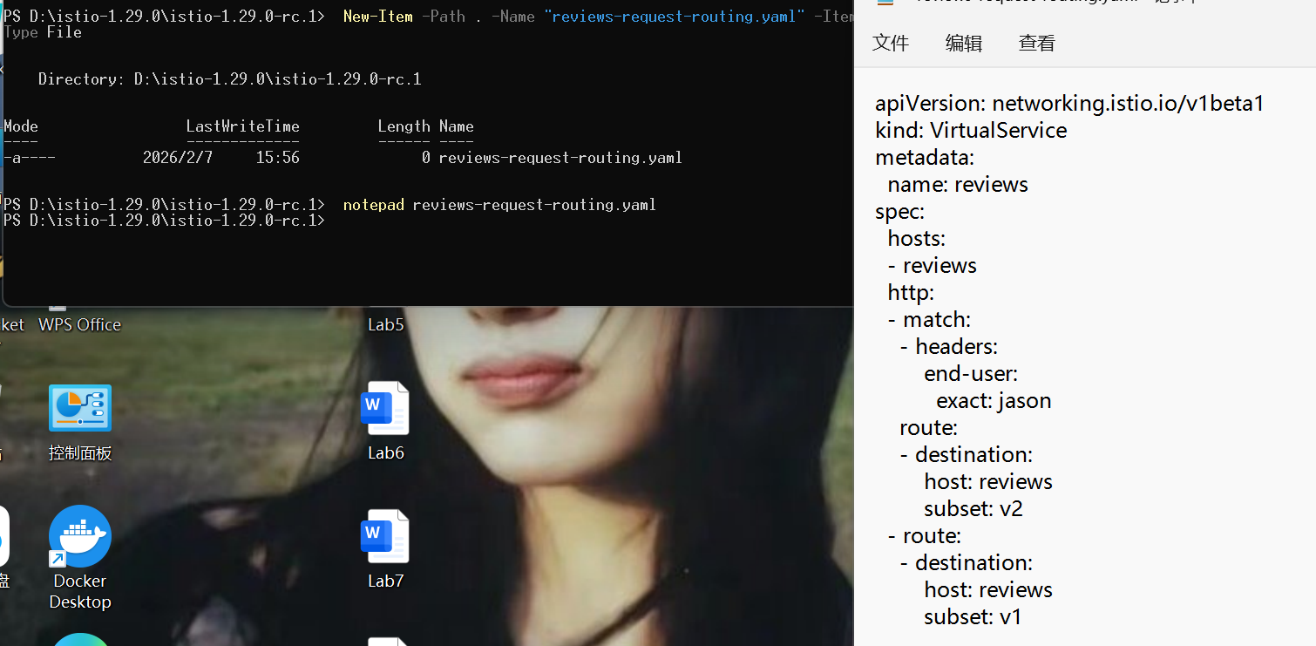
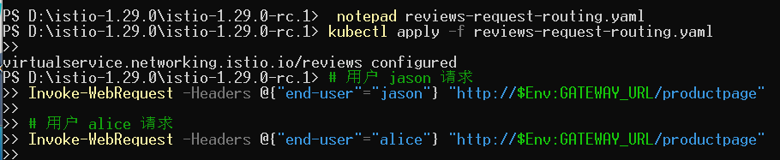
Observations:
Requests from jason always reached v2.
Other users reached the default v1 version.

Summary:
Request routing allows personalized traffic management.
Supports multiple matching conditions, such as headers, paths, and HTTP methods.

3.3 Fault Injection

Steps:
Inject a 5-second delay or 50% HTTP 500 error in a VirtualService.
Refresh the page and observe the behavior.

Observations:

Page load times were noticeably delayed due to injected latency.
Some requests returned HTTP 500 errors as expected.
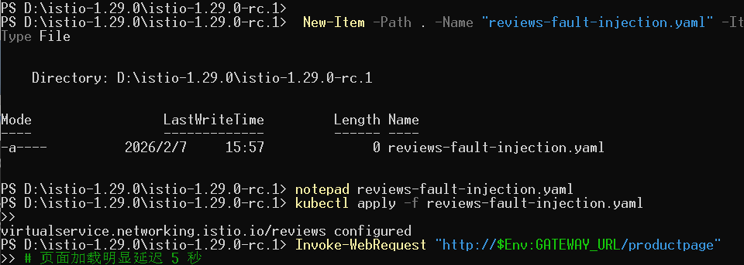
Summary:
Fault injection is useful for testing resiliency and fallback strategies.
Delay and error percentages can be adjusted to simulate different scenarios.

3.4 Circuit Breaking

Steps:
Create a DestinationRule with connection pool and outlier detection settings.
Send multiple requests and observe some requests being rejected when thresholds are exceeded.

Observations:
Requests exceeding limits were rejected, protecting the service.
System stability improved under high load.
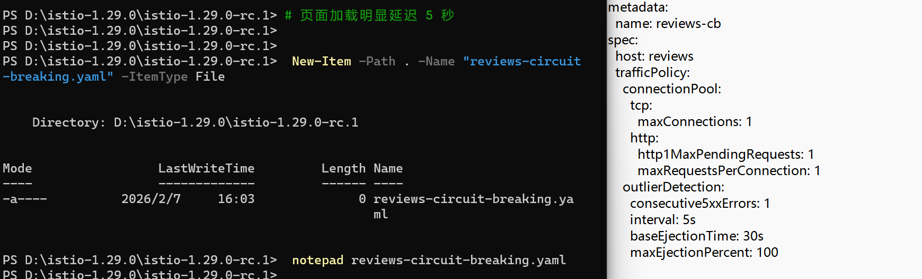
Summary:
Circuit breaking prevents service overload and cascading failures.
Thresholds can be set based on errors, connections, or request rates.

4. Overall Lab Summary
Istio provides powerful traffic management capabilities, enabling canary releases, personalized routing, fault simulation, and system protection.
The lab helped practice creating and applying DestinationRules and VirtualServices.
Accessing services in Minikube requires NodePort or port forwarding.
Traffic control improves reliability and reduces risks during upgrades in microservice architectures.

