Kubernetes Minikube Basic Lab Report
1. Objective
The objectives of this lab are:
- To understand the basic architecture of Kubernetes
- To deploy and manage containerized applications using Minikube
- To learn how to deploy, explore, expose, scale, and update applications in Kubernetes
- To become familiar with common kubectl commands
2. Experimental Environment
Operating System: Windows 11
Minikube: v1.37.0
Kubernetes: v1.34.0
Docker Desktop: 28.4.0
kubectl: v1.32.2
Module 1: Create a Kubernetes Cluster
1.1 Start Minikube
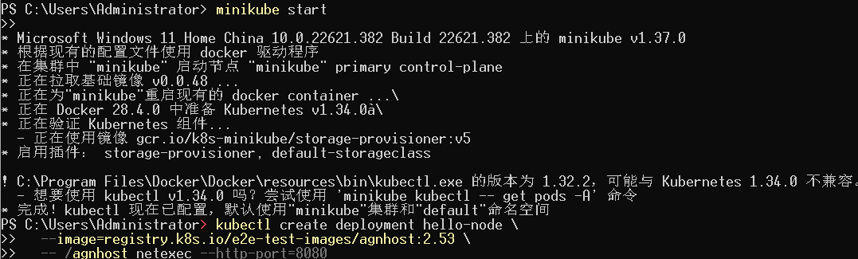
Description:
Minikube starts a local Kubernetes cluster using the Docker driver.
[Insert Screenshot: minikube start output]
1.2 Check Node Status
kubectl get nodes
Description:
The node status is Ready, indicating the cluster is running successfully.
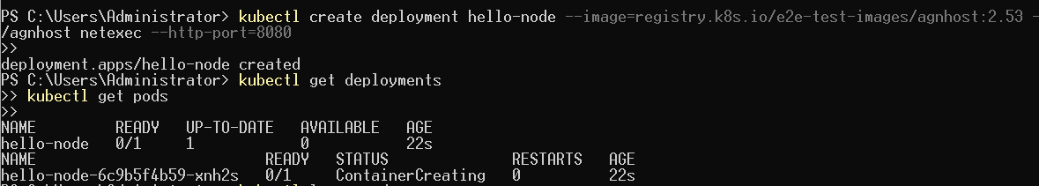
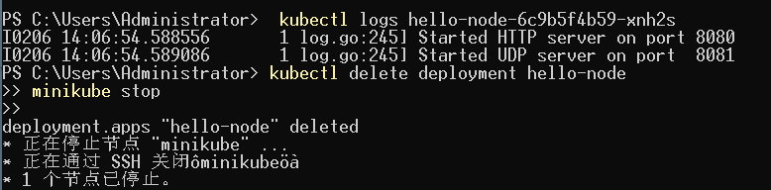
Module 2: Deploy an Application
2.1 Create Deployment
kubectl create deployment kubernetes-bootcamp --image=registry.k8s.io/minikube/kubernetes-bootcamp:v1
2.2 Verify Deployment and Pods
kubectl get deployments
kubectl get pods
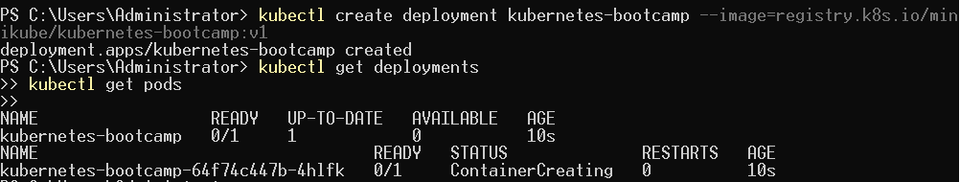
Module 3: Explore the Application
3.1 View Pod Details
kubectl describe pod <pod-name>
3.2 View Application Logs
kubectl logs <pod-name>
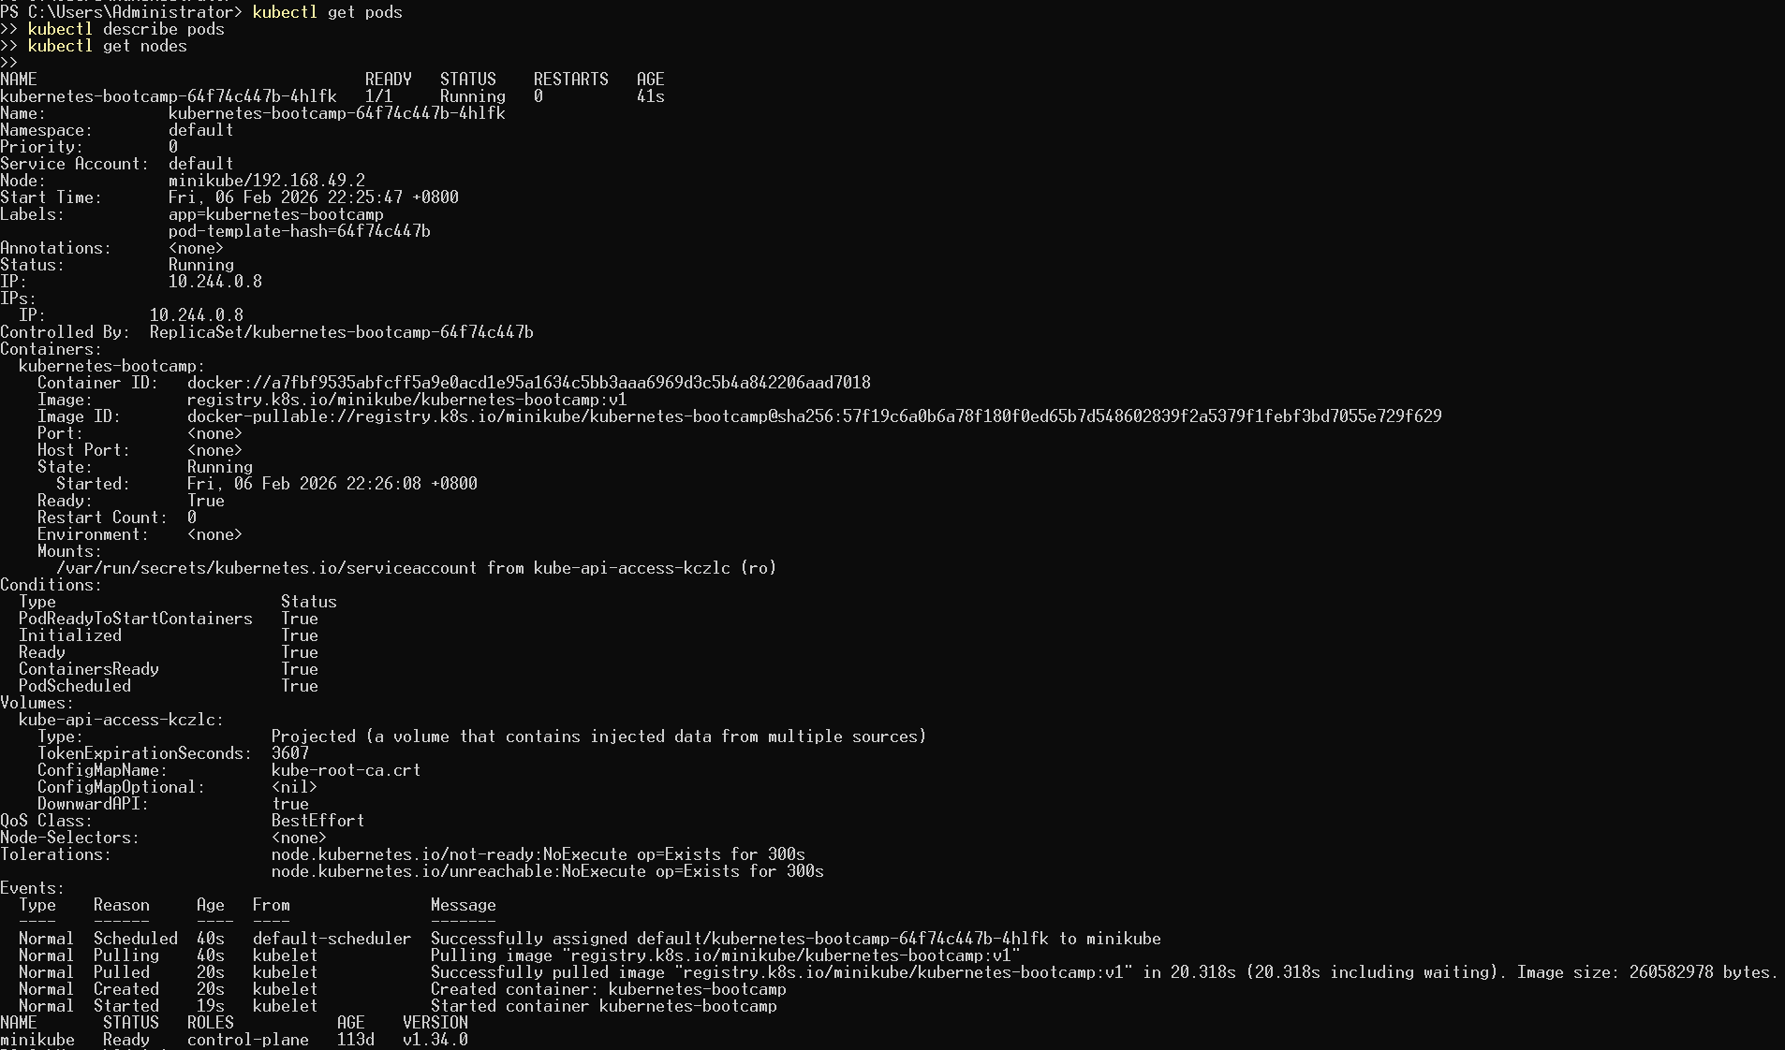
Module 4: Expose the Application
4.1 Create Service
kubectl expose deployment kubernetes-bootcamp --type=NodePort --port=8080
4.2 Check Services
kubectl get services
4.3 Access Application
minikube service kubernetes-bootcamp
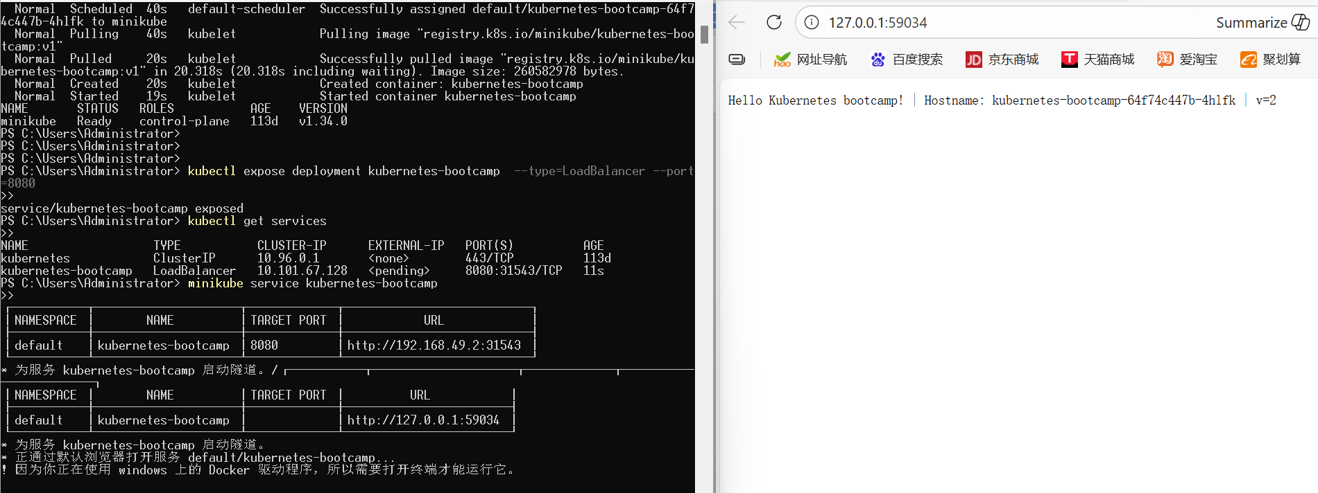
Module 5: Scale the Application
5.1 Scale Deployment
kubectl scale deployment kubernetes-bootcamp --replicas=3
5.2 Verify Pods
kubectl get pods
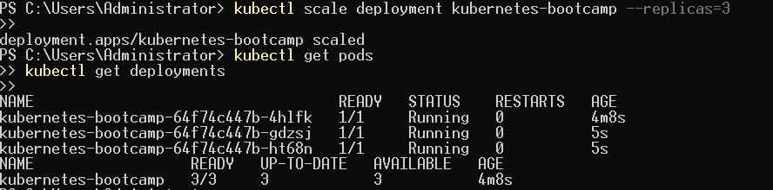
Module 6: Update the Application
6.1 Update Image
kubectl set image deployment/kubernetes-bootcamp kubernetes-bootcamp=registry.k8s.io/minikube/kubernetes-bootcamp:v2
6.2 Check Rollout Status
kubectl rollout status deployment/kubernetes-bootcamp
6.3 Access Updated Application
minikube service kubernetes-bootcamp
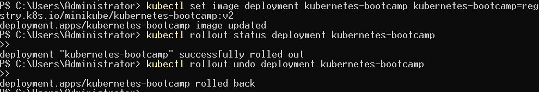
7. Results and Discussion
- A local Kubernetes cluster was successfully created.
- The application was deployed, exposed, scaled, and updated successfully.
- Core Kubernetes concepts such as Pod, Deployment, and Service were practiced.
8. Conclusion
This lab provides hands-on experience with Kubernetes fundamentals and strengthens understanding of container orchestration.

