1. Objective

The objectives of this lab are:
Install Gitea using Docker on a local machine.
Verify Git LFS (Large File Storage) support in Gitea.
Create a repository containing a large file (>1 GB) and push it using Git LFS.

2.Steps:
Install Docker Desktop and enable WSL2 backend.
Install Git for Windows and Git LFS.
Configure Git in PowerShell:
Pull the Gitea Docker image:
Create Docker volumes for data persistence:

3. Gitea Installation using Docker
Run Gitea container in PowerShell:
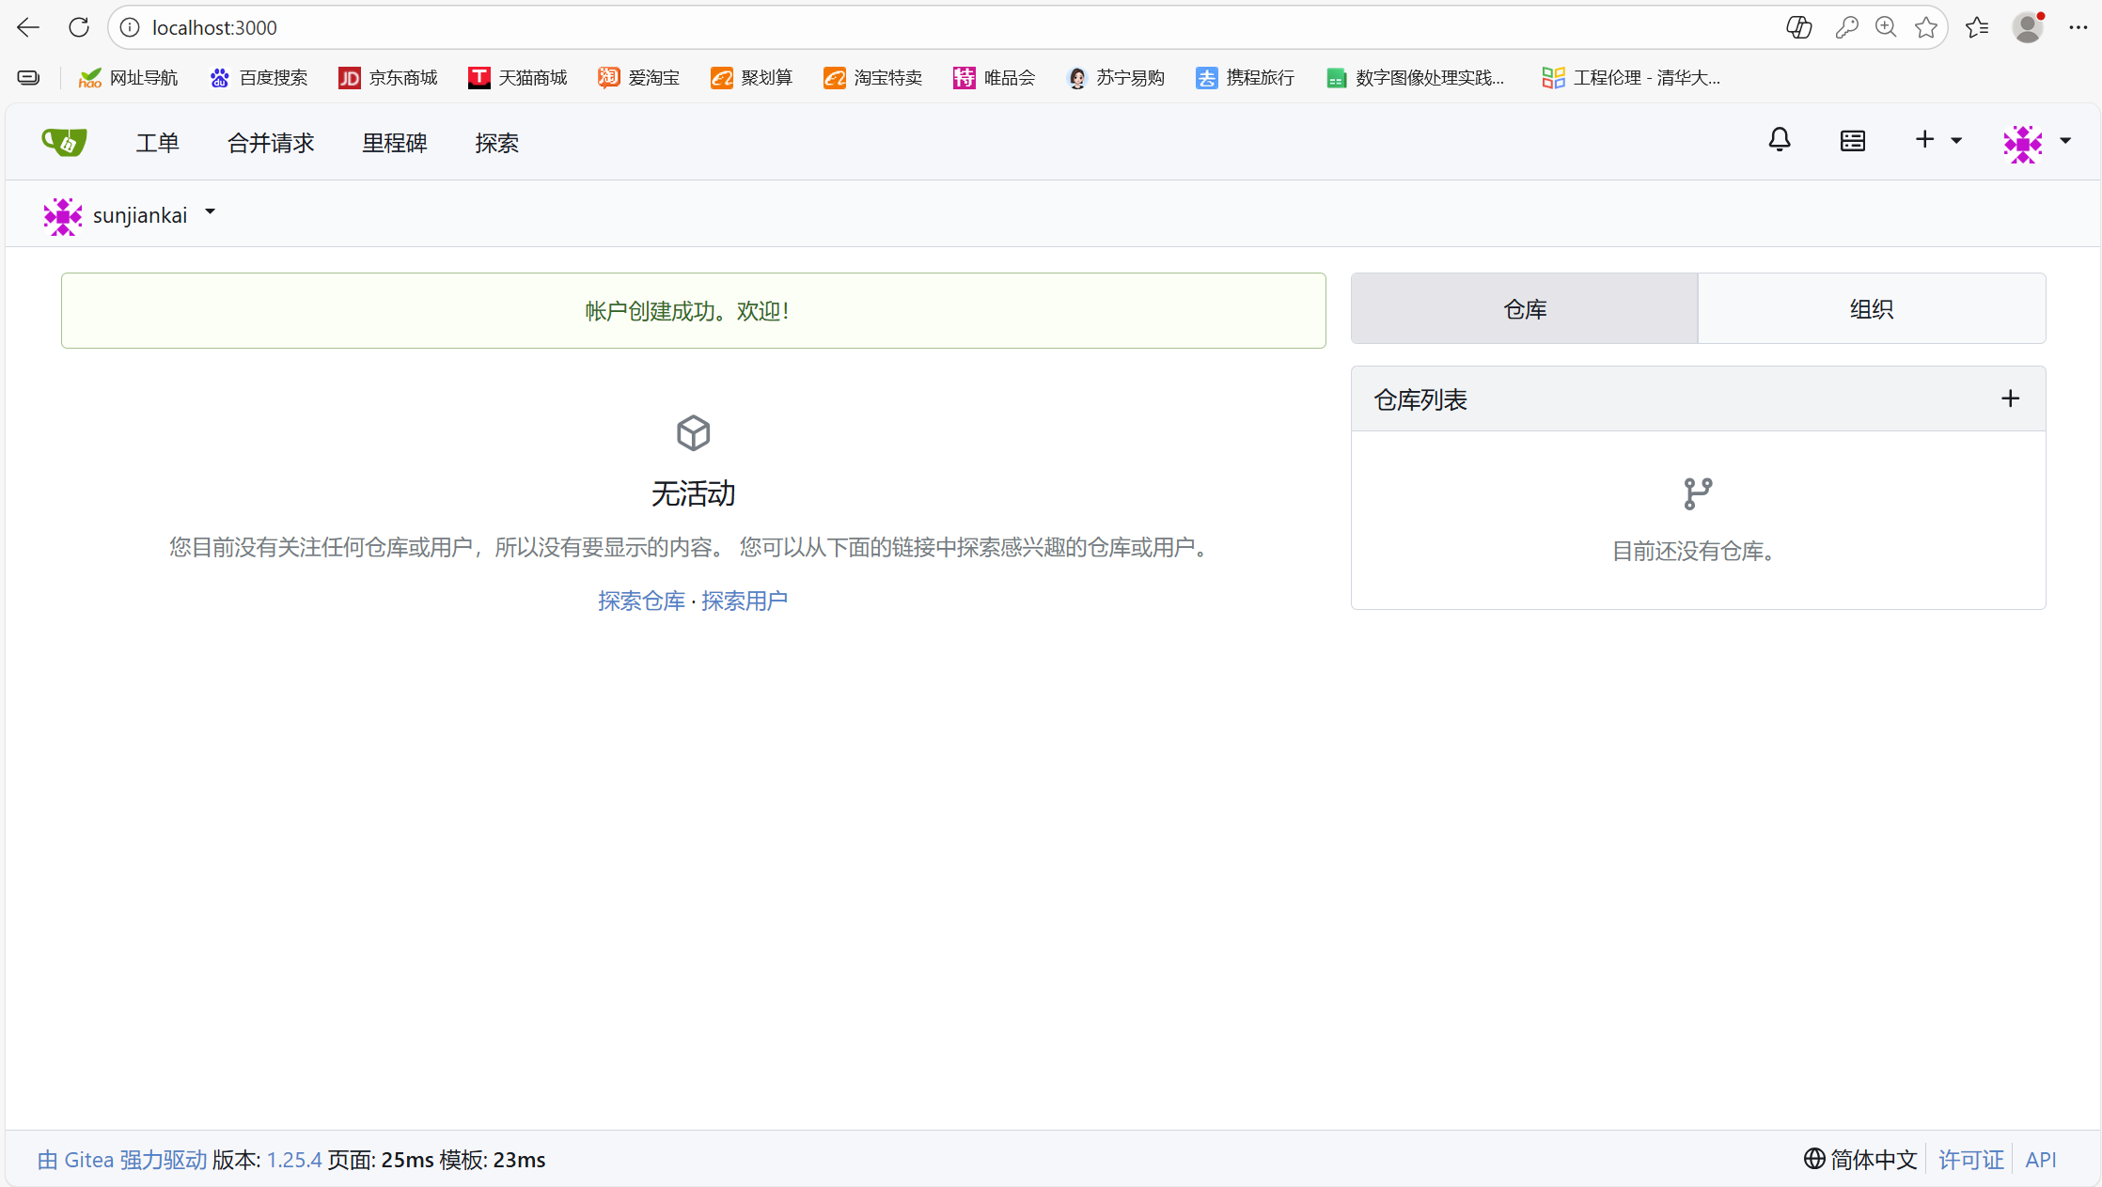

Port 3000: Gitea Web interface
Port 222: SSH access for Git

Volume gitea-data: Persistent data

4. Initial Configuration via Web Interface

Open browser: http://localhost:3000
Complete the installation wizard:
Database: SQLite (or MySQL/PostgreSQL)
Application URL: http://localhost:3000
Create admin account
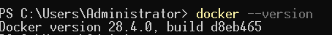

5. Enable Git LFS
Log in as admin → Settings → Git LFS → Enable Git LFS.
Verify by checking .gitattributes and LFS settings.

6. Create a Repository with a Large File

Step 1: Create repository on Gitea Web interface
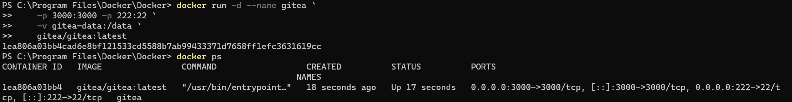
Repository Name: bigfile-repo

Initialize with README

Step 2: Clone repository locally
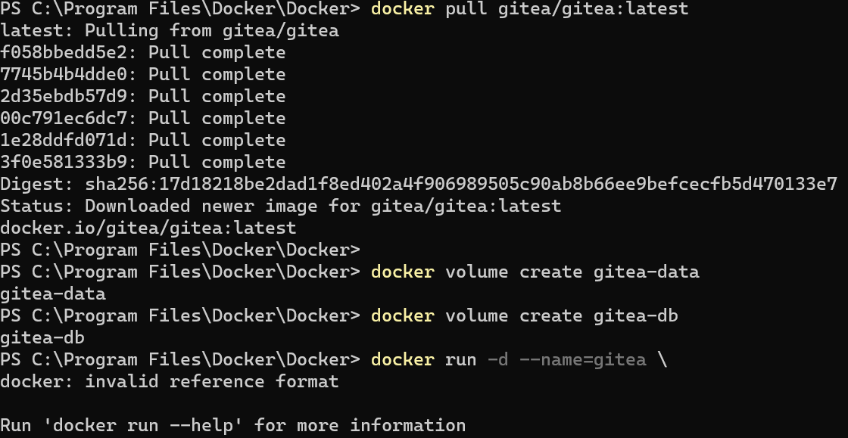
Step 3: Create 1 GB file and push using LF

