Experimental process

1 Start Minikube
Expected: Node is in Ready state.
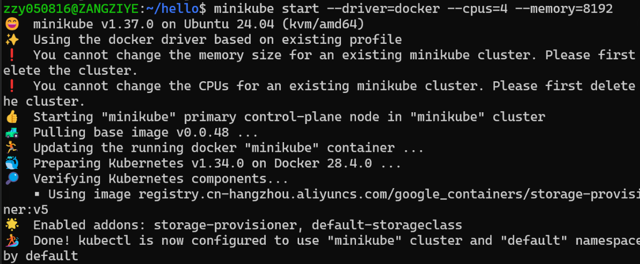
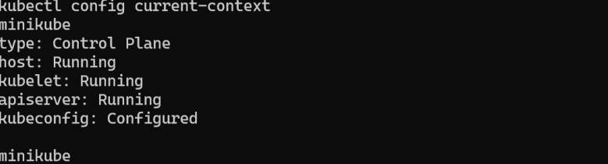
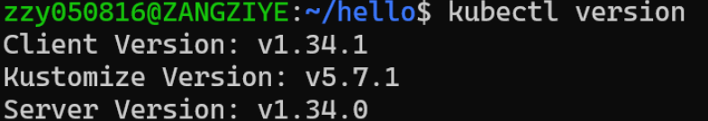

2 Install Helm
Expected output includes:

3 Install KServe CRDs

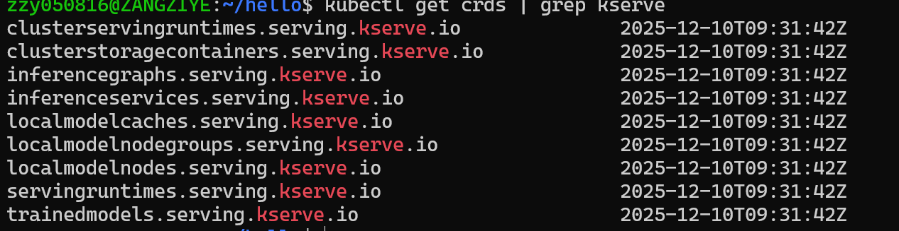

4 Install cert-manager (local YAML)
(Installed using local YAML due to WSL network limits)
All cert-manager pods must be Running.

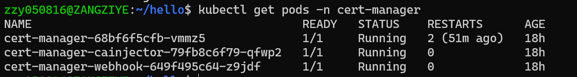

5 Install KServe Core Components
kubectl apply --server-side -f kserve.yaml
kubectl apply --server-side -f kserve-cluster-resources.yaml
3.6 Debugging Controller CrashLoopBackOff (Important Part of the Experiment)
Initially, KServe controller failed with:
"error": "invalid deployment mode. Supported modes are Serverless, RawDeployment, ModelMesh"
Fix：kubectl patch configmap/inferenceservice-config -n kserve \
--type=strategic \
-p '{"data":{"deploy":"{\"defaultDeploymentMode\":\"RawDeployment\"}"}}'
kubectl rollout restart deployment kserve-controller-manager -n kserve
Verify:

6 Deploy the InferenceService
Create namespace&Deploy the sklearn-iris model

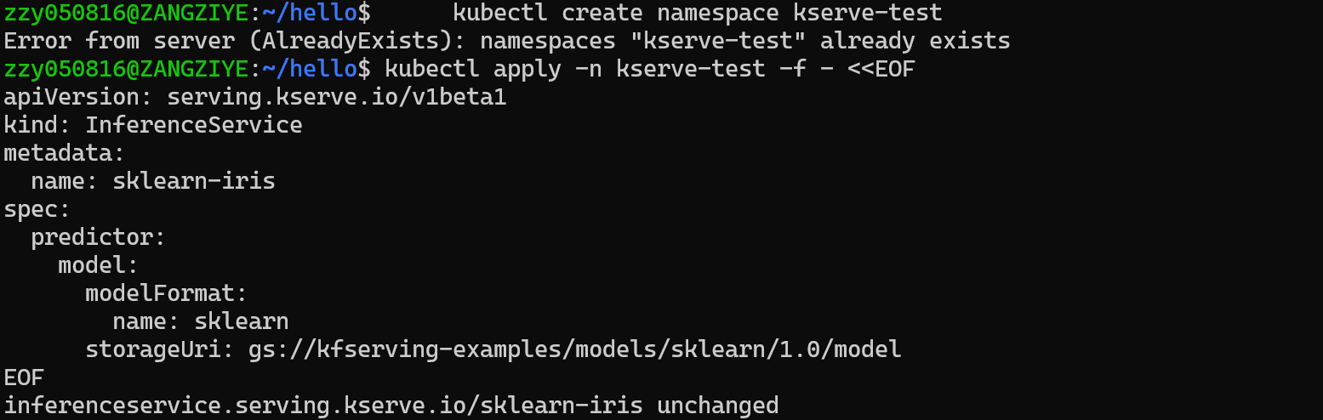
Check status:
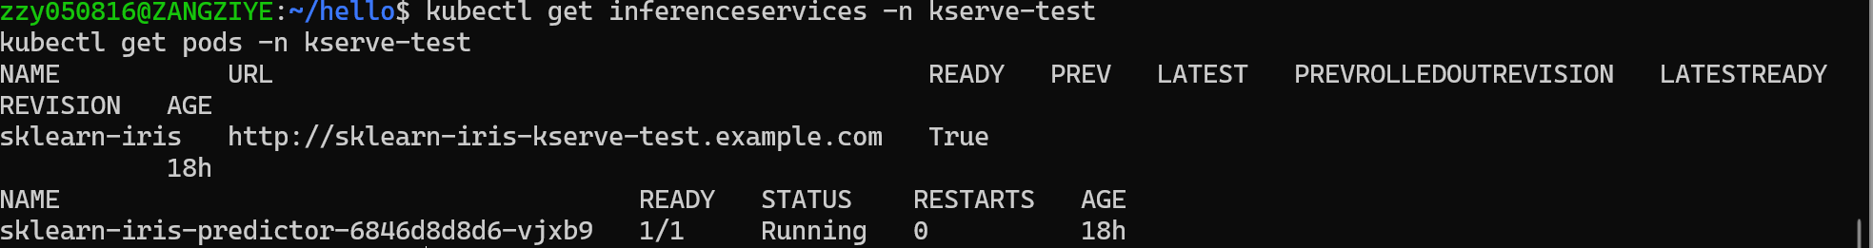

7 Access the Model Service (Port Forwarding)
Find the service:
Forward port:

8 Send Inference Request
Prepare input:
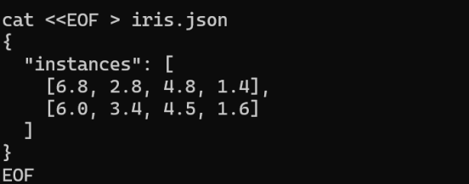
Send request:
