**Introduction to Database System Design – CS 33007**

Deliverable 2

*Krystal Davison, Wil Nahra, Chase Osborne, Sandy Zhang*

**Requirement 1**

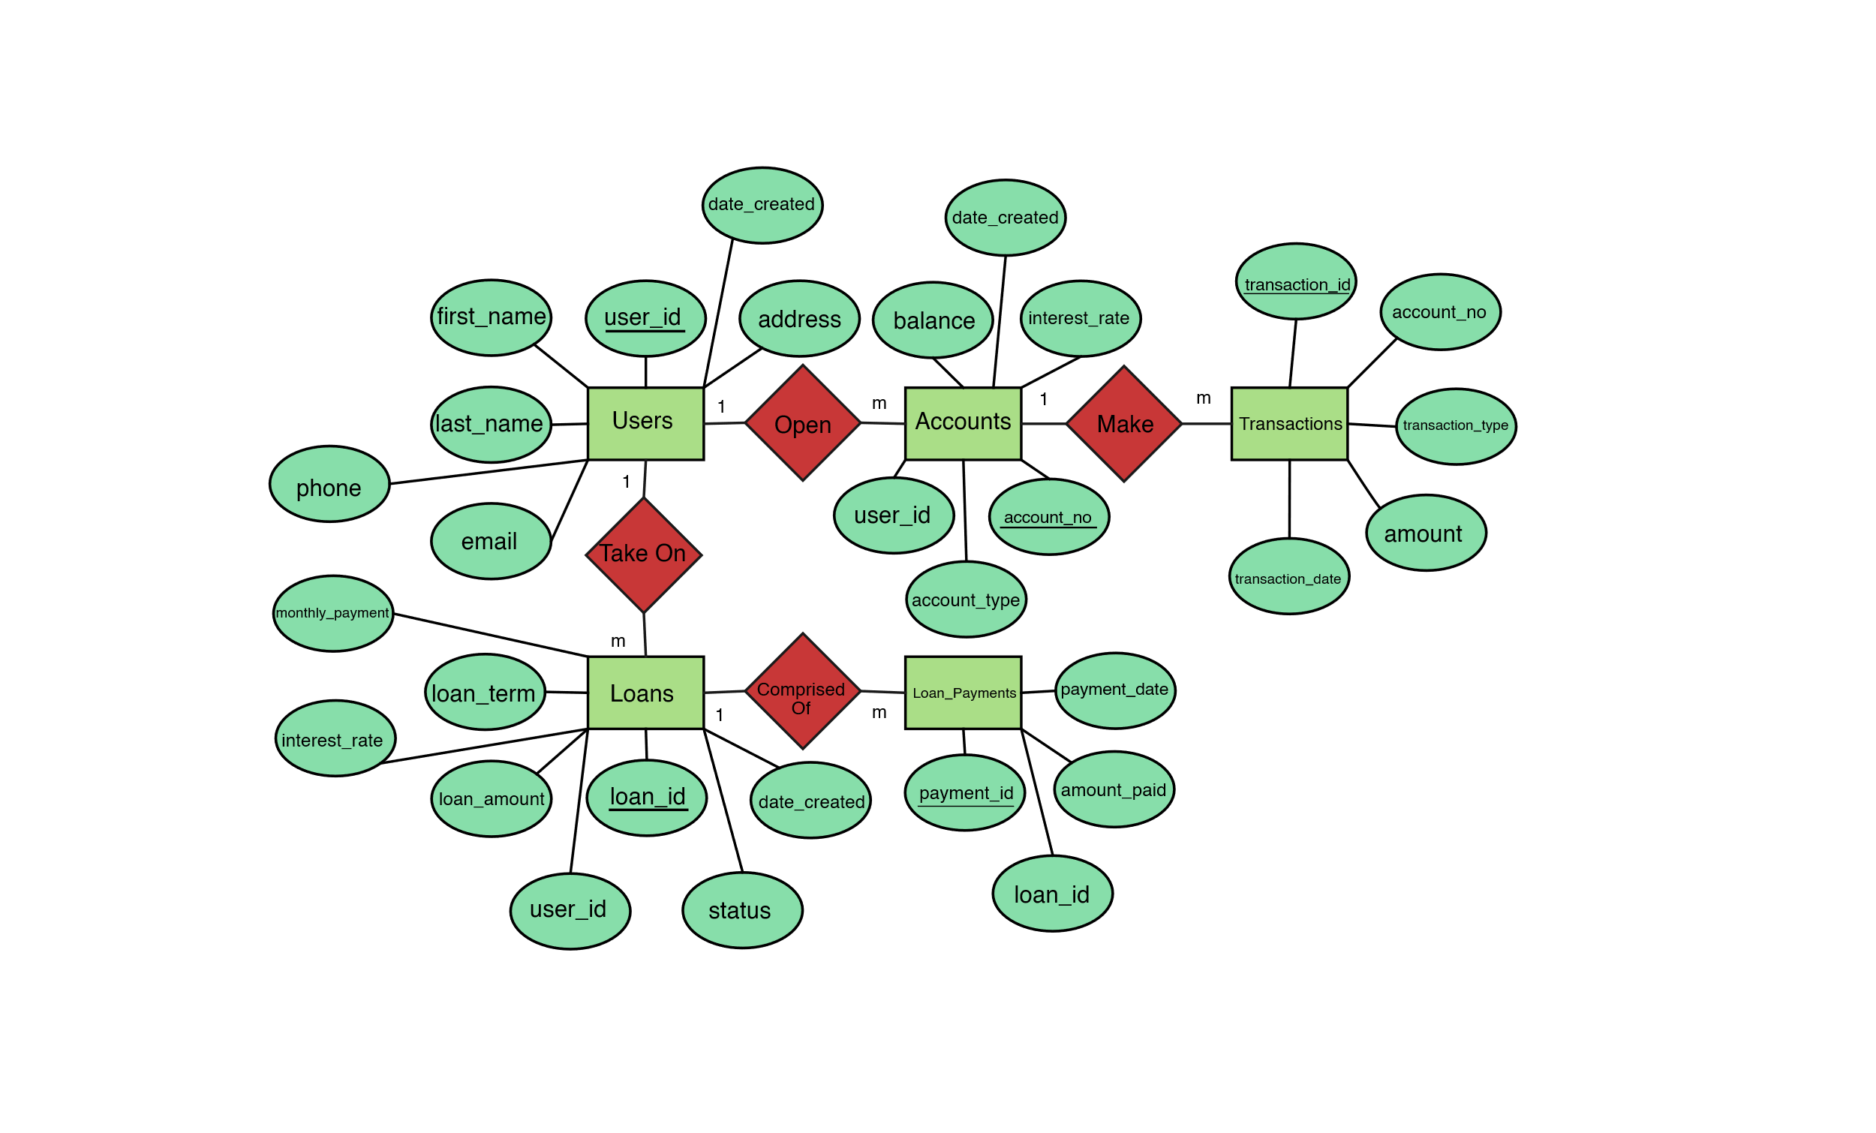

**Requirement 2**

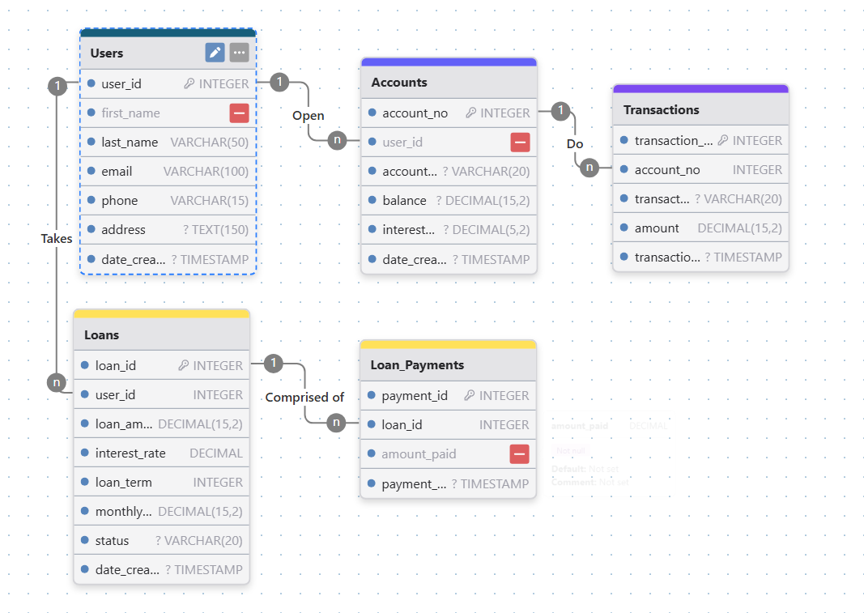

**Requirement 3**

**Some common queries are as follows:**

Deposit Query

**INSERT** **INTO** Transactions (account_id, transaction_type, amount)

**VALUES** (?, 'deposit', ?);

**UPDATE** Accounts

**SET** balance = balance + ?

**WHERE** account_id = ?;

Withdraw Query

**INSERT** **INTO** Transactions (account_id, transaction_type, amount)

**VALUES** (?, 'withdrawal', ?);

**UPDATE** Accounts

**SET** balance = balance - ?

**WHERE** account_id = ? AND balance >= ?;

Issue Loan Query

**INSERT** **INTO** Loans (user_id, loan_amount, interest_rate, loan_term, monthly_payment)

**VALUES** (?, ?, ?, ?, ?);

Loan Payment Query

**INSERT** **INTO** Loan_Payments (loan_id, amount_paid)

**VALUES** (?, ?);

**UPDATE** Loans

**SET** loan_amount = loan_amount - ?

**WHERE** loan_id = ?;

Close Account Query

**DELETE** **FROM** Accounts **WHERE** account_no = ?;