-- create
CREATE TABLE EMPLOYEE (
empid INTEGER PRIMARY KEY,
empname TEXT NOT NULL,
dept TEXT NOT NULL,
age INT,
salary DECIMAL(10,2),
FOREIGN KEY (empid) REFERENCES DEPARTMENT(deptid)
);

CREATE TABLE DEPARTMENT(
depid INTEGER PRIMARY KEY,
deptname VARCHAR(50)
);
-- insert
INSERT INTO EMPLOYEE VALUES (1, 'Clark', 1, 25, 70000);
INSERT INTO EMPLOYEE VALUES (2, 'Dave', 2, 28, 80000);
INSERT INTO EMPLOYEE VALUES (3, 'Ava', 1, 34, 90000);

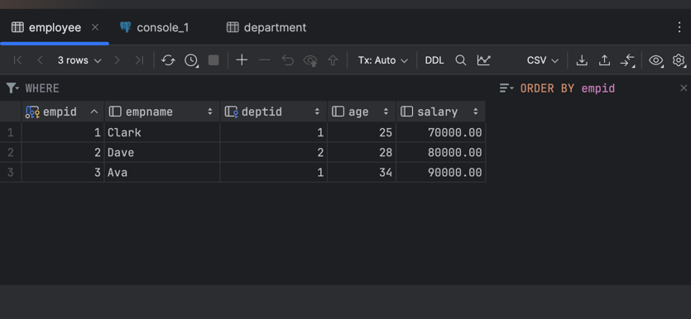

INSERT INTO DEPARTMENT VALUES (1, 'Sales');
INSERT INTO DEPARTMENT VALUES (2, 'Accounting');

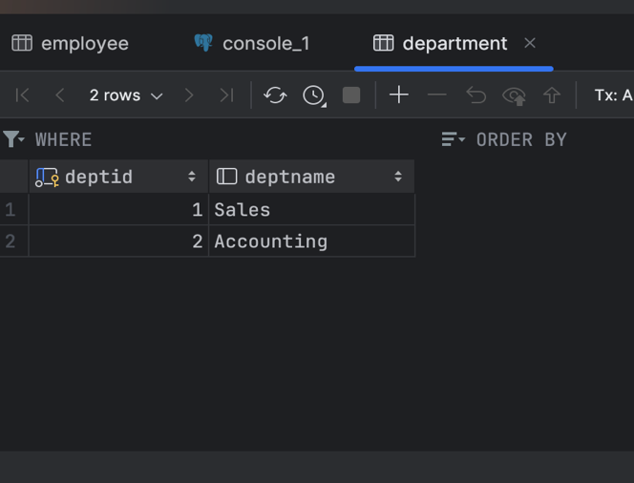
-- Get only employee names and ages.
SELECT empName, age
FROM EMPLOYEE;

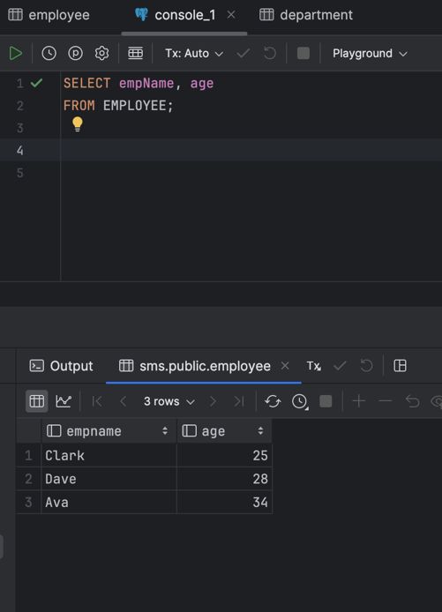

-- Find employees older than 30.
SELECT *
FROM EMPLOYEE
WHERE age > 30;

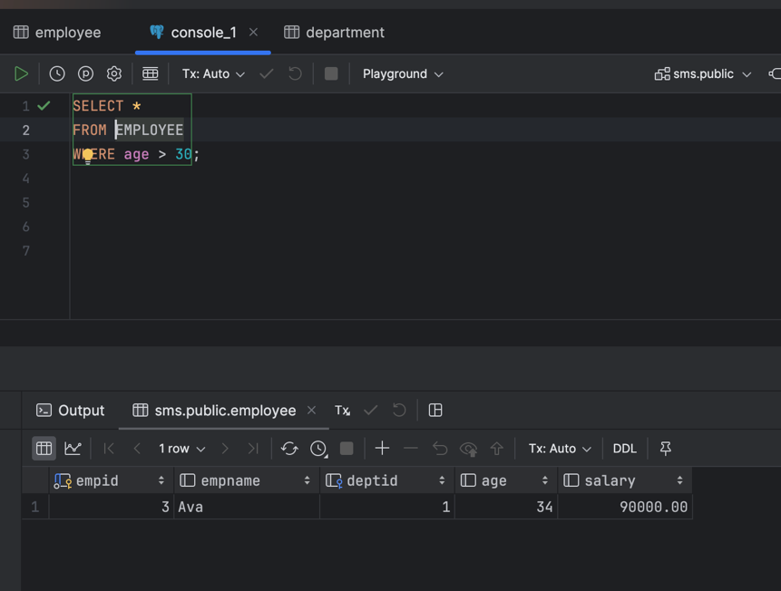

-- Find employees whose salary is greater than 80,000.
SELECT *
FROM EMPLOYEE
WHERE salary > 80000;

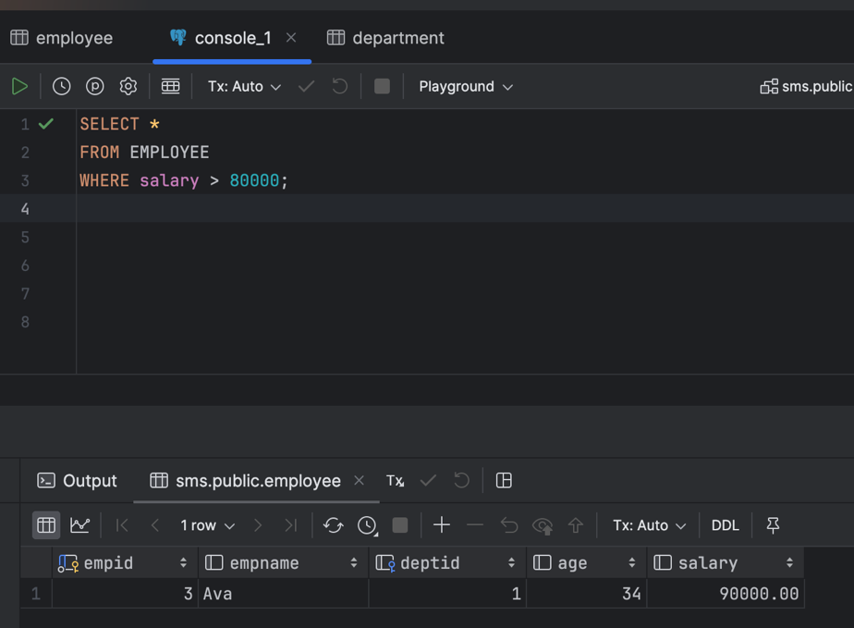

-- List employees ordered by age (ascending).
SELECT *
FROM EMPLOYEE
--where must boolean
ORDER BY age ASC;

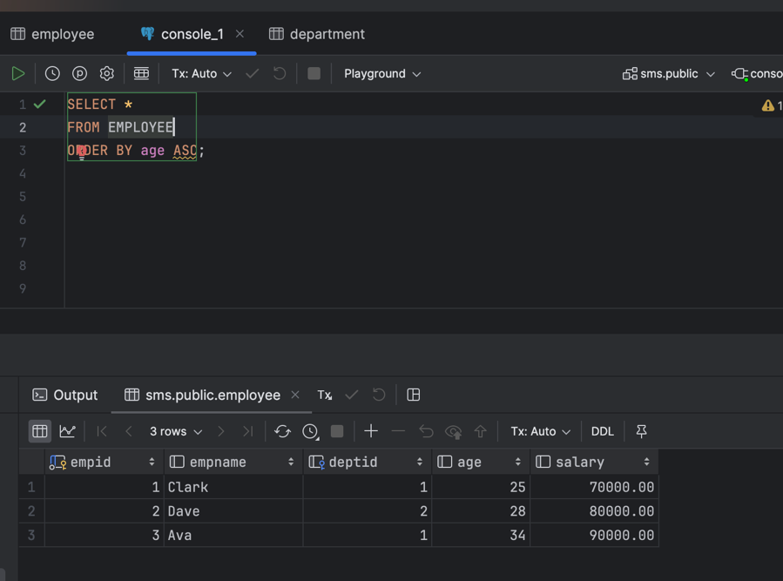

-- Get the top 3 highest-paid employees.
SELECT *
FROM EMPLOYEE
ORDER BY salary DESC
LIMIT 3;

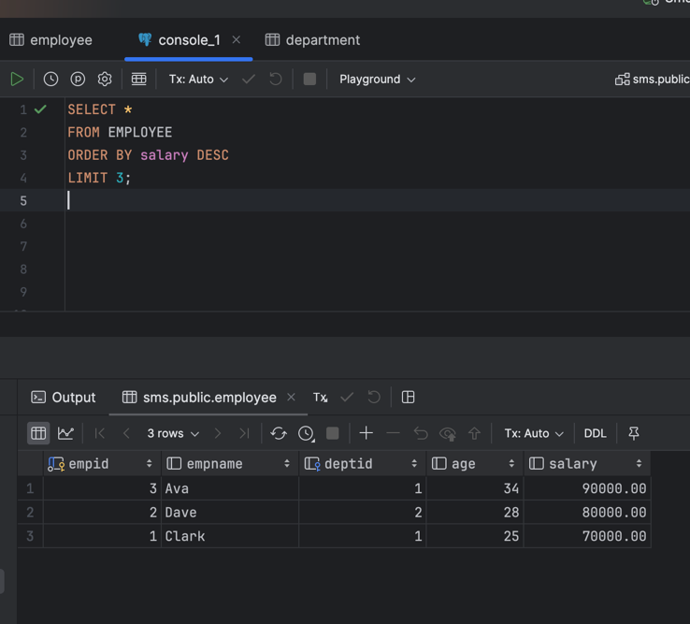

-- Count total number of employees.
SELECT COUNT(empId) AS numEmployee
FROM EMPLOYEE;

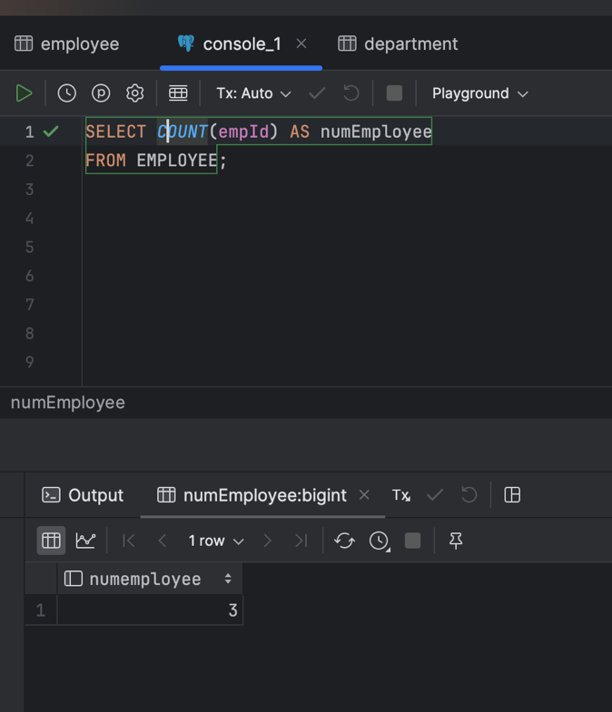

-- Find the average salary of all employees.
SELECT AVG(salary) AS averageSalary
FROM EMPLOYEE;

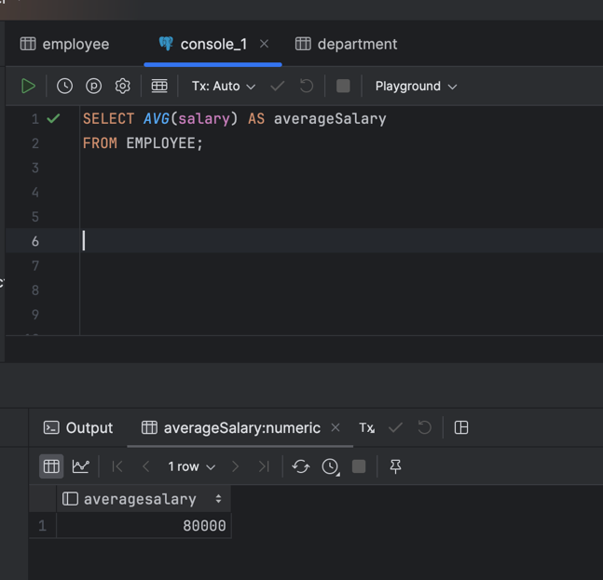

-- List employee name with department name.
SELECT e.empName, d.deptName
FROM EMPLOYEE e
JOIN DEPARTMENT d
ON e.deptId = d.deptId;

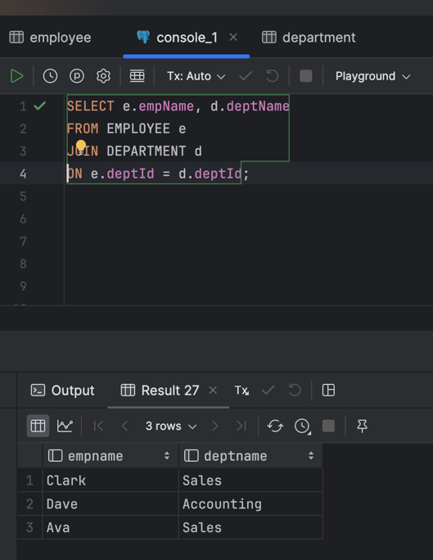

-- Find employees earning the highest salary.
SELECT *
FROM EMPLOYEE
WHERE salary = (
SELECT MAX(salary)
FROM EMPLOYEE
);

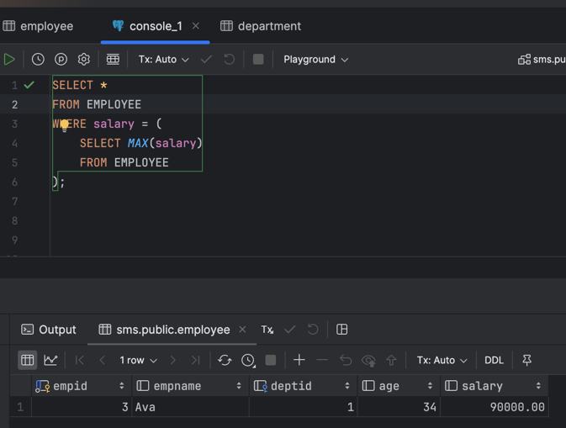

-- Find employees earning the second highest salary.
SELECT *
FROM EMPLOYEE
WHERE salary = (
SELECT MAX(salary)
FROM EMPLOYEE
WHERE salary < (
SELECT MAX( salary)
FROM EMPLOYEE
)
);

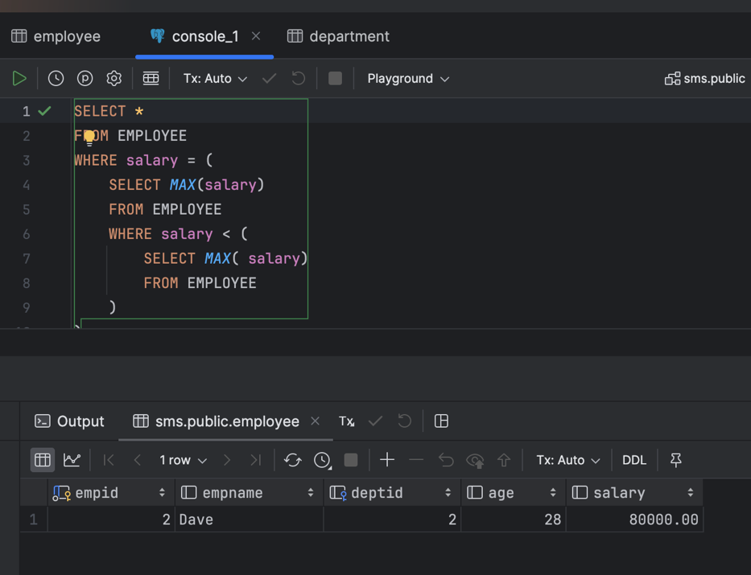

-- Find employees earning the third highest salary
SELECT *
FROM EMPLOYEE
WHERE salary = (
SELECT MAX(salary)
FROM EMPLOYEE
WHERE salary < (
SELECT MAX( salary)
FROM EMPLOYEE
WHERE salary < (
SELECT MAX( salary)
FROM EMPLOYEE
)
)
);
