Chicken wire and off the ground:

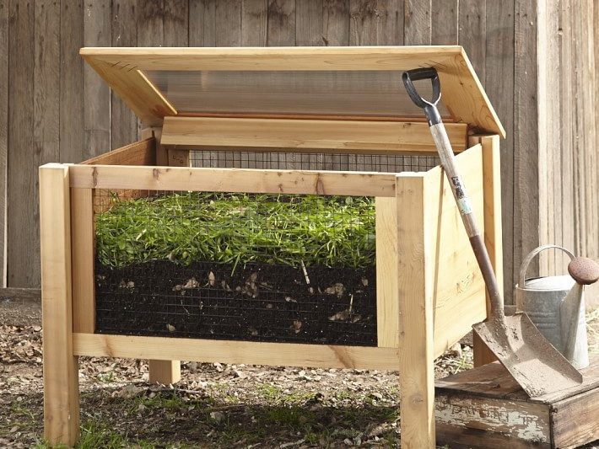

Chicken wire and on the ground. I like the little door on the bottom for emptying, but it’s not necessary. Also, I see most compost boxes directly on the ground so I think that might be a better way to go:

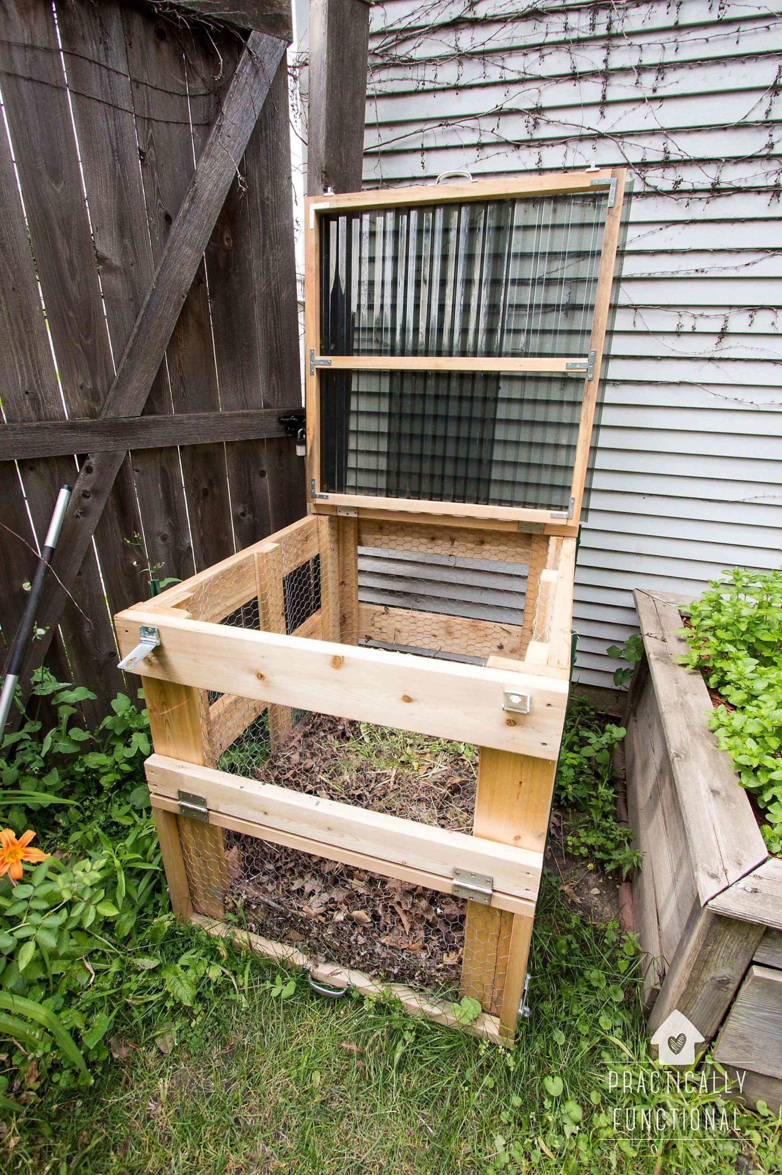

Box with slits in between the wood panels:

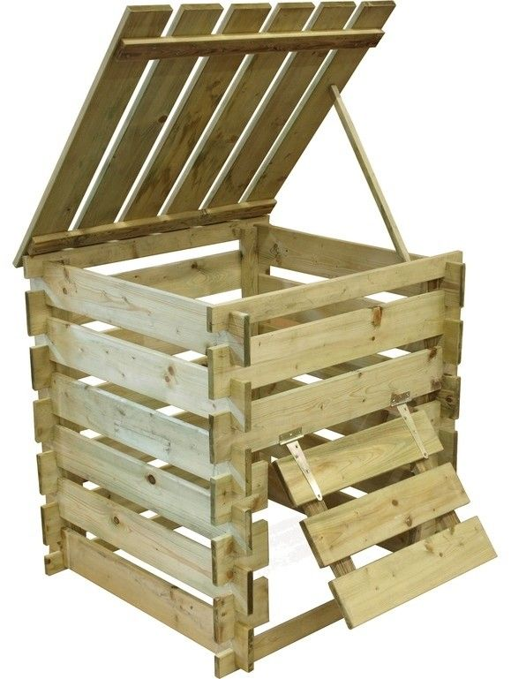

Boxes that are more sealed:

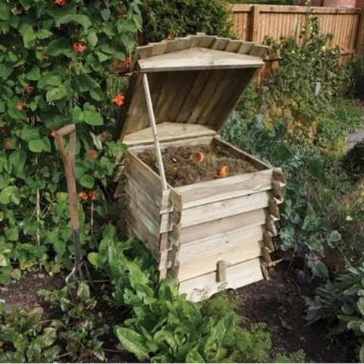 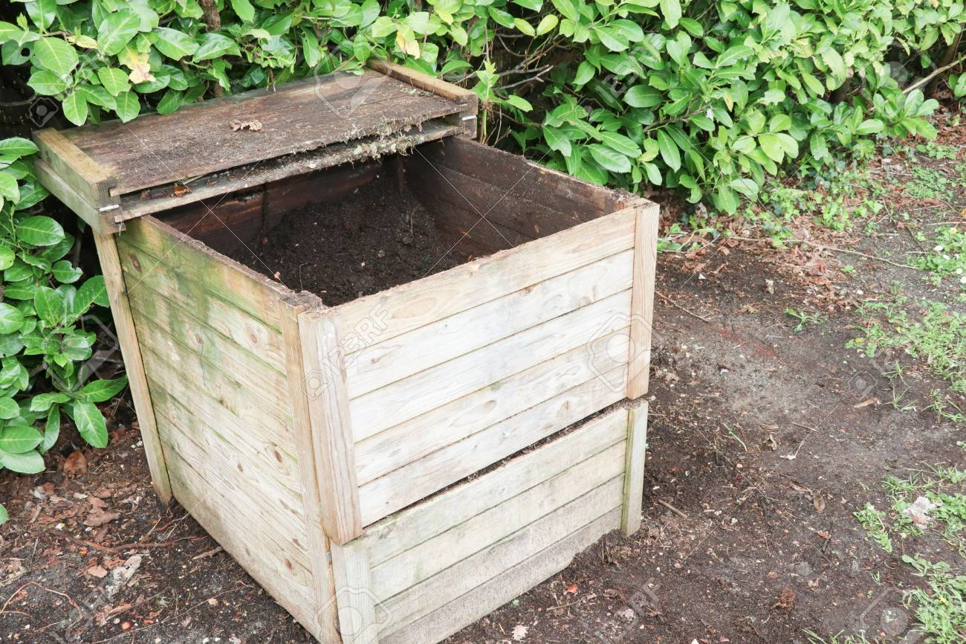

If we don’t have a door for emptying, we could make wood panels that can slide out easily like this:

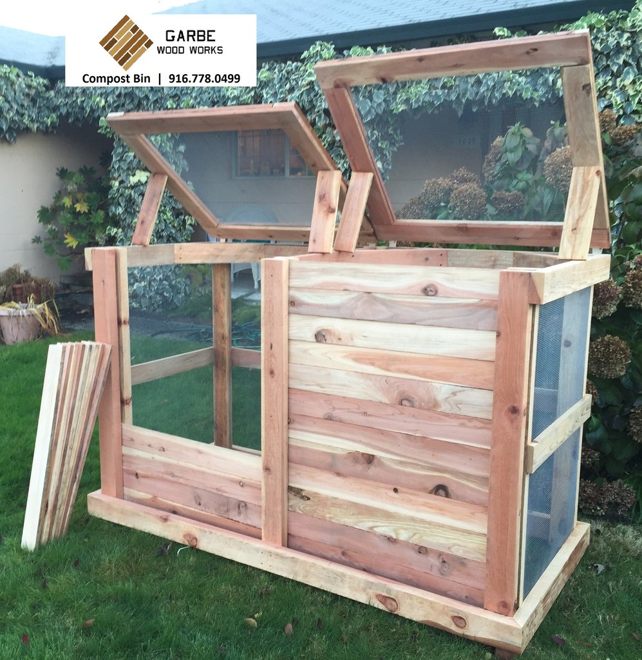

Lastly, do we want them attached and right next to each other (like picture above), or do we want two separate boxes? I think separating them might be better for research purposes especially if go with chicken wire or wooden slits because then it keeps the compost product separate:

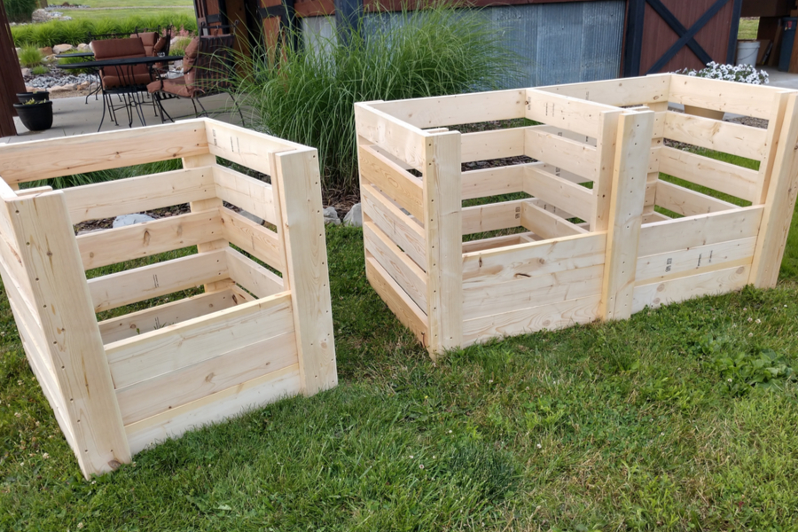

Attached boxes

Separate boxes