Geneva, 5th September 2005
Version 4

M E M O R A N D U M

A/To: Freddy Bordry, Gunnar Fernqvist, Hugues Thiesen, Valerie Montabonnet, Yves Thurel, David Nisbet, Laurent Ceccone

De/From: Quentin King

Copy/Copie: Stephen Page

Concerne/Subject: Changes to the limit properties in FGC version 2 software
_____________________________________________________________________

- New Limit Properties

Here are the new property names related to limits:

LOAD.LIMITS.I_POS[4]* | Maximum positive current
LOAD.LIMITS.I_NEG[4]* | Maximum negative current (zero for 1 & 2Q converters)
LOAD.LIMITS.I_CLOSELOOP[4]* | Current threshold to close the loop during start of 1 & 2Q converters
LOAD.LIMITS.I_MIN[4]* | Standby current and minimum current for 1 & 2Q converters
LOAD.LIMITS.DIDT[4]* | Maximum rate of change of current in either direction
VS.LIMITS.V_POS[4]* | Maximum positive voltage
VS.LIMITS.V_NEG[4]* | Maximum negative voltage
VS.LIMITS.V_Q41[2] | Exclusion zone for quadrants 4 and 1
VS.LIMITS.I_Q41[2] | Currents corresponding to V_Q41[2]
VS.LIMITS.DVDT | Maximum rate of change of voltage in either direction

* All properties that are arrays of four “[4]” have one value per load configuration:
0. Magnet circuit
1. Cable circuit
2. Short circuit
3. Test
- Current limits

All the new current limits are children of the LOAD property. This reinforces the association between these limits and the circuit.

The old names, I_MAX and I_MIN, have been changed to I_POS and I_NEG to prevent confusion over I_MIN, which was the largest negative current (e.g. -600A), but will now be the minimum positive current for 1 or 2 quadrant converters. It will also be the reference when STATE.PC is ON_STANDBY for all types of converter.

The old DIDT_MAX and DIDT_MIN limits are merged into a single DIDT limit that applies to changes in current in both directions. This removes another potential confusion because DIDT_MIN was actually the largest negative rate of change of current. This is illustrated in the following figures:

1 and 2 Quadrant Converters
Amps
LOAD.LIMITS.I_POS
LOAD.LIMITS.I_NEG
+LOAD.LIMITS.DIDT
-LOAD.LIMITS.DIDT
0
4 Quadrant Converters
Amps
LOAD.LIMITS.I_POS
LOAD.LIMITS.I_NEG
+LOAD.LIMITS.DIDT
-LOAD.LIMITS.DIDT
0
LOAD.LIMITS.I_MIN
LOAD.LIMITS.I_MIN
All these circuit related current limits are obviously dependent upon the load configuration selected using LOAD.SELECT (Magnet circuit, Cable circuit, Short circuit or Test). Therefore they are all arrays of four values.

The new FGC version 2 software will automatically apply a factor of 1.001 to I_POS, I_NEG and DIDT, and 0.999 to I_MIN, before using them as limits in real-time (the property values are not affected). This will avoid the problem seen in version 1 where floating point rounding can make the limit itself inaccessible. Note that I_MIN is not changed before being used as the standby current reference.

1 and 2 Quadrant Converters
Amps
LOAD.LIMITS.I_MIN
LOAD.LIMITS.I_CLOSELOOP
0
Time
S STATE.PC ON_STANDBY
Open loop (Vref ramps linearly)
Non-linear
region
dI/dT_{max} = 0.8 * LOAD.LIMITS.DIDT
|d²I/dT²| ≥ VS.TO_SB.ACCELERATION
Closed loop
~VS.TO_SB.START_PERIOD
d²I/dT² = VS.TO_SB.ACCELERATION
|d²I/dT²| = VS.TO_SB.ACCELERATION
Two figures are provided to illustrate the action of the different properties. In the first figure, the start up of a 1 or 2 quadrant converter (uni-polar in current) is shown together with the end of a change to ON_STANDBY. In the second figure, the start up of a 4 quadrant converter is shown with a non-zero I_MIN, also with the end of a change to ON_STANDBY. Note that the FGC holds a zero Vref for the START_PERIOD, and then closes the loop and PLEPs the reference to I_MIN.
4 Quadrant Converters
Amps
LOAD.LIMITS.I_MIN
0
Time
S STATE.PC ON_STANDBY
Open loop (Vref = 0)
dI/dT_{max} = 0.8 * LOAD.LIMITS.DIDT
Closed loop
VS.TO_SB.START_PERIOD
|d²I/dT²| = VS.TO_SB.ACCELERATION

Note also that it is now also possible switch on a converter and to go directly to IDLE. If the current is still above I_MIN, this means that the current will hold its value at the time the loop closes.

- Voltage limits

A new naming convention is also applied to the voltage limits. V_POS and V_NEG will now define the maximum positive and negative voltages for the four load configurations selected by LOAD.SELECT (Magnet circuit, Cable circuit, Short circuit or Test).

LHC will use one, two and “partial” four quadrant converters. In all cases, a basic rectangular operating zone is defined by (I_NEG,V_NEG) and (I_POS, V_POS). However, for all four types of 4 quadrant converter in the LHC, the actual operating zone may be less than this.

Version 1 software allowed the rectangle to be reduced to a parallelogram. It was specified by two properties of 2 elements each: V_IMAX[2] and V_IMIN[2]. It turns out that this is only suitable for the ±60A converters. For the ±120A and both types of ±600A, a more complicated limits regime is required.

The rated limits for all the 4 quadrant converters are shown in the following diagrams:

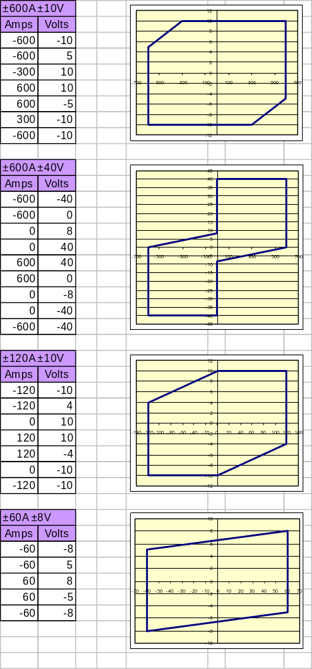

Bear in mind that in many cases, the operational limits for I and/or V will be less than the rated limits shown above. Two new properties (VS.LIMITS.I_Q41[2] and VS.LIMITS.V_Q41[2]) combined with the following rules can implement the operating zones for all the LHC 4 quadrant converters:

- The section to be excluded within the rectangle depends only on current and voltage and not on the load.
- The exclusion in quadrants 4 and 1 is defined by a line segment linking the points (I_Q41[0],V_Q41[0]) and (I_Q41[1],V_Q41[1]).
- The line segment defining the exclusion applied to quadrants 3 and 2 is rotationally symmetric to that applied to quadrants 4 and 1:
(-I_Q41[0],-V_Q41[0]) to (-I_Q41[1],-V_Q41[1]).
- The exclusion defined by the line segment is clipped by the operating rectangle (I_NEG,V_NEG) and (I_POS, V_POS) which may potentially not be centred on the origin, i.e. it is possible for |I_POS| ≠ |I_NEG| and/or |V_POS| ≠ |V_NEG|.
- The positive voltage limit will be V_POS for: I_Q41[1] ≤ I ≤ I_POS
- The negative voltage limit will be V_NEG for: I_NEG ≤ I ≤ -I_Q41[1]
- If I_NEG < I_Q41[0], then the line segment will be extrapolated for this zone.
- If I_POS > -I_Q41[0], then the line segment will be extrapolated for this zone.

The values of the new Q41 limits properties for the different converter types are given in the following table:

Converter | I_Q41[0] | V_Q41[0] | I_Q41[1] | V_Q41[1]
±600A ±10V | -600 | 5 | -300 | 10
±600A ±40V | -600 | 0 | 0 | 8
±120A ±10V | -120 | 4 | 0 | 10
±60A ±8V | -60 | 5 | 60 | 8

These do not need to depend upon the selected load (magnet circuit, cable circuit, short circuit or test) even though the outer limits (I_NEG, V_NEG) and (I_POS, V_POS) may change dramatically.

Finally, like for DIDT, the old DVDT min and max values from version 1 are merged into a single VS.LIMITS.DVDT property that defines the maximum rate of change of voltage in both directions.

The Q41 and DVDT limits depend only on the type of voltage source and could be hard coded into the FGC software and selected according to the power converter type, or they could be individual properties sent from the database. If this is the case, then the database values must be associated with the voltage source type and should not be duplicated hundreds of times for each individual converter. The whole question of database design remains open and is growing increasingly urgent.

- Conclusions

Defining limits is always going to be painful in a system with two variables, I and V, both of which have derivatives that also require limits, applied to four different load configurations. The limits presented in this paper represent a compromise between complexity and flexibility.

