IOT lab parking space detector
Author: Michal Lhotan

Parking lot application
The application consists of 4 parts: a web server written in Typescript, frontend written in Typescript using React, the data evaluator running on the Android Things board and data collector running on Arduino Mega written in C++ using the Platformio framework.

All of the source codes are in my git repository: https://github.com/lhotan/uni-parkinglot

The Android things board reads data from the arduino thorugh a USB Serial connection and processes the data and then determines if the parking lot is occupied or not and if it detects a change it will send the data to a server using REST method POST, the board has a set API key that it has to use to communicate with the server. The server according to the API key updates in memory data and lets the frontend access it through WebSocket.

The data is sent to the /lots endpoint of the webserver using the POST method, in the body you need to have a JSON encoded array e.g. “[0, 0]”, 0 tells the webserver that the parking lot is empty and 1 tells it that it’s occupied.

The frontend gets the data from the WebSocket endpoint /ws on port 8081.

Webserver & Frontend – Getting it to work
In order to build and use both parts you need the NodeJS runtime and some additional packages. You should use a package manager for this.
You will need both Node and Yarn in order to build these parts.
On Mac you should be able to install both using brew:
brew install node
brew instal yarn

The webserver hosts the frontend, you need to build the frontend first using the build-frontend.sh script,
then you can start the server with the launch-server.sh, it automatically runs on port 8080 but that can be changed in the webserver/config.ts file by changing the port variable.

Adding parking lots
In order to add a new parking lot you need to add a following command to the webserver/config.ts file with the desired parameters.
lots.push(new ParkingLot("NAME", "APIKEY"));
The API key must be unique!

Platformio Arduino – Getting it to work
The Arduino collects information from the sonar sensors and saves it in memory, the Android Things board then uses UART over USB to retrieve the data, it uses a custom protocol where you send a string e.g. “GL0T”.
- G = GET
- L = LOT
- 0 = LOT 0
- D = STOP COMMUNICATING
In this application we mostly use the GED command to get all the sensor data in array format [sen0, sen1].
In order to upload the code to the board the PlatformIO core will be enough, you can get it here https://platformio.org/install/cli. Then go to the project folder type platformio lib install to install libraries and then use platformio run and then platformio run --target upload to upload the program to the arduino. Then connect the Arduino board the the Android Things board.

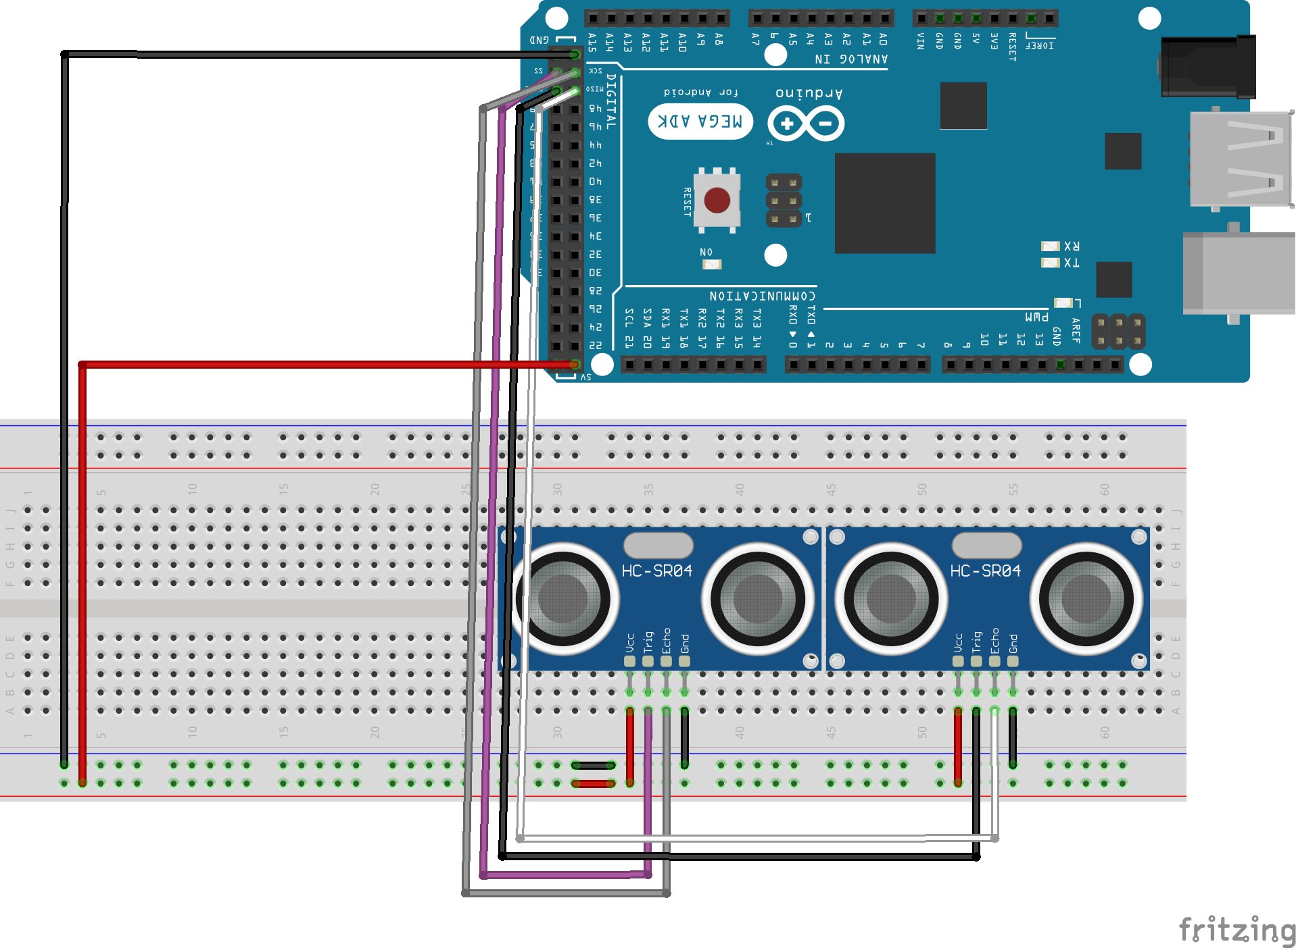

Android Things – Getting it to work
Before you can do this part you first need to upload the Arduino program to the Arduino Mega board and then connect the Arduino board to the USB of the Android Things board. You also need to connect the board to the internet using an ethernet cable.
In order to build and upload this part of the project you will need Android Studio https://developer.android.com/studio. Then open the AndroidThings project in it. Connect the android things board to your computer through the USB-C and wait until it shows up in the board selector. Then Press the run button to upload the project.

If you need to set a different serverUrl change the string on line 46 in the MainActivity.java file, you should also append the board API key to it.

