Web Programming - parking space analyzer
Authors: Michal Lhotan, Matej Weissmann

Summary
The project consists of a webserver that collects data about parking lot occupancy and then calculates the percentage of occupancy per parking lot per space per day from all the data.
If the MONGO_ENABLED flag in the config.ts file is set to true the server exposes these endpoints:
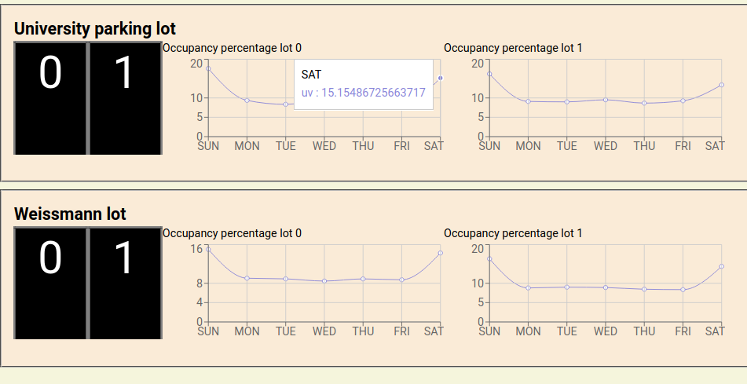
/parking
- get processed parking lot data
- used by frontend do get data to display a graph

/parking/evaluate
- evaluate collected parking data from the parking collection and put them in the processedParkingData collection in Mongo

/parking/generate
- debug endpoint, generates mock data and puts them in the parking collection

Folder structure
The most relevant parts for this project happen in src/generator.ts, src/eval.ts and mongoController.ts

src/generator.ts
Exposes the generateParkingData() function that generates mock data with the starting datetime of “2019-01-01 00:00”, it then generates 365 days worth of mock data, all of this can be changed at the top of the file. The file also contains a parkingChances array that specifies the chance of a parking lot being occupied for every hour of a day in a week, 0 means that the parking lot won’t be occupied and 15 means that it will be occupied, anything in between is based on a chance.
It dumps all the data into the parking collection in Mongo.

src/eval.ts
Exposes the evaluateParkingData() function that takes all the data in the parking collection and performs operations on it to get the percentage of occupancy per parking lot per space per day from all the data and then returns it to the processedParkingData collection.
The ouput data looks like:
interface IProcessedPercentages {
identifier: string,
lotNumber: number;
percentages: number[]
}[];
Where identifier is the name of the lot e.g. “Weissmann Lot”, “University parking lot”. The lot number is the number of the parking space e.g. 0, 1, 2… The percentages is an array of occupancy percentage of the lot per day of the week starting with Sunday, [25.0, 6.3…] where array[0] means that the spot was occupied 25/100% of the day meaning it was occupied for 6 hours.

