AGUILAR, Kryzha Lei P. November 16, 2019

2 – ECE – E ECE2112

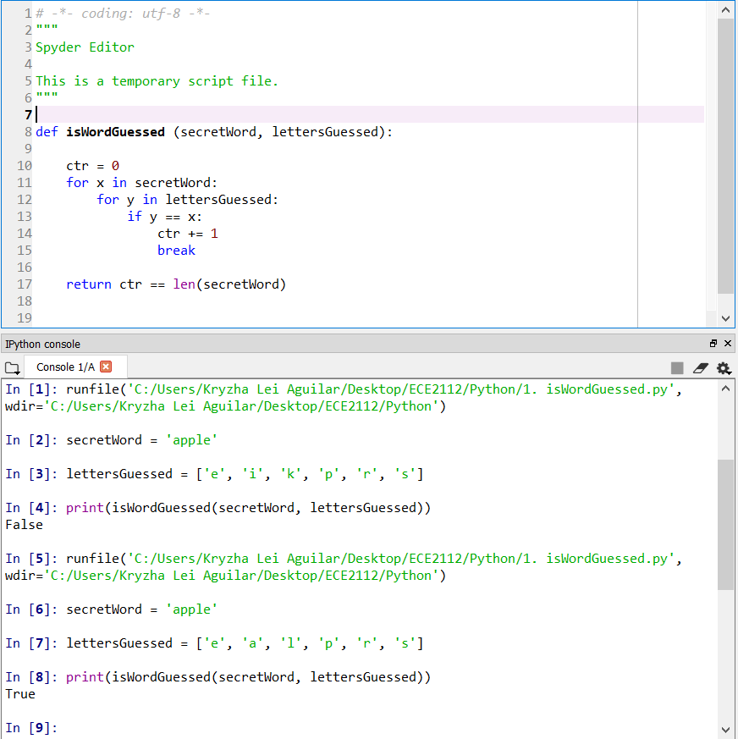**FUNCTION 1:** *isWordGuessed*

**FUNCTION 2:** *getGuessedWord*

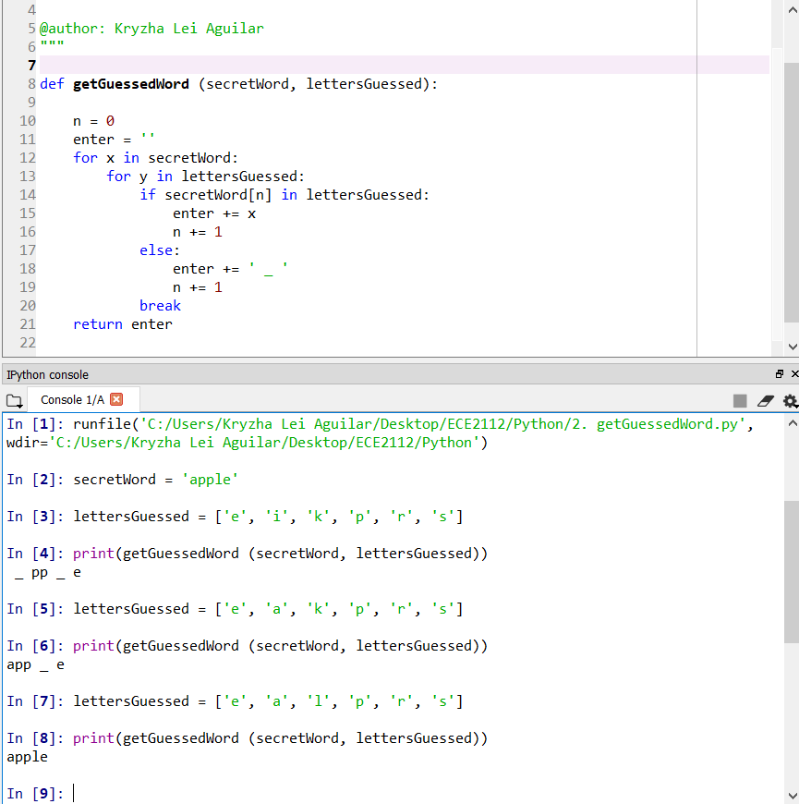

**FUNCTION 3:** *getAvailableLetters*

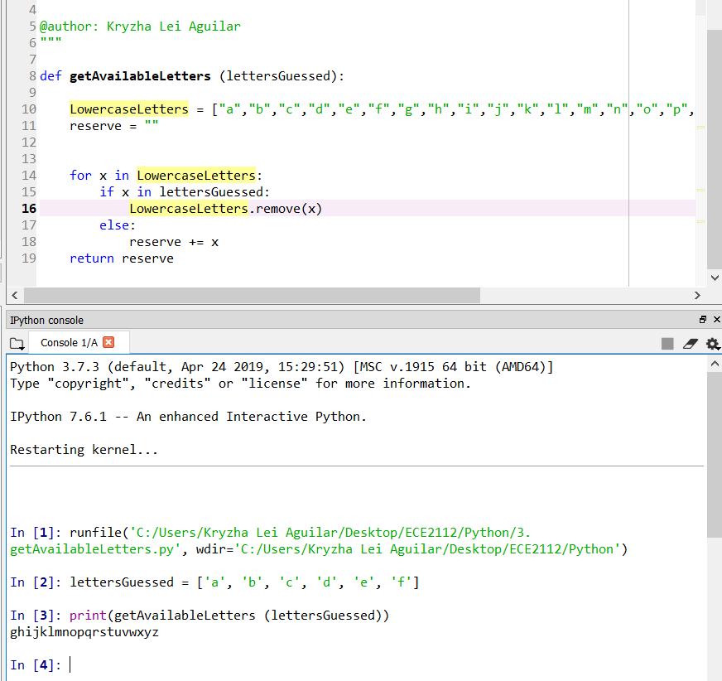

**FUNCTION 4:** *Hangaroo*

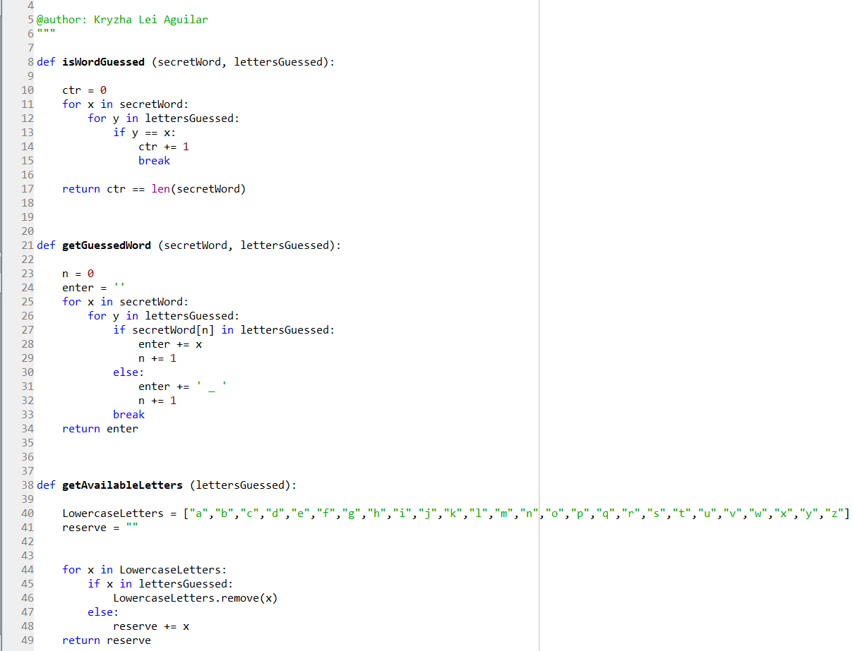

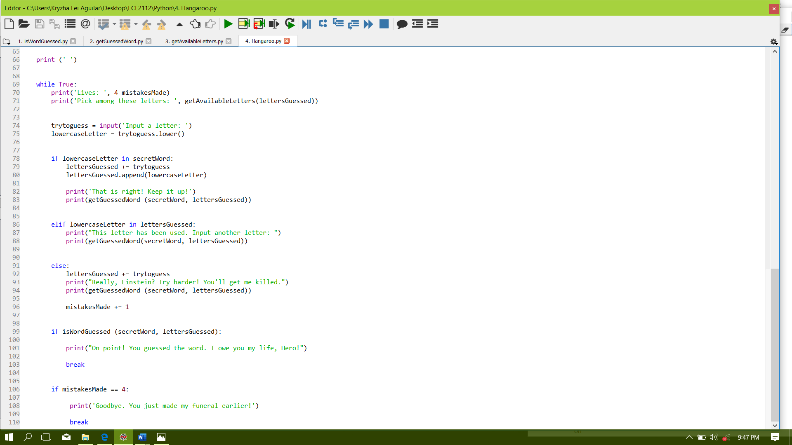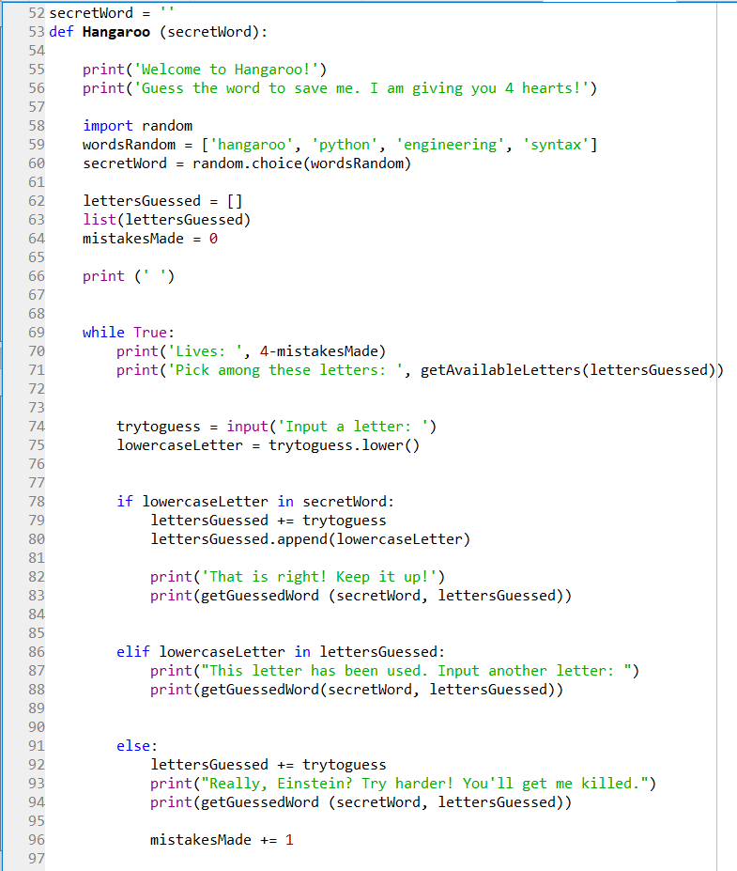

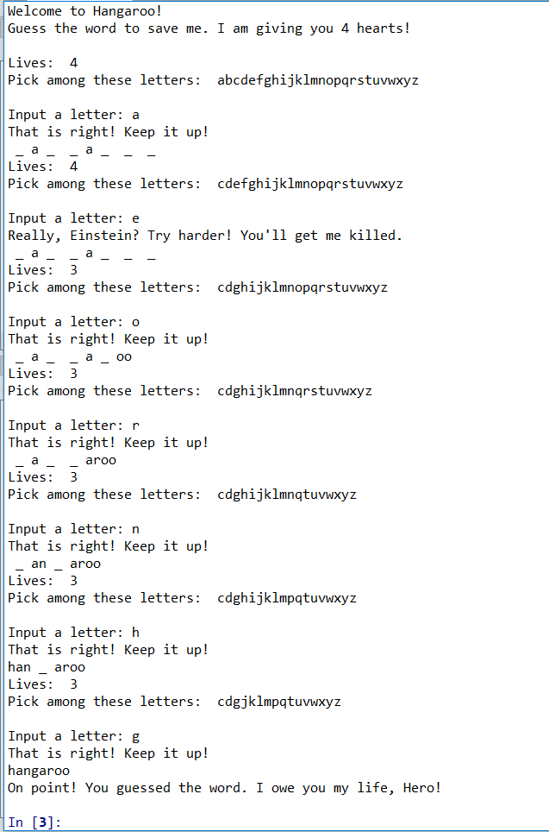**HANGAROO GAME: (***When word is guessed)*

**HANGAROO GAME: (***When word is not guessed)*

*(When letter has been selected more than once)*

