KRZYSZTOF SOKÓŁ-SZOŁTYSEK

PROGRAM 5

GRUPA PONIEDZIAŁKOWA

WYNIKI - WIELKOŚĆ ZDIAGONALIZOWANEJ MACIERZY N X N W PODANYM CZASIE

1s - 790

runfile('/home/dm/.config/spyder-py3/temp.py', wdir='/home/dm/anacondaws')

0.9955379962921143

mean logarithm:

8.8288032204

790

runfile('/home/dm/.config/spyder-py3/temp.py', wdir='/home/dm/anacondaws')

0.9991536140441895

mean logarithm:

7.93400344747

790

4 s - 1120

runfile('/home/dm/.config/spyder-py3/temp.py', wdir='/home/dm/anacondaws')

3.9286580085754395

mean logarithm:

8.54269641676

runfile('/home/dm/.config/spyder-py3/temp.py', wdir='/home/dm/anacondaws')

4.036144256591797

mean logarithm:

8.69316849413

runfile('/home/dm/.config/spyder-py3/temp.py', wdir='/home/dm/anacondaws')

3.9712326526641846

mean logarithm:

8.46199662306

16 s - 1730

runfile('/home/dm/.config/spyder-py3/temp.py', wdir='/home/dm/anacondaws')

16.195514917373657

mean logarithm:

8.91284366772

runfile('/home/dm/.config/spyder-py3/temp.py', wdir='/home/dm/anacondaws')

15.910765171051025

mean logarithm:

9.15997849888

runfile('/home/dm/.config/spyder-py3/temp.py', wdir='/home/dm/anacondaws')

15.904202699661255

mean logarithm:

8.6220791043

1m - 2700

runfile('/home/dm/.config/spyder-py3/temp.py', wdir='/home/dm/anacondaws')

59.648277044296265

mean logarithm:

9.69527633084

2700

4min - 4300

runfile('/home/dm/.config/spyder-py3/temp.py', wdir='/home/dm/anacondaws')

216.47883319854736

mean logarithm:

9.85188082381

4158

runfile('/home/dm/.config/spyder-py3/temp.py', wdir='/home/dm/anacondaws')

216.95545315742493

mean logarithm:

9.38572013421

4180

runfile('/home/dm/.config/spyder-py3/temp.py', wdir='/home/dm/anacondaws')

218.02181601524353

mean logarithm:

9.7767840864

4200

runfile('/home/dm/.config/spyder-py3/temp.py', wdir='/home/dm/anacondaws')

235.17094373703003

mean logarithm:

10.009770892

4300

16min - 6950

In [55]: runfile('/home/dm/.config/spyder-py3/temp.py', wdir='/home/dm/anacondaws')

914.6113700866699

mean logarithm:

10.4157964982

6850

In [56]: runfile('/home/dm/.config/spyder-py3/temp.py', wdir='/home/dm/anacondaws')

950.6974024772644

mean logarithm:

11.0867514838

6950

WYKRES CZASU DO WIELKOSCI MACIERZY

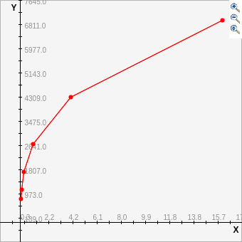

Jak widać, wzrost jest logarytmiczny - nie uzyskujemy od pewnego momentu dużego przyrostu N zwiększając czas na obliczenia

WYKRES L DO WIELKOŚCI MACIERZY

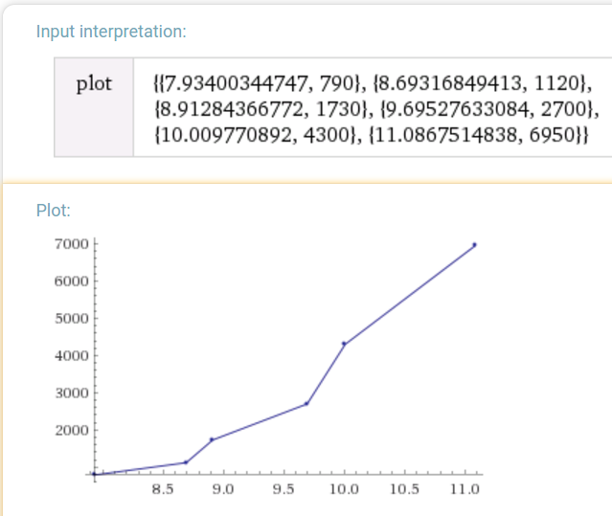

Średni logarytmiczny współczynnik uwarunkowania zmienia się nieznacznie z lekka tendencją wzrostową względem wielkości N

LISTING

# -*- coding: utf-8 -*-

"""

Spyder Editor

This is a temporary script file.

"""

# Problem V

import numpy as np

import time

n = 790

Matricescount = 10

G = [np.matrix(np.sqrt(1/n) * np.random.randn(n, n)) for i in range(Matricescount)]

time1 = time.time()

SV = [np.linalg.svd(g, compute_uv = False) for g in G]

time2 = time.time()

print(time2-time1)

K = [sv[0] / sv[n-1] for sv in SV]

print("mean logarithm:")

print(np.mean(np.log(K)))

print(n)